PCI/PICOe Backplane

Selection Guide

PAC series wall-mount chassis 4U rack-mount chassis

 | PCIe/PCI | PCIe/ PCI | HPE-3S1 | HPE-3S2 | HPE-4S1 | HPE-4S2 | HPE-5S1 | HPE-5S2 | HPE-6S1 | HPE-8S
Total Slot |  |  | 3 | 3 | 4 | 4 | 5 | 5 | 6 | 7
Expansion Slots | PCI |  | 2 | 1 | 3 | 2 | 4 | 3 | 4 | 4
 | PCIe | x4 |  | 1 |  | 1 |  | 1 | 1
 |  | x1 |  |  |  |  |  |  |  | 2
Chassis |  |  | N/A | N/A | PAC-42GH PAC-400G | PAC-42GH PAC-400G | PR-1500G RACK-500G | PR-1500G RACK-500G | N/A | N/A

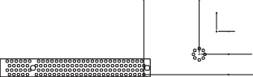 HPE-3S1-R41
0

12.98

24.56

41.07

56.97

68.68
0
9.82
41.2
180.01
189.99
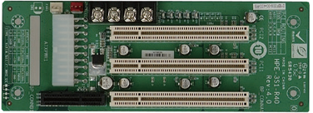

Ordering Information
HPE-3S1-R41 | 3-slot backplane with two PCI slots

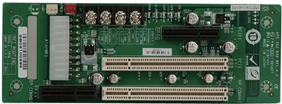
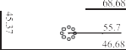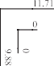 HPE-3S2-R41
128.83

140.48
HPE-4S1-R41

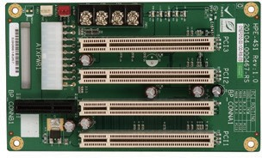

Ordering Information
HPE-4S1-R41 | 4-slot backplane with three PCI slots
PAC-42GH | 4-slot half-size compact chassis
PAC-400G | 4-slot half-size compact chassis
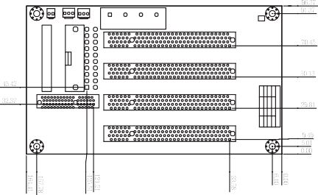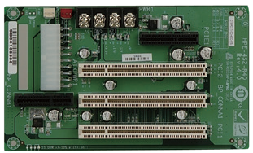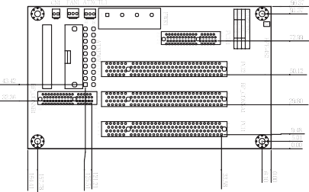 HPE-4S2-R41
CN1 FAN1 ATXCTL1

1 1 1
1
B62 B61 A62 A61
B2 B1 A2 A1
B62 B61
A62 A61
B2 B1 A2 A1
B32 B31
B2 B1
B62 B61 A62 A61
B2 B1 A2 A1
A31 A32
A1 A2
B62 B61 A62 A61
B2 B1 A2 A1
PCI ROUTING
IDSEL INT# AD31 B,C,D,A PCI1 AD30 C,D,A,B PCI2 AD29 D,A,B,C PCI3
0
PCI3 PCI2
BP_CONNA1 PCI1
PWR1
20
11
1
ATXPWR1
BP_CONNB1

Ordering Information
HPE-3S2-R41 | 3-slot backplane with one PCI slot and one PCIe x4 slot

Ordering Information
HPE-4S2-R41 | 4-slot backplane with two PCI slots and one PCIe x4 slot
PAC-42GH | 4-slot half-size compact chassis
PAC-400G | 4-slot half-size compact chassis

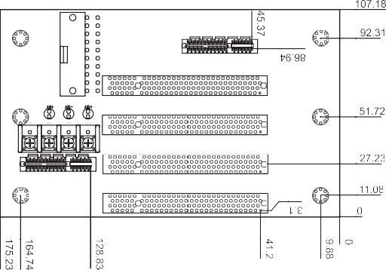
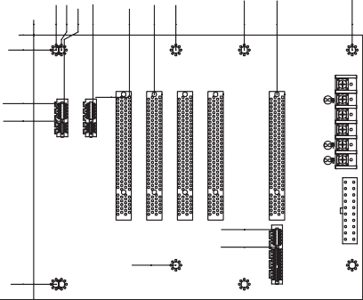
0
9.91
41.2
45.37
57.02
128.83
140.48
152.4
165
175.23
0
9.88
41.2
164.74
175.23
0
14.86
18.36
20.2
39.27
63.4
79.91
94.21
139.52
161.19
211.02

+12V -12V GND GND +5V +5V

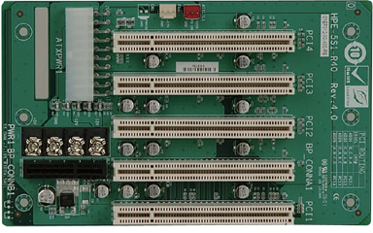
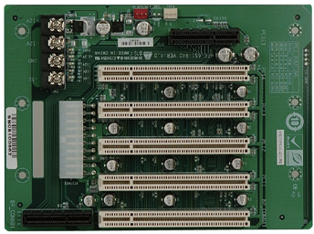
HPE-5S1-R51 HPE-6S1-R41

Ordering Information
HPE-5S1-R51 | 5-slot backplane with four PCI slots
PR-1500G | 5-slot half-size compact chassis
RACK-500G | 5U 5-slot full-size rack-mount chassis

Ordering Information
HPE-6S1-R41 | 6-slot backplane with four PCI slots and one PCIe x4 slot

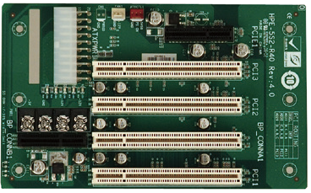
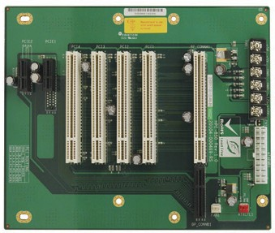
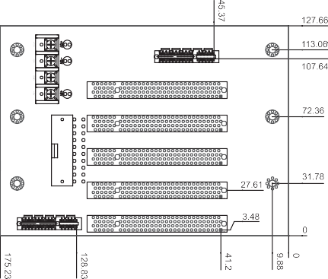
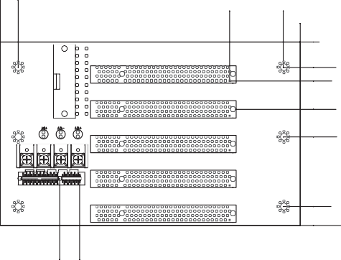 HPE-5S2-R40 HPE-8S0-R41
0

14.87
22.8

39.31

55.46
96.1

107.18
128.83
140.48

Ordering Information
HPE-5S2-R40 | 5-slot backplane with three PCI slots and one PCIe x4 slot
PR-1500G | 5-slot half-size compact chassis
RACK-500G | 5U 5-slot full-size rack-mount chassis

Ordering Information
HPE-8S0-R41 | 7-slot backplane with four PCI slots and two PCIe x1 slots

