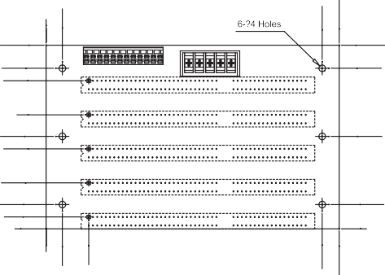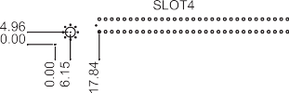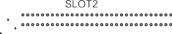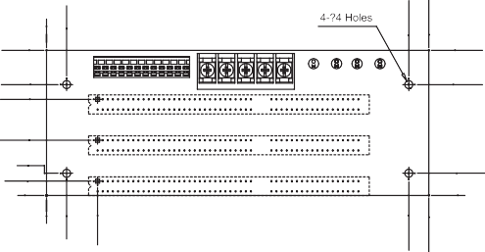BP Series Backplane
109.47
109.47
95.73
88.32
95.73
68

55.09
47.68
55.09
27.36

14.45
7.04
0
14.45
0
72.01
72.01
LED1 LED2 LED3 LED4
54.99
47.69
54.97
27.39

11
7.09
0
11.02

0
0
9.98
0
9.98
0
9.68
0
9.68
BP-3S
BP-5S
25.38
25.4
164.8
174.98
164.8
174.98
179.98
189.99
179.98
189.99
Selection Guide PAC series wall-mount chassis 4U rack-mount chassis

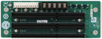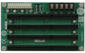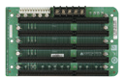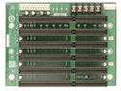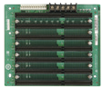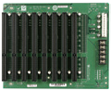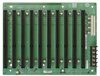

Model | BP-3S-RS-R40 | BP-4S-RS-R40 | BP-5S-RS-R40 | BP-6S-RS-R40 | BP-7S-RS-R40 | BP-8S-RS-R41 | BP-10S-RS-R40
Total Slot | 3 | 4 | 5 | 6 | 7 | 8 | 10
ISA Slot | 3 | 4 | 5 | 6 | 7 | 8 | 10
PSU Type | AT | AT | AT | AT | AT | AT | AT
Chassis | PAC-53GH | PAC-400G PAC-42GH | PR-1500G | PAC-106G PAC-1000G | PAC-700G PAC-1700G | N/A | PAC-125G
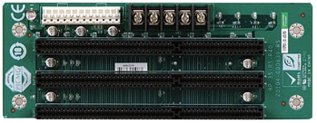
BP-3S-RS-R40

Ordering Information
BP-3S-RS-R40 | 3-slot backplane with three ISA slots
PAC-53GH | 3-slot half-size compact chassis
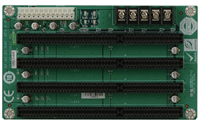
BP-4S-RS-R40

Ordering Information
BP-4S-RS-R40 | 4-slot backplane with four ISA slots
PAC-400G | 4-slot half-size compact chassis
PAC-42GH | 4-slot half-size compact chassis
BP-5S-RS-R40

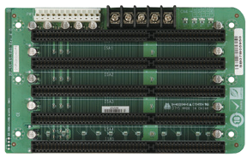

Ordering Information
BP-5S-RS-R40 | 5-slot backplane with five ISA slots
PR-1500G | 5-slot half-size compact chassis

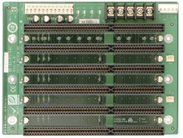
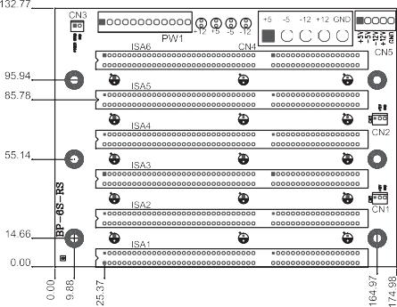
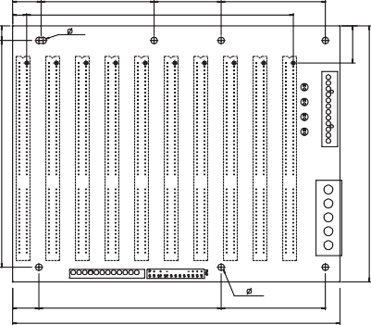
BP-10S-RS-R40
19.47
9.63
77.53
20.32x9=182.88
46
71.5
7x 4.0
BP-10S
6- 4.0
17.96
125.04
71.5
224.51
155.02
9.98
0
16.35
94.23
139.52
211
217.98
25.38
174.98
BP-6S-RS-R40

Ordering Information
BP-6S-RS-R40 | 6-slot backplane with six ISA slots
PAC-106G | 6-slot full-size compact chassis
PAC-1000G | 6-slot full-size compact chassis

Ordering Information
BP-7S-RS-R40 | 7-slot backplane with seven ISA slots
PAC-700G | 7-slot half-size compact chassis
PAC-1700G | 7-slot full-size compact chassis
BP-8S-RS-R41

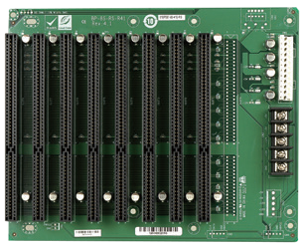
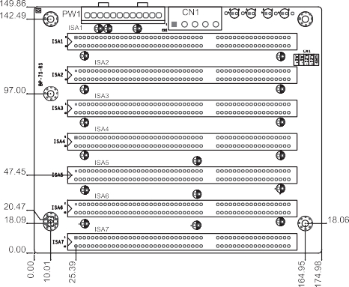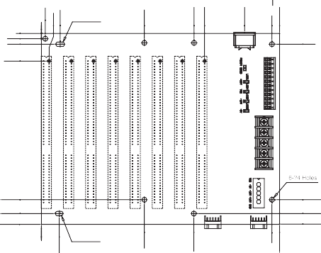6
BP-7S-RS-R40
7.5x4(OB)
0
4.88
9.88
BP-8S
9.88
25.35
152.38
152.38
164.97 164.97
174.98 174.65

6.5x4(OB)
0 3.56
7.09
17.18
94.23
139.73
149.33
185.93
211
217.98

Ordering Information
BP-8S-RS-R41 | 8-slot backplane with eight ISA slots

Ordering Information
BP-10S-RS-R40 | 10-slot backplane with ten ISA slots
PAC-125G | 10-slot full-size compact chassis

