www.ieiw or ld.com
AI Solution
Mustang-V100-MX8

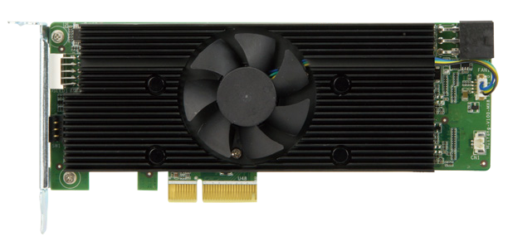

Specifications
Feature
- Half-Height, Half-Length, Single-slot compact size
- Low power consumption ,approximate 2.5W for each Intel® Movidius™ Myriad™ X VPU.
- Supported OpenVINO™ toolkit, AI edge computing ready device
- Eight Intel® Movidius™ Myriad™ X VPU can execute multiple topologies simultaneously.

Model Name | Mustang-V100-MX8
Main Chip | Eight Intel® Movidius™ Myriad™ X MA2485 VPU
Operating Systems | Ubuntu 16.04.3 LTS 64bit, CentOS 7.4 64bit, Windows10 64bit (more OS are coming soon)
Dataplane Interface | PCI Express x4
 | Compliant with PCI Express Specification V2.0
Power Consumption | <30W
Operating Temperature | 5°C~55°C (ambient temperature)
Cooling | Active fan
Dimensions Standard | Half-Height, Half-Length, Single-slot PCIe
Operating Humidity | 5% ~ 90%
Power Connector | *Preserved PCIe 6-pin 12V external power
Dip Switch/LED indicator | Identify card number
Support Topology | AlexNet, GoogleNet V1/V2/V4, Yolo Tiny V1/V2, Yolo V2/V3, SSD300,SSD512, ResNet-18/50/101/152, DenseNet121/161/169/201, SqueezeNet 1.0/1.1, VGG16/19, MobileNet-SSD, Inception-ResNetv2, Inception-V1/V2/V3/V4,SSD-MobileNet-V2-coco, MobileNet-V1-0.25-128, MobileNet-V1-0.50-160, MobileNet-V1-1.0-224, MobileNet-V1/V2, Faster-RCNN
*Standard PCIe slot provides 75W power, this feature is preserved for user in case of different system configuration

Ordering Information

Part No. | Description
Mustang-V100-MX8-R10 | Computing Accelerator Card with 8 x Movidius Myriad X MA2485 VPU, PCIe Gen2 x4 interface, RoHS

Packing List

1 X Full height bracket
1 x External power cable
1 x QIG

80.02
80.05
63.58
56.16
www.ieiw or ld.com
AI Solution

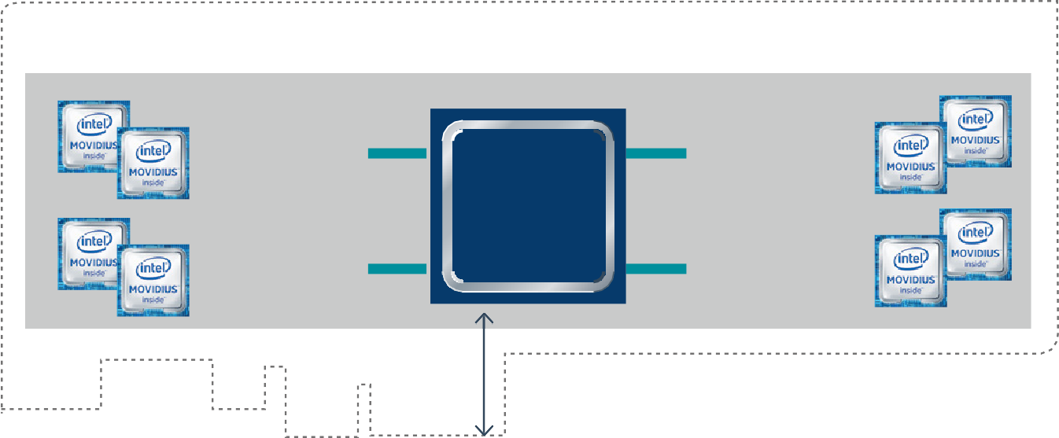
Multiple Intel® Movidius™ Myriad™ X Deep Learning Acceleration Add-in Card
PCIe Gen2 x 4
PCIe to USB3.0
PCIe to USB3.0
PCIe to USB3.0
PCIe to USB3.0

PCIe
Switch

Mustang-V100-MX8 Block Diagram
  - Intel® Movidius™ Myriad™ X VPU delivering up to 1 TOPs of dedicated networks compute
  - Interface: PCIe Gen2 x 4
  - Form Factor: Standard Half-Height, Half-Length, Single-slot
  - Cooling: Active fan.
  - Operation Temperature : 5°C~55°C(ambient temperature)
  - Operation Humidity : 5% to 90% relative humidity
  - Power Consumption: < 30W
  - Power Connector: *Preserved PCIe 6-pin 12V external power
  - DIP Switch/LED Indicator: Identify card number.
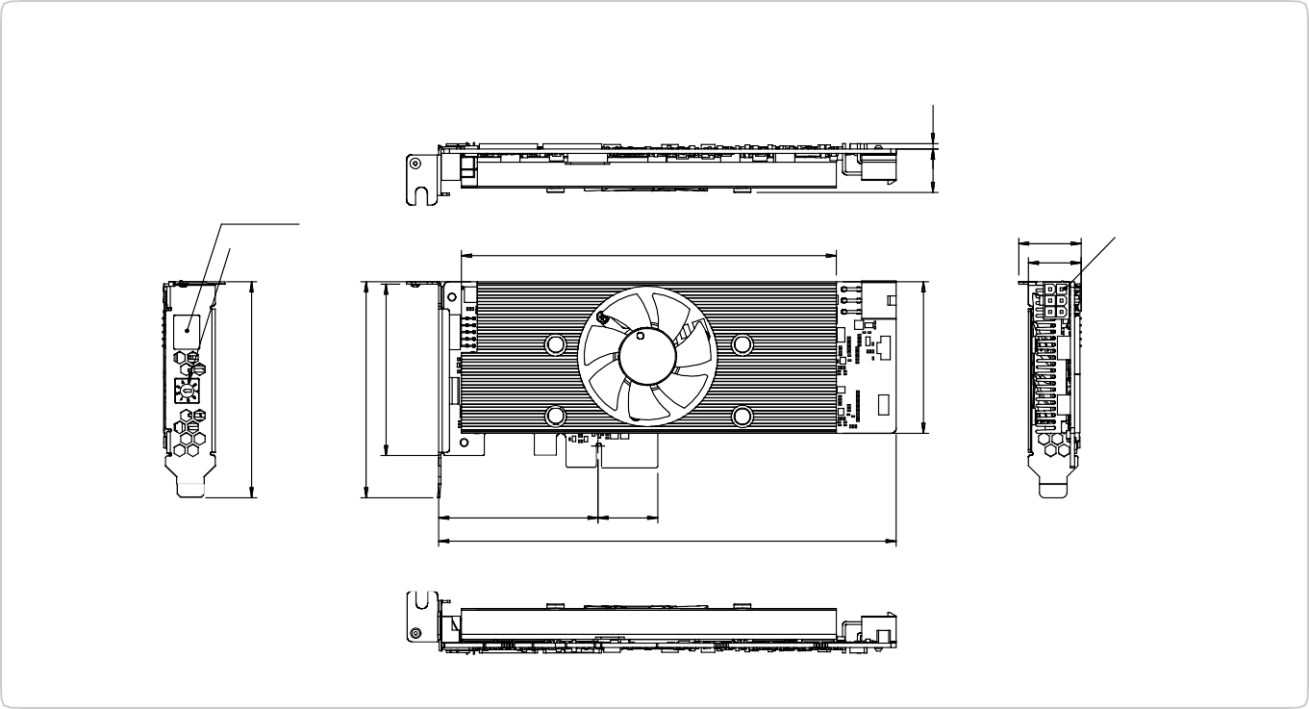*Standard PCIe slot provides 75W power, this feature is preserved for user in case of different system configuration
Mustang-V100-MX8 Dimensions (Unit: mm)
Number LED
Adjustment Button
13.16
Power In
139
59.05
22.15
169.54
19.58
16.07 2.03

