www.ieiw or ld.com
Mustang-200

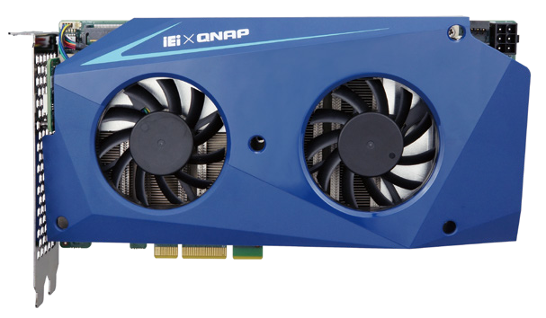

Specifications
Hardware Feature
- Dual 10Gbps network based x86 computing accelerator
- Decentralized computing architecture for independent tasks
- PCI Express x4 delivers scalable and flexible solution
- Two Intel® Core™ i7-7567U/i5-7267/Celeron® 3865U processors, up to 4.00 GHz
- Support high-end graphics engine - Intel® Iris™ Plus Graphics 650
- Pre-installed 32 GB DDR4 (max. 64 GB) and 1 TB NVMe (max. 2 TB)

AI Solution
Model Name | Mustang-200
Main Chipset | Two (2) Intel Kabylake ULT CPU
 | Intel® Core™ i7-7567U (28 W) (4M Cache, up to 4.00 GHz)
 | Intel® Core™ i5-7267U (28 W) (4M Cache, up to 3.50 GHz)
 | Intel® Celeron® 3865U (15W) (2M Cache, 1.80 GHz)
Processor Graphics | Intel® Core™ i7-7567U & i5-7267U support Iris™ Plus Graphics 650 (GT3e)  •Graphics base frequency 300 MHz  •Graphics max dynamic frequency: 1.05 GHz  •Embedded graphics DRAM per GPU: 64 MB
Intel® Celeron® 3865U supports Intel® HD Graphics 610
•Graphics base frequency 300 MHz
•Graphics max dynamic frequency: 900 MHz
Hardware Video Decode | H.264, H.265/HEVC
 | MPEG2, M/JPEG
 | VC-1
 | VP8(8 bit)/VP9(10 bit)
Hardware Video Encode | H.264, H.265/HEVC
 | MPEG2, M/JPEG
 | VC-1
 | VP8 (8-bit)
Display Output | 2 x Micro HDMI for debugging
USB 2.0 | 4 x USB 2.0 (pin header ) for debugging
Memory | (2 SO-DIMMs per CPU)  4 x DDR4 8GB SO-DIMM (Core™ i7/i5 SKU)  4 x DDR4 2GB SO-DIMM (Celeron® 3865U SKU)
Storage | 2 x Intel® SSD 600P series (Core™ i7/i5 SKU only) (512GB M.2 80mm PCIe 3.0 x4, 3D1, TLC)
Dataplane Interface | PCI Express x4
 | Compliant with PCI Express Specification V2.0
 | Compatible with PCI Express x4, x8, and x16 slots
External Interfaces | Reset button
 | Power button
Indicator | Seven segment (indicate card number and debug code)
Power Input | 12V PCIe 6-pin power input
Power Consumption | 12V@7.41A (Intel® Core™ i7-7567U SKU)
Operating Temperature | 0°C~40°C
Fan | Dual fan
Dimensions (DxWxH) | 40mm x 210mm x 111mm
Operating Humidity | 10% ~ 90%

AI Solution
120.09
128.15
100.39
100.12
www.ieiw or ld.com

Ordering Information

Part No. | Description
Mustang-200-i7-1T/32G-R10 | Computing Accelerator Card supports Two Intel® Core™ i7-7567U with Intel® 600P 1TB (512GB x2) SSD, 32GB (8GB x4) DDR4, PCIe x4 interface, QTS-Lite, and RoHS
Mustang-200-i5-1T/32G-R10 | Computing Accelerator Card supports Two Intel® Core™ i7-7267U with Intel® 600P 1TB (512GB x2) SSD, 32GB (8GB x4) DDR4, PCIe x4 interface, QTS-Lite, and RoHS
Mustang-200-C-8G-R10 | Computing Accelerator Card supports Two Intel® Celeron® 3865U with 8GB (2GB x4) DDR4, PCIe x4 interface, QTS-Lite, and RoHS (without NVMe storage)
19B00-000396-00-RS | Mustang-200 dual-port USB cable

Packing List

1 x Mustang-200
1 x QIG
1 x 4 pin to PCIe power cable
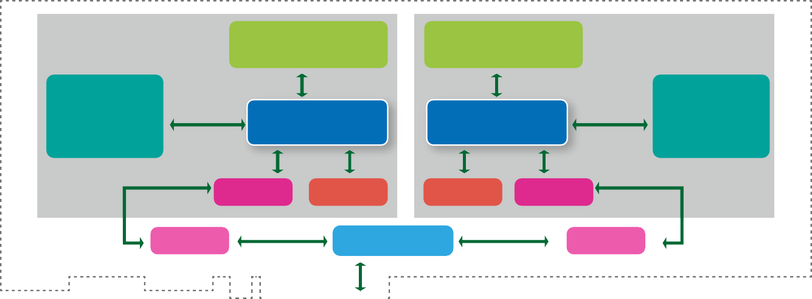
DDR4 SO-DIMMs 16GB
DDR4 SO-DIMMs 16GB
Intel® 600P PCIe x4
512GB NVMe
PCIe x4 Intel® 600P 512GB NVMe
PCIe x4
10G Mac eMMC 5.0
PCIe x4
eMMC 5.0 10G Mac
10G Ethernet
10G Mac
PCIe x4
PCIe Switch
PCIe x4
10G Mac
10G Ethernet
PCIe x4 Golden Finger
Intel® i7-7567U Iris™ Plus 650
Intel® i7-7567U Iris™ Plus 650
- Block Diagram
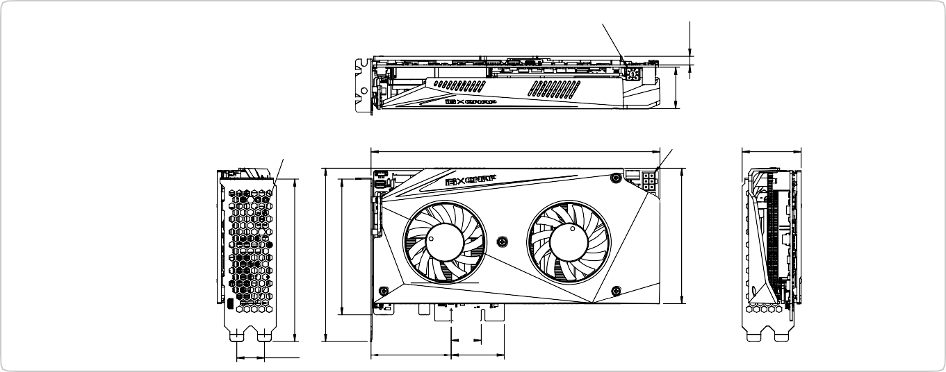Every CPU on the Mustang-200 is accompanied with 16GB (2 x 8GB) RAM and an Intel® 600P series 512GB NVMe SSD. Once installed in a PCIe x4 slot, the host computer will be connected to both computing nodes on the Mustang-200 with 10GbE networks. The advantage of utilizing network-based structures is that no proprietary hardware is needed thus a lower cost is achieved. The computing nodes are powered by QTS-Lite, a lightweight version of QNAP's award-winning QTS operating system, and the eMMC component will serve as storage for QTS- Lite.
Number Adjustment button
Mustang-200 Dimensions (Unit: mm)
212.98
Power in
43.44
Number led
20.32
59.05
39

.15

22.15
30.61
6.50

