www.ieiw or ld.com
Display System

10.1” RISC-based Panel PC
IOVU-210AR-RK39

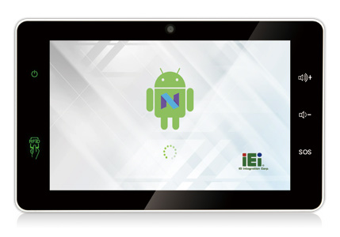
Features
- 10.1” 1280x800 LCD
- Project Capacitive Touch Screen
- CPU: Rockchip RK3399 (Dual-core Cortex-A72 up to 1.8GHz + Quad-core Cortex-A53 up to 1.5GHz)
- OS: Android 7.1
- Boot Flash: 16GB eMMC Nand Flash
- RAM: 2GB LPDDR3-1866
- Grove Interface IOT Sensor connectors

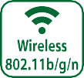
Specifications
Model |  | IOVU-210AR-RK39
Chassis | Color | White
 | Dimensions (WxHxD) (mm) | 282.5 x 174.3 x 26.8
 | System Fan | Fanless
 | Chassis Construction | PC + ABS plastic
Display | Size | 10.1"
 | Resolution | 800(RGB) x 1280
 | Brightness (cd/m²) | 250 cd/m² (typ.)
 | Contrast Ratio | 800:1(typ.)
 | Pixel Pitch (mm) | 0.0564 (H) × RGB × 0.1692 (V)
 | Viewing Angle (H/V) | 85/85/85/85 Deg.
 | Touchscreen | Project Capacitive
Motherboard | CPU | Rockchip RK3399 (Dual-core Cortex-A72 up to 1.8GHz + Quad-core Cortex-A53 up to 1.5GHz)
 | System Memory | 2GB LPDDR3-1866
Storage | SD Card | 1 x Micro SD slot
 | Flash | 16GB eMMC NAND FLASH
Communication | WLAN | 802.11 a/b/g/n/ac
 | Bluetooth | Bluetooth V4.1
 | RFID | 13.56 MHz ISO4443 A/B, read-write capable, ISO 14443A (MIFARE), ISO 14443B (FeliCa)
I/O Interfaces | COM port | 1 x RS-232 (4 pin wafer connector)  1 x RS-232/422/485 (4 pin terminal block) 2 x UART pin header with 3V (internal)
 | GPIO | - x 4 bit (2 in, 2 out)  - x 2 bit (1 in, 1 out)
 | Ethernet | 1 x GbE RJ45 by RTL8211E with PoE (PD) 1 x GbE RJ45 by RTL8211E
 | USB 3.1 Gen 1 | 1 x USB 3.1 Gen 1 (5Gb/s) Type A
 | USB 2.0 | 1 x USB 2.0 Type A  2 x USB 2.0 pin header (internal)
 | Others | 3 x I²C sensor connectors (3V)
Multimedia | Audio | 2 x Speaker (1.5W), 1 x Digital Mic in
 | Camera | Front 5-megapixel (CMOS)
LED Indicator & Button | Indicator | 1 x Power LED 1 x RFID LED
 | Button | 1 x Reset button  2 x Volume key ( up / down) on screen 1 x SOS key on screen
Power | Power Input | DC 9 V~30 V  * DC input: φ2.5/5.5mm DC Jack  * PoE: IEEE 802.3 at standard (Power Device)
 | Power Consumption | 12V @ 1.1A
Reliability | Mounting | Panel mount, In wall cage
 | Operating Temperature | -10°C ~ 50°C with air flow
 | Storage Temperature | -20°C ~ 60°C
 | Humidity | 10% ~ 90%, non-condensing
 | Weight (Net) | 0.85 kg
 | Safety/EMC | CE/FCC Class B compliant
OS | Supported OS | Android 7.1
 | Watch dog timer | Yes
* When both DC-in and PoE are connected to the device, the connection with higher voltage will be the main power source.

176.50
100.00
www.ieiw or ld.com
Display System
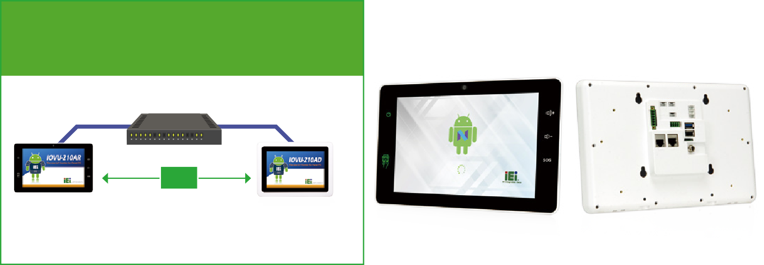
* When both DC-in and PoE are connected to the device, the connection with higher volt- age will be the main power source.
IOVU-210AD
Powered device (PD)
IOVU-210AR
Powered device (PD)
LAN Cable
LAN Cable
IEEE 802.3 at Compliant PoE Switch Power Supplying Equipment (PSE)
Power over Ethernet supported
Both of data transfer and power supply through one single LAN cable.
- Simplify the construction.
- Dual power input design.
DC

Ordering Information
Part No. | Description
IOVU-210AR-RK39-R10-TW | 10.1” TFT-LCD; Rockchip 3399 Processor, 2GB LPDDR3 , 16GB eMMC Flash, Camera, WIFI/BT, POE 802.3at, COM port, DIO, 4pin sensor connector, Front Camera, NFC, TW reg, ROHS
IOVU-210AR-RK39-R10-CN | 10.1” TFT-LCD; Rockchip 3399 Processor, 2GB LPDDR3 , 16GB eMMC Flash, Camera, WIFI/BT, POE 802.3at, COM port, DIO,  4pin sensor connector, Front Camera, NFC, CN reg, ROHS
IOVU-210AR-RK39-R10-EU | 10.1” TFT-LCD; Rockchip 3399 Processor, 2GB LPDDR3 , 16GB eMMC Flash, Camera, WIFI/BT, POE 802.3at, COM port, DIO, 4pin sensor connector, Front Camera, NFC, EU reg, ROHS
IOVU-210AR-RK39-R10-US | 10.1” TFT-LCD; Rockchip 3399 Processor, 2GB LPDDR3 , 16GB eMMC Flash, Camera, WIFI/BT, POE 802.3at, COM port, DIO,  4pin sensor connector, Front Camera, NFC, US reg, ROHS

Packing List
1 x IOVU-210AR Device
1 x Wall mount bracket
1 x Screw set

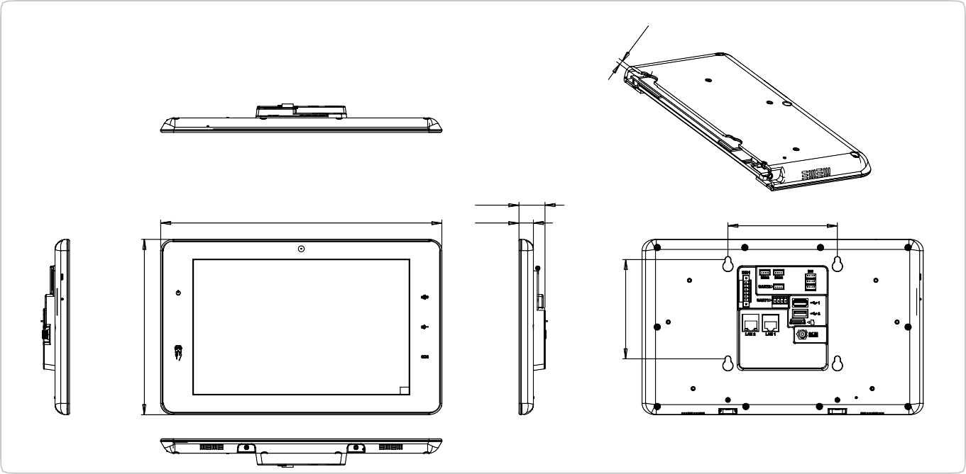Options
110.00
26.30
14.60
282.60
The wall mount screw inside the device
do not over 3mm.
IOVU-210AR-RK39 Dimensions
(Unit: mm)

Item | Part No. | Description
Power Adapter | 63040-010060-120-RS | Vin:90~264VAC;60W;Φ2.5/Φ5.5/lock
In Wall Cage | 41320-0490E4-00-RS | In wall bracket for IOVU-210AR

www.ieiw or ld.com
Display System

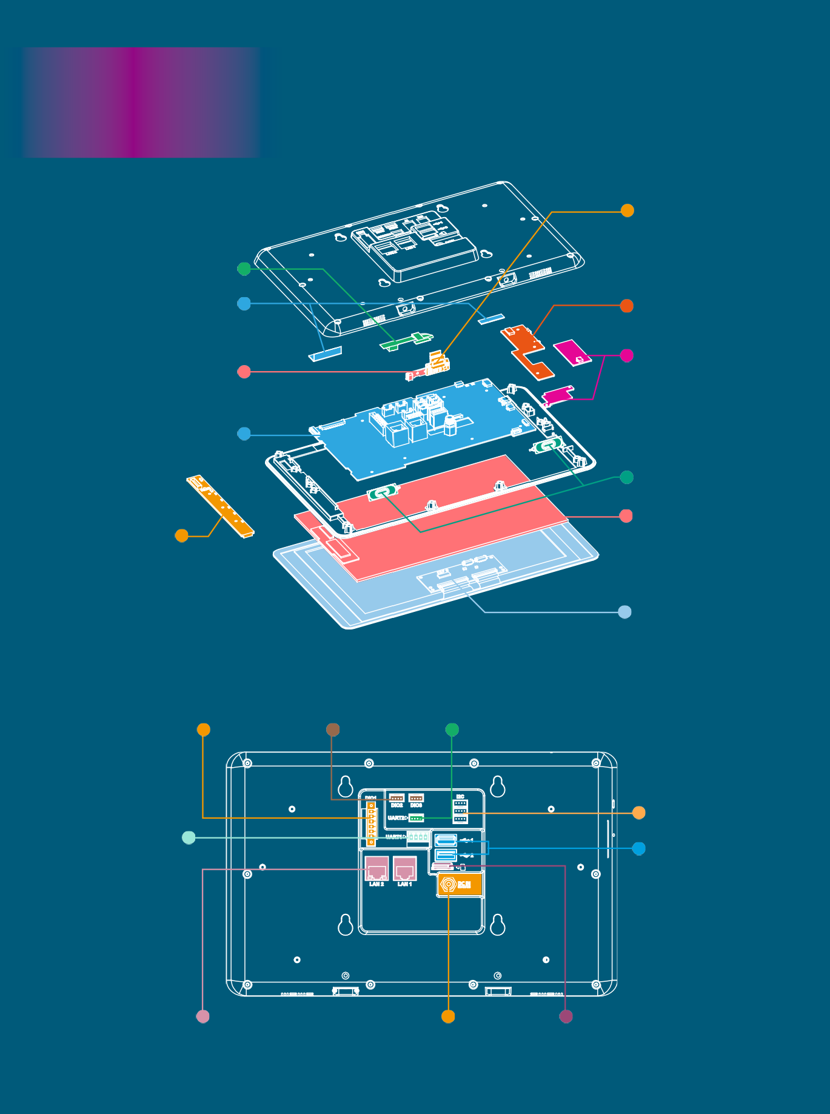
IOVU-
210AR-RK39

5 Megapixels Camera
Wi-Fi Antenna

Digital Microphone Mother Board

OSD Key Pad
Micro SD Slot
For extend the storage space.

NFC Module Indicator Pad

2 x 1.5W Speaker LCD

Touch Panel

4-bit GPIO 2 x 2-bit GPIO RS-232

RS-232/422/485
3 x I²C
USB 2.0
USB 3.1 Gen 1

1 x RJ-45 GbE LAN Port
1 x RJ-45 GbE LAN with PoE (LAN 1)
DC Jack
Micro SD Slot

