www.ieiw or ld.com
Display System

10.1” RISC Base Panel PC
IOVU-210AD-RK39

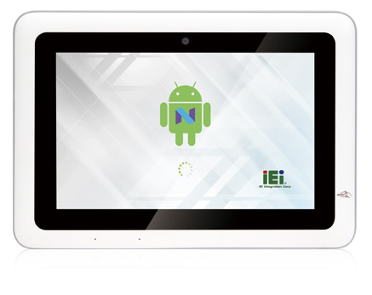Features
- 10.1” 1280x800 LCD
- Project Capacitive Touch Screen
- CPU: Rockchip RK3399 (Dual-core Cortex-A72 up to 1.8GHz + Quad-core Cortex-A53 up to 1.5GHz)
- OS: Android 7.1
- Boot Flash: 16GB eMMC Nand Flash
- RAM: 2GB LPDDR3

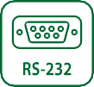
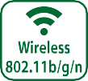
Specifications

Model |  | IOVU-210AD-RK39
Chassis | Color | White
 | Dimensions (WxHxD) (mm) | 293 x 209.5 x 44.5
 | System Fan | Fanless
 | Chassis Construction | PC + ABS plastic front, Metal rear
Display | Size | 10.1"
 | Resolution | 800(RGB) x 1280
 | Brightness (cd/m²) | 250 cd/m² (typ.)
 | Contrast Ratio | 800:1(typ.)
 | Pixel Pitch (mm) | 0.0564(H) x 0.1692(V)
 | Viewing Angle (H/V) | 85/85/85/85 Deg.
 | Touchscreen | Project Capacitive
Motherboard | CPU | Rockchip RK3399 (Dual-core Cortex-A72 up to 1.8GHz + Quad-core Cortex-A53 up to 1.5GHz)
 | System Memory | 2GB LPDDR3-1866
Storage | SD Card | 1 x Micro SD slot (Internal)
 | Flash | 16GB eMMC NAND FLASH
Communication | WLAN | 802.11 a/b/g/n/ac
 | Bluetooth | Bluetooth V4.1
 | RFID | 13.56 MHz ISO4443 A/B, read-write capable, ISO 14443A (MIFARE), ISO 14443B (FeliCa)
I/O Interfaces | COM port | 1 x RS-232 (DB-9)  1 x RS-232/422/485 (DB-9)
 | GPIO | 4 bit (2 in, 2 out)
 | Ethernet | 1 x GbE RJ45 by RTL8211E w/ PoE
 | USB 3.1 Gen 1 | 1 x USB 3.1 Gen 1 (5Gb/s) Type A  1 x USB 3.1 Gen 1 (5Gb/s) Type C OTG
 | USB 2.0 | 2 x USB 2.0 Type A  2 x USB 2.0 pin header (internal)
Multimedia | Audio | 1 x Speaker (2 W) , 2 x Digital Mic in
 | Camera | Front 5-megapixel (CMOS)
LED Indicator & Button | Indicator | 1 x Power, 1 x BT, 1 x Wi-Fi
 | Button | 1 x Reset Button
Power | Power Input | DC 9 V~30 V  * DC input: φ2.5/5.5mm DC Jack or Terminal block  * PoE: IEEE 802.3 at standard (Power Device)
 | Power Consumption | 12V @ 1.2A
Reliability | Mounting | VESA Mount 75mm x 75mm
 | Operating Temperature | -10°C ~ 50°C with air flow
 | Storage Temperature | -20°C ~ 60°C
 | Humidity | 10% ~ 90%, non-condensing
 | Weight (Net) | 1.84 kg
 | Safety/EMC | CE/FCC Class A compliant
OS | Supported OS | Android 7.1
 | Watch dog timer | Yes
* When both DC-in and PoE are connected to the device, the connection with higher voltage will be the main power source.

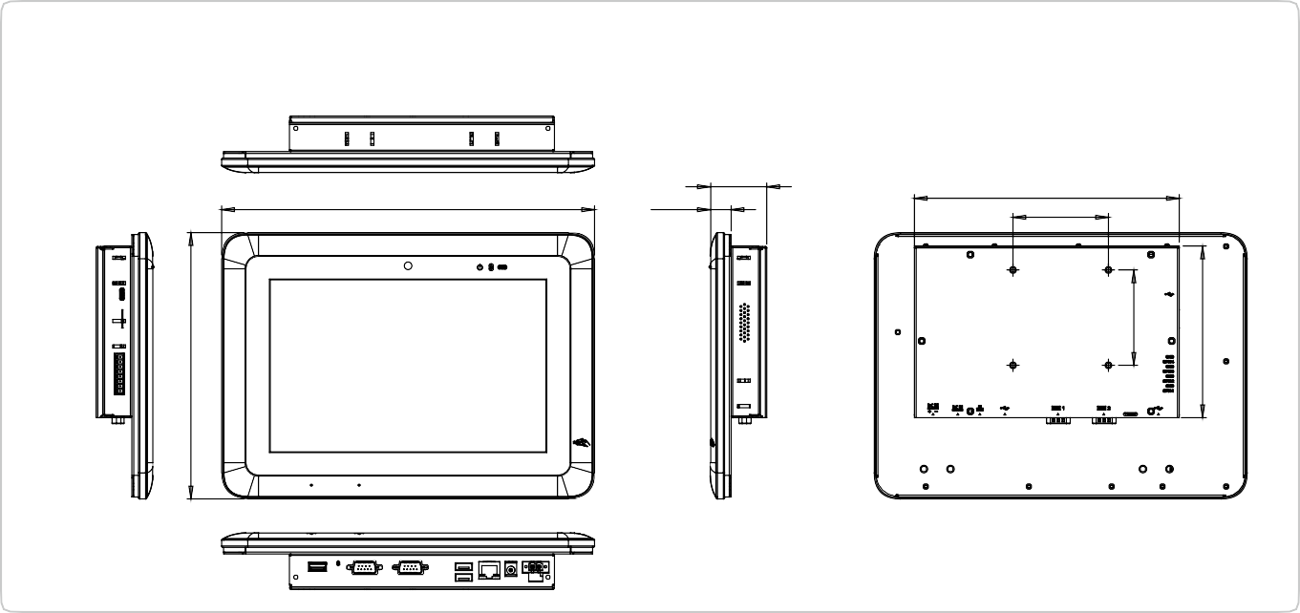
208.20
75.00
16.49
293.00
44.49
IOVU-210AD-RK39 Dimensions
(Unit: mm)
209.50
75.00
135.00
www.ieiw or ld.com
Display System

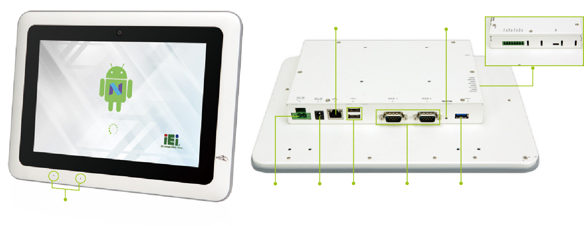
RJ-45 GbE LAN with PoE
Reset
Terminal black GPIO (4-bit)
Terminal black DC Jack 2x USB 2.0
DC input
1 x RS-232
1 x RS-232/422/485
USB 3.1 Gen 1
Mic

Ordering Information
Part No. | Description
IOVU-210AD-RK39-R10-TW | 10.1” TFT-LCD; Rockchip 3399 Processor, 2GB LPDDR3 , 16GB eMMC Flash, WiFi/BT, IEEE 802.3at for POE, phone jack, 4xGPIO, Android 7.1, NFC, TW reg, ROHS
IOVU-210AD-RK39-R10-CN | 10.1” TFT-LCD; Rockchip 3399 Processor, 2GB LPDDR3 , 16GB eMMC Flash, WiFi/BT, IEEE 802.3at for POE, phone jack, 4xGPIO, Android 7.1, NFC, CN reg, ROHS
IOVU-210AD-RK39-R10-EU | 10.1” TFT-LCD; Rockchip 3399 Processor, 2GB LPDDR3 , 16GB eMMC Flash, WiFi/BT, IEEE 802.3at for POE, phone jack, 4xGPIO, Android 7.1, NFC, EU reg, ROHS
IOVU-210AD-RK39-R10-US | 10.1” TFT-LCD; Rockchip 3399 Processor, 2GB LPDDR3 , 16GB eMMC Flash, WiFi/BT, IEEE 802.3at for POE, phone jack, 4xGPIO, Android 7.1, NFC, US reg, ROHS

Packing List
1 x IOVU-210AD Device
Options

Item | Part No. | Description
Power Adapter | 63040-010060-120-RS | Vin:90~264VAC;60W;Φ2.5/Φ5.5/lock
ARM | ARM-11-RS | Flat Panel Monitor ARM
Stand | STAND-A12-RS | LCD MONITOR/PPC STAND
Wall Mount Kit | AFLWK-19B | Monitor Wall mounting kit with lock

www.ieiw or ld.com
Display System

IOVU-
210AD-RK39

Mother Board

2W Speaker Wi-Fi Antennas
IO Board

5 Megapixels Camera NFC Module
LCD

Digital Microphone

DIO 4bit

2 x USB2.0 RS-232 RS-232/422/485

Terminal Block DC Input

USB 3.1 Gen 1

DC Jack
Reset

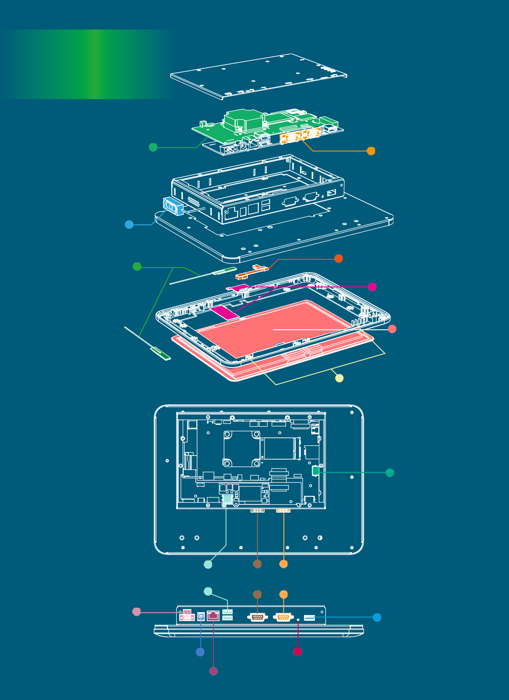
RJ45 GbE LAN with PoE(PD)

