www.ieiw or ld.com
Display System

7” RISC-based Panel PC
IOVU-207AR-RK39

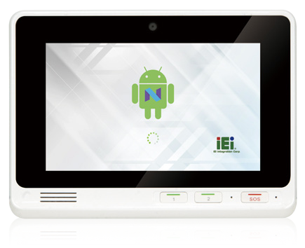Features
Specifications
- OS: Android 7.1
- CPU: Rockchip RK3399 (Dual-core Cortex-A72 up to 1.8GHz + Quad-core Cortex-A53 up to 1.5GHz)
- Boot Flash: 16G eMMC Nand Flash
- RAM: 2GB LPDDR3-1866
- 1 x SOS Key (with red bar):
Press for calling help in case emergency
2 x Function Keys ( with green bar ):
Default hot key by AP programming

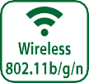

Model |  | IOVU-207AR-RK39
Chassis | Color | White
 | Dimensions (WxHxD) (mm) | 210.7 x 154.7 x 29.6
 | System Fan | Fanless
 | Chassis Construction | PC + ABS plastic front, Metal rear
Display | Size | 7"
 | Resolution | 720 RGB (H) x 1280 (V)
 | Brightness (cd/m²) | 300 cd/m2 (typ.)
 | Contrast Ratio | 800:1(typ.)
 | Pixel Pitch (mm) | 0.1239 (H) ×0.119 (V)
 | Viewing Angle (H/V) | 70/70/70/70 Deg.
 | Touchscreen | Projected capacitive
Motherboard | CPU | Rockchip RK3399 (Dual-core Cortex-A72 up to 1.8GHz + Quad-core Cortex-A53 up to 1.5GHz)
 | System Memory | 2GB LPDDR3-1866
Storage | SD Card | 1 x Micro SD slot
 | Flash | 16GB eMMC NAND FLASH
Communication | WLAN | 802.11 a/b/g/n/ac
 | Bluetooth | Bluetooth V4.1
I/O Interfaces | COM port | 2 x UART pin header with 3V (internal)
 | Ethernet | 1 x GbE RJ45 by RTL8211E
 | USB 3.1 Gen 1 | 1 x USB 3.1 Gen 1 (5Gb/s) Type A
 | USB 2.0 | 1 x USB 2.0 Type A  2 x USB 2.0 pin header (internal)
 | Others | 2 pin terminal block for SOS key
Multimedia | Audio | 1 x Speaker (2 W) , 1 x Digital Mic in
 | Camera | Front 5-megapixel (CMOS)
LED Indicator & Button | Indicator | 1 x Power LED 1 x Mail  1 x Phone  1 x Exclamation Mark
 | Button | 1 x Reset Button  1 x SOS button ( red bar )  2 x Function Key ( green bar )
Power | Power Input | DC 9 V~30 V,  φ2.5/5.5mm DC Jack
 | Power Consumption | 12V @ 1.05A
Reliability | Mounting | VESA Mount 75mmx75mm
 | Operating Temperature | -10°C ~ 50°C with air flow
 | Storage Temperature | -20°C ~ 60°C
 | Humidity | 10% ~ 90%, non-condensing
 | Weight (Net) | 0.72 kg
 | Safety/EMC | CE/FCC Class B compliant
OS | Supported OS | Android 7.1
 | Watch dog timer | Yes

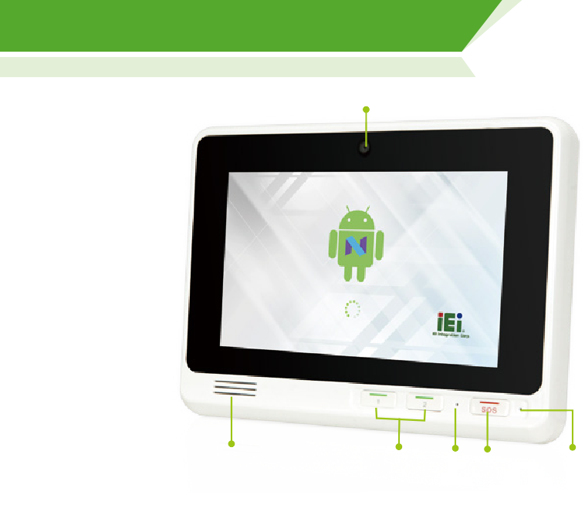
Display System

Camera

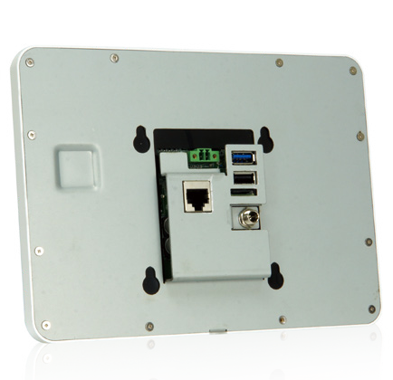
www.ieiw or ld.com

Speaker Function Key

Ordering Information
Mic
SOS Key
Reset

154.70
75.00
Part No. | Description
IOVU-207AR-RK39-R10-TW | 7” TFT-LCD; Rockchip 3399 Processor, 2GB LPDDR3 , 16GB eMMC Flash, Camera, WIFI/BT, Gigabit Ethernet, TW reg, ROHS
IOVU-207AR-RK39-R10-CN | 7” TFT-LCD; Rockchip 3399 Processor, 2GB LPDDR3 , 16GB eMMC Flash, Camera, WIFI/BT, Gigabit Ethernet, CN reg, ROHS
IOVU-207AR-RK39-R10-EU | 7” TFT-LCD; Rockchip 3399 Processor, 2GB LPDDR3 , 16GB eMMC Flash, Camera, WIFI/BT, Gigabit Ethernet, EU reg, ROHS
IOVU-207AR-RK39-R10-US | 7” TFT-LCD; Rockchip 3399 Processor, 2GB LPDDR3 , 16GB eMMC Flash, Camera, WIFI/BT, Gigabit Ethernet, US reg, ROHS

Packing List
1 x IOVU-207AR Device
1 x Wall mount bracket
1 x Screw set
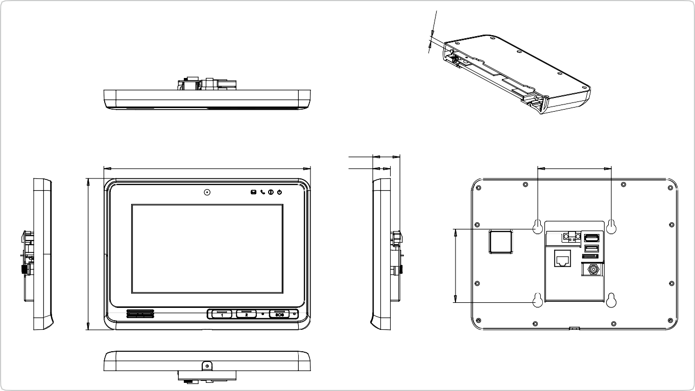Options
The wall mount screw inside the
device do not longer than 4mm.
75.00
27.60
18.00
210.70
IOVU-207AR-RK39 Dimensions
(Unit: mm)

Item | Part No. | Description
Power Adapter | 63040-010060-120-RS | Vin:90~264VAC;60W;Φ2.5/Φ5.5/lock

www.ieiw or ld.com
Display System

IOVU-
207AR-RK39

5 Megapixels Camera

Mother Board Indicator Pad
Digital Microphone

Touch Panel
Micro SD Slot
For extend the storage space.

2W Speaker

Key Pad

LCD

USB 2.0
USB 3.1 Gen 1

SOS Pin

RJ45 GbE LAN Port Micro SD Slot

DC Jack

