PEMUX backplane, 4 PCIe Gen 3.0 x8 w/ x16 slot, 6 PCIe Gen3.0 x4 w/ x4 slos, and RoHS

PEMUX-10S1-R10
Quick Installation Guide
Version 1.0

Feb.15, 2019

Package List
PEMUX-10S1-R10 package includes the following items:
- 1 x PEMUX-10S1-R10
- 1 x QIG (Quick Installation Guide)

Copyright © 2019 IEI Integration Corp.
All rights reserved.

Specifications
  - System Type: PEMUX Backplane
  - PiMax: 1 ea (full size)
  - PCI-E slot:
4 x PCIE x8 from CPU 4 x PCIE x4 from CPU
Slot type: x8 signal with x16 slot Slot type: x4 signal with x4 slot 2 x PCIE x4 from PCH
Slot type: x4 signal with x4 slot
  - Chassis: Mounting hole compatible with PCI-14S
  - Others:
ATX power connector x1 (24pin)
note: Add addtion 8pin power connector if needed
STATUS_LED1 connector (2X7 pin) x1 (pwr_led, sata_led, lan_led, 10g_led)
Reset connector (2 pin) x1 SM BUS connector (2 pin) x1 PWRGD connector (2 pin) x1 LCM connector (4 pin) x1 PWRBTN connector (2 pin) x1 Fan connector (4 pin) x4 CASE OPEN (2 pin) x1
Note:
x4 slot with open-ended connector

Ordering Information
  - PEMUX-10S1-R10:
1-Slot PEMUX backplane, 4 PCIe Gen 3.0 x8 w/ x16 slot,6 PCIe Gen3.0 x4 w/ x4 slos, and RoHS

  - RACK-305G:
4U 14-slot full-size rack-mount chassis
  - RACK-360G:
4U 14-slot full-size rack-mount chassis
  - RACK-3000G:
4U 14-slot full-size rack-mount chassis

Jumper Settings and Connectors

LABEL | FUNCTION
HDC_CONNA1, HDC_CONNB1, HDC_CONNC1 | Motherboard connectors
PCIEX16_1,  PCIEX16_4,  PCIEX16_6, PCIEX16_7 | PCIEX8 BUS connectors
PCIEX4_2,  PCIEX4_3, PCIEX4_5 | PCIEX4 BUS connectors
LCM1, LCM2 | LCM connectors
USB1 | USB connector
PSU2 | ATX power connector
PSU1 | 12V DC-IN connector
SM-BUS1 | SMBUS connector
PWRBTN1 | Power Button connector
RESET1 | Reset Button connector
BP_FAN1~BP_FAN4 | Fan connectors
PWRGD1 | Power good signal output
CASE_OPEN1 | Case open connector
PWR_SMB1 | Power supply SMBus connector
K_TYPE1, K_TYPE2 | Temperature measurement connectors
STATUS_LED1 | System status LED connector

PSU2: ATX Power Connector
PIN NO. | DESCRIPTION | PIN NO. | DESCRIPTION
1 | +3.3V | 13 | +3.3V
2 | +3.3V | 14 | -12V
3 | GND | 15 | GND
4 | +5V | 16 | PS_ON
5 | GND | 17 | GND
6 | +5V | 18 | GND
7 | GND | 19 | GND
8 | Pwr_ok | 20 | -5V
9 | STB5V | 21 | +5V
10 | +12V | 22 | +5V
11 | +12V | 23 | +5V
12 | +3.3V | 24 | GND

PSU1: 12V DC-IN Connector
PIN NO. | DESCRIPTION | PIN NO. | DESCRIPTION
1 | GND | 5 | +12V
2 | GND | 6 | +12V
3 | GND | 7 | +12V
4 | GND | 8 | +12V

BP_FAN1~BP_FAN4: Fan connectors
PIN NO. | DESCRIPTION | PIN NO. | DESCRIPTION
1 | GND | 2 | +12V
3 | FAN SENSE | 4 | FAN CONTROL

PWRGD1: Power Good output
PIN NO. | DESCRIPTION | PIN NO. | DESCRIPTION
1 | GND | 2 | Power Good

LCM1, LCM2: LCM Connectors
PIN NO. | DESCRIPTION | PIN NO. | DESCRIPTION
1 | LCM_TX | 2 | +5V
3 | LCM_RX | 4 | GND

PWRBTN1: Power Button
PIN NO. | DESCRIPTION | PIN NO. | DESCRIPTION
1 | GND | 2 | PWRBTN_N

RESET1: Reset Button
PIN NO. | DESCRIPTION | PIN NO. | DESCRIPTION
1 | GND | 2 | RESET_N

SM-BUS1: SMBUS Connector
PIN NO. | DESCRIPTION | PIN NO. | DESCRIPTION
1 | SMDATA | 2 | SMBCLK

PWR_SMB1: Power Supply SMBus Connector
PIN NO. | DESCRIPTION | PIN NO. | DESCRIPTION
1 | SMbus_CLK1 | 2 | SMbus_DAT1
3 | NC | 4 | GND
5 | NC

USB1: USB Connector
PIN NO. | DESCRIPTION | PIN NO. | DESCRIPTION
1 | +5V | 2 | GND
3 | DATAX- | 4 | DATAX+
5 | DATAX+ | 6 | DATAX-
7 | GND | 8 | +5V

CASE_OPEN1: Case Open Connector
PIN NO. | DESCRIPTION | PIN NO. | DESCRIPTION
1 | GND | 2 | CASEOPEN_N

K-TYPE1, K-TYPE2: Temperature Measurement Connectors
PIN NO. | DESCRIPTION | PIN NO. | DESCRIPTION
1 | T-SENSE_N | 2 | T-SENSE_P

STATUS_LED1: System Status LED connector
PIN NO. | DESCRIPTION | PIN  NO. | DESCRIPTION
1 | System Power LED_N | 2 | +3.3V
3 | HDD active_LED_N | 4 | +3.3V
5 | USB active_LED_N | 6 | +3.3V
7 | System Green LED_N | 8 | +3.3V
9 | System Red LED_N | 10 | +3.3V
11 | 10G LAN active LED_N | 12 | +3.3V
13 | 1G LAN active LED_N | 14 | +3.3V

Board Layout: Jumper and Connector Locations

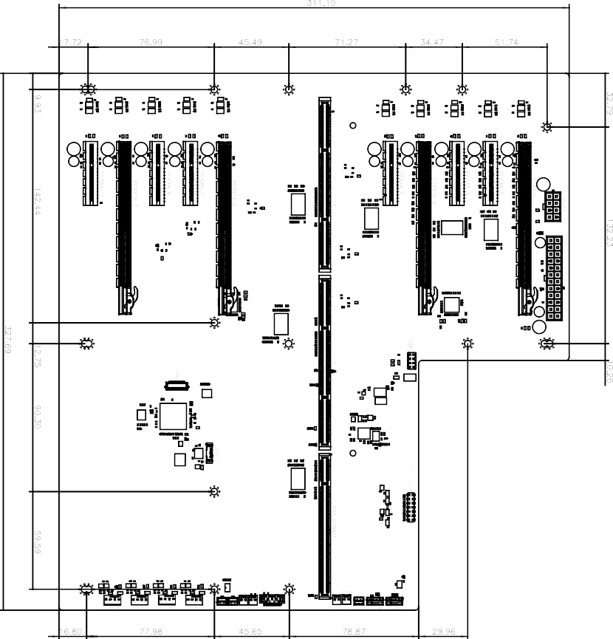

（Unit: mm）

