w w w . i ei w or l d .c om
Digital Signage System
IDS-300-BW

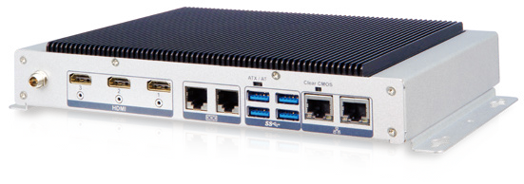Features
- Fanless system with Intel® Celeron® N3160 processor
- Three HDMI ports
- Two full-size PCIe Mini slots for expansion
- Four USB 3.1 Gen 1 (5Gb/s) ports
- Two GbE LAN ports

PCIe Mini Expansion

HDMI

Fanless
Display
Triple

GbE

USB
USB 3.1
Gen 1

Specifications
Fully Integrated I/O

Front View
Power Switch Aduio

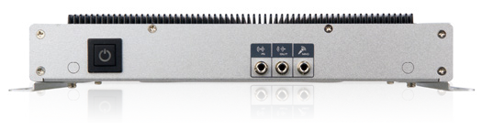

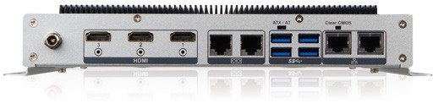Rear View
DC Input
Clear CMOS
3 x HDMI
2 x RS-232
2 x LAN
Model Name |  | IDS-300-BW
Chassis | Color | Silver
 | Dimensions (WxDxH) (mm) | 241 x 160 x 39
 | System Fan | Fanless
 | Chassis Construction | Aluminum alloys
Motherboard | CPU | Intel® Celeron® N3160  (up to 2.24GHz, quad-core, 2MB cache, TDP=6W)
 | Chipset | SoC
 | System Memory | 1 x 204-pin DDR3L SO-DIMM 4 GB pre-installed (system max: 8GB)
Storage | Hard Drive | 1 x 2.5'' SATA 6Gb/s HDD/SSD Bay
I/O Interfaces | USB 3.1 Gen 1  (5Gb/s) | 4
 | Ethernet | 2 x RJ-45 PCIe GbE by RTL8111E controller
 | COM Port | 2 x RS-232 (RJ-45)
 | Button | 1 x Power button 1 x AT/ATX Switch
 | Display | 3 x HDMI
 | Resolution | HDMI 1&2 : up to 3840x2160 @ 30Hz HDMI 3 : up to 2560x1600 @ 60Hz
 | Audio | 1 x Line-in, 1 x Line-out, 1 x Mic-in
 | Wireless | 1x 802.11a/b/g/n/ac (optional)
Expansions | PCIe Mini | 1 x Full-size PCIe Mini 1 x Full-size PCIe Mini  (supports mSATA, colay with SATA)
Power | Power Input | DC Jack: 12 V DC
 | Power Consumption | 12 V@2.48 A  (Intel® Celeron® N3160 with 4GB memory )
Reliability | Mounting | Wall mount, VESA 100
 | Operating Temperature | -10°C ~ 40°C with air flow (SSD), 10% ~ 95%, non-condensing
 | Operating Shock | Half-sine wave shock 5G, 11ms, 3 shocks per axis
 | Operating Vibration | MIL-STD-810F 514.5 C-1(HDD)
 | Weight (Net/Gross) | 1.8 kg/ 3kg
 | Safety/EMC | CE/FCC
OS | Supported OS | Microsoft® Windows® 8 Embedded, Microsoft® Windows® Embedded Standard 7 E

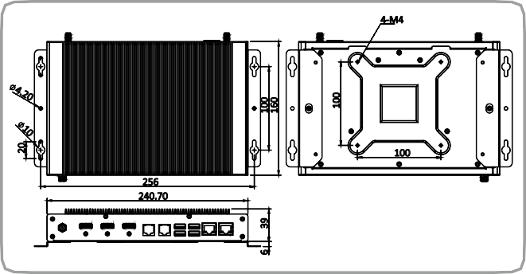Dimensions (Unit: mm)
4-M4
100
256
240.70
IDS-300-BW
20
100
160
100

Options

AT/ATX Mode

4 x USB 3.1 Gen 1

IDS-300-BW-2019-V10
Industrial System

Ordering Information
6 39
Part No. | Description
EMB-WIFI-KIT01-R20 | 1T1R wifi module kit for embedded system, IEEE802.11a/b/g/n/ ac WiFi with Bluetooth 4.0/3.0+HS, 1 x wifi module, 2 x 250mm RF cable, 2 x Antenna, RoHS
IDS-300-WES7E64-R10 | OS Image with Windows® Embedded Standard 7 E 64-bit for IDS-300, DVD-ROM, RoHS
IDS-300-W10E64-E-R10 | OS Image with Windows 10 IoT Enterprise Entry 64-bit for IDS-300,W/DVD-ROM, RoHS

Part No. | Description
IDS-300-BW-N3/4G-R10 | Fanless embedded system with Intel® Celeron N3160 1.6GHz, (up to 2.24 GHz, Quad Core, TDP 6W), pre-installed 4GB DDR3L memory, 12V DC, triple HDMI display, RoHS
Packing List
1 x Power Adapter
1 x Mounting Bracket

