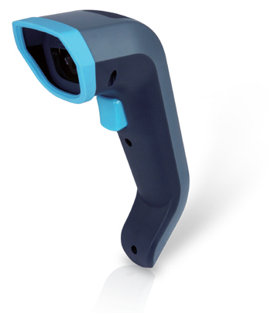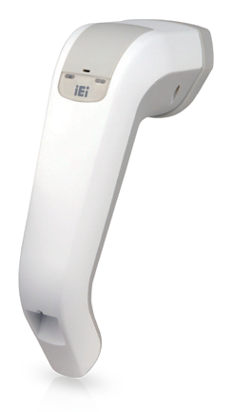HTDB-100F/FM

Handheld 1D/2D Barcode Reader, 1280x1024, 10 ~ 270 mm Reading Distance, USB Interface

◄ HTDB-100FM HTDB-100F ►

Features
- Read 1D, 2D barcodes on paper and mobile phones
- Strong ability to read barcodes and to fast decode broken, curved and blurry printed barcode
- Read multiple barcodes by holding the trigger
- IP41 rating against dust and moisture
- Rugged design, 1.8 m/5.9 ft. drop to concrete
- Ergonomic and beautiful design for long time usage, suitable for left- and right-handed users
- Medical Grade Design: Anti-bacterial surface (HTDB-100FM)

Specifications
7/8.1/10
32/64Bit

1D Barcode Reader

2D Barcode
Reader IP 41

Easy Setting for Barcode Preference or Symbology
Windows
Electrical
Interface | RJ-45 to USB 2.0
Input Voltage | 5 V
Operating Power | 2 W ~ 3 W
Mechanical
Dimensions (HxWxD) | 17.5 cm x 5.9 cm x 11.2 cm
Weight | 120 g
Environmental
Drop | Designed to withstand 20 times of 1.8 m drops to concrete  on each of the faces
Sealing | IP 41
Operating Temperature | 0°C to 55°C (32°F to 131°F)
Storage Temperature | -10°C to 65°C (13°F to 149°F)
Humidity | 0 to 95% relative humidity, non-condensing
Light Levels | 0 to 100,000 lux (9,290 foot-candles)
Light Source
Aiming Pattern | Green LED
Illumination | 660 nm LED
System Requirement
IEI HTDB Utility | Microsoft Windows 7/8.1/10 (32-bit & 64-bit)
SDK | Windows: Provides SDK and demo program with sample source code  Linux: Provides SDK and demo program with sample  source code (Ubuntu 16.04 LTS)
Scan Performance
Scan Pattern | Area image (1280 x 1024 pixel array, 1.3-megapixel)
Motion Tolerance | Up to 350 cm/s for 13 mil UPC at optimal focus
Depth of Field | 10 mm ~ 270 mm
FOV | Horizontal: 42.4º Vertical: 34.4º  Diagonal: 53º
Print Contrast | 20% minimum reflectance difference
MTF | 100 lp/mm (>10%)
Symbologies
1D | UPC/EAN, UPC/EAN with supplementals, Bookland EAN, ISSN, UCC Coupon Extended Code, Code 128, GS1- 128, ISBT 128, Code 39, Code 39 Full ASCII, Code 93,  Interleaved 2 of 5, Codabar, MSI
2D | MicroPDF417, PDF417, Data Matrix, QR Code, Micro QR  Code
Certification
Electrical Safety | UL60950-1 2nd ed, CSA C22.2 No. 60950-1 2nd ed,  EN60950-1/IEC60950-1 2nd ed
LED Safety | IEC/EN62471
EMI/RFI | FCC Part 15 Class B, EN55032 Class B, EN55024,  Medical Electrical Equipment:EN60601-1-2, FCC Part 18
Other
Green Compliant | Yes
Green Compliant  Certificate/Authority | WEEE, RoHS

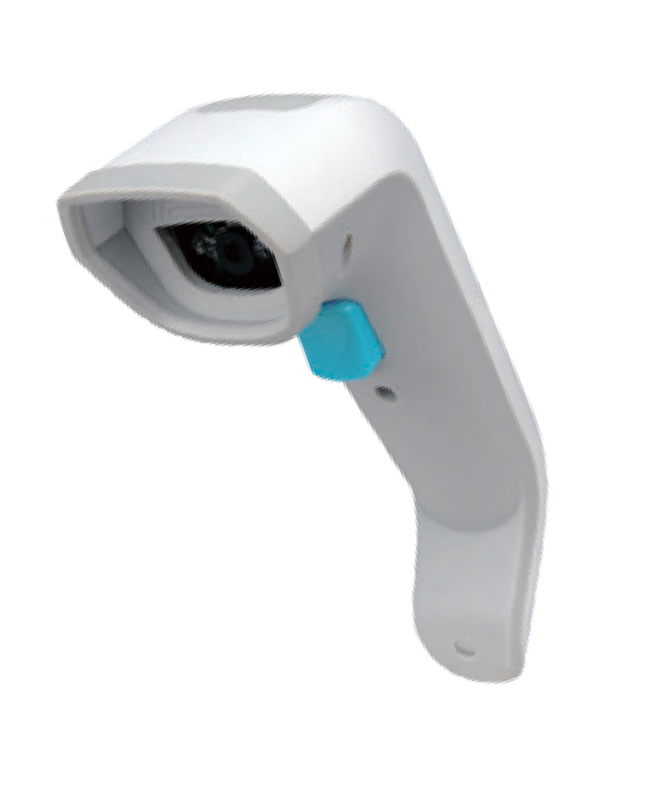To configure the barcode reader, simply scan the corresponding barcode symbols listed in the user manual. For example, if the user needs to set the exposure mode to automatic, just scan the Auto Exposure barcode.

(All Symbologies On)
(Multiple Trigger Mode)
(Auto Exposure)

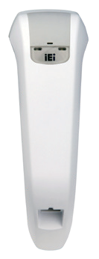External Overview

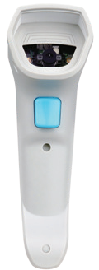Scan Window

Trigger Button
175.41 mm

59.95 mm

Decode LED Power LED

RJ-45 Port (RJ-45 to USB cable)

Applications

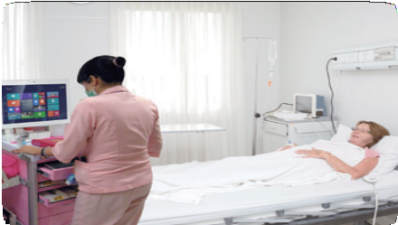

Medical
The HTDB-100F/FM can be used with medication cart or in operating room/ pharmacy/emergency room.

Industry
The HTDB-100F/FM can be used in production lines or warehouses.

Food
The HTDB-100F/FM can be used in discount stores or supermarkets.

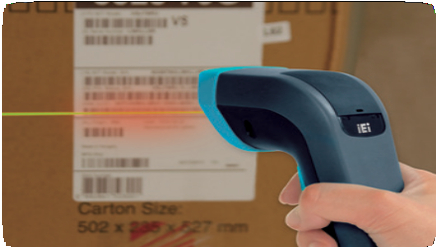
Read Multiple Barcodes
IEI handheld barcode reader has the capability to read multiple barcodes printed on one label. When you need to read multiple barcodes, just scan “Enabling to read multiple barcode” in the barcode preference of the user manual. Then, scan and read the barcodes one by one by continually holding the trigger button.
With this feature, you can not only reduce the frequency of button usage, but also increase efficiency. IEI barcode reader can block duplicate data from being sent. Therefore, lots of works for data comparison and information processing can be reduced in the application system.

HTDB-100F/FM Decode Range

Barcode Type | code39 | code128 | UPCE
Symbol Denisity | 7.5mil | 7.5mil | 13mil
Type | 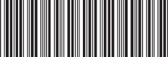  *C39042368* | 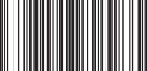  C1281903625 | 0 425261 4
Working Ranges | 30mm - 145mm | 35mm - 145mm | 20mm - 250mm

Barcode Type | Data Matrix |  | QR code
Symbol Denisity | 10mil | 20mil | 10mil | 20mil
Type |  |  |  | 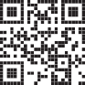
Working Ranges | 35mm - 170mm | 15mm - 270mm | 35mm - 180mm | 10mm - 270mm

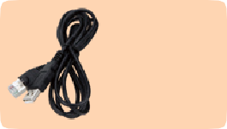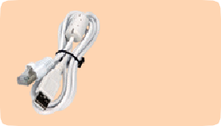Packing List

RJ-45 to USB cable (HDTB-100F only)

RJ-45 to USB cable (HDTB-100FM only)
1 x HDTB-100F/FM handheld 1D/2D barcode reader
1 x RJ-45 to USB cable | 1 x QIG

Ordering Information
Part No. | Description
HTDB-100FM-R10 | Handheld 1D/2D Barcode Reader, 1280x1024, 10 ~ 270 mm reading distance, anti-bacterial surface, USB interface, RoHS
HTDB-100F-R10 | Handheld 1D/2D Barcode Reader, 1280x1024, 10 ~ 270 mm reading distance, USB interface, RoHS

