w w w . i ei w or l d .c om
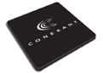
IVCME-C604
PCIe Mini Video/ Audio Capture Card with 4-Channel Video/ Audio Input, Total 120fps@D1 for 4 Channels (NTSC)
Video/Audio Input Connector (CN1)

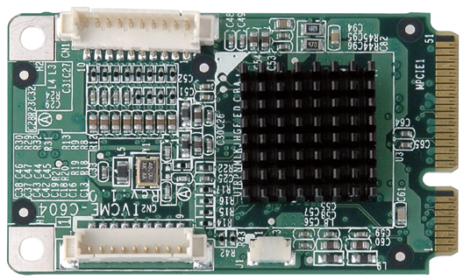GPIO Connector (CN2)
CN4
CN3
CN6
K1 RELAY
1
2
CN7
K2 RELAY
1 2
K3 RELAY
4 1
K4 RELAY
CN1
2
5
2
6
Terminal Block
Terminal Block

Features
- Single card 4-channel composite video (NTSC/PAL) solution
- PCIe Mini card interface supported
- Compatible with Linux, Windows XP and Windows 7 (32-bit and 64-bit)
- Total 120fps @ D1 for 4 channels (NTSC)
- External GPIO daughter board with 4 inputs and 4 outputs (optional)
- SDK available for customer to create customized applications

Specifications
Interface

Video Input | 4-channel composite video NTSC/PAL auto sensing
Video Input Type | BNC (BNC to DB-9 cable included)
Audio Input | 4-channel analog
Audio Input Type | RCA (RCA to DB-9 cable included)
Bus Interface | PCIe Mini
Alarm IO | Yes
Video Processing

Video Compression | Software compression
Video Engine | 1 x Conexant CX25854
Resolution | NTSC: PAL:  720 x 576 720 x 576  720 x 480 720 x 480  720 x 288 720 x 288  720 x 240 720 x 248  352 x 240
Frame Rate | NTSC: Total 120fps @ D1 for 4 channels PAL: Total 100fps @ D1 for 4 channels
Audio Processing

Audio Compression | Software compression
Sampling Rate | 8kHz, 16kHz, 32kHz, 44.1kHz and 48kHz
Quantization | 16-bit
System Requirement
Platform | x86 PC compatible computer
Memory | 512MB or above

System Block
4CH
32/64Bit

PCIe Mini
W7indows

PCIe BUS
PCIe Mini Connector

Conexant CX25854

GPIO 4 CH Inputs & 4 CH Outputs

4 CH Audio & 4 CH Video Inputs

Packing List

1 x IVCME-C604 capture card
1 x BNC to DB-9 cable
1 x RCA to DB-9 cable
1 x Video/Audio input cable kit
1 x QIG

Video/Audio Input Connector (CN1)
Pin No. | Signal
1 | GND
2 | Video In CH1
3 | Video In CH2
4 | Video In CH3
5 | Video In CH4
6 | Audio In CH1
7 | Audio In CH2
8 | Audio In CH3
9 | Audio In CH4
10 | GND

GPIO Connector (CN2)
Pin No. | Signal
1 | GND
2 | DI1
3 | DI2
4 | DI3
5 | DI4
6 | DO1
7 | DO2
8 | DO3
9 | DO4

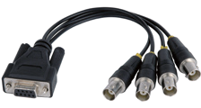
Software Support
OS Support | Microsoft Windows 7 (32-bit & 64-bit)  Linux: Ubntu 14.04 (64-bit) Kernel version: 3.13.0-32-generic

Part No. | Description
IVCME-C604-R10 | PCIe Mini video/audio capture card with 4-channel video/  audio input, total 120fps@D1 for 4 channels (NTSC)
VIOCARD-GPIO-RS-R10 | 8 GPIO channels  (4 digital inputs and 4 relay outputs)
32031-000100-100-RS | GPIO card to IVCME capture card connection cable

DB-9 to BNC Jack

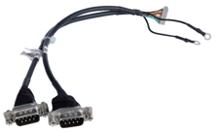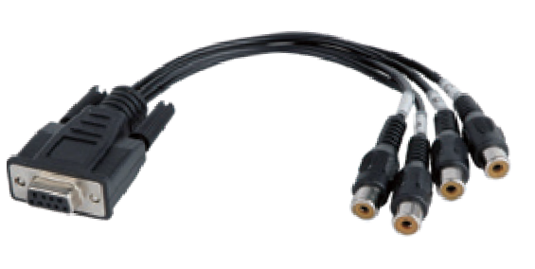4-Channel Video Input
DB-9 to Input Jack
DB-9 to RCA Jack
4-Channel Audio Input

Others

Ordering Information

IVCME-C604-2019-V10
Video Capture Solutions
COM1 NC1 NO1
COM2 NC2 NO2 COM3 NC3 NO3 COM4 NC4 NO4
IN1+ IN1- IN2+ IN2- IN3+ IN3-
IN4+ IN4-
Dimensions | 51 mm x 30 mm
Operating Temperature | 0°C ~ 60°C, non-condensing
Power Consumption | 1.65W (3.3V@0.5A)

