w w w . i ei w or l d .c om

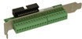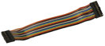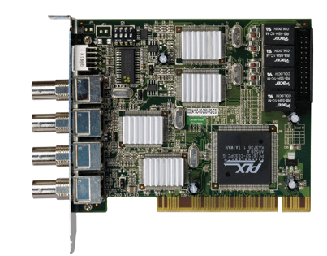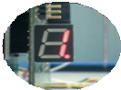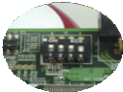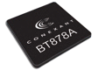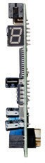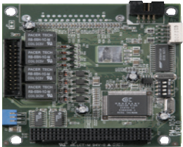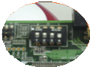IVC-200G-RS
PM-1056-4P-RS-R21
PCI-104 Video Capture Card with Four Video Input Channels, Total 30 fps@720x480 (NTSC)
The ID is programmed by a 4-digit DIP switch
Digit LED to show its ID
PCI video Capture Card with Four Video Input Channels, Total 120 fps@720x480 (NTSC)

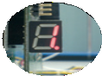The ID is programmed by a 4-digit DIP switch

Digit LED to show its ID
(identification)

Specifications
Interface

Notice: IVC-200-RS-R20 does not support GPIO function and has no relay components on board.

IVC-200G-RS-R20
GPIO daughter board and cable
Applications: Video surveillance, security, public transportations, police and government

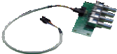
Specifications
Interface
Video Input | 4-channel composite video NTSC, PAL and SECAM auto sensing
Connector | BNC
Audio Input | 4-channel analog audio
Connector | DB9 to 3.5mm phone jack audio cable
PCIe  Interface | PCI 2.1 compliance
Card ID | Selectable with LED for ID indication
Alarm I/O | External GPIO daughter board with 4 inputs and 4 outputs (optional)

(identification)

VIN-KIT-01
4 x BNC Connector Board

Video Input | 4 channels composite video  NTSC, PAL and SECAM auto sensing
Video Input Type | BNC
PCI Interface | PCI Rev 2.1 compliance
CARD ID | DIP switch selectable with LED for ID indication
Alarm I/O | GPIO daughter board with 4 inputs and 4 outputs  (IVC-200G-RS-R20 only)

Software Support

Device Driver | Windows 98 SE, ME, 2000, XP / Linux kernel 2.4
SDK | Provides SDK and demo program with sample source code
Video Processing

Video Engine | 4 x Conexant Fusion BT878A
 | NTSC: |  | PAL / SECAM:
 | 720 x 480 | 640 x 288 | 720 x 576 | 640 x 480
Resolution | 720 x 288  720 x 240 | 640 x 240  352 x 288 | 720 x 480  720 x 288 | 640 x 288  640 x 240
 | 640 x 480 | 352 x 240 | 720 x 240 | 352 x 288
 |  |  | 704 x 576
Frame Rate | NTSC: Up to 120 fps per channel
 | PAL /SECAM: Up to 100 fps per channel
Multiple Card Support

Card | Video  Port | Audio  Port | Max. Channel /  Resolution Support | Total Frame  (NTSC/PAL)
1 | 4 | N/A | 4 channels, D1 (720 x 480) | 120/100 fps
4 | 16 | N/A | 16 channels, QVGA (320 x 240) | 480/400 fps
System Requirement

System | x86 compatible computer
Graphics | DirectX compatible VGA card supporting YUV overlay mode
Functionality

Video Loss Detection | Yes
Multi-screen Support | Yes
Others

Dimensions | 119.91 mm x 106.68 mm
Operating Temperature | 0°C ~ 60°C (32°F~140°F), non-condensing
Power Consumption | 15W, 3A@5V (with relay)

Packing List

IVC-200G-RS-R20 | 1 x IVC-200G-RS-R20
 | 1 x GPIO daughter board with cable
 | 1 x QIG
IVC-200-RS-R20 | 1 x IVC-200-RS-R20
 | 1 x QIG
Ordering Information
Software support

Device Driver | Windows 2000, XP, Linux Kernel 2.4
SDK | Provides SDK and demo program with sample source code
Video Processing

Video Engine | 1 x Conexant Fusion™ BT878A
Resolution | NTSC: 720 x 480  720 x 288  720 x 240  640 x 480  640 x 288  640 x 240 | PAL / SECAM: 720 x 576  720 x 480  720 x 288  720 x 240  704 x 576  640 x 480
Frame Rate | NTSC: Total 30fps @D1 for 4 channels PAL/SECAM: 25fps @D1 for 4 channels
Multiple Card Support

Card | Video Port | Audio Port | Max. Channel / Resolution Support | Total Frame (NTSC/PAL)
1 | 4 | N/A | 4 channels, D1 (720 x 480) | 30/25 fps
4 | 16 | N/A | 16 channels, D1 (720 x 480) | 120/100 fps
System Requirement

System | x86 compatible computer
Graphics | DirectX compatible VGA card with YUV overlay mode supporting
Functionality

Video / Audio Synchronization | Yes
Video Loss Detection | Yes
Motion Detection | Hardware built-in
Watermarking | 128-bit secret key, adjustable length
Others

Dimensions | 95.89 mm x 90.17 mm
Operating Temperature | 0°C ~ 60°C (32°F~140°F), non-condensing
Power Consumption | 3.5W@5V (with relay)

Packing List

1 x PM-1056 | 1 x User manual
1 x Audio cable (P/N: 32000-038100-RS) | 1 x Video flat cable (P/N: 32000-038100-RS)
Ordering Information

IVC-100G-2018-V11
Video Capture Solutions
Part No. | Description
IVC-200G-RS-R20 | PCI video capture card with four video input channels, total 120  fps@720x480 (NTSC), and GPIO daughter board
IVC-200-RS-R20 | PCI video capture card with four video input channels, total 120  fps@720x480 (NTSC)

Part No. | Description
PM-1056-4P-RS-R21 | PCI-104 video capture card with four video input channels,  total 30 fps@720x480 (NTSC)
PM-1056-4PB-RS-R21 | PCI-104 video capture card with four video input channels,  total 30 fps@720x480 (NTSC), and VIN-Kit-01

