Multiple input types supported by HDC-701EL:
HDC-701EL Video Capture Card Solution
The HDC-701EL video capture card supports full HD video compression using H.264 technology. It offers one-channel HDMI/DP/DVI-I/YPbPr input and one-channel HDMI bypass output. It supports multiple input types, and allows one-channel encode, PiP screen encode from two video sources, OSD screen encode, and cropping video for later encode. User can preview the video from HDMI bypass output during editing or encoding video.
- HDMI interface ● DP interface ● DVI-I interface
- VGA interface ● YPbPr interface which supports sync on green

Video Scaler Functions

- It can convert a signal from a lower resolution to a higher resolution without affecting the video quality.
- It can convert a non-standard resolution (such as 1280*960) to the resolution supported by the HDC-701EL.

◆ Picture in Picture (PiP) Function
The video sources from two interfaces can be displayed on the same screen simultaneously and the PiP screen can be encoded by the HDC-701EL.

- OSD (on-screen display) Information such as date,resolution etc. and the video source can be displayed on the same screen simultaneously and the OSD screen can be encoded by the HDC-701EL.
- Cropping
Cuts the outer part of an image in order to improve the composition, emphasize the subject or change the ratio.

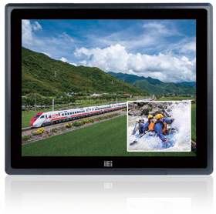
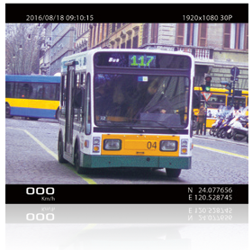
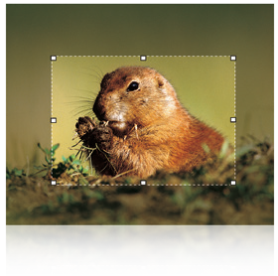
Applications

◆ PIP Application  OSD Application
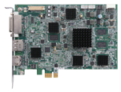Healthcare Solution
Video Input Source
(choose two different interfaces from
the five)
HDMI
Out
Computer Monitor
HDC-701EL
With PIP Function
Monitor

HDMI DP DVI-I YPbPr

Computer Monitor with HDC-701EL
- Can display two different sources together.
- Allows you to adjust where to put the small video.
- Can display two videos and record the videos at the same time.

Monitor
The raw data from two different signals can be displayed at the same time.

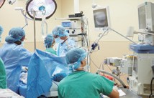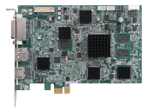 Operating Room: A567 Doctor name: IEI
Video Input Source
(choose one inferface from the five)
Date:2016/ 11/25 Time: 15:05
Capture
HDC-701EL
With OSD Function

HDMI DP DVI-I YPbPr
With the OSD function, for example, the date, time, operating room’s number and doctor’s name can be displayed on the monitor when using in a surgery room. The surgery with the OSD information can be recorded by using the HDC-701EL capture card and the file can be saved for future reference. The scenario described above is just one of many possible scenarios in which the HDC-701EL is used to capture video with OSD information. In addition to that, IEI is capable to customize the OSD information to be displayed for other applications based on customer’s needs.

HDC-701EL

PCI Express Video/Audio Capture Card with One Channel HDMI/DP/DVI-I/ YPbPr Input and One Channel HDMI Output, 1920x1080@30p, and H.264 Hardware Encoder

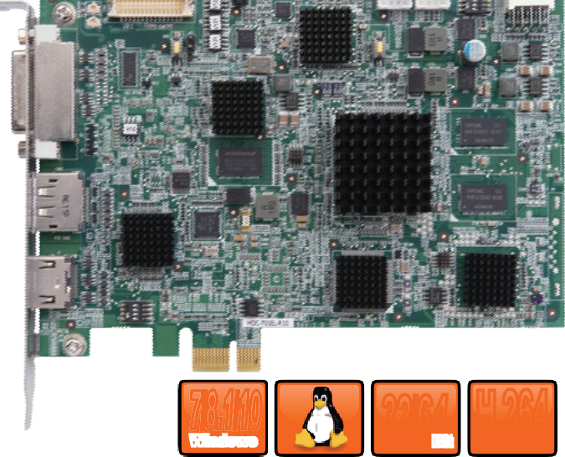H.264 Hardware Encoder
7/8.1/10
Windows
32/64Bit
H.264
MPEG-4/AVC
Video Recording/Streaming

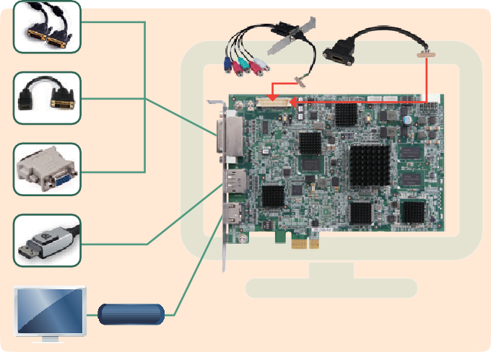
▼YPbpr
▼HDMI
DVI-I
DVI male to HDMI female converter
HDMI
VGA to DVI-I
adapter
VGA
DP
HDMI OUT

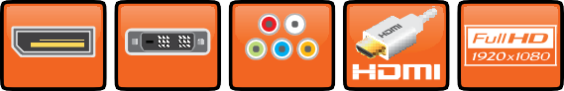
DP
DVI-I
YPbPr

Features
  - 1-channel HDMI/DP/DVI-I/YPbPr input with H.264 hardware compression and 1-channel HDMI output
  - High quality video recording up to 1080p30
  - HDMI output supports video preview up to 1080p60, so you can watch video while recording or editing
  - Provides DirectShow filter
  - Equipped with video scaler for PIP, OSD, cropping (optional)
  - Windows/Linux OS supported

Specifications

Interface
Input | Video input channel | 1 channel
 | Video input type | HDMI/DP/DVI-I/YPbPr
 | Audio input channel | 1 channel
 | Audio input type | HDMI (stereo video)
Output | Video output channel | 1 channel (1080p 60)
 | Video output type | HDMI
 | Audio output channel | 1 channel
 | Audio output type | HDMI (stereo)

Dimensions (Unit: mm)

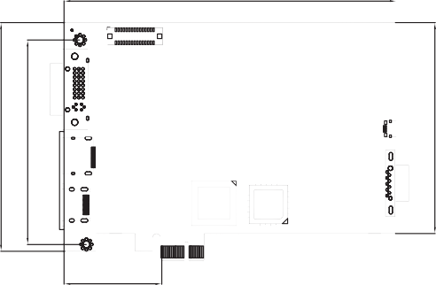System Requirement
45.67
106.68
95.40

154.94
98.43

System | Intel® Core™2 Duo 2.4GHz or above
Memory | 2GB or more

PC Interface Video Processing
Type | PCIe x1

Software Support

OS Support | Microsoft Windows 7/8.1/10 (32-bit & 64-bit) Linux: Ubuntu 16.04 (64-bit) (Kernel version: 4.4.0-21-generic)
SDK | Windows: Provides SDK and demo program with sample  source code  Linux: Provides SDK and demo program with sample source code
Functionality

Multiple Card Support | 4 cards, 4 channels
Scaling | Video scaling support, OSD, PIP, Cropping
Others
Dimensions | 155 mm x 111 mm
Operating Temperature | 0°C ~ 60°C (32° ~ 140°F), non-condensing
Power Consumption | 15W

Packing List
Hardware Encoder | H.264/AVC High Profile Level 4.1
Recording Datarate | Up to 30Mbps
Video Input Resolution | 1920 x 1080 24p/25p/30p/50p/60p  1920 x 1080 60i/59.94i/50i 1280 x 1024 30p  1280 x 800 60p 1280 x 768 60p  1280 x 720 50p/60p 1024 x 768 60p  800 x 600 60p 720 x 576 50p  720 x 480 60p 640 x 480 60p
Recording Formats | 1920 x 1080 24p/25p/30p 1280 x 1024 30p  1280 x 800 60p 1280 x 768 60p  1280 x 720 50p/60p 1024 x 768 60p  800 x 600 60p 720 x 576 50p  720 x 480 60p 640 x 480 60p

1 x HDC-701EL
1 x QIG

Audio Processing
Ordering Information

Audio Sampling Frequencies | 44.1k, 48k Hz
Audio Compression | MPEG4-AAC
Recording Datarate | 128kbps

Part No. | Description
HDC-701EL-R10 | PCI Express video/audio capture card with one channel HDMI/DP/DVI-I/YPbPr input and one channel HDMI bypass output,1920x1080@30p, and H.264 hareware encoder

