Long Distance High-Definition Compression Solution

Nowadays, more and more equipments are equipped with SDI output for television studios and other broadcasting applications. SDI is a high capacity interface used as a way of exporting uncompressed digital video in real time. That makes it ideal for live feed productions (such as a live TV show), as well as for editing and monitoring video at the highest possible quality. Since SDI is designed primarily
for professional use, it is also compatible with a variety of video

Broadcasting Solutions
H.264 video encoder can be a part of streaming server in the application for broadcasting
Preview for

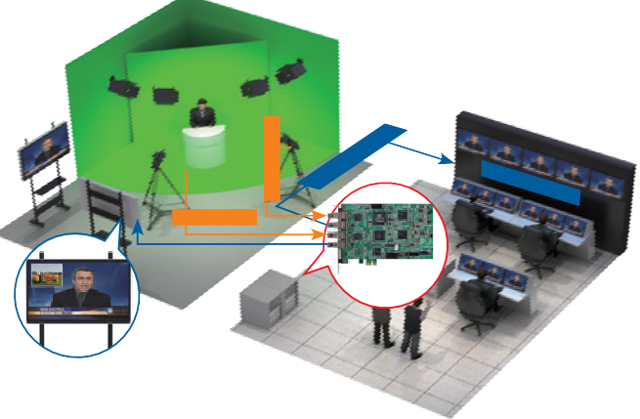
devices found in broadcast studios, including monitors, tape decks and switchers. SDI exports uncompressed SD and HD video over a coaxial cable.

SDI total solutions

- SDI

- SDI

- HDMI
Video Mixer

HDMI SDI
Video Mixer

Preview CH1 CH2
STILL FRZ
42” LCD TV/Monitor
Output CH3 CH4
OUT1 OUT2

Camcorder #2
SDI IN CH1
Master Audio Mix

SDI Monitor #2
SDI IN CH2

SDI LOOP CH2

HDC-502E

H.264 Encoder/

LAN

HD/SD-SDI Recorder (HDC-502E)

Cloud
l

Streaming Server (HDC-502E) VOD

- Long Distance and High Quality Capture Card

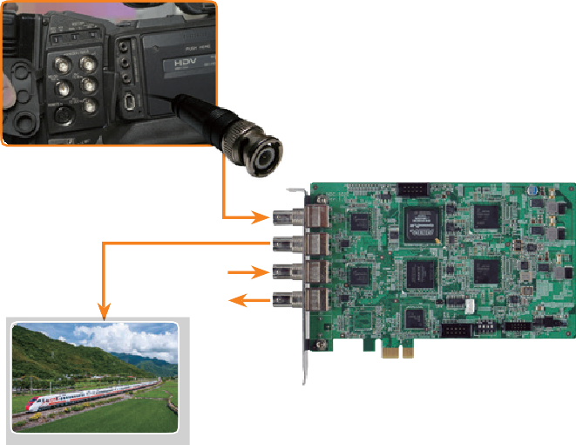 SDI in studio editing field
HDC-502E
SDI-In

SDI-Loop

SDI-In
SDI-Loop
SDI (Serial Digital Interface) is a family of video interfaces used for broadcast-grade video. A related standard known
as high-definition serial digital interface (HD-SDI) provides
a nominal data rate of 1.485 G-bit/s. IEI SDI product, the HDC-502E, is designed with 2-channel SDI input, 2-channel SDI loop and 1-channel SDI output for high quality and long distance signal transmission. It achieves this through a 100 m (HD-SDI)/300 m (SD-SDI) coaxial cable without compression and with no data loss for professional studio, broadcast and transportation video applications.
High definition capturing has become a trend of the industrial surveillance. The HD-CCTV camera with SDI interface provides long distance transmission compared to analog camera and
IP camera. The advantage is that SDI interface can transmit
high-definition 1080p video via coaxial cable instead of network
cable. In other words, users can enjoy 1080p HD video over

existing analog system without any changes.

◆ SDI in high quality surveillance field
HD-CCTV1 camera V.S. IP camera
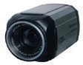
High definition
BNC

HD-CCTV1
C

SDI

BNC
OAXIAL
Uncompressed raw data for editing

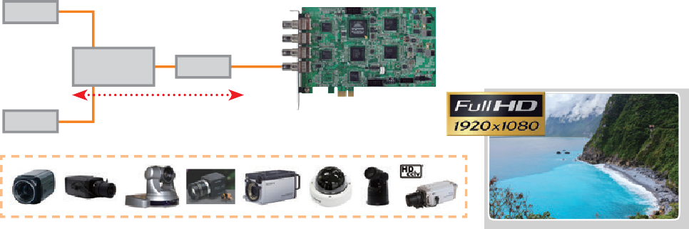HDC-502E

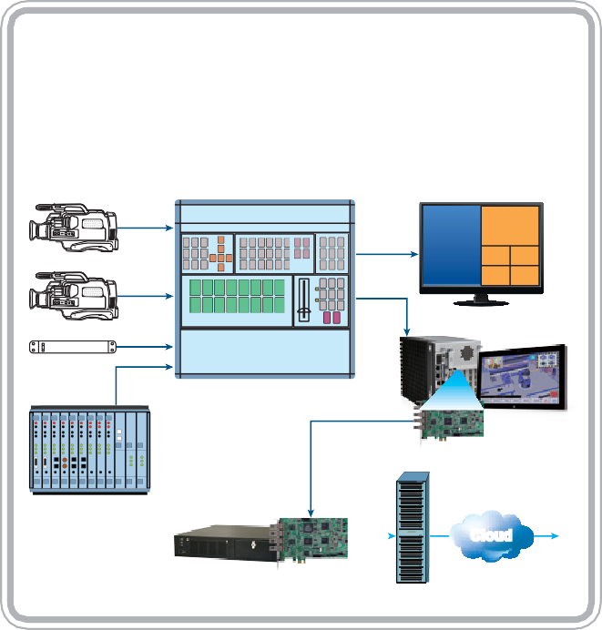High definition

HD-CCTV2

BNC
100 meters
Using SDI for security allows transmission of 720p and 1080p resolution over a coaxial cable.

HDC-502E
PCIe Video/Audio Capture Card with Two Channel 3G-SDI Inputs, Two Channel 3G-SDI Loop Outputs, 1920x1080@60p and H.264 Hardware Encoder

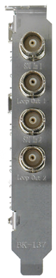
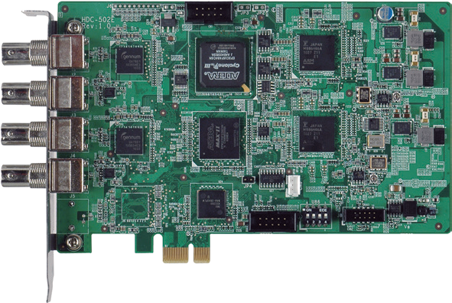SDI In1
7/10
Windows
32/64Bit
H.264
MPEG-4/AVC
3G-SDI

Loop Out1

SDI In2

Loop Out2

PCIe Bus

Features
- 2-channel 3G-SDI input with H.264 hardware compression and 2-channel 3G-SDI output
- High quality video encoding up to 1080p60
- Low power consumption
- SDK available for customer to create customized applications
- Applications: professional studio, broadcast and transportation video applications
- Windows/Linux OS supported

System Block

Specifications
Interface

Video Input | 2 channels
Video Input Type | 3G-SDI
Audio Input | 2 channels
Audio Input Type | 3G-SDI
Loop Through Output | 2 channels
Loop Through Type | 3G-SDI
Bus Interface | PCIe x1
Video Processing

Video Compression | H.264/AVC High Profile Level 4.2
Input Resolution & Frame Rate | 1920 x 1080 x 60p / 50p / 30p / 25p / 24p 720 x 480 x 60i  1920 x 1080 x 60i / 50i 720 x 576 x 50i  1280 x 720 x 60p / 50p / 30p / 25p / 24p
Record Resolution / Frame Rate / Bit Rate | 1920 x 1080 x 60p, encoding video -bit rate from 6Mbps to 20Mbps  1280 x 720 x 60p, encoding video -bit rate from 4Mbps to  20Mbps
Audio Processing

Audio Compression | MPEG-1 Audio Layer 2
Bit Rate | 256k
Functionality

Multiple Card Support | 4 cards, 8 channels

Packing List

System Requirement
Out 2
Loop
3G-SDI
3G-SDI
In 2
Out 1
Loop
3G-SDI
3G-SDI
In 1
3G-SDI
Rx
3G-SDI
Rx
PCIe x1
Bridge
CPLD
H.264 CODEC
H.264 CODEC

FPGA

System | x86 PC compatible computer, Intel® Pentium® 4 2.0GHz or above for video record  Recommends using a DXVA or CUDA capable graphics  card for real-time video playback
Memory | 1GB or more
Software Support

OS Support | Microsoft Windows 7/10 (32-bit & 64-bit)  Linux: Ubuntu 16.04 (64-bit) (Kernel version: 4.4.0-21X64-  generic)
SDK | Windows: Provides SDK and demo program with sample  source code  Linux: Provides SDK and demo program with sample source code
Others

Dimensions (WxH) (mm) | 188 mm x 125 mm
Operating Temperature | 0°C ~ 60°C (32°F ~ 140°F), non-condensing
Power Consumption | 14.2W (12V@0.76A, 3.3V@1.52A)

Ordering Information
Part No. | Description
HDC-502E-R10 | PCI Express video/audio capture card with two channel 3G-SDI inputs, two channel 3G-SDI loop outputs, 1920x1080@60p, and  H.264 hardware encoder

1 x HDC-502E capture card
1 x QIG

