w w w . i ei w or l d .c om

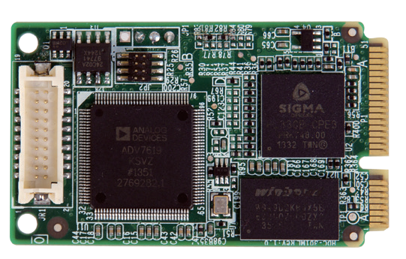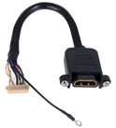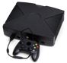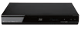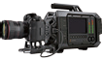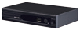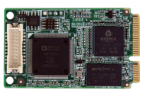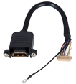
HDC-301MS
PCIe Mini Video/Audio Capture Card with One Channel HDMI Input, 1920x1080@30p, and H.264 Hardware Encoder

H.264 Hardware Encoder
Video Recording/Streaming
HDMI IN
STB
HD camcorder
Blue-ray player
Game player Xbox360/PS4
PCIe Mini

Features
7/8.1/10
Windows
32/64Bit
H.264
MPEG-4/AVC
- 1-channel HDMI input with H.264 hardware compression
- High quality video recording up to 1080p30
- Provides DirectShow filter
- Low power consumption
- Windows/Linux OS supported
Dimensions (Unit: mm)

Specifications
30.00
11.18
Interface

Input | Video input channel | 1 channel
 | Video input type | HDMI
 | Audio input channel | 1 channel
 | Audio input type | HDMI (stereo)
PC Interface Video Processing
Type | PCIe Mini

Hardware Encoder | H.264/AVC High Profile Level 4.1
Recording Datarate | Up to 30Mbps
Video Input Resolution | 1920 x 1080 24p/25p/30p/50p/60p  1920 x 1080 60i/59.94i/50i 1280 x 1024 30p  1280 x 800 60p 1280 x 768 60p  1280 x 720 50p/60p 1024 x 768 60p  800 x 600 60p 720 x 576 50p  720 x 480 60p 640 x 480 60p
Recording Formats | 1920 x 1080 24p/25p/30p 1280 x 1024 30p  1280 x 800 60p 1280 x 768 60p  1280 x 720 50p/60p 1024 x 768 60p  800 x 600 60p 720 x 576 50p  720 x 480 60p 640 x 480 60p

Audio Processing

Audio Sampling Frequencies | 44.1k, 48k Hz
Audio Compression | MPEG4-AAC
Recording Datarate | 128kbps
System Requirement
System | Intel® Core™ 2 Duo 2.4GHz or above
Memory | 2GB or more

Software Support
50.93

OS Support | Microsoft Windows 7/8.1/10 (32-bit & 64-bit) Linux: Ubuntu 16.04 (64-bit) (Kernel version: 4.4.0-21-generic)
SDK | Windows: Provides SDK and demo program with sample  source code  Linux: Provides SDK and demo program with sample source code
Functionality

Multiple Card Support | 4 cards, 4 channels
Scaling | Video scaling down compression
Others

Dimensions | 51 mm x 30 mm
Operating Temperature | 0°C ~ 60°C (32° ~ 140°F), non-condensing
Power Consumption | 3W

Packing List

1 x HDC-301MS
1 x HDMI input cable
1 x QIG

Ordering Information

HDC-301MS-2018-V10
Video Capture Solutions
Part No. | Description
HDC-301MS-R10 | PCIe Mini video/audio capture card with one channel HDMI input, 1920x1080@30p, and H.264 hardware encoder

