w w w . i ei w or l d .c om
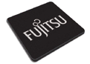
HDC-301E
PCI Express Video/Audio Capture Card with One Channel HDMI Input and One Channel HDMI Output, 1920x1080@60p, and H.264 Hardware Codec
H.264 Hardware Codec

1-channel HDMI output

1-channel HDMI input

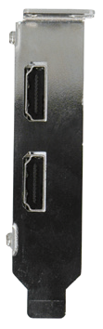
7 32

H.264

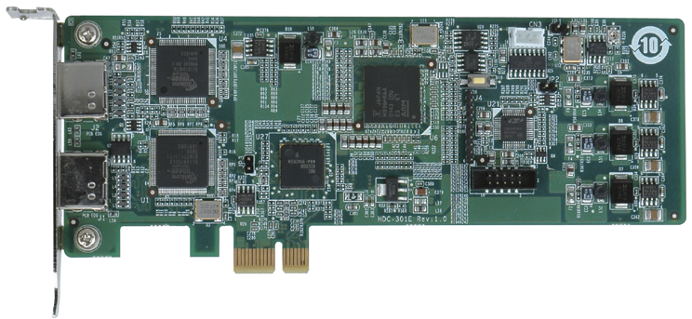Features
Windows
Bit MPEG-4/AVC

- 1-channel HDMI input with H.264 hardware compression and 1-channel HDMI output

PCIe Bus
- High quality video encoding or decoding up to 1080p60
- HDMI output port supports low-delay video pass through up to 1080p60, so you can check video while recording
- HDMI output port supports playback video file captured by HDC-30X
series cards
- Low power consumption
- SDK available for customer to create customized applications
- Windows/Linux OS supported

System Block

Specifications

HDMI
In

HDMI
out

HDMI
Rx

H.264 CODEC

HDMI
Tx
PCIe x1
Bridge
Interface

Video Input | 1 channel
Video Input type | HDMI
Audio Input | 1 channel
Audio Input Type | HDMI
Video Output | 1 channel
Video Output Type | HDMI
Audio Output | 1 channel
Audio Output Type | HDMI
Bus Interface | PCIe x1
Loop Through | 1 channel
Video Processing

Video Compression | H.264/AVC High Profile Level 4.2
Input Resolution & Frame Rate | 1920 x 1080 x 60p / 59.94p / 50p 720 x 480 x 60i / 59.94i  1920 x 1080 x 60i / 59.94i / 50i 720 x 576 x 50i  1280 x 720 x 60p / 59.94p / 50p
Record Resolution / Frame Rate / Bit Rate | 1920 x 1080 x 60p / 59.94p / 50p, encoding video -bit rate from 6Mbps to 20Mbps  1920 x 1080 x 60i / 59.94i / 50i, encoding video -bit rate from 6Mbps to 20Mbps  1280 x 720 x 60p / 59.94p / 50p, encoding video -bit rate from 4Mbps to 20Mbps  720 x 480 x 60i / 59.94i, encoding video -bit rate from 2Mbps to 10Mbps  720 x 576 x 50i, encoding video -bit rate from 2Mbps to  10Mbps

Packing List

Functionality Audio Processing

System Requirement
Multiple Card Support | No

Audio Compression | MPEG-1 Audio Layer 2
Bit Rate | 256k

System | x86 PC compatible computer, Intel® Pentium® 4 2.0GHz or above for video record  Recommends using a DXVA or CUDA capable graphics card  for real-time video playback
Memory | 1GB or more
Software Support

OS Support | Microsoft Windows 7 32-bit  Linux: Ubuntu 16.04 (64-bit) Kernel version: 4.4.0-21 x64
SDK | Windows: Provides SDK and demo program with sample  source code  Linux: Provides SDK and demo program with sample source code
Others

Dimensions | 168 mm x 69 mm
Operating Temperature | 0°C ~ 65°C, non-condensing
Power Consumption | 6.07 W (12V@0.3A, 3.3V@0.72A)

Ordering Information
Part No. | Description
HDC-301E-R10 | PCI Express video/audio capture card with one channel HDMI input and one channel HDMI output, 1920x1080@60p, and  H.264 hardware codec

HDC-301E-2018-V11
Video Capture Solutions
1 x HDC-301E
1 x Full size bracket
1 x QIG

