HDB-301R

w w w . i ei w or l d .c om

USB 3.1 Gen 1 (5Gb/s) Uncompressed Video/Audio Capture Box with One Channel HDMI Input and One Channel HDMI Bypass Output, 1920x1080@60p

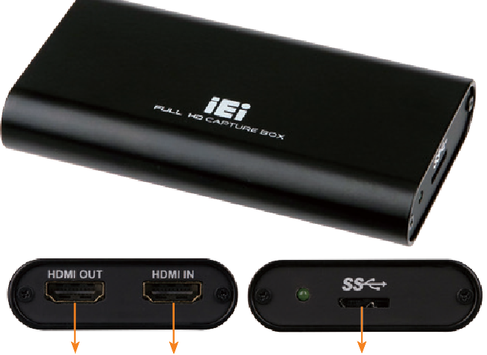
Machine Vision/Broadcast & Post Production
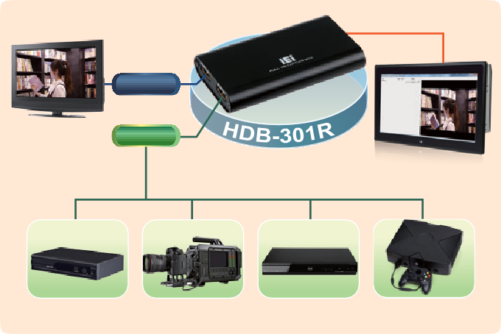
USB 3.0
HDMI OUT
(bypass)

HDMI IN
STB
HD camcorder
Blue-ray player
Game player Xbox360/PS4

HDMI Out
32/64Bit

7/8.1/10
Windows

Features
HDMI In
USB 3.1 Gen 1 (5Gb/s)

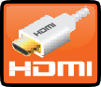
Dimensions (Unit: mm)

- 1-channel HDMI input and 1-channel HDMI bypass output
USB 3.1
- Capture High-Definition HDMI video to your PC
- Capture with USB 3.1 Gen 1 (5Gb/s) bandwidth, enabling you to capture 1080p video at 60fps
- Deliver uncompressed video to your PC with ultra-low latency
- Preview the video with its original color and high video quality
- For audio mastering 48kHz audio, provides the power you need to integrate into any audio environment
- Compatible with OBS, XSplit, PotPlayer
- Support Windows/Linux (Ubuntu)/MAC OS

Specifications
Interface

Input | Video input channel | 1 channel
 | Video input type | HDMI
 | Audio input channel | 1 channel
 | Audio input type | HDMI (stereo)
No Delay Pass Through | Video output channel | 1 channel
 | Video output type | HDMI
 | Audio output channel | 1 channel
 | Audio output type | HDMI (stereo)
PC Interface Video Processing
Type | USB 3.1 Gen 1 (5Gb/s)

Color Space | YUV 4:2:2
Video Input Resolution | 1920 x 1080 24p/25p/30p/50p/59.54p/60p  1680 x 1050 30p/60p 1280 x 720 30p/50p/59.94p/60p  1440 x 900 30p/60p 1024 x 768 30p/60p  1360 x 768 30p/60p 800 x 600 60p  1280 x 1024 30p/60p 720 x 576 50p  1280 x 800 30p/60p 720 x 480 59.94p/60p  1280 x 768 30p/60p 640 x 480 60p
Video Preview | 1920 x 1080 24p/25p/30p/50p/59.54p/60p  1680 x 1050 30p/60p 1280 x 720 30p/50p/59.94p/60p  1440 x 900 30p/60p 1024 x 768 30p/60p  1360 x 768 30p/60p 800 x 600 60p  1280 x 1024 30p/60p 720 x 576 50p  1280 x 800 30p/60p 720 x 480 59.94p/60p  1280 x 768 30p/60p 640 x 480 60p

Audio Processing

18 105

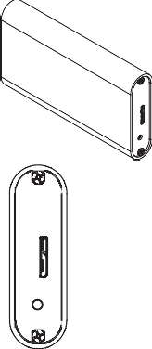
Preview System Requirement
58

System | Intel® Core™ i5-3400 or above
Memory | 4GB or more
Software Support

OS Support | Microsoft windows 7/ 8.1/10 (32-bit & 64-bit) Linux: Ubntu 14.04.2 (64-bit) (Kernel version: 3.16.0-30-generic)  macOS High Sierra (version 10.13) Operating System that support UVC
SDK | Windows: Provides SDK and demo program with sample source code  Linux: Provides SDK and demo program with sample source code
Others

Dimensions | 105 mm x 58 mm x 18 mm
Operating Temperature | 0°C ~ 60°C (32° ~ 140°F), non-condensing
Power Consumption | 4W
Weight | 112g

Packing List
1 x QIG
1 x USB 3.1 Gen 1 (5Gb/s) cable

1 x HDB-301R

Ordering Information
Part No. | Description
HDB-301R-R10 | USB 3.1 Gen 1 (5Gb/s) Uncompressed video/audio capture box with one channel HDMI input and one channel HDMI bypass output,1920x1080@60p

HDB-301R-2019-V10
Video Capture Solutions
Audio Sampling Frequencies | 44.1k, 48k Hz

