Machine Vision Solutions

Machine Vision

w w w . i ei w or l d .c om

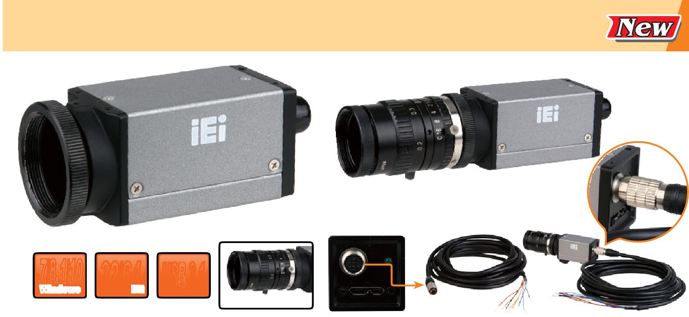
HSC-13M4-E

USB 3.1 Gen 1 (5Gb/s) Monochrome Camera & Opto-isolated I/O, 1/1.8” E2V CMOS, Global Shutter, 1280x1024 Pixels, without Lens, RoHS

7/8.1/10
Windows

Features
32/64Bit USB 3.1

Camera Lens (optional)

- Compact 1/1.8” E2V CMOS sensor
- Large pixel: 5.3 µm
- Resolution: 1280 x 1024 (1.3-megapixel)
- Frame rates up to 60FPS with 1280 x 1024 resolution
- Global shutter
- USB3 Vision V1.0 & GenICam standard
- IEI SDK

Specifications
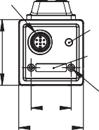
Camera
Resolution | 1280 x 1024
Frame Rate (fps) | 60FPS (Max)
Megapixels | 1.3-megapixel
Chrome | Mono
Sensor Name | E2V EV76C560
Sensor Type | CMOS
Readout Method | Global shutter
Sensor Size (inch) | 1/1.8"
Pixel Size (µm) | 5.3µm
Lens Mount | CS-mount
A/D Bits (ADC) | 8-bit/10-bit
Acquisition Modes | Continuous, Single Frame, Multi Frame
Partial Image Modes | Pixel binning, decimation, ROI
Opto-isolated I/O Ports | 1 input, 1 output
Non-isolated I/O Ports | 1 RS-232
Auxiliary Output | 5V, 100 mA max
Interface | USB 3.1 Gen 1 (5Gb/s)
Machine Vision Standard | USB3 Vision v1.0
Compliance | CE, FCC

Dimensions (Unit: mm)
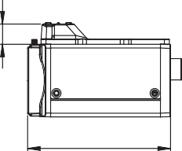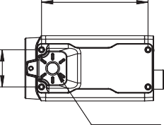47.1
57

1/4-20UNC
8
16.5

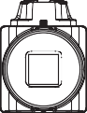

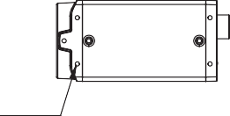Packing List
4-M2X4

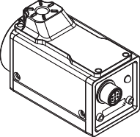
HR25
29

LED USB 3.0
M2
29
18

1 x HSC-13M4-E | 1 x Mounting bracket
1 x CS to C mount adapter | 1 x QIG

Software Support

OS Support | Microsoft Windows 7/8.1/10 (32-bit & 64-bit)
SDK | Windows: Provides SDK and demo program with sample source code
Others

Ordering Information

HSC-13M4-E-2019-V10
Part No. | Description
HSC-13M4-E-R10 | USB 3.1 Gen 1 (5Gb/s) monochrome camera & opto-isolated I/O, 1/1.8” E2V CMOS, global shutter, 1280x1024 pixels, without lens, RoHS
32001-019800-100-RS | USB 3.1 Gen 1 (5Gb/s) cable, 1800mm, USB 3.1 Gen 1 (5Gb/s) A type male and micro USB 3.1 Gen 1 (5Gb/s) B type male+screw, RoHS
32033-001000-100-RS | IO connecting cable with an 8-pin male connector (HR25-7TP- 8P), flying leads in 3 meter lengths, 28AWG, RoHS (custom lengths upon request)
7I003-M1620MPW2-RS | Camera lens, 2/3", focal length 16mm, F2.0 C-Mount, RoHS
7I003-M3514MP-RS | Camera lens, 2/3", focal length 35mm, F1.4 C-Mount, RoHS
7I003-SV1214V-RS | Camera lens, 1/2", focal length 12mm, F1.4 C-Mount, RoHS
7I003-SV1614V-RS | Camera lens, 2/3", focal length 16mm, F1.4 C-Mount, RoHS
7I003-SV2514V-RS | Camera lens, 1", focal length 25mm, F1.4 C-Mount, RoHS

Dimensions (mm) | 29 mm x 29 mm x 57 mm
Weight (grams) | 85g
Operating Temperature | 0° ~ 50°C
Storage Temperature | -30° ~ 60°C
Operating Humidity | 20% ~ 80%
Storage Humidity | 30% ~ 95%
Power Requirements | 5V via USB 3.1 Gen 1 (5Gb/s) or 6-18V via Opto- isolated input

