w w w . i ei w or l d .c om
15” XGA AFOLUX Panel PC

Intel® Atom™ N270 1.6GHz Processor
AFL-15AE-N270

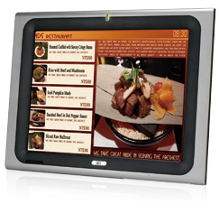
Specifications
Features
- 15" TFT LCD with resistive touch screen
- System memory up to 2 GB RAM
- Built-in 802.11b/g/n wireless LAN
- Selectable AT/ATX power mode through the switch inside the chassis
- Built-in two speakers
- One CompactFlash® slot
- IP 64 compliant front panel
- IEI One Key Recovery solution allows you to create rapid OS backup and recovery (over 4GB storage capacity is suggested)

Wireless 802.11b/g/n
Touchscreen

IP64

Speakers

Fanless

Display System
Model | AFL-15AE-N270
LCD Size | 15”
Max Resolution | 1024 x 768
Brightness (cd/m²) | 250
Contrast Ratio | 700:1
LCD Color | 16.7M
Pixel Pitch (mm) | 0.297(H) x 0.297(V)
Viewing Angle (H-V) | 170º/160º
Backlight MTBF | 30000 hrs
SBC Model | AFLMB2-945GSE-N270-R10
CPU | Intel® Atom™ N270 1.6GHz processor
Chipset | Intel® 945GSE + ICH7M
RAM | Supports one 400MHz or 533MHz DDR2 SO-DIMM (Max. 2GB)
I/O Ports | - x RS-232 COM Port  1 x RS-232/422/485 COM Port  - x RJ-45 for GbE 4 x USB 2.0  1 x Power Switch 1 x Reset Button  1 x Audio Port (line-out) 1 x VGA Port  1 x Power Jack
Storage | CF Type II
Watchdog Timer | Software programmable supports 1~255 sec. system reset
Audio | AMP 1.5W + 1.5W (internal speakers)
Wireless Connection | 1 x Wireless LAN 802.11b/g/n Module (internal PCIe Mini interface)
Construction Front Panel | ABS + PC Plastic front frame
LED Function | 1 x Power on/off LED on front panel
Mounting | Panel, Wall, Rack, Stand and Arm, VESA 100mm x 100mm
Front Panel Color | Sliver (877U) & Gray (ABSA2037)
Dimensions (WxHxD) (mm) | 394 x 309 x 61
Operation Temperature (°C) | 0°C ~40°C with SATA HDD  -10°C ~50°C with CF Card or SATA interface 2.5” SSD HDD
Storage Temperature (°C) | -20°C ~ 60°C
N/G Weight | 3.2 Kg
IP Level | IP 64 compliant front panel
Safety & EMC | CE / FCC
Touch Screen | 5-wire resistive type (Touch controller IC is on board)
Power Adapter | P/N: 63040-010060-110-RS  60W Power Adapter (Meet PSE)  Input: 90VAC~264VAC, 50/60Hz / Output: 12VDC
Power Requirement | 12VDC
Power Consumption | 49W

w w w . i ei w or l d .c om

Ordering Information
Part Number | Description
AFL-15AE-N270/R/1G-R23 | 15” 250cd/m² XGA fanless panel PC with Intel® Atom™ N270 1.6GHz CPU, 1GB DDR2 RAM, 802.11b/g/n wireless module, touch screen, R23

ISMM Supported Functions
 | Voltage | Fan | Smart Fan | Temperature | WDT | Cash Drawer
AFL-15AE-N270 | V |  |  | V | V

Packing List
Item | Part Number | Q’ty | Specification
Screw Pack | 44013-030041-RS | 4 | M3;5mm
Power Adpater | 63040-010060-110-RS | 1 | 90~264V AC; 12V DC; 60W (Meet PSE)
Power Cord | 32000-000002-RS | 1 | 1750mm; European Standard
Utility CD | 7B000-000087-RS | 1
Touch Pen | 43125-0002C0-00-RS | 1
One Key Recovery CD |  | 1

Options

Model | AFL-15AE-N270
Panel Mounting Kit | AFLPK-15
Wall Mounting Kit | AFLWK-19B
Rack Mounting Kit | AFLRK-15-R11
Arm | ARM-11-RS / ARM-31-RS
Stand | STAND-A19-RS / STAND-A21-R10-R10 / STAND-210-R11
OS: Win XPE (1 GB CF card) | AFLCF-15-N270-XPE-R31
OS: Win 7 Embedded (2GB CF card) | AFLCF-15-N270-WES7E-R31
Hybrid Card Reader | AFLP-17AMSI-U
Magnetic Stripe Reader | AFLP-17AMSR-U
DC 12V Input UPS | AUPS-B10-R10 (14.8V 3800mAH)
DC 9~36V Input UPS | AUPS-B20-R10 (14.8V 3800mAH)

Fully Integrated I/O
12V DC Input Power Switch
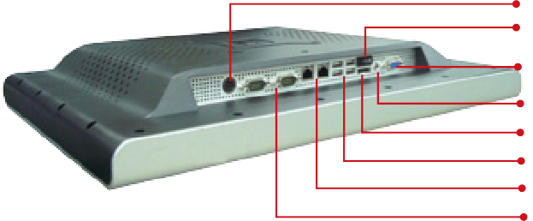
VGA Output Line-out External SATA
4 x USB 2.0
2 x LAN
1 x RS-232
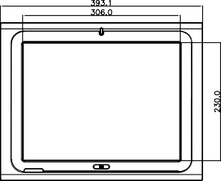
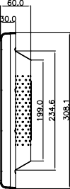
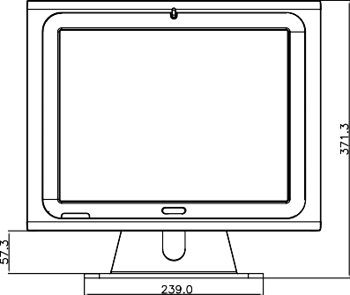
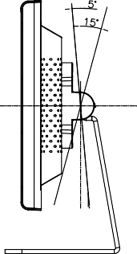
1 x RS-232/422/485

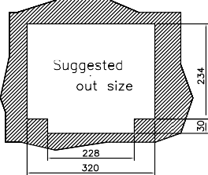
Display System
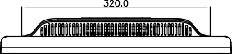
AFL-15A
Dimensions (Unit: mm)

