12.1” XGA AFOLUX Panel PC
Intel® Atom™ N270 1.6GHz Processor
Intel® Atom™ N2600 1.6GHz Processor
AFL-12A-N26
AFL-12A-N270

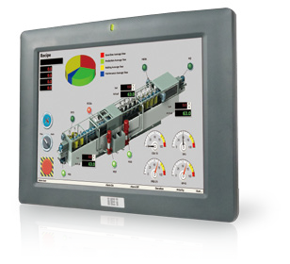
Features
- 12.1" TFT LED backlight LCD with resistive touch screen
- Fanless cooling system
- 9V~28V wide range DC power input (for Intel® N2600 platform)
- Selectable AT/ATX power mode through the switch inside the chassis
- One CompactFlash® slot
- IP 64 compliant front panel
- IEI One Key Recovery solution allows you to create rapid OS backup and recovery (Suggest over 4GB storage capacity)

Specifications

Fanless

Speakers

Wireless 802.11b/g/n
Model | AFL-12A-N270 | AFL-12A-N26
LCD Size | 12.1”
Max Resolution | 1024 x 768
Brightness (cd/m²) | 500
Contrast Ratio | 700 : 1
LCD Color | 262K
Pixel Pitch (mm) | 0.240 (H) x 0.240 (V)
Viewing Angle (H-V) | 160° / 160°
Backlight MTBF | 50000 (LED Backlight)
SBC Model | AFLMB-945GSE-N270-R10 | AFLMB-CV-N2600-R10
CPU | Intel® Atom™ processor N270 1.6GHz CPU | Intel® Atom™ N2600 dual core 1.6 GHz CPU
Chipset | Intel® 945GSE + ICH7M | Intel® NM10
RAM | Supports one 400MHz or 533MHz DDR2  SO-DIMM (Max. 2GB) | One 800 MHz 204-pin DDR3 SO-DIMM slot  (Max. 2GB) pre-installed wiith 2GB
I/O Ports | - x RS-232 COM Port  1 x RS-232/422/485 COM Port  - x RJ-45 for Giga LAN 4 x USB 2.0  1 x Power Switch 1 x Reset Button 1 x External SATA 1 x Audio Port  1 x Power Jack | 1 x 9-28V lockable DC Jack 1 x RJ-45 for RS-232  1 x RS-232/422/485  - x VGA  - x GbE LAN  4 x USB 2.0  1 x Power switch 1 x Reset button 1 x AT/ATX switch 1 x Line out
Storage | CF Type II | mSATA
Watchdog Timer | Software programmable supports 1~255 sec. system reset
Audio | AMP 1.5W + 1.5W (internal speaker) | AMP 2W + 2W (internal speaker)
Wireless Connection | 1 x Wireless LAN 802.11b/g/n Module  (internal PCIe Mini card interface) | 1 x Wireless LAN 802.11b/g/n Module  (internal PCIe Mini card interface) Telec certified
Drive Bay | 1 x 2.5” SATA HDD bay | 1 x 2.5” SATA HDD & 1 x mSATA SSD
Construction Front Panel | ABS + PC Plastic front frame
LED Function | 1 x Power on/off LED on front panel
Mounting | Panel, Wall, Rack, Stand and Arm VESA 75mm x 75mm / 100mm x 100mm
Front Panel Color | Gray 7539U
Dimensions (WxHxD) (mm) | 304 x 246 x 50
Operation Temperature (°C) | 0°C ~40°C with SATA HDD  -10°C ~50°C with CF Card or SATA interface 2.5” SSD HDD | -10°C~50°C
Storage Temperayure (°C) | -20°C ~ 60°C
N/G Weight | 1.8 Kg
IP Level | IP 64 compliant front panel
Safety & EMC | CE / FCC
Touch Screen | 5-wire resistive type (touch controller IC is on board)
Power Adapter | P/N: 63040-010060-130-RS  60W Power Adapter (Meet PSE) Input: 90VAC~264VAC, 50/60Hz  Output: 12VDC | P/N: 63040-010060-120-RS  60W Power Adapter (Meet PSE) Input: 90VAC~264VAC, 50/60Hz  Output: 12VDC
Power Requirement | 12VDC | 9-28V DC
Power Consumption | 32W | 32W

Display System
w w w . i ei w or l d .c om

Ordering Information

Part Number | Description
AFL-12A-N270/R/1G-R24 | 12.1” 500 cd/m², XGA fanless panel PC with Intel® Atom™ N270 1.6GHz, 802.11b/g/n wireless module, capitalize touch screen, 1GB DDR2 533MHz, R24
AFL-12A-N26/R/2G-R11 | 12.1” 500cd/m², XGA fanless panel PC with Intel® Atom™ cedarview N2600 dual core 1.6GHz, 802.11b/g/n wireless module, touch screen, 2GB DDR3, R11

ISMM Supported Functions

 | Voltage | Fan | Smart Fan | Temperature | DIO | WDT | Cash Drawer
AFL-12A-N270 | V |  |  | V |  | V
AFL-12A-N26 | V |  |  | V |  | V

Packing List

Item | Part Number | Q’ty | Specification
Screw Pack | 44013-030041-RS | 4 | M3; 5mm
Power Adpater | 63040-010060-120-RS  63040-010060-130-RS | 1 | 90~264V AC; 12V DC; 60W (for N2600) (Meet PSE)  90~264V AC; 12V DC; 60W (N270) (Meet PSE)
Power Cord | 32000-000002-RS | 1 | 1750mm; European Standard
Utility CD | 7B000-000087-RS | 1
Touch Pen | 43125-0002C0-00-RS | 1
One Key Recovery CD |  | 1
RJ45 to RS-232 Transfer Cable | 32005-000200-200-RS | 1 | 300MM; RJ45 to RS-232 transfer cable

Options
Model | AFL-12A-N270 | AFL-12A-N26
Panel Mounting Kit | AFLPK-12
Wall Mounting Kit | AFLWK-12
Rack Mounting Kit | AFLRK-12
Arm | ARM-11-RS / ARM-31-RS
Stand | STAND-A12-RS/STAND-100-RS | STAND-A12-RS / STAND-100-RS
VSTAND | VSTAND-A12
9~30VDC to 12VDC  Converter Module | IDD-930160-KIT
OS: Win XPE  (1 GB CF card) | AFLCF-07-N270-XPE-R24 | AFL-W07-N26-XPE-R11*
OS: Win 7 Embedded  (4 GB CF card or CD-ROM) | AFLCF-07-N270-WES7E-R24 | AFL-W07-N26-WES7E-R11*
Magnetic Stripe Reader | AFLP-12AMSR-U
DC 12V Input UPS | AUPS-A10-R10 (7.4V 3800mAH)
DC 9~36V Input UPS | AUPS-A20-R10 (7.4V 3800mAH)
DC jack to terminal block power  converter cable | 32002-005500-100-RS

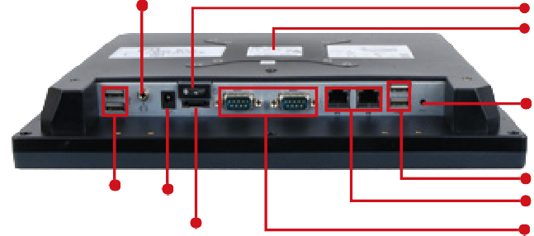DC power input

2 x USB Audio
External SATA

Power switch
Standard VESA mounting

AFL-12A-N270
Fully Integrated I/O
Reset Button

2 x USB
2 x LAN
1 x RS-232, 1 x RS-232/422/485
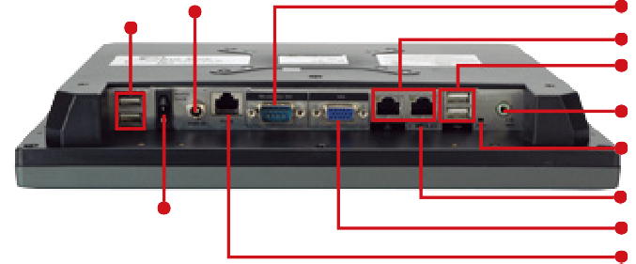
selectable COM port

AFL-12A-N26
Fully Integrated I/O

Lockable DC Jack 2 x USB 2.0

RS-232/422/485
2 x LAN Port 2 x USB 2.0

Line Out Reset Button
AT/ATX Switch

Power Switch

VGA RS-232

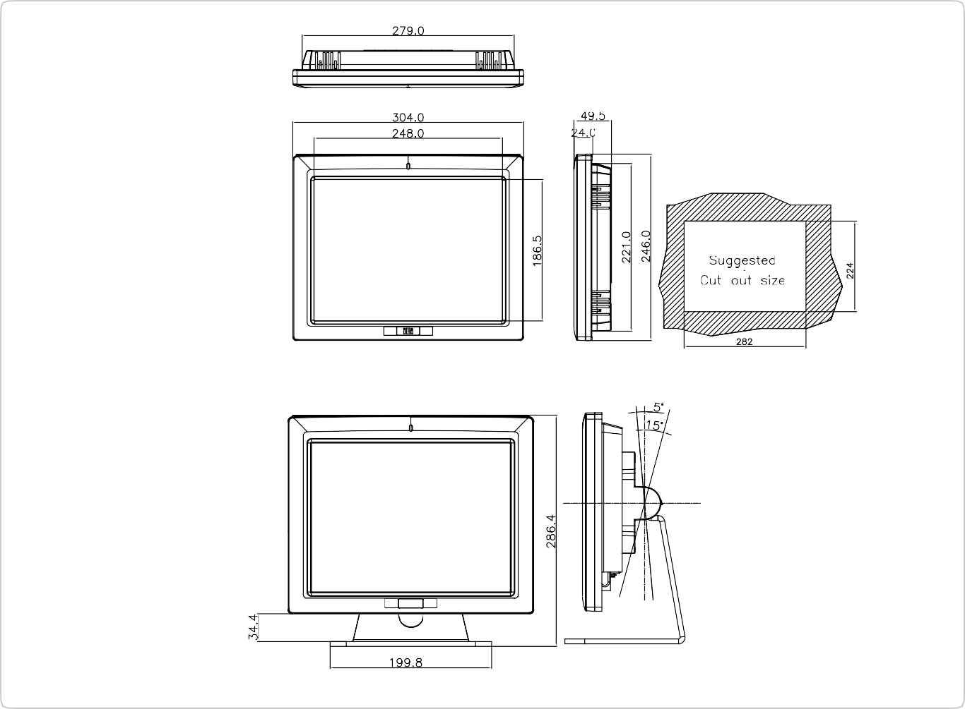

Dimensions (Unit: mm)

