Display System
w w w . i ei w or l d .c om
10.4” SVGA AFOLUX Panel PC
Intel® Atom™ N270 1.6GHz Processor
AFL-10A-N270

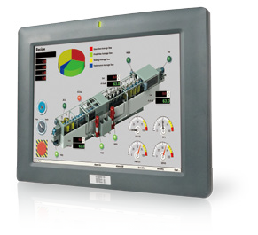
Advanced Features
- 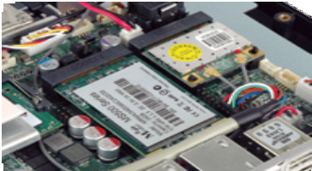PCIe Mini card slot compatible with mSATA and PCIe Mini device

2

1
IEI patented PCIe Mini interface provides PCIe x 1 and USB signals such as PCIe Mini SSD and wireless LAN card for full- size or half-size devices!
- Enhanced MIMO Technology Preinstalled 2.4GHz 802.11b/g/n Wi-Fi module supports 2Tx/2Rx 2-stream MIMO
with up to 300Mbps data rate for a 40MHz
channel!

Specifications

Fanless

Speakers

Wireless 802.11b/g/n

Model | AFL-10A-N270
LCD Size | 10.4”
Max Resolution | 800 x 600
Brightness (cd/m²) | 400
Contrast Ratio | 700:1
LCD Color | 262K
Pixel Pitch (mm) | 0.264 (H) x 0.264 (V)
Viewing Angle (H-V) | 160° / 140°
Backlight MTBF | 50000 hrs (LED Backlight)
SBC Model | AFLMB-945GSE-N270-R10
CPU | Intel® Atom™ processor N270 1.6GHz CPU
Chipset | Intel® 945GSE + ICH7M
RAM | Supports one 400MHz or 533MHz DDR2 SO-DIM (Max. 2GB)
I/O Ports | - x RS-232 COM Port  1 x RS-232/422/485 COM Port  - x RJ-45 for Giga LAN 2 x USB 2.0  1 x Power Switch 1 x Reset Button 1 x External SATA 1 x Audio Port  1 x Power Jack
Storage | CF Type II
Watchdog Timer | Software programmable supports 1~255 sec. system reset
Audio | AMP 1.5W + 1.5W (internal speakers)
Wireless Connection | 1 x Wireless LAN 802.11b/g/n Module (internal PCIe Mini card interface)
Construction Front Panel | ABS + PC Plastic front frame
LED Function | 1 x Power on/off LED on front panel
Mounting | Panel, Wall, Rack, Stand and Arm VESA 75mm x 75mm / 100mm x 100mm
Front Panel Color | Gray 7539U
Dimensions (WxHxD) (mm) | 276 x 222 x 51
Operation Temperature (°C) | -10°C ~50°C
Storage Temperayure (°C) | -20°C ~ 60°C
N/G Weight | 1.4 Kg
IP Level | IP 64 compliant front panel
Safety & EMC | CE / FCC
Touch Screen | 5-wire resistive type (touch controller IC is on board)
Power Adapter | P/N: 63040-010060-130-RS  60W Power Adapter (Meet PSE) Input: 90VAC~264VAC, 50/60Hz  Output: 12VDC
Power Requirement | 12V DC
Power Consumption | 28W

w w w . i ei w or l d .c om

Ordering Information

Part Number | Description
AFL-10A-N270/R/1G-R24 | 10.4” 400cd/m² SVGA fanless panel PC with Intel® Atom™ N270 1.6GHz, 802.11b/g/n wireless module, touch screen,1GB DDR2 533, R24
ISMM Supported Functions
 | Voltage | Temperature | WDT
AFL-10A-N270 | V | V | V
Packing List
Item | Part Number | Q’ty | Specification
Screw Pack | 44013-030041-RS | 4 | M3; 5mm
Power Adpater | 63040-010060-130-RS | 1 | 90~264V AC; 12V DC; 60W (Meet PSE)
Power Cord | 32000-000002-RS | 1 | 1750mm; European Standard
Utility CD | 7B000-000087-RS | 1
Touch Pen | 43125-0002C0-00-RS | 1
One Key Recovery CD |  | 1
RJ45 to RS-232 Transfer Cable | 32005-000200-200-RS | 1 | 300MM; RJ-45 to RS-232 transfer cable
Options
Model | AFL-10A-N270
Panel Mounting Kit | AFLPK-12
Wall Mounting Kit | AFLWK-12
Rack Mounting Kit | AFLRK-10
Arm | ARM-11-RS / ARM-31-RS
Stand | STAND-A12-RS / STAND-100-RS
VSTAND | VSTAND-A10-R11
9~30VDC to 12VDC Converter Module | IDD-930160-KIT
OS: Win XPE (1 GB CF card) | AFLCF-07-N270-XPE-R24
OS: Win 7 Embedded  (4 GB CF card or CD-ROM) | AFLCF-07-N270-WES7E-R24
Magnetic Stripe Reader | AFLP-10AMSR-U
DC 12V Input UPS | AUPS-A10-R10 (7.4V 3800mAH)
DC 9~36V Input UPS | AUPS-A20-R10 (7.4V 3800mAH)
DC jack to terminal block power converter cable | 32002-005500-100-RS
*OS image with CD-ROM

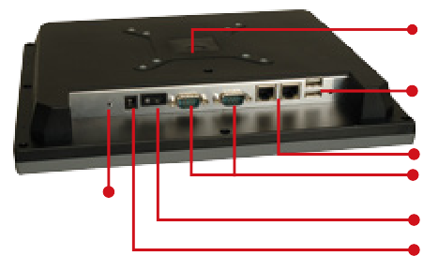Standard VESA mounting
Audio

Fully Integrated I/O
2 x USB

2 x LAN
1 x RS-232
1 x RS-232/422/485 selectable COM port
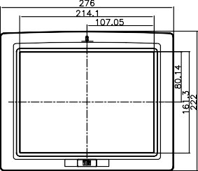
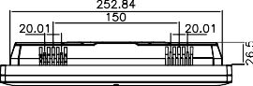
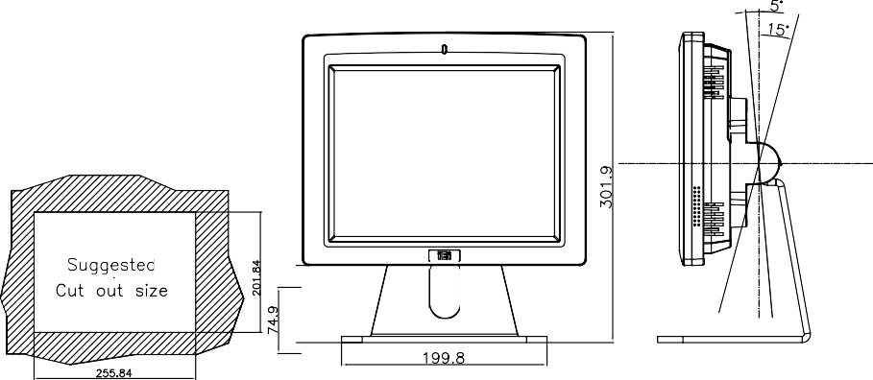
Power switch DC power input

Display System
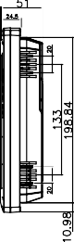
Dimensions (Unit: mm)

