w w w . i ei w or l d .c om
Intel® Celeron® N2807 (Dual Core, 1.58 GHz)
Intel® Celeron® J1900 (Quad Core, 2.0 GHz)
AFL3-08A-BT
AFL3-W07A-BT

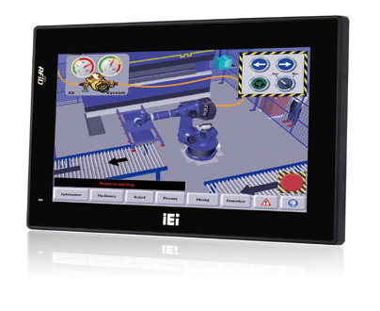Specifications
Features
- W7”~8.4” light industrial interactive panel PC
- 9 V ~ 30 V wide range DC input with lockable DC jack
- Selectable AT/ATX power mode
- Built-in speakers
- One mSATA slot
- IP64/IP65 compliant front panel
- IEI One Key Recovery solution alllows you to create rapid OS backup and recovery (suggested with over 4GB storage capacity)

Display System
Model |  | AFL3-W07A-BT | AFL3-08A-BT
LCD | Size | 7” | 8.4”
 | Resolution | 1024 x 600 (16:9) | 800 x 600 (4:3)
 | Brightness (cd/m²) | 500 | 450
 | Contrast Ratio | 700:1 | 600:1
 | LCD Color | 16.2M | 16.2M
 | Pixel Pitch (mm) | 0.0635 (H) x 0.1905 (V) | 0.213 (H) x 0.213 (V)
 | Viewing Angle (H-V) | 150º / 145º | 160º / 140º
 | Backlight MTBF(hrs) | 20000 hrs | 50000 hrs
Touch | Touch Screen | Projected capacitive with USB interface (anti-UV / anti-glare coating) | 5-wire resistive with RS-232 interface (anti-glare coating) Projected capacitive with USB interface (anti-UV / anti-glare coating)
 | Touch Controller | EETI EXC3160 | PenMount DMC 9000/EETI EXC3146
Motherboard | CPU | Intel® Celeron® N2807 (dual core, 1.58 GHz) | Intel® Celeron® J1900 (quad core, 2.0 GHz)
 | RAM | 2GB DDR3L onboard RAM/ 4GB DDR3L onboard RAM | One 204-pin 2 GB 1333MHz single-channel, 2GB DDR3L SO-DIMM pre-installed (system max. 8GB)
 | Ethernet | 2 x PCIe GbE by RTL8111E controller | 2 x PCIe GbE by RTL8111E controller
 | Audio Codec | ALC892 | ALC892
Storage |  | mSATA | mSATA
I/O Ports & Switch |  | 2 x RS-232 COM port (DB-9 connector) 2 x USB 3.1 Gen 1 (5Gb/s)  2 x GbE LAN  1 x Power switch 1 x Reset button 1 x AT/ATX switch  1 x 9-30V Lockable power jack | 1 x RS-232 COM port (RJ-45 connector)  - x RS-232/422/485 COM port (DB-9 connector) (RI/5V/12V)  - x USB 3.1 Gen 1 (5Gb/s) 2 x RJ-45 for GbE LAN  1 x Power switch  1 x Audio port (line-out) 1 x Reset button  1 x AT/ATX switch  1 x 9-30V DC Lockable power jack
Audio |  | AMP 2W (internal speaker, left channel output) | AMP 2W + 2W (internal speaker)
Camera and Microphone |  | N/A | 2-megapixel with low light function, digital microphone
Wireless & Bluetooth |  | IEEE 802.11 a/b/g/n/ac, Bluetooth V4.0 half-size mini-PCIe slot (PCIe/USB signal) | IEEE 802.11a/b/g/n/ac  half-size mini-PCIe slot (PCIe signal)
OSD Function |  | Software OSD
Physical | Front Panel Construction | PC + ABS Plastic
 | Mounting | Panel, Wall, Stand, Arm, Rack VESA 75mm x 75mm
 | Color | Black C
 | Dimensions (WxHxD) (mm) | 191 x 127 x 43 | 233 x 175 x 50
 | Cut-out Dimensions (WxH) (mm) | 182 x 111 | 207 x 143
 | Net/Gross Weight (kgs) | 0.73/1.81 | 0.8/2.44
Environment | Operating Temperature (°C) (Ambient with air flow) | -20°C~50°C | -15°C~55°C
 | Storage Temperature (°C) | -20°C~60°C | -20°C~65°C
 | Humidity | 10% to 95% (non-condensing)
 | IP Level | IP 65 compliant front panel | IP 64 compliant front panel
 | Safety&EMC | CE / FCC
 | Thermal Solution | Fanless
Power | Power Requirement | 9 V ~ 30 V
 | Power Consumption | 12V@2.08  (Intel® N2807 CPU with 2GB 1333 MHz DDR3L memory) | 12V@2A  (Intel® J1900 CPU with 2GB 1333 MHz DDR3L memory)

Display System
w w w . i ei w or l d .c om

Ordering Information

Part No. | Description
AFL3-W07A-BT-N1/PC/2G-R13 | 7” 500 cd/m² 1024 x 600 HD fanless panel PC with Intel® Celeron® N2807 dual core 1.58 GHz, 802.11a/b/g/n/ac, projected capacitive touch screen, on-board 2GB DDR3L RAM, R13
AFL3-W07A-BT-N1/PC/4G-R13 | 7” 500 cd/m² 1024 x 600 HD fanless panel PC with Intel® Celeron® N2807 dual core 1.58 GHz, 802.11a/b/g/n/ac, projected capacitive touch screen, on-board 4GB DDR3L RAM, R13
AFL3-W07A-BT-N1/PC/2G/MF-R13 | 7” 500 cd/m² 1024 x 600 HD fanless panel PC with Intel® Celeron® N2807 dual core 1.58 GHz, 802.11a/b/g/n/ac, projected capacitive touch screen, on-board 2GB DDR3L RAM, Mifare RFID,R13
AFL3-08A-BT-J1/PC/2G-R13 | 8.4” 450cd/m² SVGA fanless panel PC with Intel® Celeron® J1900 quad core 2 GHz, 802.11a/b/g/n/ac wireless module, projected capacitive touch screen, 2GB DDR3L RAM, R13
AFL3-08A-BT-J1/R/2G-R13 | 8.4” 450cd/m² SVGA fanless panel PC with Intel® Celeron® J1900 quad core 2 GHz, 802.11 a/b/g/n/ac wireless module, resistive touch window, 2GB DDR3L RAM, R13

Options

Item | AFL3-W07A-BT | AFL3-08A-BT
Panel Mounting Kit | AFL3PK-W07A-R11 | AFL3PK-08A-R10
Wall Mounting Kit | AFLWK-12 | AFLWK-12
Rack Mounting Kit | AFL3RK-W07A-R11 | AFL3RK-08A-R10
Arm | ARM-11-RS/ARM-31-RS | ARM-11-RS/ARM-31-RS
Stand | STAND-B08/STAND-100-RS | STAND-B08/STAND-100-RS
V-Stand | VSTAND-A07-R11 | VSTAND-A10-R11
Magnetic Card Reader | AFL3P-W7MSR-U-R10 | AFL3P-W10MSR-U-R10
Barcode Scanner | N/A | AFL3-2D-R11
RFID Reader  (13.56 MHz Mifare Type) | AFL3-W07A-BT-N1/PC/2G/MF-R12 | N/A (Customized by project base)
*OS: Win 7 Embedded (64-bit) | AFL3-W07A-BT-WES7P64-R11 (for PCAP touch) | AFL3-W07A-BT-WES7P64-R11 (for PCAP touch)  AFL3-W07A-BT-WES7E64-R11 (for Resistive touch)
*OS: Win 8 Embedded (64-bit) | AFL3-W07A-BT-WE8S64-R10
*OS: Win 10 IOT Enterprise (64-bit) | AFL3-W07A-BT-W10E64-E-R10
*OS image with CD-ROM without storage

Packing List

Item | Part No. | Q’ty | Remark
Setting kit | 46003-002600-RS | 2
Round head machine screw | 44003-020041-RS | 2 | M2*4 round head machine screw
 | 44003-020041-RS | 4 | M2*4 round head machine screw
Pan head machine screw | 44403-040061-RS | 4 | M4*6 pan head machine screw
Fix holder | 46003-009500-RS | 2
Power cord | 32702-000400-200-RS | 1
Power adapter | 63040-010036-121-RS | 1 | 36W; Vin: 90V~264V AC; Vout: 12VDC; Φ2.5/Φ5.5/lock
RJ-45 to DB-9 COM port transfer cable | 32005-004600-100-RS (AFL3-08A) | 1 | 300mm, 26AWG,  (A) D-SUB 9 male, (B) RJ-45

w w w . i ei w or l d .c om

AFL3-W07A
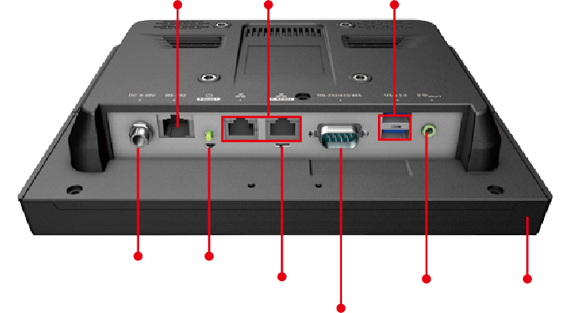
Fully Integrated I/O
AFL3-08A
Fully Integrated I/O

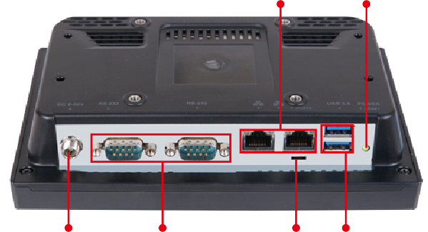
2 x GbE LAN

Power Button
RS-232 2 x GbE LAN
2 x USB 3.1 Gen 1 (5Gb/s)

9V ~ 30V DC Jack

2 x RS-232

AT/ATX Switch

2 x USB 3.1 Gen 1
(5Gb/s)

9V ~ 30V DC Jack

Reset Button
AT/ATX Switch
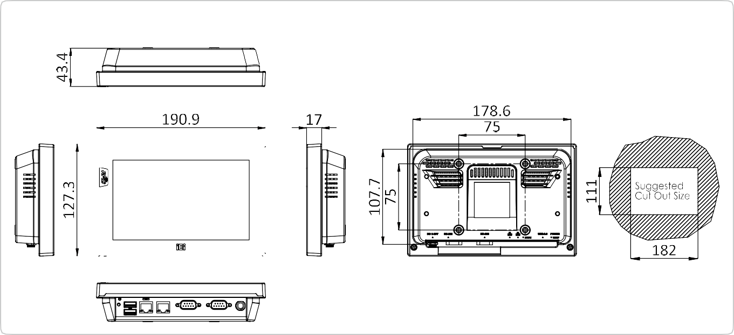RS-232/422/485 Port
AFL3-W07A-BT Dimensions (Unit: mm)

Line-out Digital Microphone

Display System

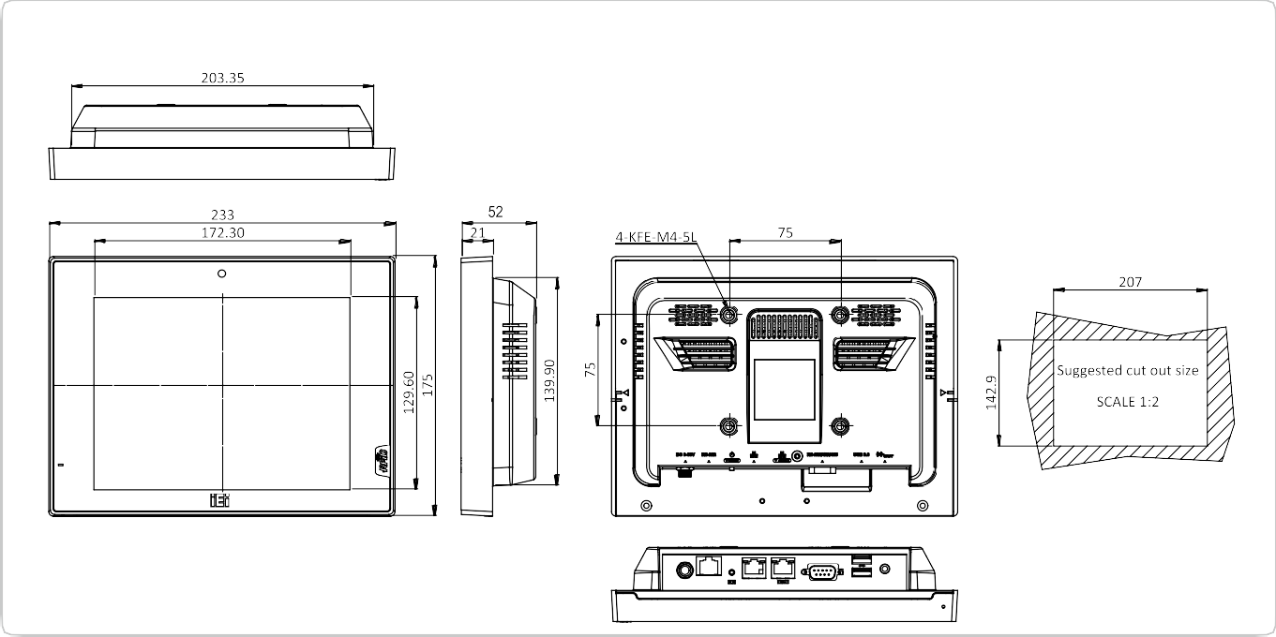
AFL3-08A-BT Dimensions (Unit: mm)

