Display System
w w w . i ei w or l d .c om
Intel® Atom™ N2600 Dual Core Processor
AFL2-08A-N26

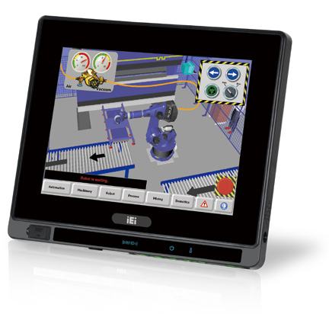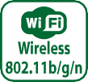Features
- Flat-bezel LCD with LED backlight
- Intel® Atom™ N2600 dual core 1.6 GHz processor
- One 800 MHz 204-pin DDR3 SO-DIMM slot (system max. 2GB) pre-installed with 2GB
- 5-wire resistive type touch screen supported
- Wi-Fi 802.11b/g/n high speed wireless
- Built-in EM or Mifare RFID reader (optional)
- IP64 compliant front panel
- Auto dimming control

Specifications
 | Model | AFL2-08A-N26
LCD  Specifications | Size | 8''
 | Resolution | 800 (W) x 600 (H)
 | Brightness (cd/m²) | 350 cd/m²
 | Contrast Ratio | 500:1
 | LCD Color | 16.2 M
 | Pixel Pitch (mm) | 0.2025 (H) x 0.2025 (V)
 | Viewing Angle (H-V) | 140°(H) / 130°(V)
 | Backlight MTBF | 30000 hrs (LED backlight)
Touch | Touch Screen | 5-wire rsistive type with RS-232 interface
 | Touch Controller | PenMount DMC9000
System | CPU | Intel® Atom™ N2600 dual core 1.6 GHz CPU
 | Chipset | Intel® NM10
 | RAM | Support one 800 MHz 204-pin DDR3 SO-DIMM slot (max. 2GB) pre-installed wiith 2GB
 | Ethernet | Realtek RTL8111E PCIe GbE controller supporting ASF 2.0
 | Audio Codec | Realtek ALC892 HD Audio codec
 | Storage | mSATA
 | Input / Output | 1 x Mini USB 2.0 port on front panel 1 x MicroSD card slot on front panel 1 x Power switch  1 x AT/ATX switch 1 x Reset button  1 x Clear CMOS button  1 x DC input jack
Other Features | Audio | AMP 0.8 W + 0.8 W
 | Camera | 2megapixel with low light function
 | Microphone | Digital Microphone
 | RFID Reader | EM 125 KHz or Mifare 13.56 MHz card reader (optional)
 | MSR Card Reader | MSR card reader (optional)
 | OSD Function | LCD on/off, brightness up/down, volume up/down,hotkey
 | Ambient Light Sensor | Yes
 | Infrared Remote Controller | Yes
 | System Cooling | Fanless
Connectivity | Wireless | IEEE 802.11b/g/n module Telec certified
Physical | Construction Front Panel | PC + ABS plastic front frame
 | Mounting | Wall, Panel, Stand, RACK Mounting and VESA 75 mm x 75mm
 | Color | Black
 | Dimensions (WxHxD)(mm) | 215 x 188 x 46
 | Weight (N/G) | 1.43 kg / 2.2 kg
Environment | Operating Temperature (°C) (Ambient with air flow) | -20°C ~ 40°C
 | Storage Temperature (°C) | -20°C ~ 60°C
 | Humidity | 10% to 95% (non-condensing)
 | IP Level | IP 64 compliant front panel
 | Safety&EMC | CE / FCC
Power | Power Supply | 36W power adapter Input: 90VAC~264VAC, 50/60 Hz, Output: 12VDC
 | Power Requirement | 9 ~ 36 VDC
 | Power Consumption | 12V@2.27A (Intel® Atom™ N2600 CPU with 2GB DDR3 momory)

w w w . i ei w or l d .c om

Ordering Information
Part No. | Description
AFL2-08A-N26/R/2G-R12 | 8" 350 cd/m² SVGA fanless panel PC with Intel® Atom™ N2600 dual core 1.6GHz, 802.11b/g/n wireless module, resistive touch screen, microphone, 2megapixel webcam, 2GB DDR3 RAM, R12

Options Packing List
Item | AFL2-08A-N26
Panel Mounting Kit | AFL2PK-08A
Wall Mounting Kit | AFLWK-12
Rack Mounting Kit | AFL2RK-08A
Stand | STAND-B08/STAND-C12-R10 / STAND-100-RS
V-stand | VSTAND-A07-R11
Magnetic stripe reader | AFL2P-08AMSR-U-R10
EM RFID Reader | AFL2-EM-RFID-KIT01-R10
Mifare RFID Reader | AFL2-MF-RFID-KIT01-R11
OS: Win XPE (CD-ROM) | AFL2-W07A-CV-XPE-R12
OS: Win 7 Embedded (DVD-ROM) | AFL2-W07A-CV-WES7E-R12 (for Resistive Touch)

Item | P/N | Q'ty | Description
Utility CD | 7B000-000889-RS | 1 | drivers and user manual
One Key Recovery CD |  | 1
Power adapter | 63040-010036-111-RS | 1 | 90VAC~264VAC, 50/60 Hz,  Output: 12VDC, 36W (Meet PSE)
Power cord | 32000-000002-RS | 1 | European standard, 1830mm
RJ-11 to DB-9 COM port  cable |  | 1
IR remote controller | 7Z000-SLPCB001-RS | 1
Pen | 43125-0002C0-00-RS | 1 | For Resistive Touch

Fully Integrated I/O

2 x USB 3.0
RJ-45 for RS-422/485

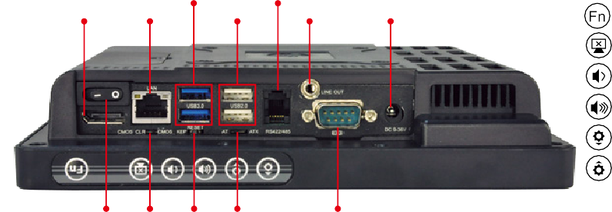Fn
Display Port
LAN
2 x USB 2.0
Line-out
9-36V DC Jack

Backlight On/Off Audio -
Audio + Brightness - Brightness +

RFID Enable/Disable Audio Mute
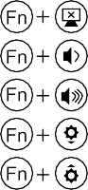
Camera Enable/Disable

Front Side USB Enable/Disable Power On / Off

Power Switch CMOS Reset

AT/ATX

RS-232

Display System

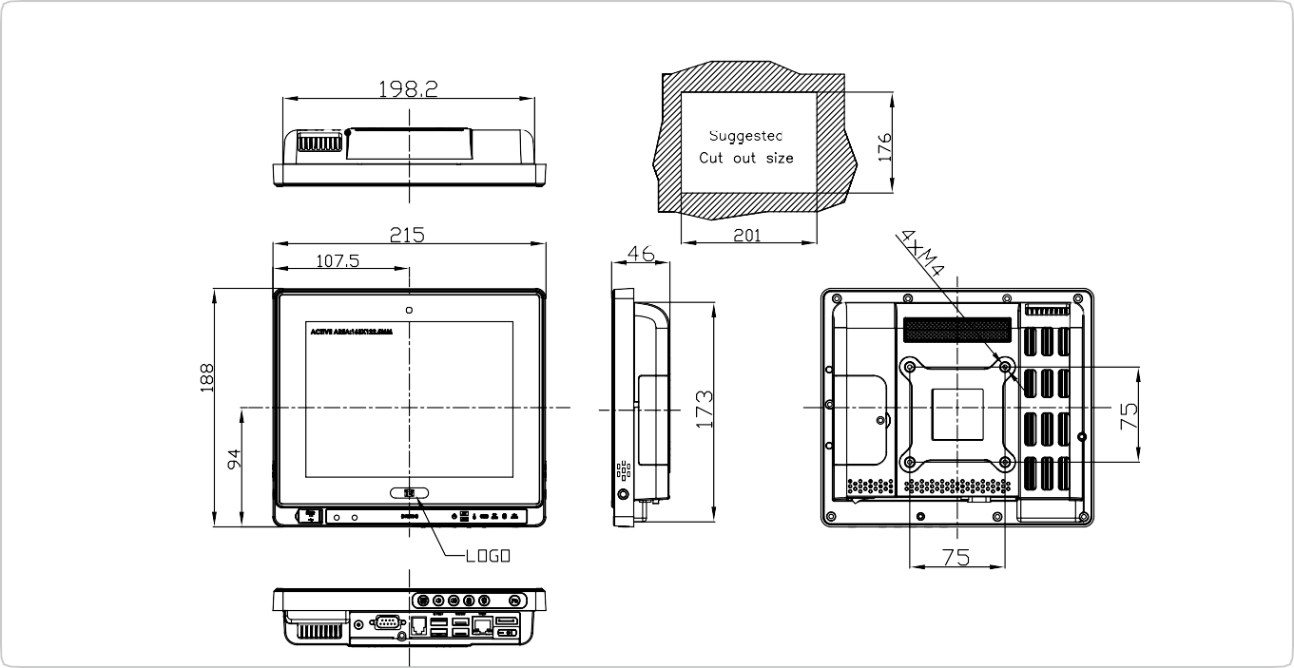
AFL2-08A Dimensions
(Unit: mm)

