Single Board Computer

Peripherals

w w w . i ei w or l d .c om

PCI Express Power over Ethernet card, 4-port 1000 Base(T), 802.3af compliant
IPCIE-4POE

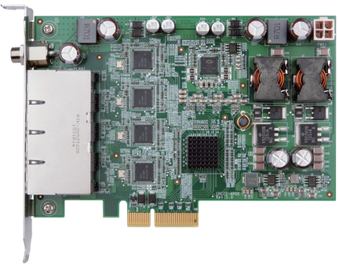
Features
- PCI Express® x4 compliant
- Support for IEEE 802.3af for PoE (Power over Ethernet) with 15.4 watts per port
- Support link aggregation/jmbo frames (9 Kbyte)
- Supports 12~24 AT/ATX DC input power

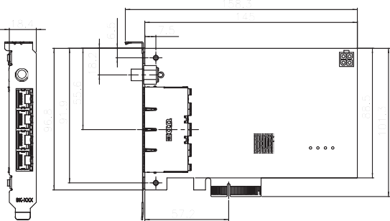
Dimensions (mm)

Specifications
Interface: PCI Express® x4 Ethernet
Intel® i210 AT controller
9kB jumbo frame
IEEE 802.3az, IEEE1588
PoE Capability IEEE 802.3af
15.4W / 48V DC per port

Packing List

PWR Input 12~24V DC input
Internal DC input (2x2 ATX) External DC input (Φ2.1/Φ5.5)
Operating Temperature: 0°C ~ 60°C Storage Temperature: -10°C ~ 70°C
Operating Humidity: 5% ~ 95%, non-condensing CE/FCC compliant

Ordering Information
Part No. | Description
IPCIE-4POE-R10 | PCI Express Power over Ethernet card, 4-port 1000 Base(T), 802.3af compliant
63040-010090-120-RS | Adapter power, FSP, FSP090-DIEBN2, 9NA0904712, Vin:  90~264VAC, 90W, Plug=7.5mm, Cable=1500mm, Erp (no load 0.5W), Vout: 19VDC, Φ2.1/Φ5.5/lock, CCL, RoHS
63040-010065-200-RS | Adapter power, FSP, FSP065-REBN2, 9NA0654709, Vin: 90~264VAC, 65W, Dim: 46.3x108.3x30mm, Plug=7.5mm,  Cable=1500mm, Erp (no load 0.1W), Vout: 19VDC, Φ2.1/  Φ5.5/lock, CCL, RoHS

1 x IPCIE-4POE card
1 x QIG
PCIe Mini USB 3.1 Gen 1 (5Gb/s) Adapter Card, RoHS
MPCIE-USB3
IEI USB 3.1 Gen 1 (5Gb/s) Expanded Solution
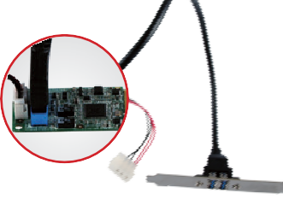
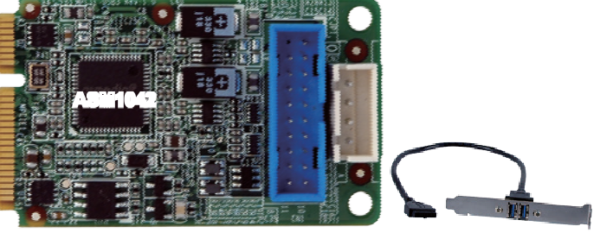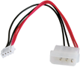The MPCIE is applied to add additional super speed USB 3.1 Gen 1 (5Gb/s) ports for the motherboard with a PCIe Mini slot.

ASM1042

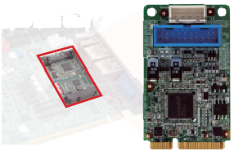Power adapter cable
Motherboard with PCIe Mini Slot

Specifications
Form Factor
PCI Express Mini card

USB 3.1 Gen 1 (5Gb/s) cable

Operating Temperature
-10°C ~ 60°C

Features

MPCIE-USB3
5V
Power Input
Two USB 3.1 Gen 1 Ports

USB 3.1 Gen 1 (5Gb/s) Controller Asmedia ASM1042A
Internal Connector
1 x 20-pin (2x10) box header Power Jack
1 x 4-pin box header
Compatible OS
Windows® XP/Server 2003/Server 2008/Vista/7/8.1/10 Linux kernel version 2.6.32 above

Packing List
Operating Humidity
5% ~ 95%, non-condensing Dimensions (LxW)
50 mm x 30 mm
Weight 70g
CE/FCC compliant
- Supports two external USB 3.1 Gen 1 (5Gb/s) type A ports
- USB 3.1 Gen 1 (5Gb/s) provides up to 5Gbps of transferring rate
- Backward compatible with USB 2.0 and USB 1.0/1.1 devices
- Fully compliant with USB 3.1 Gen 1 (5Gb/s) rev 1.0 specifications and Intel® xHCI rev
0.96 specifications, with transfer rates up to 5Gbps
- Compliant with PCI Express Mini specification 1.2

Dimensions (mm)

IPCIE-4POE-2019-V10
1 x MPCIE-USB3 PCIe Mini USB 3.1 Gen 1 (5Gb/s) adapter card
1 x Dual USB 3.1 Gen 1 (5Gb/s) type A port cable with bracket
1 x Power cable | 1 x QIG

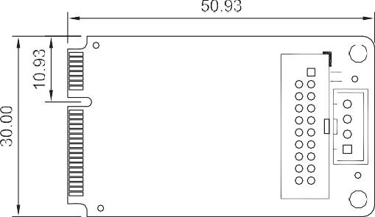
Ordering Information
Part No. | Description
MPCIE-USB3-R11 | PCIe Mini USB 3.1 Gen 1 (5Gb/s) adapter card, RoHS
19800-010500-200-RS | Dual USB 3.1 Gen 1 (5Gb/s) type A port cable with bracket

