TANK-870-Q170

High-Performance 6th/7th Generation Intel® Core™ Processor
- 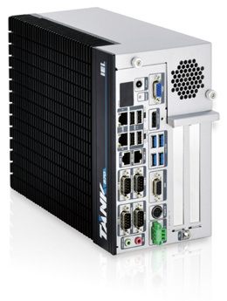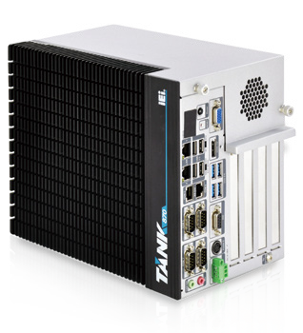Fanless Embedded Computer

w w w . i ei w or l d .c om

Features
  - 6th/7th Gen Intel® Core™ processor platform with Intel® Q170 chipset and DDR4 memory
  - Triple independent display with high resolution support
  - Rich high-speed I/O interfaces on one side for easy installation
  - On-board internal power connector for providing power to add-on cards
  - Great flexibility for hardware expansion

2-slot

4-slot
Fanless
Display
Triple
PCI/PCIe DDR4
Expansion
2133

Smart Choice for Surveillance System
The TANK-870-Q170 integrated with IEI PoE Ethernet port expansion card can be used as a surveillance system for factory and public security. IEI PoE expansion card can support up to four PoE IEEE802.3af ports (max. 15.4 W per port ) by PCIe x4.

IP Camera
IPCIE-4POE

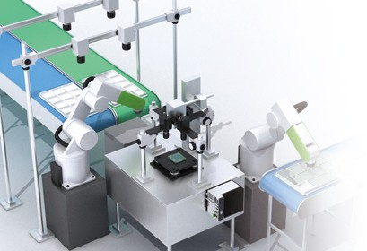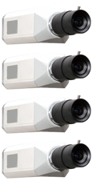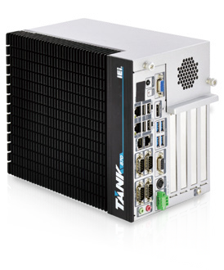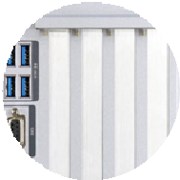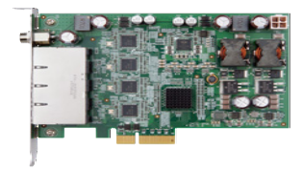5V@3A or 12V@3A Internal Power Connector
Industrial System
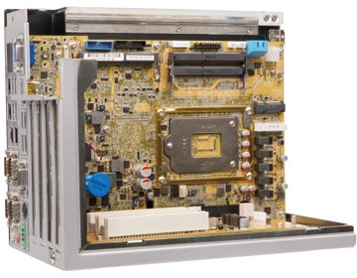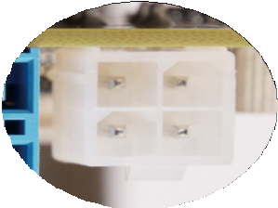The TANK-870-Q170 provides the most convenient 4-pin internal power connector for add-on card usage, adding more flexibility to the embedded system in industrial environment.
+12V
GND

+5V

GND
Fully Integrated I/O
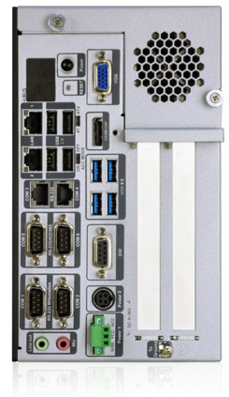Power Switch
- Long-press 2 sec. to power on
- Long-press 5 sec. to power off

LED

4 x USB 2.0

2 x GbE LAN

2 x RS-232
4 x USB 3.0

2 x RS-232/
422/485
DIO

2 x RS-232

Audio

Power2 (DC Jack)

Reset VGA

AT/ATX
Mode

HDMI+DP
ACC Mode

Expansion Slots 2-slot:
2 x Expansion Slots 4-slot:
4 x Expansion Slots

To Ground
Power1 (Terminal Block)

Industrial System

w w w . i ei w or l d .c om

Flexible Expansion Interface

Backplane | TANK-870-Q170i-2A | TANK-870-Q170i-2B | TANK-870-Q170i-4A |  | TANK-870-Q170i-4B
Slot Type | PCIe x16 | PCIe x16 | PCIe x16 | PCIe x16 | PCIe x16 | PCI
Signal | PCIe x8 | PCIe x16 | PCIe x8 | PCIe x8 | PCIe x16 | PCI
Slot Type | PCIe x16 | PCI | PCI | PCI | PCI | PCI
Signal | PCIe x8 | PCI | PCI | PCI | PCI | PCI
PCIe Mini | N/A | N/A | 1 |  | 1
* The expansions described above are provided by the backplanes
Specifications

Model Name |  | TANK-870-Q170
Chassis | Color | Black C + Silver
 | Dimensions (WxDxH) (mm) | 2-slot: 121.5 x 255.2 x 205  4-slot: 154.8 x 255.2 x 205
 | System Fan | Fanless
 | Chassis Construction | Extruded aluminum alloys
Motherboard | CPU | Intel 7th Gen Core CPU &  Intel® Core™ i7-6700TE (2.4 GHz, quad-core, TDP=35W) Intel® Core™ i5-6500TE (2.3 GHz, quad-core, TDP=35W)
 | Chipset | Intel® Q170
 | System Memory | 2 x 260-pin DDR4 SO-DIMM,  one 4 GB pre-installed (system max: 32GB)
IPMI | iRIS Solution | 1 x iRIS-2400 (optional)
Storage | Hard Drive | 2 x 2.5'' SATA 6Gb/s HDD/SSD bay (RAID 0/1 support)
I/O Interfaces | USB 3.0 | 4
 | USB 2.0 | 4
 | Ethernet | 2 x RJ-45  LAN1: Intel® I219LM PCIe controller LAN2 (iRIS): Intel® I210 PCIe controller
 | COM Port | 4 x RS-232 (2 x RJ-45, 2 x DB-9 w/2.5KV isolation protection) 2 x RS-232/422/485 (DB-9)
 | Digital I/O | 8-bit digital I/O , 4-bit input / 4-bit output
 | Display | 1 x VGA  1 x HDMI/DP  1 x iDP (optional)
 | Resolution | 1 x VGA (Up to 1920 x 1200@60Hz)  1 x HDMI/DP (Up to 3840x2160@30Hz / 4096×2304@60Hz)
 | Audio | 1 x Line-out, 1 x Mic-in
 | Wireless | 1 x 802.11 a/b/g/n/ac (optional)
 | TPM | 1 x TPM pin header (2 x 10 pin)
Expansions | Backplane | 2-slot model: 1 x PCIe x16, 1 x PCI 2-slot model: 2 x PCIe x8  4-slot model: 2 x PCIe x8, 2 x PCI, 1 x Full-size PCIe Mni 4-slot model: 1 x PCIe x16, 3 x PCI, 1 x Full-size PCIe Mni
 | PCIe Mini | 1 x Half-size PCIe Mini slot  1 x Full-size PCIe Mini slot (supports mSATA, colay with SATA)*
Power | Power Input | DC Jack: 9 V~36 V DC  Terminal Block: 9 V~36 V DC
 | Power Consumption | 19 V@3.68 A (Intel® Core™ i7-6700TE with 8 GB memory)
 | Internal Power output | 5V@3A or 12V@3A
Reliability | Mounting | Wall mount
 | Operating Temperature | i7-6700TE -20°C ~ 45°C with air flow (SSD), 10% ~ 95%, non-condensing i5-6500TE -20°C ~ 60°C with air flow (SSD), 10% ~ 95%, non-condensing
 | Storage Temperature | -40°C ~85°C with air flow (SSD), 10% ~ 90%, non-condensing
 | Operating Shock | Half-sine wave shock 5G, 11ms, 100 shocks per axis
 | Operating Vibration | MIL-STD-810G 514.6 C-1 (with SSD)
 | Weight (Net/Gross) | 2-slot: 4.2 kg/6.3 kg 4-slot: 4.5 kg/6.5 kg
 | Safety/EMC | CE/FCC
OS | Supported OS | Microsoft® Windows® 8 Embedded, Microsoft® Windows® Embedded Standard 7 E, Microsoft® Windows® 10 IoT Enterprise
* TANK-870-Q170-QGW has no Full-size PCIe mini slot

Industrial System

w w w . i ei w or l d .c om

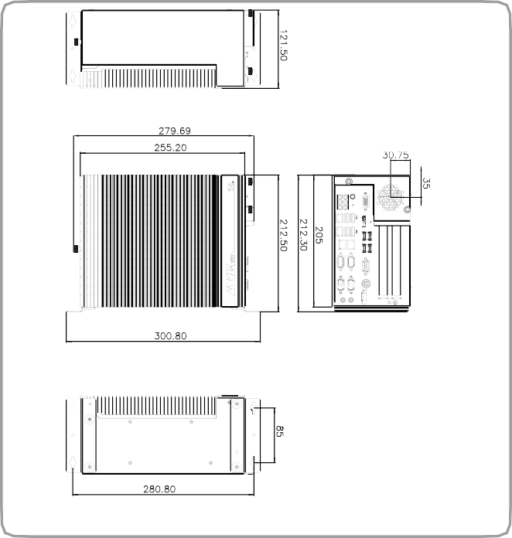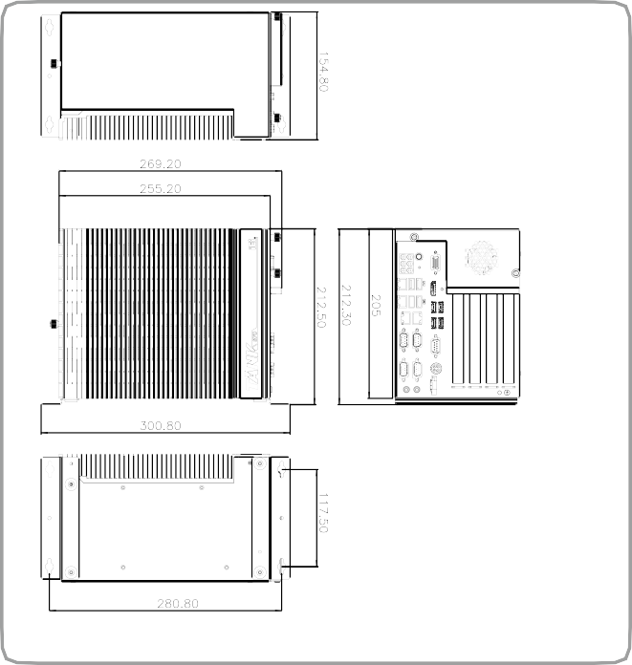Dimensions (Unit: mm)
TANK-870-Q170i-2 slot
TANK-870-Q170i-4 slot

Ordering Information

Part No. Description
TANK-870-Q170i-i5/4G/2A-R11 Ruggedized fanless embedded system with Intel® Core™ i5-6500TE 2.3 GHz (up to 3.3 GHz, quad core, TDP 35W), 4GB DDR4 pre- installed memory, 2 x PCIe by 8 expansion, VGA/HDMI+DP/iDP, iRIS-2400 optional, 9~36V DC, RoHS
TANK-870-Q170i-i5/4G/2B-R11 Ruggedized fanless embedded system with Intel® Core™ i5-6500TE 2.3 GHz (up to 3.3 GHz, quad core, TDP 35W), 4GB DDR4 pre- installed memory, 1 x PCIe by 16 & 1 x PCI expansion, VGA/HDMI+DP/iDP, iRIS-2400 optional, 9~36V DC, RoHS
TANK-870-Q170i-i5/4G/4A-R11 Ruggedized fanless embedded system with Intel® Core™ i5-6500TE 2.3 GHz (up to 3.3 GHz, quad core, TDP 35W), 4GB DDR4 pre- installed memory, 2 x PCIe by 8 & 2 x PCI expansion, VGA/HDMI+DP/iDP, iRIS-2400 optional, 9~36V DC, RoHS
TANK-870-Q170i-i5/4G/4B-R11 Ruggedized fanless embedded system with Intel® Core™ i5-6500TE 2.3 GHz (up to 3.3 GHz, quad core, TDP 35W), 4GB DDR4 pre- installed memory, 1 x PCIe by 16 & 3 x PCI expansion, VGA/HDMI+DP/iDP, iRIS-2400 optional, 9~36V DC, RoHS
TANK-870-Q170i-i7/4G/2A-R11 Ruggedized fanless embedded system with Intel® Core™ i7-6700TE 2.4 GHz (up to 3.4 GHz, quad core, TDP 35W), 4GB DDR4 pre- installed memory, 2 x PCIe by 8 expansion, VGA/HDMI+DP/iDP, iRIS-2400 optional, 9~36V DC, RoHS
TANK-870-Q170i-i7/4G/2B-R11 Ruggedized fanless embedded system with Intel® Core™ i7-6700TE 2.4 GHz (up to 3.4 GHz, quad core, TDP 35W), 4GB DDR4 pre- installed memory, 1 x PCIe by 16 & 1 x PCI expansion, VGA/HDMI+DP/iDP, iRIS-2400 optional, 9~36V DC, RoHS
TANK-870-Q170i-i7/4G/4A-R11 Ruggedized fanless embedded system with Intel® Core™ i7-6700TE 2.4 GHz (up to 3.4 GHz, quad core, TDP 35W), 4GB DDR4 pre- installed memory, 2 x PCIe by 8 & 2 x PCI expansion, VGA/HDMI+DP/iDP, iRIS-2400 optional, 9~36V DC, RoHS
TANK-870-Q170i-i7/4G/4B-R11 Ruggedized fanless embedded system with Intel® Core™ i7-6700TE 2.4 GHz (up to 3.4 GHz, quad core, 4GB DDR4 pre-installed memory, 1 x PCIe by 16 & 3 x PCI expansion, VGA/HDMI+DP/iDP, iRIS-2400 optional, 9~36V DC, RoHS
TANK-870-Q170-QGW-2A-R11 Ruggedized Fanless embedded system with Intel® Core i5-6500TE 2.3GHz, (up to 3.3 GHz, Quad Core, TDP 35W), 8GB DDR4 pre-installed memory, 2 x PCIe by 8 expansion, VGA/HDMI+DP/iDP, iRIS-2400 optional, 9~36V DC, with QTS-Gateway, RoHS

Options

Part No. Description
32702-000400-200-RS European power cord
63040-010120-210-RS Power adapter, FSP120-ABBN2, 9NA1205302, Active PFC, Vin:90~264VAC, 120W, plug=6.5mm, cable=1500mm, Erp (no load 0.15W),
Vout:19VDC, 4-pin DIN with lock, CCL, RoHS
iRIS-2400-R10 IPMI 2.0 adapter card with AST2400 BMC chip for DDR3 SO-DIMM socket interface
EMB-FAN-KIT02-R10 Fan Module;MODIFY 31100-000272-RS;+12V DC;4PIN;40*40*15mm ;STANDARD;;FD124015LB2W3;; L= 400mm MOLEX 5051-04P P=2.54;CCL;RoHS
EMB-WIFI-KIT01-R20 1T1R wifi module kit for embedded system, IEEE802.11a/b/g/n/ac WiFi with Bluetooth 4.0/3.0+HS, 1 x wifi module, 2 x 250mm RF cable, 2 x Antenna, RoHS
DP-DP-R10 DisplayPort to DisplayPort converter board (for IEI IDP connector)
DP-HDMI-R10 DisplayPort to HDMI converter board (for IEI IDP connector)
DP-LVDS-R10 DisplayPort to 24-bit dual channel LVDS converter board (for IEI IDP connector)
DP-VGA-R10 DisplayPort to VGA converter board (for IEI IDP connector)
DP-DVI-R10 DisplayPort to DVI-D converter board (for IEI IDP connector)
IPCIE-4POE-R10 PCI Express Power over Ethernet frame grabber card, 4-port 1000 Base(T), 802.3af compliant, RoHS
TANK-870-Q170-WES7E64-R10 OS Image with Windows® Embedded Standard 7 E 64-bit for TANK-870-Q170 Series, with DVD-ROM, RoHS
TANK-870-Q170-W10E64-H-R10 OS Image with Windows® Embedded Standard 10 E High End 64-bit for TANK-870-Q170-i7 Series, with DVD-ROM, RoHS TANK-870-Q170-W10E64-V-R10 OS Image with Windows® Embedded Standard 10 E Value 64-bit for TANK-870-Q170-i5 Series, with DVD-ROM, RoHS TPM-IN02-R20 20-pin Infineon TPM2.0 module, software mangement tool, firmware v5.5
* The TANK-870 can support up to 40°C operating temperature when installing with the IPCIE-4POE-R10.

Packing List
1 x Chassis Screw
1 x Mounting Bracket

