- Intel® HM86 mobile solution
- Three different expansion slot options
TANK-860-HM86

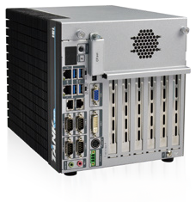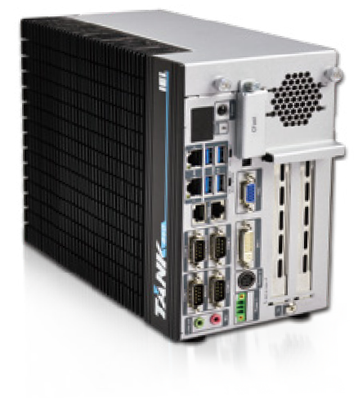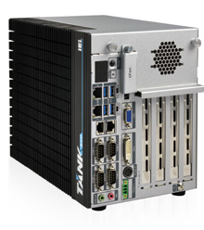Features
2-slot
6-slot
4-slot
- Intel® HM86 chipset + 4th generation Intel® Core™ CPU
- Great flexibility of expansion slots
» 2-slot model: 2 x PCIe by 16, 1 x PCIe Mini slot
» 4-slot model: 2 x PCIe by 16, 2 x PCI, 2 x PCIe Mini slot
» 6-slot model: 1 x PCIe by 16, 2 x PCIe by 4, 3 x PCI, 2 x PCIe Mini slot
- IPMI function for remote control management
- Three independent video outputs support high resolution
- 2 x 2.5" SATA HDD bay design fulfills high storage demand

Fanless
Display
Triple
Expansion
PCIe Mini

Dual LAN

PCI/PCIe
Expansion

Automation Solution
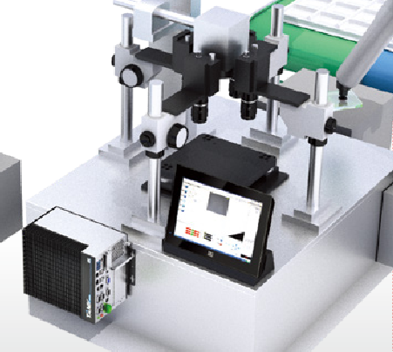The TANK-860 is a fanless expandable embedded system with PCIe and/or PCI slots. With rich I/O, customers can make it as a control center. Furthermore, the ruggedized design makes the TANK-860 more reliable even in harsh environments.
PCI/PCIe Expansion
Ruggedized System
Rich I/O
Data Acquisition
Machine Vision
Automation

Dual 2.5’’ SATA HDD/SSD Bay
With two 2.5" SATA HDD/SSD bays, users can fulfill large storage requirement and use it as a terminal for data acquisition. The easy-to-assemble design reduces user fatigue in system installation.

Swappable CFast Design
CFast is based on the Serial ATA bus and supports up to 300 MBps transfer rates, which is much higher than the CF card. With the hot-swappable design, users can replace the CFast even when the system is running.

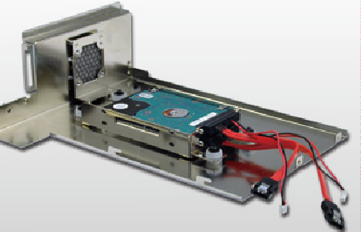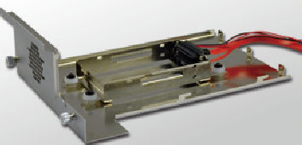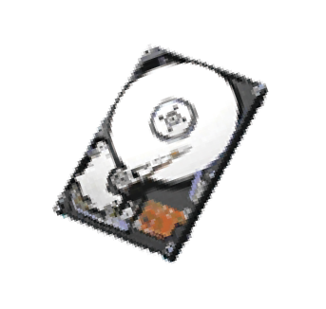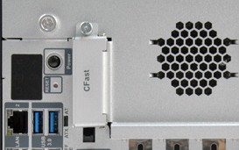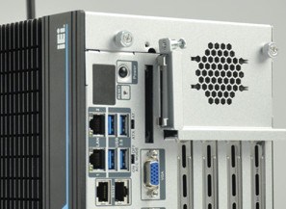
2 x 2.5'' SATA 6Gb/s
HDD/SSD bay

w w w . i ei w or l d .c om

Abundant Expansion Interface
The TANK-860 series has a great variety of different expansion interfaces. From basic 2-slot expansion model to advanced 6-slot expansion model, customers can choose the most suitable one to apply.
- slot 4-slot 6-slot
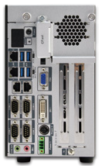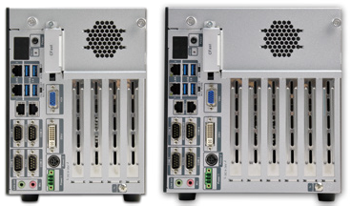

Versatile Expansion Interface

 | 2-slot model | 4-slot model |  | 6-slot model
Physical Slot | PCIe x16 | PCIe x16 | PCIe x16 | PCIe x16 | PCIe x4 | PCIe x4
Signal | PCIe x8 | PCIe x8 | PCIe x8 | PCIe x8 | PCIe x4 | PCIe x4
Slot type | PCIe x16 | PCI | PCI | PCI | PCI | PCI
Signal | PCIe x8 | PCI | PCI | PCI | PCI | PCI

Wide Range Temperature
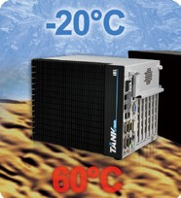The TANK-860-HM86 series is designed to withstand wide range of temperatures. With this design, the TANK-860-HM86 series can even be installed in a high- temperature roadside cabinet.
iRIS Solution
By installing the IEI iRIS-2400 module, the TANK-860 is capable to complete your IoT application through the advanced remote control features, such as power management and control, remote KVM for device status monitoring, sending active alerts and warning messages by e-mail or SMS.

Triple Display
The TANK-860 contains VGA/DisplayPort/DVI video outputs, which can be applied to multi-display application and support high Full HD video quality.
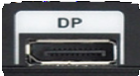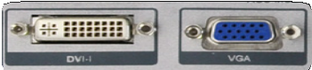
Anti-Vibration and Anti-Shock Design
With the rugged design, the TANK-860-HM86 series is reliable in industrial environments to resist strong vibrations and can be used as a core computer required to be installed on moving objects.
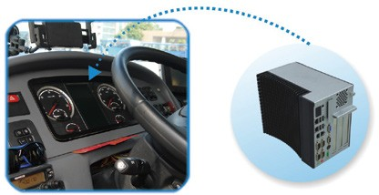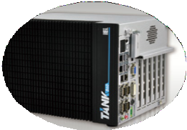
Wide Range DC Power Input
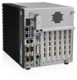The TANK-860-HM86 series accepts wide range DC power input, allowing it to be powered anywhere, no matter if a 12 V/24 V DC source or a 19 V power adapter is available.

Dual DC Power Input
The TANK-860-HM86 adopts dual DC power input design, which ensures uninterrupted power supply to the system and eliminates the risk of sudden shutdown and data loss, even if one power is unavailable or low voltage capacity is present.

Fully Integrated I/O
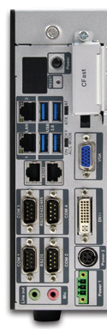Front View Rear View

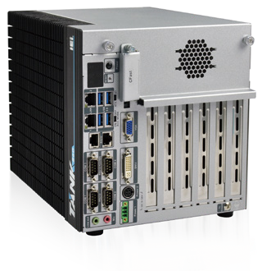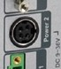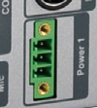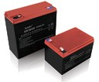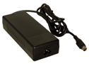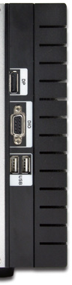Power Switch
Power 1
Power 2
10.5 V~36 V DC adapter
9 V~36V car lead-acid battey pack

ACC
+
-

  - Long-press 2 sec. to power on
  - Long-press 5 sec. to power off

Reset

CFast

DisplayPort

DIO

2 x USB 2.0
OLED

2 x LAN

4 x USB 3.0
2 x RS-232

AT/ATX
Mode
ACC Mode VGA

Industrial System
2 x RS-232/422/485

2 x RS-232

Audio

DVI-I

Power2 (DC Jack)
Power1 (Terminal Block)

Specifications

Model Name |  | TANK-860-HM86
Chassis | Color | Black C + Silver
 | Dimensions (WxHxD) (mm) | 2 slot: 121.5 x 255.2 x 205  4 slot: 154.8 x 255.2 x 205  6 slot: 195.4 x 255.2 x 205
 | System Fan | Fanless
 | Chassis Construction | Extruded aluminum alloys
Motherboard | CPU | Intel® Core™ i5-4400E 2.7 GHz Intel® Celeron® 2000E 2.2 GHz
 | Chipset | Intel® HM86
 | System Memory | 2 x 204-pin DDR3 SO-DIMM,  one 4GB pre-installed (system max: 16 GB)
IPMI | iRIS Solution | 1 x iRIS-2400 (optional)
Storage | Hard Drive | 2 x 2.5'' SATA 6Gb/s HDD/SSD bay
 | CF Card/CFast | 1 x CFast
I/O Interfaces | USB 3.0 | 4
 | USB 2.0 | 2
 | Ethernet | 2 x RJ-45  1 x PCIe GbE by Intel® I210  1 x PCIe GbE by Intel® I217LM
 | COM Port | 4 x RS-232 (2 DB-9 w/ isolation, 2 RJ-45) 2 x RS-232/422/485 (DB-9)
 | Digital I/O | 8-bit digital I/O, 4-bit input/4-bit output
 | Display | 1 x VGA, 1 x DVI-I, 1 x DisplayPort
 | Resolution | VGA: Up to 1920 x 1200@60Hz DVI-I: Up to 2500 x 1600@60Hz  Displayport: Up to 2500 x 1600@60Hz
 | Audio | 1 x Line-out, 1 x Mic-in
 | Wireless | 1 x 802.11b/g/n (optional)
Expansions | PCI/PCIe | 2 A: Two PCIe x8 (physical PCIe x16 slot)  4 A: Two PCIe x8 (physical PCIe x16 slot) + 2 x PCI  6 A: One PCIe x8 (physical PCIe x16 slot) + two PCIe x4 + three PCI
 | PCIe Mini | 2A: 1 x Full-size (supports mSATA, colay with SATA) 4A: 1 x Full-size (supports mSATA, colay with SATA)  + 1 x Full-size (on backplane)  6A: 1 x Full-size (supports mSATA, colay with SATA)  + 1 x Full-size (on backplane)
Power | Power Input | DC Jack: 9 V~36 V DC  Terminal Block: 9 V~36 V DC
 | Power Consumption | 19 V@3.34 A  (Intel® Core™ i5-4400E with 4 GB memory)
Reliability | Mounting | Wall mount
 | Operating Temperature | -20°C ~ 60°C with air flow (SSD), 5% ~ 95%, non-condensing
 | Storage Temperature | -30°C ~70°C with air flow (SSD), 5% ~ 90%, non-condensing
 | Operating Shock | Half-sine wave shock 5G, 11ms, 3 shocks per axis
 | Operating Vibration | MIL-STD-810F 514.5C-2 (with SSD)
 | Weight (Net/Gross) | 2-slot: 4.2 kg/6.3 kg 4-slot: 4.5 kg/6.5 kg 6-slot: 4.8 kg/6.9 kg
 | Safety/EMC | CE/FCC
OS | Supported OS | Microsoft® Windows® 8 Embedded, Microsoft® Windows® Embedded Standard 7 E
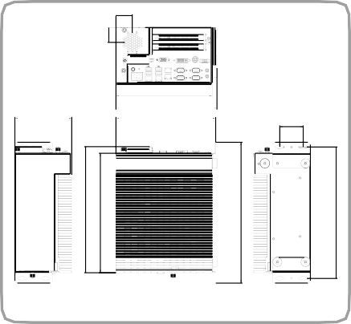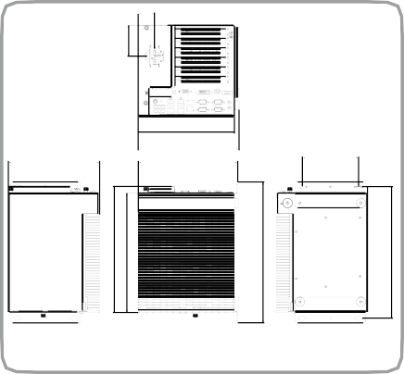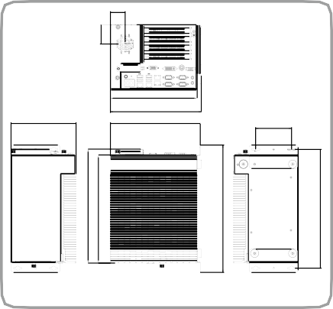Dimensions (Unit: mm)

TANK-860-HM86-2 slot

TANK-860-HM86-6 slot

TANK-860-HM86-4 slot
269.20
255.20
31.80
300.80
280.80
269.20
255.20
45.80
300.80
280.80
269.20
255.20
66.25
300.80
280.80

Ordering Information

Part No. | Description
TANK-860-HM86i- i5/4G/2A-R10 | Intel® Core™ i5-4400E 2.7 GHz dual-core, TDP 37W, 4GB DDR3 pre-installed memory, 2 x PCIe expansion, VGA/DVI-I/ DisplayPort, iRIS-2400 optional, 9 V~36 V DC, R10, RoHS
TANK-860-HM86i- i5/4G/4A-R10 | Intel® Core™ i5-4400E 2.7 GHz dual-core, TDP 37W, 4GB DDR3 pre-installed memory, 2 x PCIe and 2 x PCI expansion, VGA/  DVI-I/DisplayPort, iRIS-2400 optional, 9 V~36 V DC, R10, RoHS
TANK-860-HM86i- i5/4G/6A-R10 | Intel® Core™ i5-4400E 2.7 GHz dual-core, TDP 37W, 4GB DDR3 pre-installed memory, 3 x PCIe and 3 x PCI expansion, VGA/  DVI-I/DisplayPort, iRIS-2400 optional, 9 V~36 V DC, R10, RoHS
TANK-860-HM86i- C/4G/2A-R10 | Intel® Celeron® 2000E 2.2 GHz dual-core, TDP 37W, 4GB DDR3 pre-installed memory, 2 x PCIe expansion, VGA/DVI-I/ DisplayPort, iRIS-2400 optional, 9 V~36 V DC, R10, RoHS
TANK-860-HM86i- C/4G/4A-R10 | Intel® Celeron® 2000E 2.2 GHz dual-core, TDP 37W, 4GB DDR3 pre-installed memory, 2 x PCIe and 2 x PCI expansion, VGA/  DVI-I/DisplayPort, iRIS-2400 optional, 9 V~36 V DC, R10, RoHS
TANK-860-HM86i- C/4G/6A-R10 | Intel® Celeron® 2000E 2.2 GHz dual-core, TDP 37W, 4GB DDR3 pre-installed memory, 3 x PCIe and 3 x PCI expansion, VGA/  DVI-I/DisplayPort, iRIS-2400 optional, 9 V~36 V DC, R10, RoHS
TANK-860-QGW- i5/8G/2A-R10 | Intel® Core™ i5-4400E CPU, 2 x 4GB DDR3 memory, 2 x PCIe expansion, Dual GbE, COM, DIO, VGA/DVI-I/DisplayPort, iRIS- 2400 optional, with QTS-Gateway, 9 V~36 V DC, RoHS
TANK-860-QGW- i5/8G/4A-R10 | Intel® Core™ i5-4400E CPU, 2 x 4GB DDR3 memory, 2 x PCIe and 2 x PCI expansion, Dual GbE, COM, DIO, VGA/DVI-I/ DisplayPort, iRIS-2400 optional, with QTS-Gateway, 9 V~36 V DC, RoHS
TANK-860-QGW- i5/8G/6A-R10 | Intel® Core™ i5-4400E CPU, 2 x 4GB DDR3 memory, 3 x PCIe and 3 x PCI expansion, Dual GbE, COM, DIO, VGA/DVI-I/ DisplayPort, iRIS-2400 optional, with QTS-Gateway, 9 V~36 V DC, RoHS
Options

Part No. | Description
32702-000400-200-RS | European power cord
63040-010120-210-RS | Power adapter, FSP120-ABBN2, 9NA1205302, Active PFC,  Vin:90~264VAC, 120W, plug=6.5mm, cable=1500mm, Erp  (no load 0.15W), Vout:19VDC, 4-pin DIN with lock, CCL, RoHS
19Z00-000605-00-RS | Fan, +12V DC, 4-pin, 40 mm x 40 mm x10 mm, 6500RPM, RoHS
iRIS-2400-R10 | IPMI 2.0 adapter card with AST2400 BMC chip for DDR3 SO-DIMM socket interface
EMB-WIFI-KIT11-R20 | 1T1R wifi module kit for embedded system, IEEE802.11a/b/g/n/ac WiFi with Bluetooth 4.0/3.0+HS, 1 x wifi module, 2 x 350mm RF cable, 2 x Antenna, RoHS
TANK-860-HM86  -WES7E-R10 | OS Image with Windows® Embedded Standard 7 E for TANK-860 H Series, with CD-ROM, RoHS
Packing List

1 x Utility CD | 1 x Chassis Screw
1 x One Key Recovery CD | 1 x Mounting Bracket

