- Fanless DIN-Rail Embedded System
- Intel® E3845 1.91GHz/Intel® N2800 1.86GHz Solution
120-BT
DRPC- 100-CV

Features
DRPC-120-BT
- Intel® Atom™ E3845 1.91GHz
- 1 x 2.5'' SATA HDD/SSD drive bay
- DDR3L 1.35V SO-DIMM support

- Programmable OLED display
- 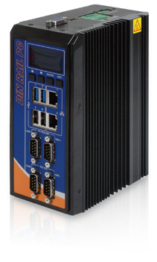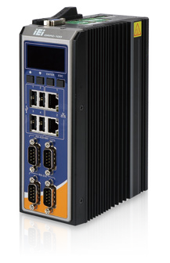8-bit digital I/O (4-bit inputs/outputs)
DRPC-120-BT
DRPC-100-CV
- IEI iRIS-2400 solution

Fanless Expansion
PCIe Mini
Dual LAN RS-232
/422/485

DRPC-100-CV
  - Intel® Atom™ N2800 1.86GHz
  - Serial, CAN-bus and digital I/O interfaces with isolation protection

- 1 x PCIe Mini expansion slot for add- on function purpose
- Programmable OLED display

Fanless SATA 3Gb/s
GbE
CAN-Bus Expansion
PCIe Mini

User Friendly Installation
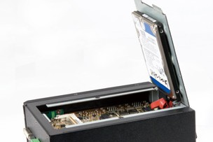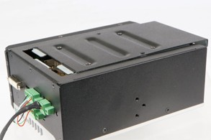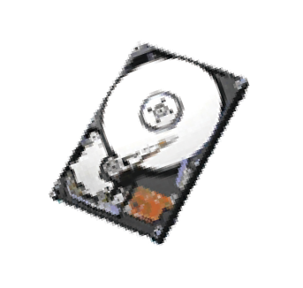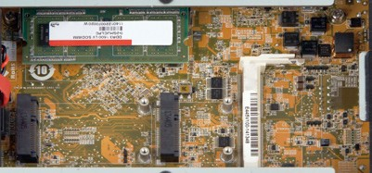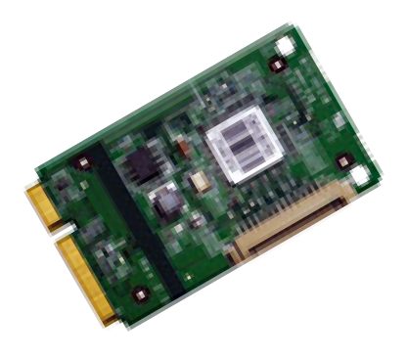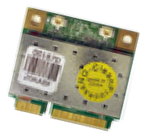The DRPC-120 is designed with an easy removable back cover for users to install SATA HDD, PCIe Mini cards, DDR3 memory modules or iRIS-2400 modules conveniently.

1 x 2.5'' SATA 6Gb/s HDD/SSD Bay

DDR3 SO-DIMM memory

8-Channel Digital I/O

Fanless
Full-size PCIe Mini Half-size PCIe Mini

The DRPC-120 is outfitted with 8-channel (4-bit input and 4-bit output) digital I/O to provide digital input and output signals for control of industrial devices.
The DRPC-100/120 series provides the best components for generating less heat, while
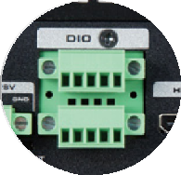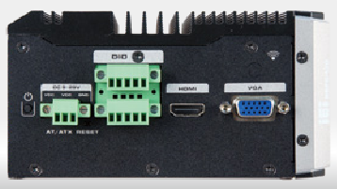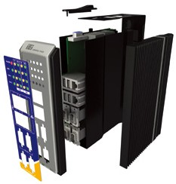m aint aining high s y s t em performance. With the fanless design, the DRPC- 100/ 120 reduces system failure caused by fans and extends the lifetime of the device.

iRIS Solution
By installing the IEI iRIS-2400 module, the DRPC-120 is capable to complete your IoT application through the advanced remote control features, such as power management and control, remote KVM for device status monitoring, sending active
alerts and warning messages by e-mail or SMS.
Communication Gateway
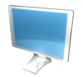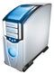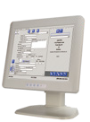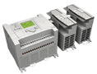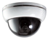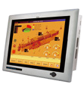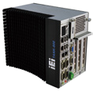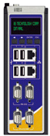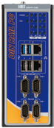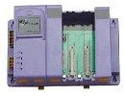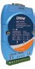For high surge ESD automation environments, the DRPC-100 provides isolated digital IO, CAN-bus and serial communication ports.

Ethernet
Database

DIN Rail Standard
A DIN rail is a metal rail of a standard type widely used for mounting circuit breakers and industrial control equipment inside equipment racks. These products are typically made from cold rolled carbon steel sheet with a zinc-plated and chromated bright surface finish. The term derives from the original specifications having been published by Deutsches Institut für Normung (DIN) in Germany, which have since been adopted as European (EN) and international (ISO) standards.

VGA

Ethernet

DIO

RS-232
PC/ERP

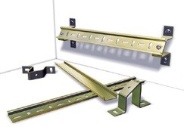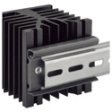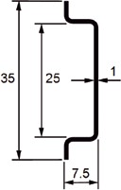HMI

CAN-bus

RS-422/485

Converter

PAC

Devices

PLC

Alarm

OLED Indicator Function

- 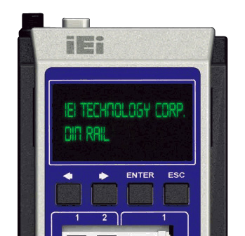Programmable OLED Display
Users can program their own APIs to show any information by the OLED display.
- Programmable Function Keys
Users can program the four keys to control DRPC-100 & OLED display.
- Terminal Screen & Status Display
It supports both text format and graphic format.
- Protocol & Demo Source Code Open
IEI provides the protocol & demo source code for users to program their own usage.

Fully Integrated I/O
DRPC-100/120 OLED indicator

Programmable OLED indicator

Function Keys

DRPC-120 Front View

DRPC-120 Top Side View

DRPC-100 Front View

DRPC-100 Top Side View

LED indicators

2 x LAN
2 x USB 3.0

2 x USB 2.0

2 x RS-422/485
isolated

2 x RS-232
isolated

9 V~30 V DC-in
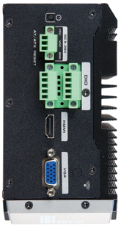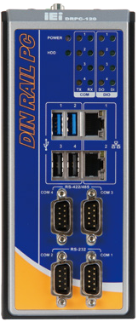Power switch AT/ATX mode
Reset

8-bit digital I/O

HDMI

VGA

Antenna connector

Programmable OLED indicator

Function keys

2 x LAN

4 x USB 2.0

2 x RS-422/485
isolated

2 x RS-232
isolated
9 V~28V DC-in

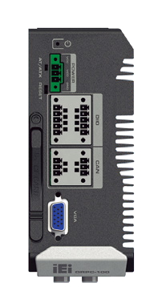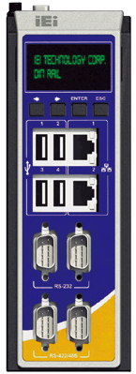Power switch AT/ATX Mode
Reset

8-bit digital I/O
isolated
CF

2 x CAN-bus
isolated

VGA

Specifications

Model Name |  | DRPC-120-BT | DRPC-100-CV
Chassis | Color | Black | Black
 | Dimensions (WxDxH) (mm) | 74.08 x 140 x 171.5 | 59.4 x 140 x 171.5
 | System Fan | Fanless | Fanless
 | Chassis Construction | Extruded aluminum alloys | Extruded aluminum alloys
Motherboard | CPU | Intel® Atom™ E3845 1.91 GHz | Intel® Atom™ N2800 1.86 GHz
 | Chipset | SoC | Intel® NM10
 | System Memory | 1 x 204-pin DDR3L SO-DIMM 2 GB pre-installed (system max: 8GB) | 1 x 204-pin DDR3 SO-DIMM 2 GB pre-installed (system max: 4GB)
IPMI | iRIS Solution | 1 x iRIS-2400 (optional) | N/A
Storage | Hard Drive | 1 x 2.5'' SATA 3Gb/s HDD/SSD bay | N/A
 | CF card | N/A | 1
I/O Interfaces | USB 3.0 | 2 | N/A
 | USB 2.0 | 2 | 4
 | Ethernet | 2 x RJ-45  1 x PCIe GbE by Intel® I210 controller 1 x PCIe GbE by Intel® I211 controller | 2 x RJ-45 Realtek 8111E PCIe GbE
 | COM Port | 2 x RS-232 (DB-9 w/3KV isolation protection*)  2 x RS-422/485 (DB-9 w/3KV isolation protection*) | 2 x RS-232 (DB-9 w/3KV isolation protection*)  2 x RS-422/485 (DB-9 w/3KV isolation protection*)
 | Digital I/O | 8-bit digital I/O, 4-bit input/4-bit output | 1 x Phoenix terminal block w/ 3KV isolation protection 8-bit digital I/O, 4-bit input/4-bit output
 | CAN-bus | N/A | 1 x Phoenix terminal block w/ 3KV isolation protection, supporting 2-port CAN-bus
 | Display | 1 x VGA, 1 x HDMI | 1 x VGA
 | Resolution | Up to 1920 x 1200 @ 60Hz | Up to 1920 x 1200 @ 60Hz
 | Wireless | 1 x 802.11a/b/g/n/ac (optional) | 1 x 802.11a/b/g/n/ac (optional)
 | Other | N/A | SATA DOM support
Expansions | PCIe Mini | 1 x Half-size PCIe Mini slot (w/o USB signal)  1 x Full-size PCIe Mini slot (supports mSATA, colay with SATA)** | 1 x Full-size PCIe Mini slot (supports mSATA, colay with SATA)
Power | Power Input | 3-pin terminal block: 9 V ~ 28 V DC | 3-pin terminal block: 9 V ~ 28 V DC
 | Power Consumption | 12 V@ 2.1 A  (Intel® Atom™ E3845 with 2 GB memory ) | 12 V@1.85 A  (Intel® Atom™ N2800 with 2 GB DDR3 memory)
Reliability | Mounting | DIN-rail | DIN-rail
 | Operating Temperature | -20ºC ~ 60ºC with air flow (mSATA), 5% ~ 95%, non-condensing | -25°C ~65°C with air flow (mSATA), 5% ~ 95%, non-condensing
 | Operating Shock | Half-sine wave shock 5G, 11ms, 3 shocks per axis | Half-sine wave shock 3G, 11ms, 3 shocks per axis
 | Operating Vibration | MIL-STD-810F 514.5C-2 (with SSD) | MIL-STD-810F 514.5C-2
 | Weight (Net/Gross) | 1.4 kg/2.5 kg | 1 kg/2 kg
 | Safety/EMC | CE/FCC | CE/FCC
OS | Supported OS | Microsoft® 8,  Microsoft® Windows® Embedded Standard 7 E | Microsoft® Windows® Embedded Standard 7 E, Microsoft® Windows® XP Embedded
* COM port isolation: 3 kV for 1 sec, 2.5 kV for 1 minute
** DRPC-120-QGW-E5-LED/4G-R10 has only one Half-size PCIe Mini slot

Ordering Information
Part No. | Description
DRPC-120-BTi-E5-OLED/2G-R10 | Fanless embedded system, Intel® Bay-Trail E3845 1.91 GHz, TDP 10W, 2GB DDR3L pre-installed memory, one VGA, one HDMI, 8 CH DIO, iRIS-2400 optional, 9 V~28 V DC, OLED indicators, R10, RoHs
DRPC-120-BTi-E5-LED/2G-R10 | Fanless embedded system, Intel® Bay-Trail E3845 1.91 GHz, TDP 10W, 2GB DDR3L pre-installed memory, one VGA, one HDMI, 8 CH DIO, iRIS-2400 optional, 9 V~28 V DC, LED indicators, R10, RoHs
DRPC-120-QGW-E5-LED/4G-R10 | Fanless embedded system with Intel® Bay-Trail E3845 1.91 GHz, TDP 10W,4 GB DDR3L pre-installed memory, with QTS-Gateway, 1 x VGA, 1 x HDMI, 8 CH DIO, iRIS-2400 optional,9 V~28 V DC, LED indicators, RoHs
DRPC-100-CV-LED-R10 | Extended temperture fanless embedded system with Intel® Atom™ N2800, with 2 GB DDR3 memory, two GbE, four USB 2.0, two RS-232, two RS-422/485, two CAN-bus, one 8-bit DIO, 9 V~28V DC, -20ºC to 65ºC, LED indeicators, RoHS
DRPC-100-CV-OLED-R11 | Extended temperture fanless embedded system with Intel® Atom™ N2800, with 2 GB DDR3 memory, two GbE, four USB 2.0, two RS-232, two RS-422/485, two CAN-bus, one 8-bit DIO, 9 V~28V DC, -20ºC to 65ºC, OLED indeicators, RoHS
Packing List
1 x Utility CD | 1 x Screw kit | 1 x Mounting bracket
1 x One Key Recovery CD | 1 x SATA cable & SATA power cable

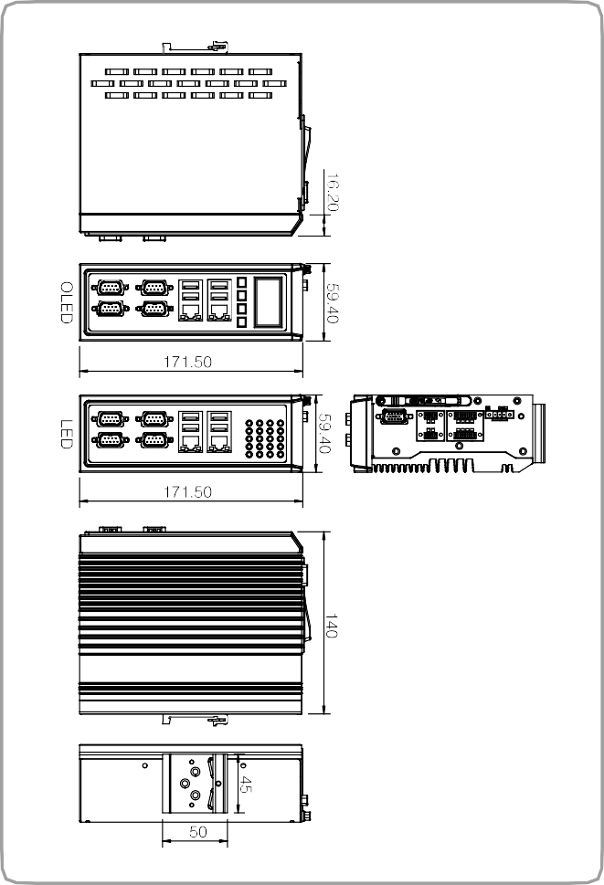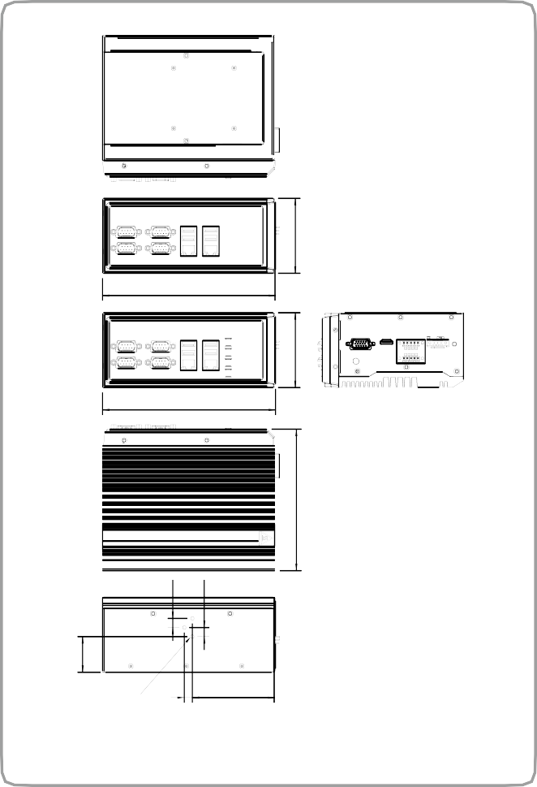Dimensions (Unit: mm) Dimensions (Unit: mm)
DRPC-100-CV
171.50
171.50
8
81.70
DRPC-120-BT

Options
3-NUT-#6-32
35.27
DRPC-120-BT series

Item

OS: Windows Embedded 7 Wireless kit
Adapter

Power Cable Power Cord
DIN-Rail mounting kit

Part No.
DRPC-120-WES7E-R10 (CD-ROM)
EMB-WIFI-KIT01-R20

63040-010036-121-RS

32102-026500-100-RS
32702-000400-200-RS DK-DRPC-R10

Description

OS Image with Windows® Embedded Standard 7 E for DRPC-120 Series, CD-ROM, RoHS

1T1R wifi module kit for embedded system, IEEE802.11a/b/g/n/ac WiFi with Bluetooth 4.0/3.0+HS, 1 x wifi module, 2 x 250mm RF cable, 2 x Antenna, RoHS
Adapter Power, FSP, FSP036-RBBN2, Vin: 90V~264VAC, 36W, Erp(NO LOAD 0.1W), Vout:12VDC,
Φ2.5/Φ5.5/lock, CCL, RoHS
Power cable 200mm, (A) DC jack to (B) 3-pin terminal block P=3.5 European power cord
Rugged DIN-Rail mounting kit only for DRPC series

DRPC-100-CV series

Item Part No. Description
OS: Win XPE (4GB CF card) DRPCCF-100-CV-XPE-R10 OS Image with XPE, for DPRC-100-CV Series, W/CompactFlash® Memory Card 4GB

OS: Windows Embedded 7 (4GB CF card)
74.08
74.08
140
9
9

Wi-Fi module
Antenna RF cable Adapter

Power cable Power cord
DIN-rail mounting kit
DRPCCF-100-CV- WES7E-R10

27310-000012-RS

32505-000900-100-RS

32501-000600-100-RS

63040-010036-121-RS

32102-026500-100-RS
32702-000400-200-RS DK-DRPC-R10

OS Image with Windows® Embedded Standard 7 E for DPRC-100-CV Series, in 4 GB CompactFlash® card

Wireless LAN module, Wi-Fi with Bluetooth 4.0/3.0+HS, AzureWave, AW-CB161H, IEEE802.11a/b/g/n/ac, 2.412 GHz~2.472 GHz, 5.15 GHz~5.85 GHz, PCIe Mini, a(13dBm), b(16dBm), g(13dBm), n(12dBm), ac(10dBm),
3.3 V, Realtek RTL8821AE, 1T1R, RoHS
External antenna, WLAN, RG 178,108MM, peak gain 2.0DBI, Exceltek, 2.4 GHz~2.5 GHz/5.15 GHz~5.85 GHz, reverse SMA plug, RoHS
Antenna, RF cable, RF cable, outside diameter:1.13 mm, 500 mm, 0 GHz~6 GHz, (A) Reverse SMA jack, one nut + two washer, (B) I-PEX, RoHS
Adapter Power, FSP, FSP036-RBBN2, Vin:90~264VAC, 36W, Erp(NO LOAD 0.1W), Vout:12VDC,
Φ2.5/Φ5.5/lock, CCL, RoHS
Power cable 200mm, (A) DC jack to (B) 3-pin terminal block P=3.5 European power cord
Rugged DIN-Rail mounting kit only for DRPC series

