Single Board Computer

Peripherals

w w w . i ei w or l d .c om

MPCIE-UART-KIT01-R10

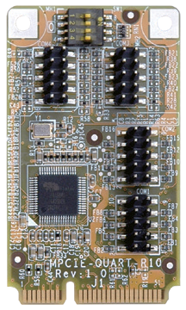
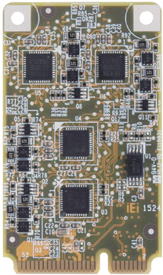
Features

PCI Express Mini Card Supports Quad-port RS-232/422/485, Full Size, RoHS

- PCI Express Mini supports quad-port RS-232/422/485
- 128 bytes transmit/receive FIFO
- High-speed 16C550/16C650/16C750/16C850 compatible UARTs
- Baud rate supports 115.2K, max. up to 1.5M

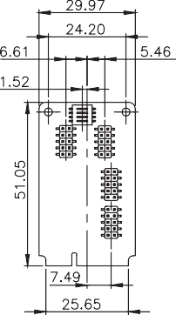
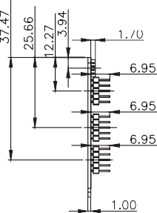
Dimensions (mm)

Specifications
Form Factor: PCI Express Mini card
PCI Express Bridge to Quad Serial Port: Fintek F81504 Buffer/Transceiver Series: F81439
IO: 4 x RS-232/422/485 (2x5-pin header) Operating Temperature: 0°C ~ 60°C
Operating Humidity: 5% ~ 95%, non-condensing Dimensions (LxW): 51 mm x 30 mm
Weight: GW: 100g / NW: 50g CE/FCC compliant

Packing List

1 x MPCIE-UART-KIT01-R10 module

Ordering Information
1 x QIG
4 x D-SUB9 male cable
Part No. | Description
MPCIE-UART-KIT01-R10 | PCI Express Mini card supports quad-port RS-232/422/485, full size, RoHS

MPCIE-UART-KIT02-R10
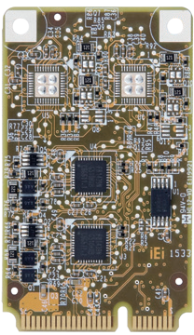
Features

PCI Express Mini Card Supports Dual-port RS-232/422/485, 16-bit GPIO, Full Size, RoHS

- PCI Express Mini supports dual RS-232/422/485 and 16-bit GPIO ports
- 128 bytes transmit/receive FIFO
- High-speed 16C550/16C650/16C750/16C850 compatible UARTs
- Baud rate supports 115.2K, max. up to 1.5M
- All GPIO supports digit IO for input/output control, output data control, input status
- Support High/Low Level/Pulse, Open Drain/Push Pull function selection
Dimensions (mm)

Specifications
MPCIE-UART-KIT01-2019-V10
Form Factor: PCI Express Mini card
PCI Express Bridge to Quad Serial Port: Fintek F81504 Buffer/Transceiver Series: F81439
IO
2 x RS-232/422/485 (2x5-pin header) 2 x 8 bit GPIO (2x5-pin header)
Operating Temperature: 0°C ~ 60°C
Operating Humidity: 5% ~ 95%, non-condensing Dimensions (LxW): 51 mm x 30 mm
Weight: GW: 100g / NW: 50g CE/FCC compliant

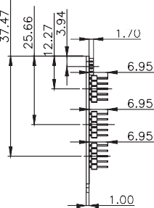
Packing List

1 x MPCIE-UART-KIT02-R10 module

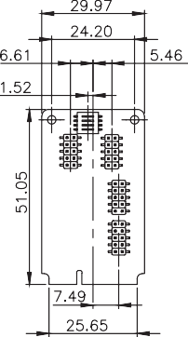
Ordering Information
1 x QIG
2 x D-SUB 9 male cable
Part No. | Description
MPCIE-UART-KIT02-R10 | PCI Express Mini card supports dual-port RS-232/422/485, 16-bit GPIO, full size, RoHS

