Single Board Computer

Peripherals

w w w . i ei w or l d .c om

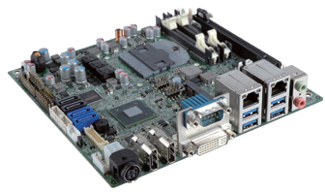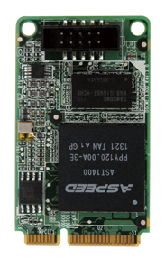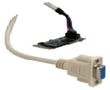IGCME-1300-R11

IEI Scalable Display Solution
The IGCME-1300 is applied to expand one VGA port for the IEI motherboard with a PCIe Mini slot for multiple display applications.

Features
- Support PCIe VGA/2D controller, 1920x1200@60Hz 32bpp
- DDR3 SDRAM supports up to 800 MHz speed
- Compliant with PCI Express Mini specification 1.2

Specifications
HDMI
LVDS

PCIe Mini VGA Adapter Card, RoHS

Add additional VGA display output via IGCME-1300

Form Factor
1st VGA
DVI-D
Scalable VGA
2nd VGA
PCI Express Mini card
Display Controller Aspeed AST1400
Internal Connector
1 x 10-pin (2x5) box header by 2.0mm pitch Compatible OS
Win7/Win8/Server 2003/Server 2008/Server 2012
Linux kernel version 2.6.32 above Power Supply
On-board 3.3V
Operating Temperature
-10°C ~ 60°C
Operating Humidity
5% ~ 95%, non-condensing Dimensions (LxW)
50mm x 30mm
Weight 70g
CE/FCC compliant

Packing List

Multiple Display Configuration
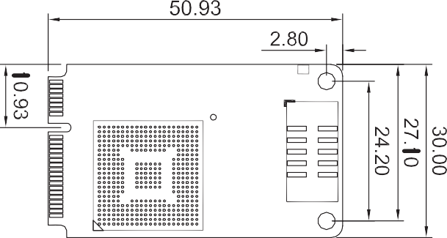
Dimensions (mm)

Ordering Information

IGCME-1300

1 x IGCME-1300 PCIe Mini VGA adapter card | 1 x QIG
VGA cable, 600 mm length (Pitch=2.0mm) (P/N: 32003-001500-100-RS)

Part No. | Description
IGCME-1300-R11 | PCIe Mini VGA adapter card, RoHS

PCIe Mini USB 3.0 Adapter Card, RoHS
MPCIE-USB3
IEI USB 3.0 Expanded Solution
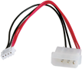
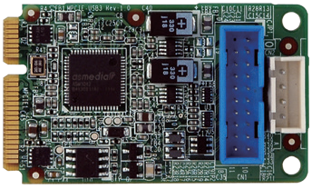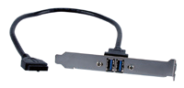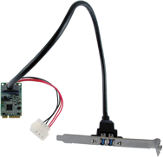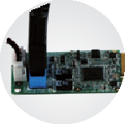The MPCIE is applied to add additional super speed USB 3.0 ports for the motherboard with a PCIe Mini slot.
ASM1042
Power adapter cable
USB 3.0 cable
5V
Power Input
Two USB 3.0 Ports

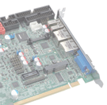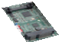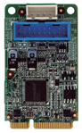
Motherboard with PCIe Mini Slot

Specifications
Form Factor

Operating Temperature

Features

MPCIE-USB3

PCI Express Mini card USB 3.0 Controller Asmedia ASM1042A Internal Connector
1 x 20-pin (2x10) box header
Power Jack
1 x 4-pin box header Compatible OS
Windows® XP/Server 2003/Server 2008/Vista/7/8.1/10
Linux kernel version 2.6.32 above

Packing List
1 x MPCIE-USB3 PCIe Mini USB 3.0 adapter card
1 x Dual USB 3.0 type A port cable with bracket
1 x Power cable | 1 x QIG

Ordering Information
-10°C ~ 60°C
Operating Humidity
5% ~ 95%, non-condensing Dimensions (LxW)
50 mm x 30 mm
Weight 70g
CE/FCC compliant
- Supports two external USB 3.0 type A ports
- USB 3.0 provides up to 5Gbps of transferring rate
- Backward compatible with USB 2.0 and USB 1.0/1.1 devices
- Fully compliant with USB 3.0 rev 1.0 specifications and Intel® xHCI rev 0.96 specifications, with transfer rates up to 5Gbps
- Compliant with PCI Express Mini specification 1.2
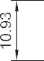Dimensions (mm)

IGCME-1300-2018-V10
Part No. | Description
MPCIE-USB3-R11 | PCIe Mini USB 3.0 adapter card, RoHS
19800-010500-200-RS | Dual USB 3.0 type A port cable with bracket

