IEI iDP Introduction

iDP (IEI Internal DisplayPort)

The iDP connector is provided on the IEI products. Through the IEI iDP converter cards, the iDP connector can support different display specifications, such as VGA, HDMI, DVI-D and LVDS.
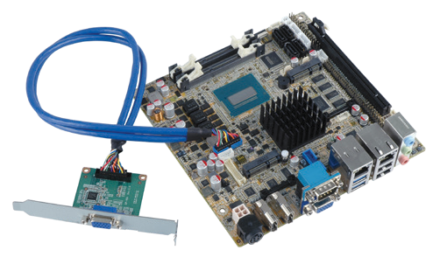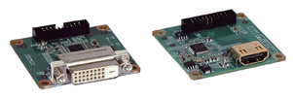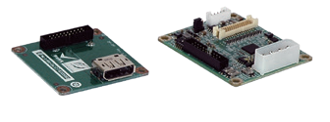
iDP
Flexible Display Output Options

iDP converter cards with brackets
Easy Installation on the Chassis

iDP Supported Models
HPCIE-C236 | IMBA-Q170-i2 | KINO-DH110 | WAFER-AL
HPCIE-Q710 | IMBA-H110 | KINO-AQ170 | WAFER-ULT3/ULT4
SPCIE-C236 | IMBA-Q870-i2 | KINO-DH810 | WAFER-BTW2
PCIE-Q170 | IMBA-C2260-i2 | KINO-DQM871-i1 | WAFER-BT-i1
SPCIE-C2260-i2 | IMB-H110 | KINO-ABT-i2 | WAFER-ULT/ULT2-i1
PCIE-Q870-i2 | IMB-Q870-i2 | NANO-AL/ALW2 | WAFER-KBN-i1
IMBA-C2360-i2 | IMB-H810-i2 | NANO-ULT3

DisplayPort Expansion Board (for IEI iDP Connector), RoHS
DP-DP-R10

Features
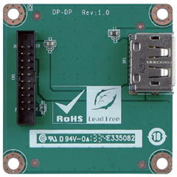
- DisplayPort to DisplayPort output
- Resolution support up to 1920x1200

Specifications
Display Input: 1 x IEI iDP connector Display Output: 1 x DisplayPort Temperature: -20°C ~ 60°C Humidity: 5 ~ 95% non-condensing
Dimensions: 50 mm x 50 mm
Dimensions (mm)

Packing List Ordering Information
1 x DP-DP expansion board | 1 x QIG
1 x IEI iDP connector cable, 450 mm length

Part No. | Description
DP-DP-R10 | DisplayPort expansion board (for IEI iDP connector), RoHS

DisplayPort to HDMI 1.3a Converter Board (for IEI iDP connector), RoHS
DP-HDMI-R10

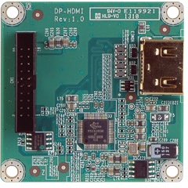
Features
- DisplayPort to HDMI 1.3a output
- Support up to 1920x1200 resolution

Specifications
Display Input: IEI iDP connector Display Output: 1 x HDMI 1.3a Display IC: Parade - PS161 (DP to HDMI 1.3a)
Temperature: -10°C ~ 60°C Humidity: 5 ~ 95% non-condensing
Dimensions: 50 mm x 50 mm
Dimensions (mm)

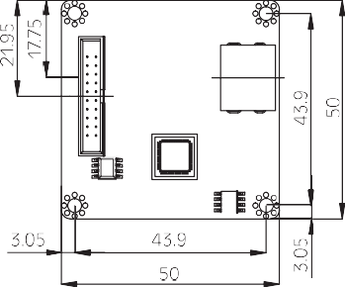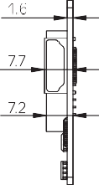

Packing List Ordering Information
1 x DP-HDMI converter board | 1 x QIG
1 x Internal DisplayPort cable, 450 mm length

Part No. | Description
DP-HDMI-R10 | DisplayPort to HDMI 1.3a converter board (for IEI iDP connector), RoHS

DisplayPort to 24-bit Dual-channel LVDS Converter Board (for IEI iDP Connector), RoHS
DP-LVDS-R10

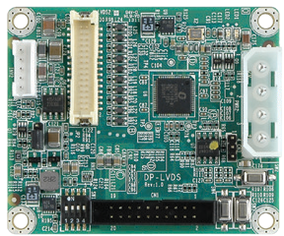
Features
- DisplayPort to LVDS output
- Supports 24-bit dual-channel up to 1920x1200

Specifications
Display Input: 1 x IEI iDP connector
Display Output: 1 x LVDS 24-bit dual-channel Display IC: Chrontel - CH7511B (DP to LVDS) Temperature: -10°C ~ 60°C
Humidity: 5% ~ 95 non-condensing
Dimensions: 60 mm x 50 mm
Dimensions (mm)

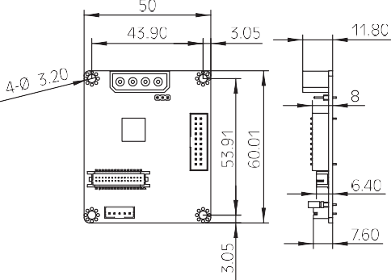Packing List Ordering Information
1 x DP-LVDS converter board | 1 x QIG
1 x Internal DisplayPort cable, 450 mm length

Part No. | Description
DP-LVDS-R10 | DisplayPort to 24-bit dual-channel LVDS converter board (for IEI iDP connector), RoHS

DisplayPort to VGA Converter Board (for IEI iDP Connector), RoHS
DP-VGA-R10

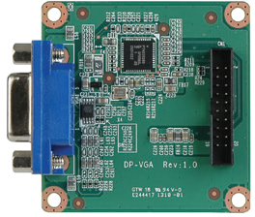
Features
- DisplayPort to VGA output
- Support up to 1920x1200 resolution

Specifications
Display Input: 1 x IEI iDP connector Display Output: 1 x VGA
Display IC: NXP - PTN3392 (DP to VGA)
Temperature: -10°C ~ 60°C Humidity: 5% ~ 95 non-condensing
Dimensions: 50 mm x 50 mm
Dimensions (mm)

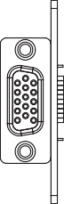
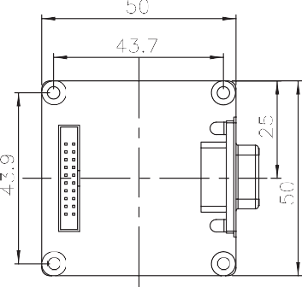
Packing List Ordering Information
1 x DP-VGA converter board | 1 x QIG
1 x Internal DisplayPort cable, 450 mm length

Part No. | Description
DP-VGA-R10 | DisplayPort to VGA converter board (for IEI iDP connector), RoHS

DisplayPort to DVI Converter Board (for IEI iDP Connector), RoHS
DP-DVI-R10

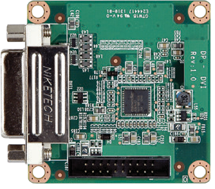
Features
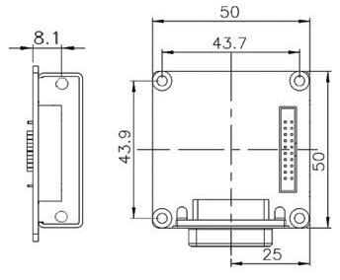
- DisplayPort to DVI output
- Support up to 1920x1200 resolution

Specifications
Display Input: 1 x IEI iDP connector Display Output: 1 x DVI
Display IC: Parade - PS161 (DP to HDMI / DVI)
Temperature: -10°C ~ 60°C Humidity: 5% ~ 95 non-condensing
Dimensions: 50 mm x 50 mm
Dimensions (mm)

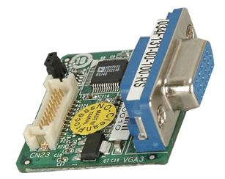Packing List
LVDS-VGA-R10
Single-channel LVDS to VGA Converter Board (Support IEI Model Only)

Dimensions (mm)
36.07mm
12.50mm
Features
32.51mm
1 x DP-DVI converter board | 1 x QIG
1 x Internal DisplayPort cable, 450 mm length

- Provide 2nd VGA option for dual VGA display
- Resolution adjusted by BIOS: Support 1024x768, 800x600, 640x480
- 18-bit LVDS to VGA converter board

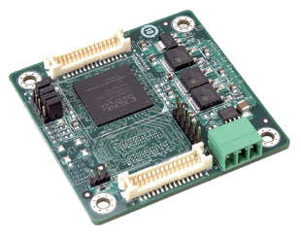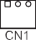Packing List
LVDS24-01
24-bit dual-channel output
18-bit to 24-bit LVDS Converter Board
Dimensions (mm)

Features
- Resolution supports up to 1280x1024
- Support below configuration:
» Single-channel 18-bit to single-channel 24-bit
» Single-channel 18-bit to dual-channel 24-bit
18-bit single/
dual-channel input
* Note: The module does not support dual-channel 18-bit to single-channel 24-bit conversion. Ordering Information
» Dual-channel 18-bit to dual-channel 24-bit
1 x LVDS to VGA converter board
1 x QIG

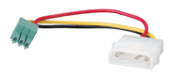Packing List

Power cable
P/N: 32100-130300-RS
Ordering Information

Part No. | Description
DP-DVI-R10 | DisplayPort to DVI converter board (for IEI iDP connector), RoHS

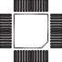
Ordering Information

Part No. | Description
LVDS-VGA-R10 | 18-bit LVDS to VGA converter board
32600-112300-RS | 30-pin LVDS connecting cable
32602-026400-100-RS | 20-pin LVDS connecting cable

Part No. | Description
LVDS24-01-R10 | 18-bit to 24-bit LVDS converter board
32602-007900-100-RS | Single-channel 18-bit 20-pin to 24-bit 30-pin LVDS connection cable
32602-008000-200-RS | Dual-channel 18-bit 30-pin to 24-bit 30-pin LVDS connection cable

1 x 18-bit to 24-bit LVDS converter board
1 x Power cable
1 x QIG

