Intel® x IEI TANK AIoT Developer Kit

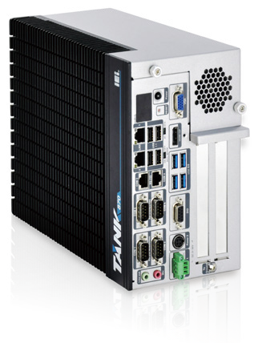Features
- 6th/7th Gen Intel® Core™/Xeon® processor platform with Intel® Q170/C236 chipset and DDR4 memory
- Dual independent display with high resolution support
- Rich high-speed I/O interfaces on one side for easy installation
- On-board internal power connector for providing power to add-on cards
- Great flexibility for hardware expansion
- Pre-installed Open Visual Inference & Neural Network Optimization (OpenVINO™) toolkit
- Pre-installed Ubuntu 16.04 LTS

DDR4 2133
Display
Dual

Deep learning and inference
Deep learning is part of the machine learning method. It allows computational models that are composed of multiple processing layers to learn representations of data with multiple levels of abstraction.Deep neural network and recurrent neural network architectures have been used in applications such as object recognition, object detection, feature segmentation, text-to-speech, speech-to-text, translation, etc.In some cases the performance of deep learning algorithms can be even more accurate than human judgement.

Al
Sense, learn, reason, act, and adapt to the real world without explicit programming

Perceptual Understanding
Detect patterns in audio or visual data

Machine Learning
Computational methods that use learning algorithms to build a model from data (in supervised, unsupervised, semi-supervised, or reinforcement mode)

Deep Learning
Algorithms inspired by neural networks with multiple layers of
neurons that learn successively complex representations

Convolutional Neural Networks (CNN)
DL topology particularly effective at image classification

Data Analytics
Build a representation, query, or model that enables descriptive, interactive, or predictive analysis over any amount
of diverse data

In the past, machine learning required researchers and domain experts knowledge to design filters that extracted the raw data into feature vectors. However, with the contributions of deep learning accelerators and algorithms, trained models can be applied to the raw data, which could be utilized to recognize new input data in inference.
Learning from existing data
Training
Training Dataset
Predict new input data
Inference
New Data
Trained Model
?
Forward
Forward
DOG
CAT
「DOG」
Backward

OpenVINO™ toolkit
OpenVINO™ is based on convolutional neural networks (CNN), the toolkit extends workloads across Intel® hardware and maximizes performance.
It can optimize pre-trained deep learning models such as Caffe, MXNET, and Tensorflow. The tool suite includes more than 20 pre-trained models, and supports 100+ public and custom models (includes Caffe*, MXNet, TensorFlow*, ONNX*, Kaldi*) for easier deployments across Intel® silicon products (CPU, GPU/Intel® Processor Graphics, FPGA, VPU).

- Intel® Deep Learning Deployment Toolkit
  - Model Optimizer
  - Inference Engine
- Optimized computer vision libraries
- Intel® Media SDK
- OpenCL™ graphics drivers and runtimes.
(OpenCL™ is the trademark of Apple Inc. used by permission by Khronos)
- 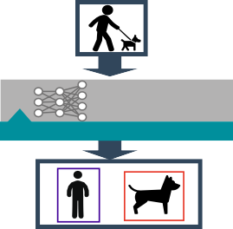Current Supported Topologies: AlexNet, GoogleNet, Tiny Yolo, LeNet, SqueezeNet, VGG16, ResNet (more variants are coming soon)
OpenVINO™ toolkit
Video Decode
Intel® Media SDK H.264 H.265 MPEG-2
Image Process
Inference Engine
Intel®
Deep learning Development toolkit
Image Process
OpenCV OpenVX Mophology Blob detect
OpenCV OpenVX Overlay Text
Video Encode
Intel® Media SDK H.264 H.265 MPEG-2
Intel Accelerator
Optimize IR
Inference Engine

Convert to optimized Intermediate Representation

IR

Model Optimizer

Trained Model

CPU
GPU
FPGA
VPU

Smart Choice for Inference System With AI
Artificial Intelligence, AI, is changing our lives from the past to the future. It enables machine learning by using a variety of training models to simulate and infer the status or appearance of objects. For example, the inference system with the video analysis model can perform face and vehicle license plate analysis for safety and security purposes.
The TANK AIoT Dev. Kit features rich I/O and dual PCIe slots (x16) to support add-ons like the Acceleration cards (Mustang-F100-A10 & Mustang-V100-MX8) or the PoE (IPCIE-4POE) to enhance performance and function for various applications.

Machine Vision
Vision Analytics on the factory floor adds intelligence to factories design and process. Today's technologies automate the collection, storage, retrieval, and decision making across multiple factories and factory sub-systems at the edge.

Numerous Vehicle License Plate Analysis
Efficient road tolling and parking reduces fraud related to non-payment, makes charging effective, and reduces required manpower to process. Vehicle license plate analysis can be deployed on highways for electronic toll collection, and can be implemented as a method of cataloguing the movement of traffic as well as provide enhanced security by establishing data on suspicious vehicles in a more efficient way.

Numerous Face Recognition
Face analysis with AI has explosive growth in various domains. It not only infers human features like gender, age and facial expression, but also identifies identity, which can greatly reduce labor costs and provide services via big data in retail, finance and medicine.

Specifications
TANK AIoT Dev. Kit-2018-V13

Model Name |  | TANK AIoT Dev. Kit
Chassis | Color | Black C + Silver
 | Dimensions (WxHxD) (mm) | 121.5 x 255.2 x 205 mm (4.7” x 10” x 8”)
 | System Fan | Fan
 | Chassis Construction | Extruded aluminum alloys
 | Weight (Net/Gross) | 4.2 kg (9.26 lbs)/ 6.3 kg (13.89 lbs)
Motherboard | CPU | Intel® Xeon® E3-1268LV5 2.4GHz (up to 3.4 GHz, Quad Core, TDP 35W) Intel® Core™ i7-7700T 2.9GHz (up to 3.8 GHz, Quad Core, TDP 35W) Intel® Core™ i5-7500T 2.7GHz (up to 3.3 GHz, Quad Core, TDP 35W) Intel® Core™ i7-6700TE 2.4 GHz (up to 3.4GHz, quad-core, TDP=35W) Intel® Core™ i5-6500TE 2.3 GHz (up to 3.3GHz, quad-core, TDP=35W)
 | Chipset | Intel® Q170/C236 with Xeon® E3 only
 | System Memory | 2 x 260-pin DDR4 SO-DIMM,  8 GB pre-installed (for i5/i5KBL/i7 sku) 16 GB pre-installed (for i7KBL sku)  32 GB pre-installed (for E3 sku)
Storage | Hard Drive | 2 x 2.5’’ SATA 6Gb/s HDD/SSD bay, RAID 0/1 support (1x 2.5” 1TB HDD pre-installed)
I/O Interfaces | USB 3.0 | 4
 | USB 2.0 | 4
 | Ethernet | 2 x RJ-45  LAN1: Intel® I219LM PCIe controller with Intel® vPro™ support LAN2 (iRIS): Intel® I210 PCIe controller
 | COM Port | 4 x RS-232 (2 x RJ-45, 2 x DB-9 w/2.5KV isolation protection) 2 x RS-232/422/485 (DB-9)
 | Digital I/O | 8-bit digital I/O, 4-bit input / 4-bit output
 | Display | 1 x VGA  1 x HDMI/DP  1 x iDP (optional)
 | Resolution | VGA: Up to 1920 x 1200@60Hz  HDMI/DP: Up to 3840x2160@30Hz / 4096×2304@60Hz
 | Audio | 1 x Line-out, 1 x Mic-in
 | TPM | 1x Infineon TPM 2.0 Module
Expansions | Backplane | 2 x PCIe x8
 | PCIe Mini | 1 x Half-size PCIe Mini slot  1 x Full-size PCIe Mini slot (supports mSATA, colay with SATA)
Power | Power Input | DC Jack: 9 V~36 V DC  Terminal Block: 9 V~36 V DC
 | Power Consumption | 19 V@3.68 A  (Intel® Core™ i7-6700TE with 8 GB memory)
 | Internal Power output | 5V@3A or 12V@3A
Reliability | Mounting | Wall mount
 | Operating Temperature | Xeon® E3 -20°C ~ 60°C with air flow (SSD), 10% ~ 95%, non-condensing i7-7700T -20°C ~ 35°C with air flow (SSD), 10% ~ 95%, non-condensing i5-7500T -20°C ~ 45°C with air flow (SSD), 10% ~ 95%, non-condensing i7-6700TE -20°C ~ 45°C with air flow (SSD), 10% ~ 95%, non-condensing i5-6500TE -20°C ~ 60°C with air flow (SSD), 10% ~ 95%, non-condensing
 | Operating Vibration | MIL-STD-810G 514.6 C-1 (with SSD)
 | Safety/EMC | CE/FCC/RoHS
OS | Supported OS | Win10/Linux Ubuntu 16.04 LTS

Fully Integrated I/O

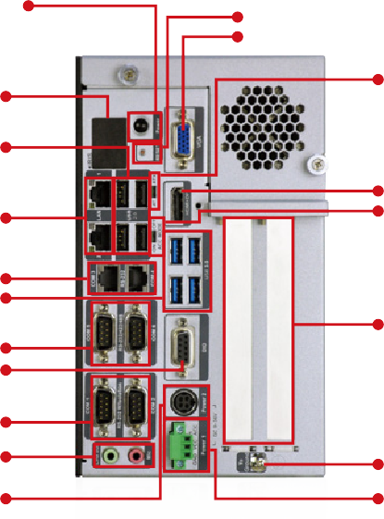
Power Switch
- Long-press 3 sec. to power on
- Long-press 5 sec. to power off

Reset VGA

LED 4 x USB 2.0

2 x GbE LAN

2 x RS-232
4 x USB 3.0

2 x RS-232/
422/485
DIO

AT/ATX Mode

HDMI+DP
ACC Mode

2 x Expansion Slots

Dimensions

(Unit: mm)
2 x RS-232

Audio

Power2 (DC Jack)

To Ground

Power1 (Terminal Block)

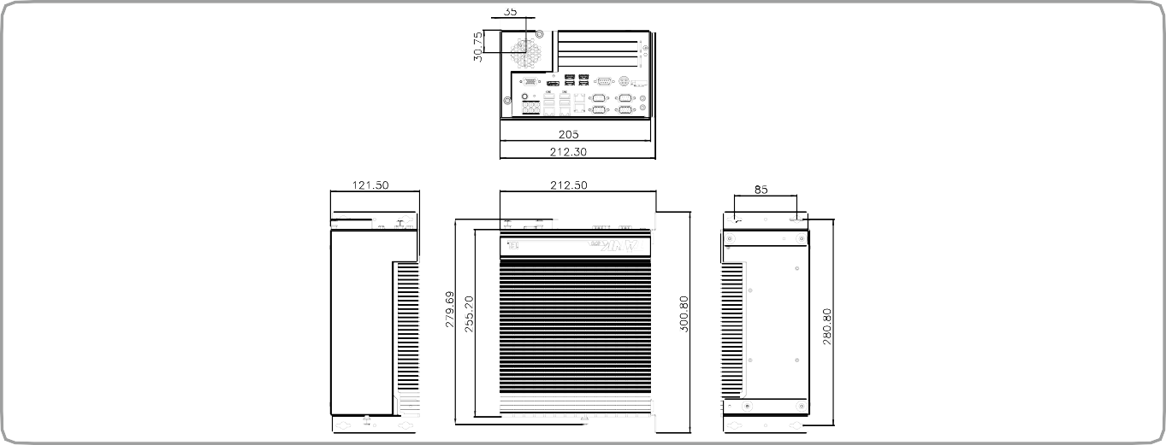
TANK AIoT Dev. Kit

Ordering Information
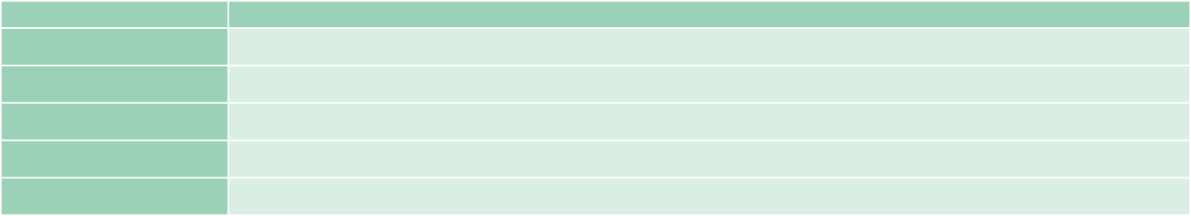
Part No. Description
TANK-870AI-E3/32G/2A-R11 Ruggedized embedded system with Intel® Xeon® E3-1268LV5 2.4GHz, (up to 3.4 GHz, Quad Core, TDP 35W), 32 GB DDR4 pre-installed memory, 2 x PCIe by 8 expansion, 2.5” 1TB HDD , TPM 2.0 , 9~36V DC, 120W AC DC power adaptor , RoHS
TANK-870AI-i7KBL/16G/2A-R11 Ruggedized embedded system with Intel® Core™ i7-7700T 2.9GHz, (up to 3.8 GHz, Quad Core, TDP 35W), 16 GB DDR4 pre-installed memory, 2 x PCIe by 8 expansion, 2.5” 1TB HDD , TPM 2.0 , 9~36V DC, 120W AC DC power adaptor, RoHS
TANK-870AI-i5KBL/8G/2A-R11 Ruggedized embedded system with Intel® Core™ i5-7500T 2.7GHz, (up to 3.3 GHz, Quad Core, TDP 35W), 8 GB DDR4 pre-installed memory, 2 x PCIe by 8 expansion, 2.5” 1TB HDD , TPM 2.0 , 9~36V DC, 120W AC DC power adaptor , RoHS
TANK-870AI-i7/8G/2A-R11 Ruggedized embedded system with Intel® Core™ i7-6700TE 2.4GHz, (up to 3.4 GHz, Quad Core, TDP 35W), 8 GB DDR4 pre-installed memory, 2 x PCIe by 8 expansion, 2.5” 1TB HDD , TPM 2.0 , 9~36V DC, 120W AC DC power adaptor , RoHS
TANK-870AI-i5/8G/2A-R11 Ruggedized embedded system with Intel® Core™ i5-6500TE 2.3GHz, (up to 3.3 GHz, Quad Core, TDP 35W), 8 GB DDR4 pre-installed memory, 2 x PCIe by 8 expansion, 2.5” 1TB HDD , TPM 2.0 , 9~36V DC, 120W AC DC power adaptor , RoHS

AI Accelerator Card Options
Part No. Description
Mustang-F100-A10-R10 PCIe FPGA Highest Performance Accelerator Card with Arria 10 1150GX support DDR4 2400Hz 8GB, PCIe Gen3 x8 interface, RoHS
Mustang-V100-MX8-R10 Computing Accelerator Card with 8 x Movidius Myriad X MA2485 VPU, PCIe Gen2 x4 interface, RoHS

Peripheral Options
Part No. Description
IPCIE-4POE-R10 PCI Express Power over ethernet card, 4-port 1000 Base(T), 802.3af compliant, RoHS
63040-010150-400-RS Adapter Power; FSP; FSP150M-ABA; 9NA1505201; Active PFC; Vin: 90 ~ 264VAC; 150W; Dim: 85 x 170 x 42.5mm; Plug=6.5mm; Cable=1200mm;
MEDICAL; Vout: 19VDC; Din 4Pin/lock; CCL; RoHS
72213100-5010000-000-RS 2.5” HDD;WD;Caviar Blue;WD10SPZX;SATA3.0(6Gb/s, 600MB/s);1TB;128MB;5400 RPM;NoAssign;NoAssign;;CCL;RoHS

Packing List
1 x Chassis Screw
1 x Mounting Bracket
1 x QSG
1 x 120W Adapter
1 x Power Cord

