www.ieiw or ld.com
AI Solution

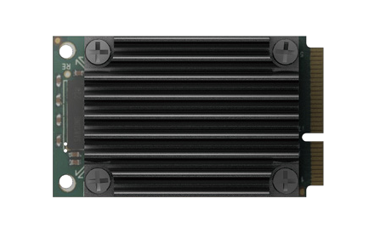The Mustang-MPCIE-MX2 card included two Intel® Movidius™ Myriad™ X VPU, providing an flexible AI inference solution for compact size and embedded systems.
Mustang-MPCIE-MX2
Feature
- miniPCIe form factor (30 x 50 mm)
- 2 x Intel® Movidius™ Myriad™ X VPU MA2485
- Power efficiency ,approximate 7.5W
- 0°C~55°C (In TANK AIoT Dev. Kit)
- Powered by Intel's OpenVINO™ toolkit
Welcome
OEM
Introduction
VPU is short for vision processing unit. It can run AI faster, and is well suited for low power consumption applications such as surveillance, retail, transportation. With the advantage of power efficiency and high performance to dedicate DNN topologies, it is perfect to be implemented in AI edge computing device to reduce total power usage, providing longer duty time for the rechargeable edge computing equipment.

Key Features of Intel® Movidius™ Myriad™ X VPU:
- Native FP16 support
- Rapidly port and deploy neural networks in Caffe and Tensorflow formats

10X Higher Performance
1 Trillion operatioms per second

- End-to-End acceleration for many common deep neural networks
- Industry-leading Inferences/S/Watt performance

Specifications

Model Name | Mustang-MPCIE-MX2
Main Chip | 2 x Intel® Movidius™ Myriad™ X MA2485 VPU
Operating Systems | Ubuntu 16.04.3 LTS 64bit, CentOS 7.4 64bit, Windows® 10 64bit
Dataplane Interface | miniPCIe
Power Consumption | Approximate 7.5W
Operating Temperature | 0°C~55°C (In TANK AIoT Dev. Kit)
Cooling | Passive/Active Heatsink
Dimensions | 30 x 50 mm
Operating Humidity | 5% ~ 90%
Support Topology | AlexNet, GoogleNetV1/V2, Mobile_ SSD, MobileNetV1/V2, MTCNN, Squeezenet1.0/1.1, Tiny Yolo V1 & V2, Yolo V2, ResNet-18/50/101

Ordering Information
1 TOPS
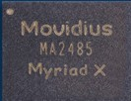1 Trillion operatioms per
second of dedicated neural networks compute
Dimensions (Unit: mm)
11.15

24.2
27.1
30

ULTRA
Low power

47
50.5
2.45
Part No. | Description
Mustang-MPCIE-MX2-R10 | Deep learning inference accelerating miniPCIe card with 2 x Intel® Movidius™ Myriad™ X MA2485 VPU, miniPCIe interface 30mm x 50mm, RoHS

Packing List
1 x QIG

