Teleh
lution
IEI introduces the AfoBot, an assistant robot with 8” screen, to offer an open, flexible and affordable way to develop innovative devices with state-of-the-art components and to design applications based on Android 6.0
platform that can quickly be transformed into final solution.
Android Open Development Platform
IEI has released a SDK for the Android 6.0 open platform to enable developers, content creators, and service providers to build apps and value-added experiences for home, office, retail and healthcare industries.
APP APP
APP
APP
APP
APP
ealth / Telemedicine So (ODM & OEM)
Any idea?

Wireless Mobility
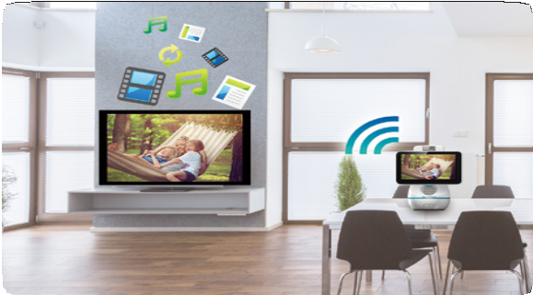
Sleek and compact design makes AfoBot a convenient device to any environments. With its built-in wireless functions, you can place AfoBot in the living room and use it as a multi- function remote controller to control your home devices, or use it as a conference control terminal that can improve your meeting efficiency.

1.7kg light weight

Access Point

Miracast

802.11 a/b/g/n Bluetooth 4.0

Voice-Activated Robot
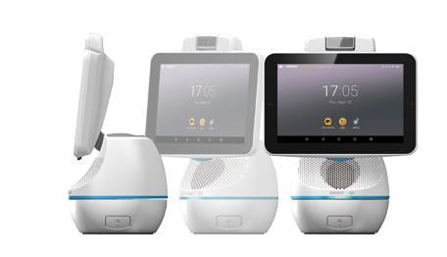You can talk to AfoBot just like talking with your friends and family. AfoBot provides hands-free voice control, and enables you to launch programs, commands and actions via voice commands - you can ask or command AfoBot for information and get results or responses instantly.
Screen On, Screen Off
Turn Left, Turn Right,
Rotate Camera
Turn up, Turn down
Rotate Body
Play, Pause Desktop Screen

- Voice and video call
- Auto answer calls from AfoTalk (iOS, Android) or other AfoBot.
- Conference recording
- Supports single or multiple peer calls
- On-line/Off-line voice recognition
Hi AfoBot! Play music!
- Echo cancelling, noise reduction, auto gain control
- 360º omni-directional audio

100º
Tilt 5-megapixel

- point touch
10
Point
Touch

360º
Body Rotation

Programmable RGB LED

8core
A53
Voice-recognition

33º
Panel Tilt

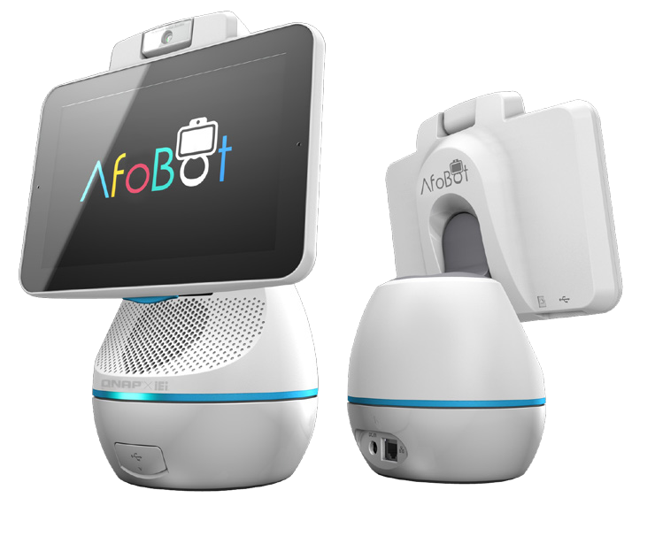The Value of Software & Hardware Integration with AfoBot

  - Call taxi
  - Prescription ordering & delivery
  - Preventive health caring
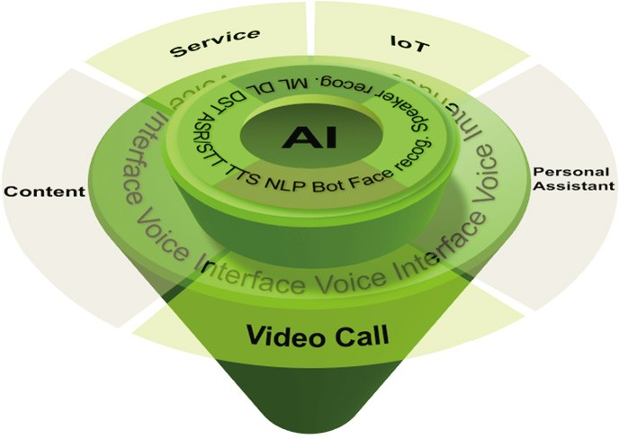
  - Online shopping
  - Order food delivery
  - Hotel or restaurant reservation

- Music: KKBOX, Spotify
- Video: Youtube, LiTV, Netflix
- Education: eNewton, encyclopedia
- Control smart home devices
- Home caring
- Home security

- Alarm
- Timer
- Calendar/Reminder
- Picture taking
- Video recording
- Album
- News
- Weather
- Stock
- Voice control TV
- Real-time translation
- Emergency call

  - Group call
  - Auto answering (optional)
  - Remote control of camera rotation
  - Face tracking
  - Auto record child
  - Public mode
  - WiDi/DLAN/Miracast
  - Recording video call

AfoBot
8” TFT LCD with 1280 x 800 Full HD

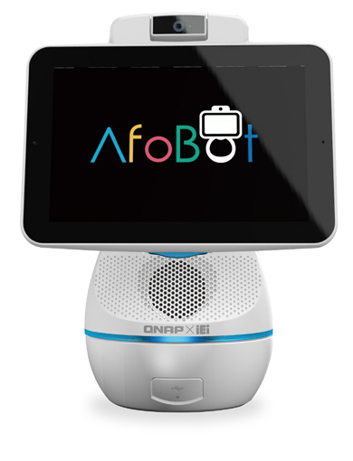
Features
- 8” 16:10 IPS TFT LCD (1280x800)
- 8-core Cortex-A53 1.5GHz
- 32GB eMMC flash on-board
- 5-megapixel camera, 2592×1944@15fps, F2.2, FF, FOV 103.5° 1/4” OV5640 image sensor
- IEEE 802.11 a/b/g/n; 2x2 802.11n, Bluetooth 4.0
- 5200 mAh Li-ion battery (2 x 18650 3600mAh)
- Android 6.0

Specifications

Bluetooth

Miracast

1.7kg light weight

Access Point

Model | AfoBot
Display | 8” TFT LCD with 1280 x 800 Full HD
Processor | 8-core Cortex-A53 SoC
Touch Screen | Projected capacitive touch screen with 10-point multi-touch
Memory | On-board 2 GB LPDDR3
Video Codec | 4K*2K H.264/H.265, 4K*2K@60Hz
Storage | On-board 32GB eMMC 1 x microSD card slot
Wireless Connectivity | Wi-Fi 802.11 a/b/g/n dual band Wi-Fi Direct for Miracast Bluetooth 4.0, BLE support  Wi-Fi access point
Power Adapter | AC Input: 100-240V AC, 50/60Hz  DC Output: 12V 2.5A
Motion | Body: 360° horizontal pan (motorized) Camera: 100° tilt (motorized)  Panel: 33° tilt (manual)
I/O Interface | 1 x USB2.0 Type C 1 x USB2.0 Type A 1 x GbE LAN
Camera | 5-megapixel camera, F2.2, FOV103º
Audio | 2 x Digital microphone  5W 4Ω stereo reflective speaker  Echo cancelling, noise reduction and auto gain control
Operating System | Host: Android 6.0  Client APP: Android / iOS
Color | Pantone White and pantone 312C
Size | 271 mm x 213 mm x 136 mm
Weight | 1730g
Certificate | CE, FCC Class B and BSMI
Battery | Lithium Ion; 5200mAH; 3.7V; battery run time: 5 hrs

Ordering Information

Part No. | Description
AfoBot-F08A-AD6-TW-R21 | 8” Assistant Robot with 8-core Cortex-A53 SoC, Wi-Fi 802.11 a/b/g/n ,BT 4.0, 5MP webcam, PCAP touch, on- board 32GB eMMC,Android 6.0, Conexant CX20921, Wifi code: TW, R21
AfoBot-F08A-AD6-BAT- TW-R21 | 8” Assistant Robot with 8-core Cortex-A53 SoC, Wi-Fi 802.11 a/b/g/n ,BT 4.0, 5MP webcam, PCAP touch, on- board 32GB eMMC,Android 6.0, 5200AH 1S2P Li-ion battery, Conexant CX20921, Wifi code: TW, R21
AfoBot-F08A-AD6-EU-R21 | 8” Assistant Robot with 8-core Cortex-A53 SoC, Wi-Fi 802.11 a/b/g/n ,BT 4.0, 5MP webcam, PCAP touch, on- board 32GB eMMC,Android 6.0, Conexant CX20921, Wifi code: EU, R21
AfoBot-F08A-AD6-BAT- EU-R21 | 8” Assistant Robot with 8-core Cortex-A53 SoC, Wi-Fi 802.11 a/b/g/n ,BT 4.0, 5MP webcam, PCAP touch, on- board 32GB eMMC,Android 6.0, 5200AH 1S2P Li-ion battery, Conexant CX20921, Wifi code: EU, R21

Options
Item | Description
33502-000394-RS | EU power plug
33502-000393-RS | US power plug
33502-000392-RS | UK power plug

Packing List

Item | Q’ty
QIG | 1
Power adapter | 1

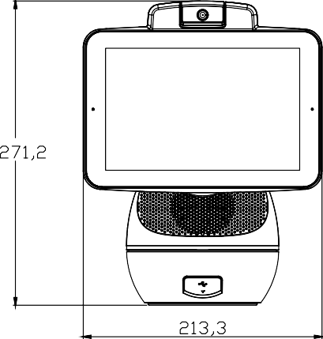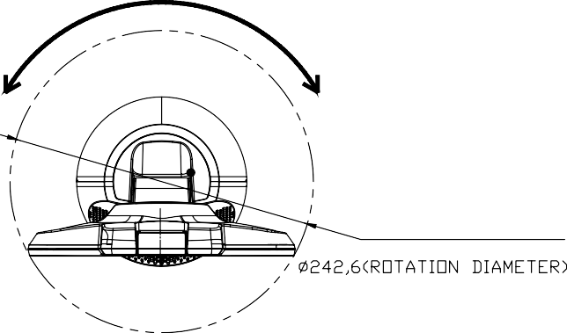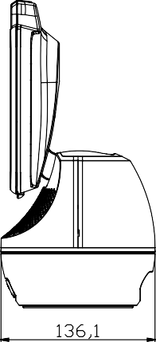
AfoBot
Dimensions (Unit: mm)

Camera Tilt 100°

360° Rotate

Panel Tilt 33°

