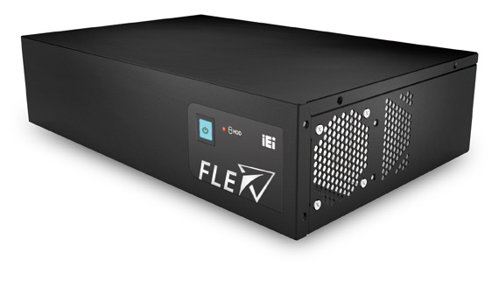Hardware Feature
2U AI Modular PC with 8th Generation LGA1151 Core™ i7/i5/i3 and Pentium® Processor
FLEX-BX200
Specifications
- 2U AI Modular PC with 8th Generation LGA 1151 Intel® Core™ i7/i5/i3 and Pentium® processor
- Four hot-swappable and accessible HDD drive bays, support RAID 0/1/5/10
- Two PCIe 3.0 by 4 and two PCIe 3.0 by 8 slots
- Dual M.2 2280 PCIe Gen 3.0 x4 NVMe™ SSD support
- QTS-Gateway support

Model |  | FLEX-BX200-Q370
System | CPU | 8th Genertion Intel® Core™ i7/i5/i3 porcessors in the LGA 1151 package (Please choose the TDP of the the processor under 65W)
 | Chipset | Intel® 300 Series Chipsets Q370 (Coffee Lake)
 | Memory | 2 x 288-pin 2666/2400 MHz dual-channel DDR4 unbuffered DIMM supporting up to 64GB
 | Graphics Engine | Intel® HD Graphics Gen 9 Engines with Low power 16 execution unit, supports DX2015, OpenGL 5.X and OpenCL2. x, ES 2.0
 | Ethernet | Intel® I211 controller
Storage |  | 4 x accessible 2.5" HDD/SSD SATA 6 Gb/s bay (with RAID 0/1/5/10 support) with LED indicator 2 x NGFF M.2(2280) M Key socket (support NVMe SSD)
I/O Ports and Switches |  | 1 x HDMI output 2 x GbE LAN  6 x USB 3.1 Gen 1 (5Gb/s) Type-A 2 x RS-232 DB-9 type  1 x Mic in1 x Line out 1 x AC Inlet  Power button with power LED (power on=Blue) AT/ATX mode switch  Reset button
Expansion Slots |  | 2 x PCIe 3.0 by 8 (by 16 slot)  2 x PCIe 3.0 by 4 (Maximum card size supported: 68 mm x 167 mm)
Thermal Solution |  | System Fan x3, CPU Cooler x1
Power supply |  | AC input ATX power supply  - 250W power supply  - Input: 115VAC~230VAC, 50/60Hz  - Output (Max.): 3.3V@12A, 5V@14A, 12V@25A, -12V@0.3A,+5Vsb@3A  - 350W power supply (Build to Order)  - Input: 115VAC~264VAC, 50/60Hz  - Output (Max.): 3.3V@14A, 5V@16A, 12V@29A, -12V@0.3A,+5Vsb@3A  -Efficiency: Full load (100%) 87%, Typical load (50%) 90%, Light load (20%) 87%
Watchdog Timer |  | Software Programmable support 1~255 sec. System reset
Construction | Chassis Construction | Metal Housing
 | Mounting | Wall and Rack Mount
 | Color | Black
 | Dimensions (LxDxH) (mm) | 357 x 230 x 88
 | Weight (kg) Net/Gross | 4/6
Environmental | Operating Temperature | -20°C ~ 50°C (with SSD and TDP 65W processor)  -20°C ~ 40°C (with HDD or add-on cards without fan)
 | Storage Temperature | -20°C ~ 60°C
 | Operating Humidity | 5% ~95%, non-condensing
 | Vibration | 5~17Hz, 0.1 double amplitude displacement 17~640Hz 1.5G acceleration peak to peak
 | shock | 10G acceleration part to part (11ms)

Ordering Information

Part No. | Description
FLEX-BX200-Q370-P/25-R10 | 2U AI Modular Box PC, Intel® Pentium® Gold G5400T Processor (2-core, 4-thread, 3.10 GHz) TDP 35W, two PCIe x4 and two PCIe x8 slots, four HDD bays, 250W PSU, R10
FLEX-BX200-Q370-i3/25-R10 | 2U AI Modular Box PC, Intel® Core™ i3-8100T Processor (4-core, 4-thread, 3.10 GHz) TDP 35W, two PCIe x4 and two PCIe x8 slots, four HDD bays, 250W PSU, R10
FLEX-BX200-Q370-i5/25-R10* | 2U AI Modular Box PC, Intel® Core™ i5-8500T Processor (6-core, 6-thread, 2.1 GHz) TDP 35W, two PCIe x4 and two PCIe x8 slots, four HDD bays, 250W PSU, R10
FLEX-BX200-Q370-i7/25-R10* | 2U AI Modular Box PC, Intel® Core™ i7-8700T Processor (6-core,12-thread,2.4 GHz) TDP 35W, two PCIe x4 and two PCIe x8 slots, four HDD bays, 250W PSU, R10
FLEX-BX200-Q370-P/35-R10* | 2U AI Modular Box PC, Intel® Pentium® Gold G5400T Processor (2-core, 4-thread, 3.10 GHz) TDP 35W, two PCIe x4 and two PCIe x8 slots, four HDD bays, 350W PSU, R10
FLEX-BX200-Q370-i3/35-R10* | 2U AI Modular Box PC, Intel® Core™ i3-8100T Processor (4-core, 4-thread, 3.10 GHz) TDP 35W, two PCIe x4 and two PCIe x8 slots, four HDD bays, 350W PSU, R10
FLEX-BX200-Q370-i5/35-R10* | 2U AI Modular Box PC, Intel® Core™ i5-8500T Processor (6-core, 6-thread, 2.1 GHz) TDP 35W, two PCIe x4 and two PCIe x8 slots, four HDD bays, 350W PSU, R10
FLEX-BX200-Q370-i7/35-R10* | 2U AI Modular Box PC, Intel® Core™ i7-8700T Processor (6-core,12-thread,2.4 GHz) TDP 35W, two PCIe x4 and two PCIe x8 slots, four HDD bays, 350W PSU, R10
*Build to order

Packing List

Item | Q’ty | Remark
32702-000200-100-RS | 1 | European power cord, 1830mm
41020-0521C2-00-RS | 2 | wall mount kit, black
44035-040062-RS | 4 | M4*6 oval head screw for wall mount kit, black
 | 1 | Key for HDD cover

Options

Part No. | Description
FLEX-BXRK-R10 | Rack mount kit

I/O Interface

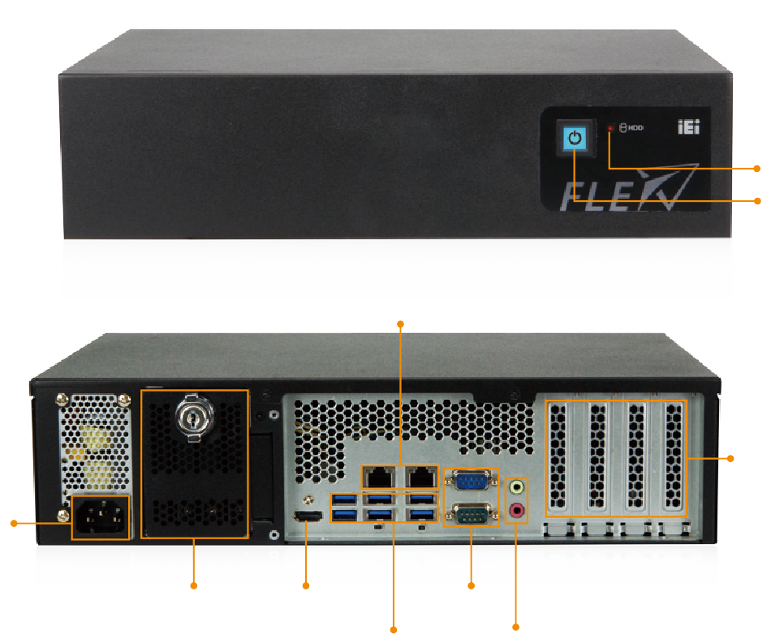
HDD status LED
Power button with power LED

GbE LAN

2 x PCIe 3.0 x8 (x16 slot) 2 x PCIe 3.0 x4 (x4 slot)

AC Inlet

4 x Hot swappable 2.5”HDD
HDMI 2.0 output
2 x RS-232

6 x USB 3.1 Gen 1 Audio (Mic-in, Line-out)

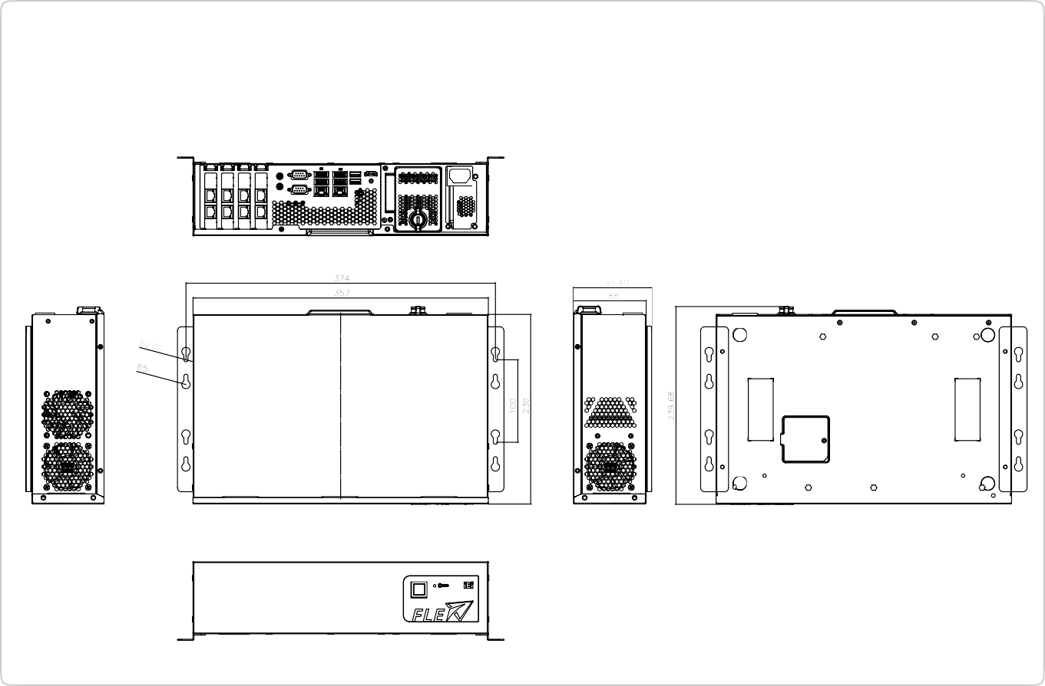

FLEX-BX200
Dimensions (Unit: mm)

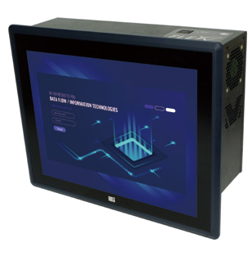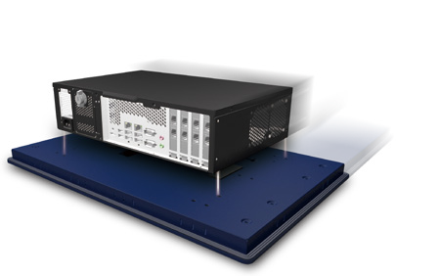
FLEX-BX200 Series
+
FLEX-PLKIT Series
=
PPC-FxxC Series
FLEX-BX200-2019-V10
Configurable Systems
Panel Kit Modules

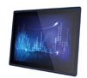
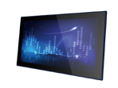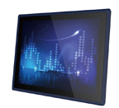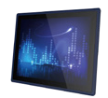Specifications

Model |  | FLEX-PLKIT-F15 | FLEX-PLKIT-F17 | FLEX-PLKIT- FW15 | FLEX-PLKIT- FW19 | FLEX-PLKIT- FW22 | FLEX-PLKIT- FW24
TFT LCD | LCD Size | 15” | 17” | 15.6" | 18.5" | 21.5” | 23.8”
 | Max. Resolution | 1024x768 | 1280x1024 | 1366x768 | 1366x768 | 1920x1080 | 1920x1080
 | Brightness (cd/m²) | 450 | 350 | 400 | 400 | 250 | 250
 | Contrast Ratio | 800:1 | 1000:1 | 500:1 | 1000:1 | 1000:1 | 3000:1
 | LCD Color | 16.2M | 16.7M | 16.2M | 16.7M | 16.7M | 16.7M
 | Viewing Angle (H/V) | 160°/150° | 170°/160° | 170°/160° | 170°/160° | 170°/160° | 178°/178°
 | Backlight MTBF (Hrs) | 70,000 | 50,000 | 50,000 | 50,000 | 30,000 | 30,000
Touch Screen |  | PCAP touch with 10-point multitouch and anti-glare coating
Video Interface |  | LVDS
IP Rating |  | IP66-rated front panel
Other |  | Support FLEX-BX200-Q370 only

Ordering Information

Part No. | Description
FLEX-PLKIT-F15/PC-R10 | 15" 450cd/m² 1024 x768 FLEX modular resistive touch window/LCD kit, R10
FLEX-PLKIT-F17/PC-R10 | 17" 350cd/m² 1280 x 1024 FLEX modular PCAP touch window/LCD kit, R10
FLEX-PLKIT-FW15/PC-R10 | 15.6" 400cd/m² 1366 x 768 FLEX modular PCAP touch window/LCD kit, R10
FLEX-PLKIT-FW19/PC-R10 | 18.5" 400cd/m² 1366 x 768 FLEX modular PCAP touch window/LCD kit, R10
FLEX-PLKIT-FW22/PC-R10 | 21.5" 250cd/m² 1920 x 1080 FLEX modular PCAP touch window/LCD kit, R10
FLEX-PLKIT-FW24/PC-R10 | 23.8" 250cd/m² 1920 x 1080 FLEX modular PCAP touch window/LCD kit, R10

Options

Item | FLEX-PLKIT-F15 | FLEX-PLKIT-FW15 | FLEX-PLKIT-F17 | FLEX-PLKIT-FW19 | FLEX-PLKIT-FW22 | FLEX-PLKIT-FW24
Panel Mount Kit | FPK-12-R10 | FPK-14-R10 | FPK-13-R10 | FPK-13-R10 | FPK-13-R10 | FPK-14-R10
Rack Mount Kit | FRK15C-R10 | FRKW15C-R10 | FRK17C-R10 | FRKW19C-R10 | N.A. | N.A.

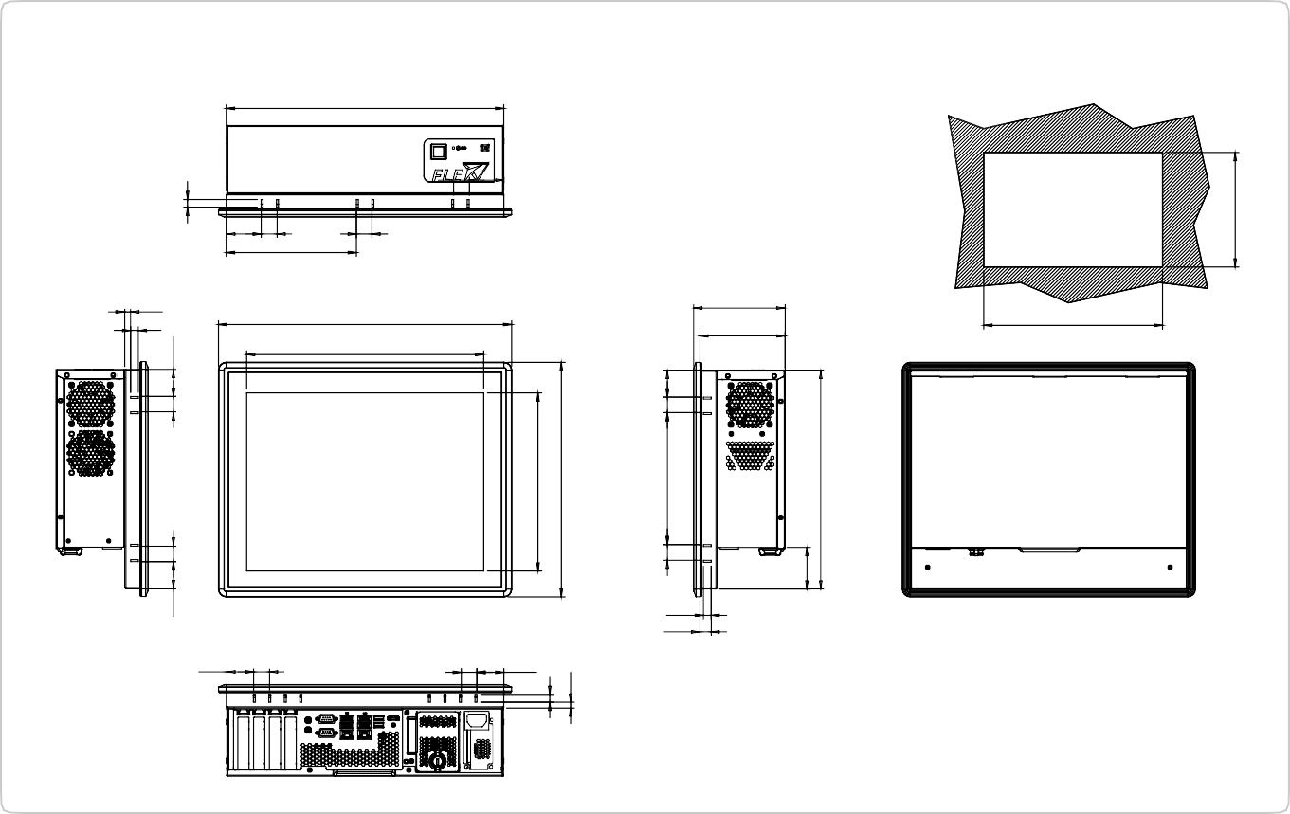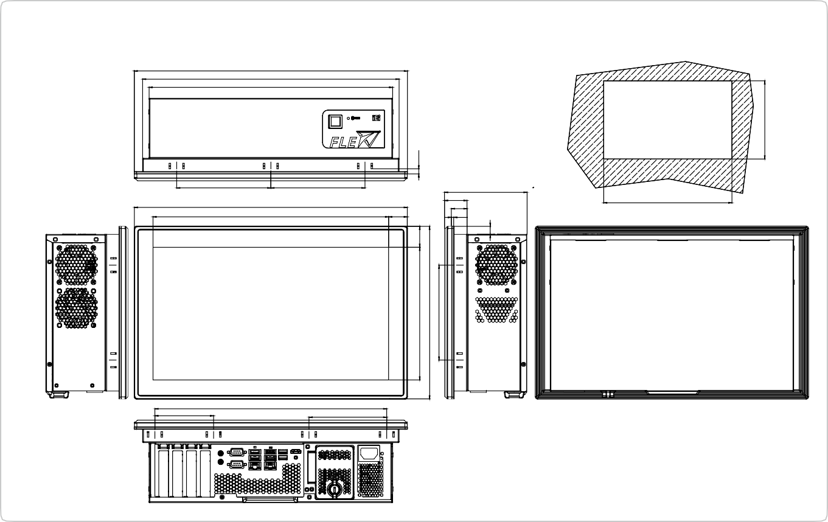
20 34.75
34.75 20
10
14.50
361.1
Suggested cut out size
306
110
378.50
117.96
7.50
10
44.7520 20
167.80
PPC-F15C-Q370 Dimensions (Unit: mm)
358.10
114
86
339.90
3.50
27.34
379.1
33
23
400.10
345.43
121
138.05
138.05
Suggested Cut out Size
Scale 1:2
PPC-FW15C-Q370 Dimensions (Unit: mm)
400.70
376.10
357
34.75
20
20
34.75
10
230
303
10
7.50
194.74
253.30
139.30
30.71
7.50
20
170.60
20 34.75
12
53.60
282.60
232.3
285.6
Configurable Systems

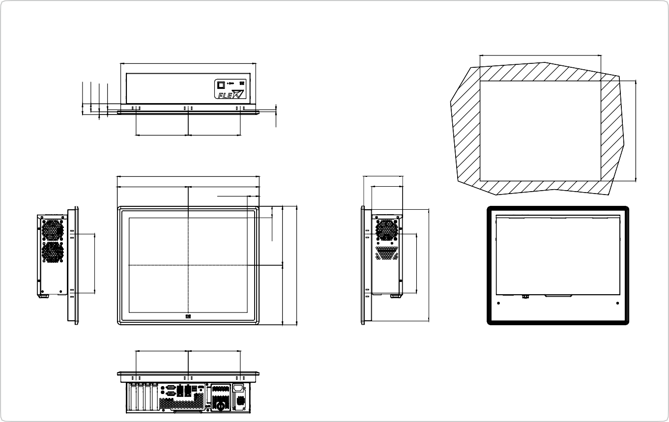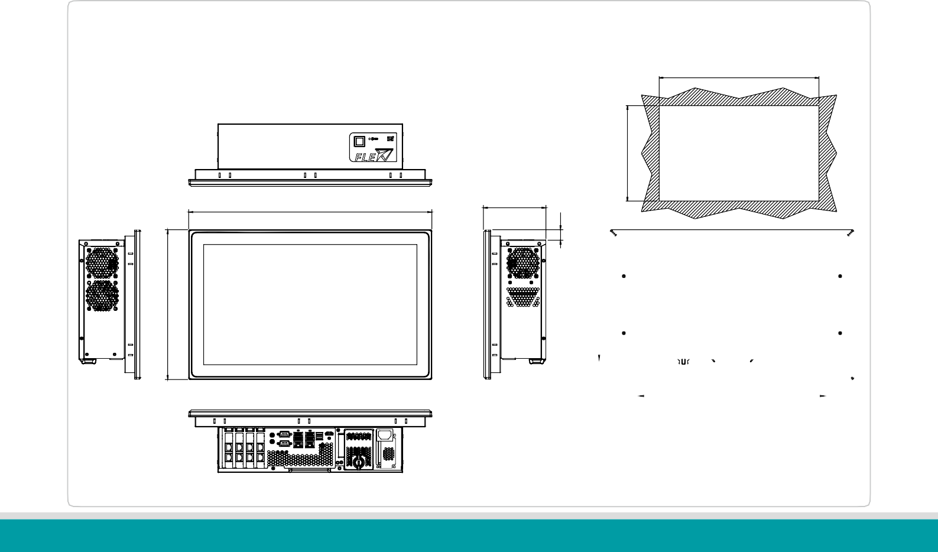
150
150
111
88
204.20
34.20
204.20
408.40
Suggested Cutout Size
150
150
388
391
PPC-F17C-Q370 Dimensions (Unit: mm)
PPC-FW19C-Q370 Dimensions (Unit: mm)
447.80
469.80
120.80
FLEX-BX200-2019-V10

Suggested Cut Out Size
31
23
8
6
289.20
170
33.55
169.70
6
171.70
341.40
20.10
170
321
230
267.20
324
Configurable Systems

357

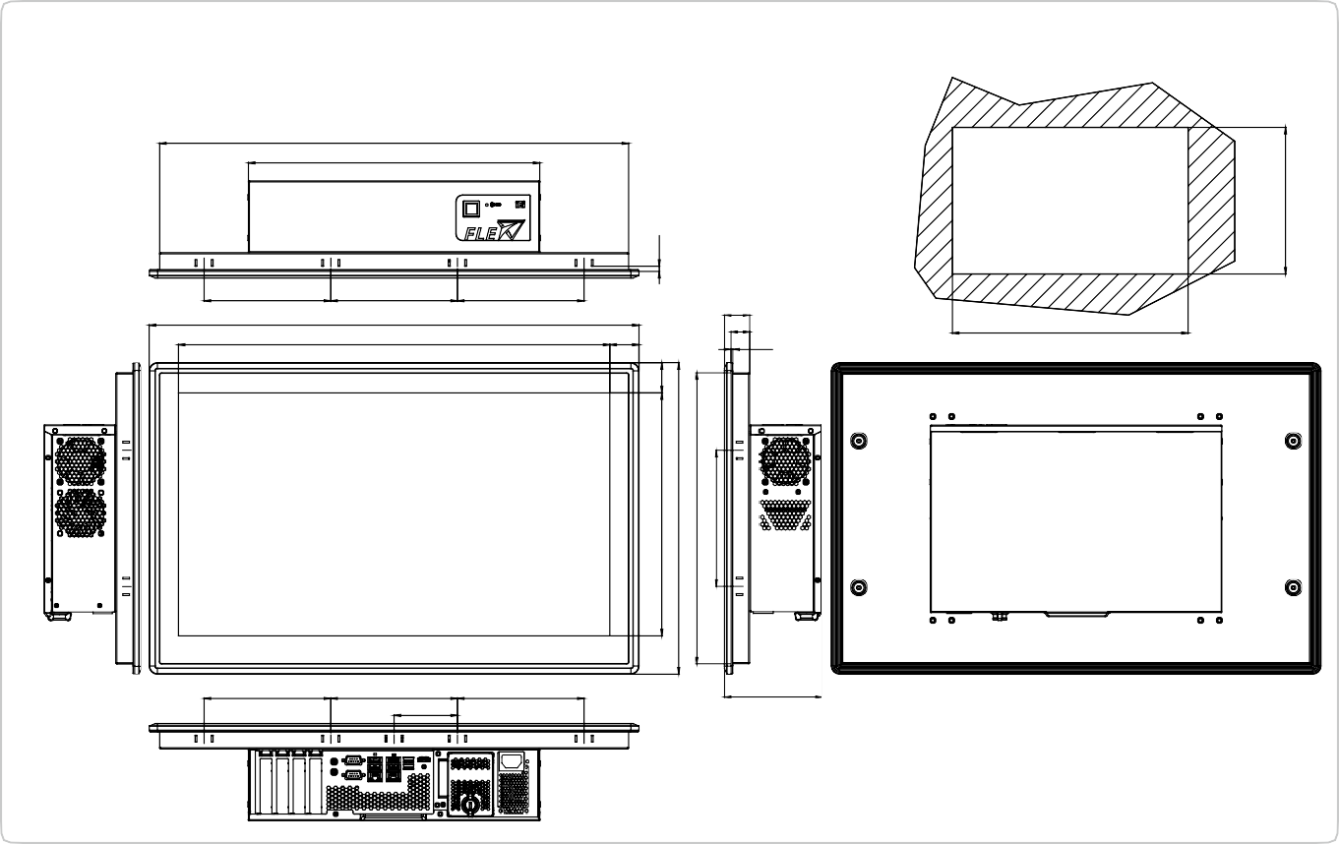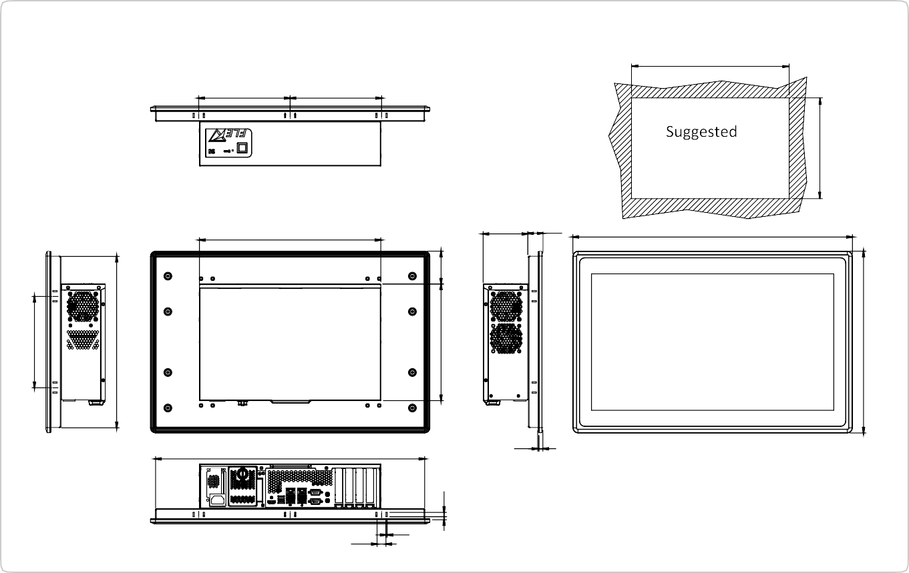
119
155.2
155.2
77.6
155.2
577.6
31
23
2.3
35.7
155.2
155.2
600
528.6
155.2
Suggested Cut Out Size Scale 1:2
PPC-FW24C-Q370 Dimensions (Unit: mm)
574.6
357
17.50
2.50
530
2.30 8
550.40
88 29.80
357
Cut out Size
180
180
533
PPC-FW22C-Q370 Dimensions (Unit: mm)
180
338
230
64.70
6
8.50
6.3
298
382
356.6
166.6
37
341
358.40
359.6
Configurable Systems

