WISE-4610

LoRa/LoRaWAN Outdoor Wireless I/O Module

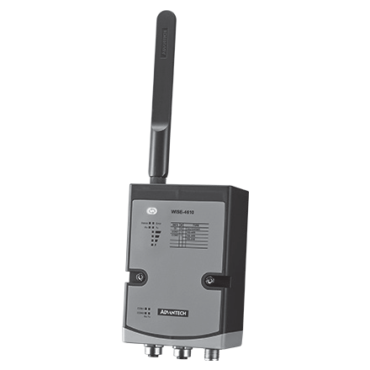
Features
- For North America, Europe, and Japan
- Longer communication range
- Better penetration through concrete and steel
- Less interference than 2.4GHz spectrum
- Application-ready I/O combination with IP65 enclosure
- Powered by solar rechargeable battery or 10~50VDC input
- Global Positioning System (GPS) support

Introduction
LPWAN is a type of wireless telecommunication wide area network designed to allow long range communications at a low data rate among IoT applications, such as sensors operated on a battery. Its benefits is to offer multi-year battery lifetime for sensors/applications to send small amounts of data over long distances a few times per hour suitable for different environments.
LoRa and LoRaWAN are one of category of LPWAN which belong to the non-cellular LPWAN wireless communication network protocols enables very long range transmissions with low power consumption, operating in the non-licensed spectrum. What is the difference between LoRa and LoraWAN? LoRa (Long Range) is a patented wireless data communication of IoT technology and acquired by Semtech in 2012 which holds the IP for LoRa transmission methodology.

Star Topology
The LoRaWAN networks in a star topology have gateway relaying the data between the sensor nodes and the network server.
Communication between the sensor nodes and the gateway goes over the wireless channel utilizing the LoRa physical layer, whilst the connection between the gateways and the central server are handled over a backbone IP-based network.
The LoRaWAN end nodes(sensors) typically use Low Power and are battery powered (Class A and Class B). LoRa embedded sensors that run on batteries that lasts from 2–5 years typically. The LoRa sensors can transmit signals over distances from 1km—10km.
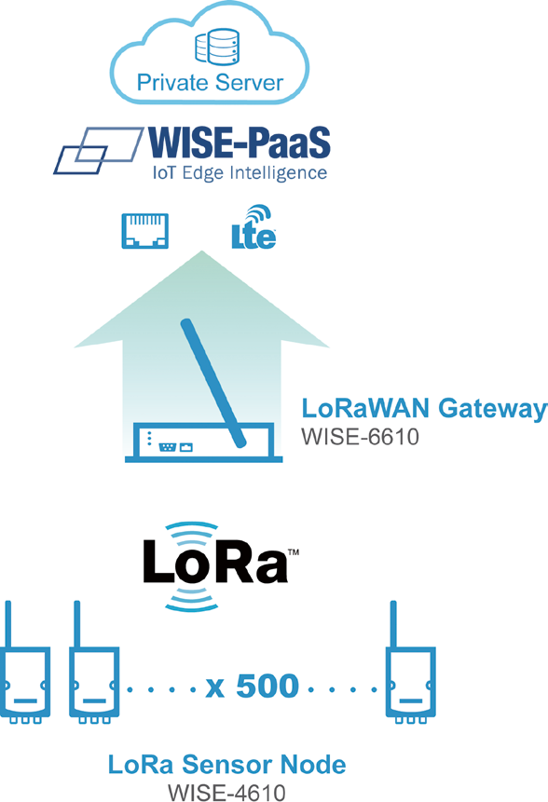
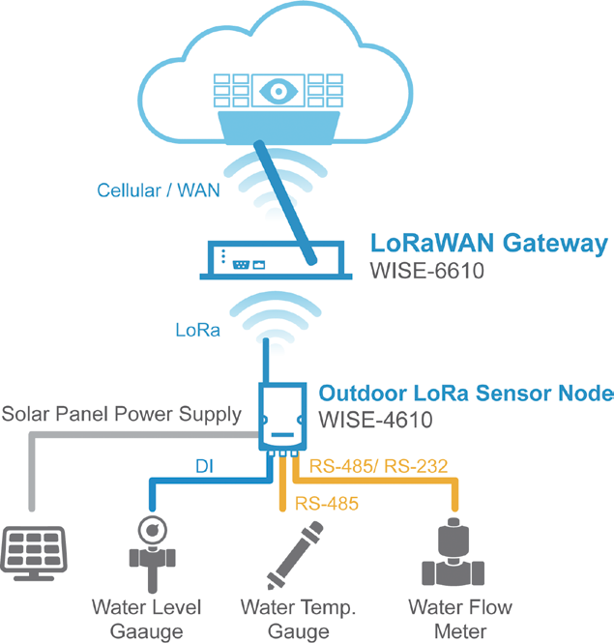

Wireless IoT Sensing Devices
All product specifications are subject to change without notice. Last updated: 24-Apr-2019

Common Specification

Wireless Communication

Digital Input
- Channels 4
- Input Type Dry Contact (Wet Contact by request)
- Logic Level 0: Open

WISE-4610

- IEEE Standard IEEE 802.15.4g
- Frequency Band EU 863-870 (MHz)
- Isolation Voltage

1: Close to DCOM 3,000Vrms

US 902-928 (MHz)
AU (JP) 915-928 (MHz)

Supports 200Hz Counter Input (16-bit + 1-bit overflow)
- Keep/Discard Counter Value when Power-off


Spreading Factor 7~12
- Outdoor Range 5km with line of sight (with 2 dBi Antenna)
- Transmit Power Up to +18dBm
- Receiver Sensitivity Up to -136dBm at SF = 12 / 125KHz
- Data Rate 50 kbps at FSK mode EU868
21.9 kbps at SF7 mode US915
5.47 kbps at SF7 mode JP923
- Topology Star
- Function End Node
GPS1
- GNSS Systems GPS, GLONASS, Galileo, BeiDou, QZSS and SBAS signals
- Max. Update Rate Single GNSS: up to 18 Hz Concurrent GNSS: up to 10 Hz
- Accuracy Position: 2.5 m CEP (50% confidence)
With SBAS: 2.0 m CEP (50% confidence)
- Acquisition Cold starts: 57 s Aided starts: 7 s
Supports 200Hz Frequency Input
- Supports Inverted DI Status

Pin Assignment
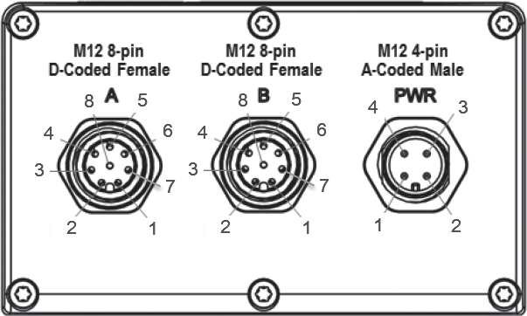

General
- Power Input Built-in 4000mA Lithium rechargeable battery pack2
 | Model Name | WISE-S614 | WISE-S672
 | Pin Number
A | 1 | DI0 | DI0
 | 2 | DI1 | DI1
 | 3 | DI2 | DI2
 | 4 | DI3 | DI3
 | 5 | NC | DI4
 | 6 | NC | DI5
 | 7 | NC | NC
 | 8 | DI COM | DI COM
B | 1 | IA0+ | DATA1-
 | 2 | IA0- | DATA1+
 | 3 | IA1+ | TX
 | 4 | IA1- | RX
 | 5 | IA2+ | DATA2-
 | 6 | IA2- | DATA2+
 | 7 | IA3+ | NC
 | 8 | IA3- | GND
PWR | 1 | +VS | +VS
 | 2 | -VS | -VS
 | 3 | SP+ | SP+
 | 4 | SP-

- Battery Life
- Configuration Interface
- Connector
- LED Indicator
- Mounting
or 10~50VDC external power
6 months (1 hour data update and 1 day GPS update) Micro-B USB
Power: M12 4-pin code-A male x 1 I/O: M12 8-pin code-D female x 2
Status, Error, Tx, Rx, Battery/Signal Level DIN 35 rail, wall, pole, and stack

- Dimension (W x H x D) 82 x 122 x 49 mm (without antenna)

Environment
- Operating Temperature2 With battery: 0~60°C
Without battery:: -25~70°C
- Operating Humidity 5~95% RH
1 No GPS version, can be ordered upon request
2 No battery version, can be ordered upon request

WISE-S672

Serial Port
- Port Number 2
- Type Port 1: RS-485
Port 2: RS-485/232
- Serial Signal RS-485: DATA+, DATA- RS-232: Tx, Rx, GND
- Data Bits 7, 8
- Stop Bits 1, 2
- Parity None, Odd, Even
 Baud Rate (bps) 1200, 2400, 4800, 9600, 19200, 38400, 57600, 115200
- Protection 15 kV ESD
- Protocol Modbus/RTU (Total 32 address)

Digital Input
- Channels 6
- Input Type Dry Contact (Wet Contact by request)
- Logic Level 0: Open
1: Close to DCOM
- Isolation Voltage 3,000Vrms
- Supports 200Hz Counter Input (16-bit + 1-bit overflow)
- Keep/Discard Counter Value when Power-off
- Supports 200Hz Frequency Input
- Supports Inverted DI Status

WISE-S614

Analog Input
- Channels 4
- Resolution 16-bit
- Sampling Rate 1Hz per channel
- Accuracy ±0.1% of FSR (Voltage)
±0.2% of FSR (Current)
 Input Range ±5V, ±10V, 0~5V, 0~10V, 0~20mA, 4~20mA, ±20mA
- Input Impedance > 2M Ω (Voltage)
120 Ω (External resistor for current)
- Isolation Voltage 3000Vrms
- Over Voltage Protection ±35 VDC
- Burn-out Detection Yes (4~20mA only)
- Supports Data Scaling and Averaging

Ordering Information

Wireless Sensor Node
- WISE-4610-S672NA LoRa Outdoor WSN with 6DI & 2COM - NA915
- WISE-4610-S672EA LoRa Outdoor WSN with 6DI & 2COM - EU868
- WISE-4610-S672JA LoRa Outdoor WSN with 6DI & 2COM - JP923
- WISE-4610-S614NA LoRa Outdoor WSN with 4AI & 4DI - NA915
- WISE-4610-S614EA LoRa Outdoor WSN with 4AI & 4DI - EU868
- WISE-4610-S614JA LoRa Outdoor WSN with 4AI & 4DI - JP923

Accessories
 1654011516-01 M12 Connector 8P Male
 1655005903-01 M12 Connector 4P Male
- 1700028162-01 2M M12 code-A 4-pin female cable for power wiring
- 1700028163-01 2M M12 code-D 8-pin male cable for I/O wiring
- PWR-242-AE DIN Rail Power Supply (2.1A Output Current)
- PWR-243-AE Panel Mount Power Supply (3A Output Current)
- PWR-244-AE Panel Mount Power Supply (4.2A Output Current)

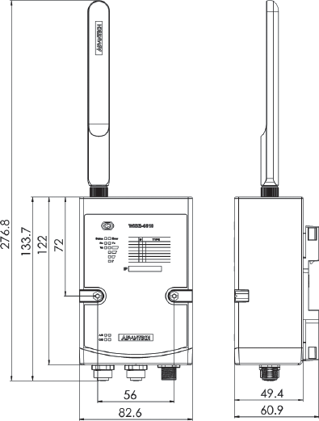
Dimensions Unit: mm

Online Download www.advantech.com/products

