ADAM-4118 ADAM-4150 ADAM-4168
Robust 8-ch Thermocouple Input Module with Modbus
Robust 15-ch Digital I/O Module with Modbus
Robust 8-ch Relay Output Module with Modbus

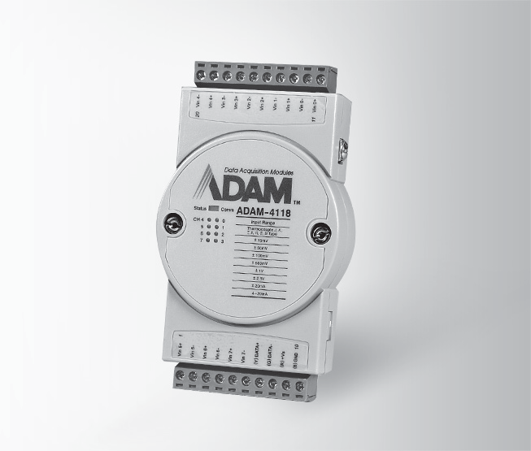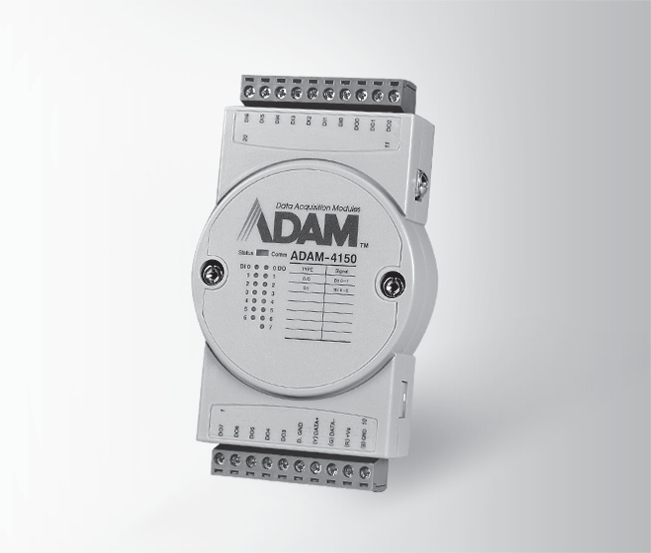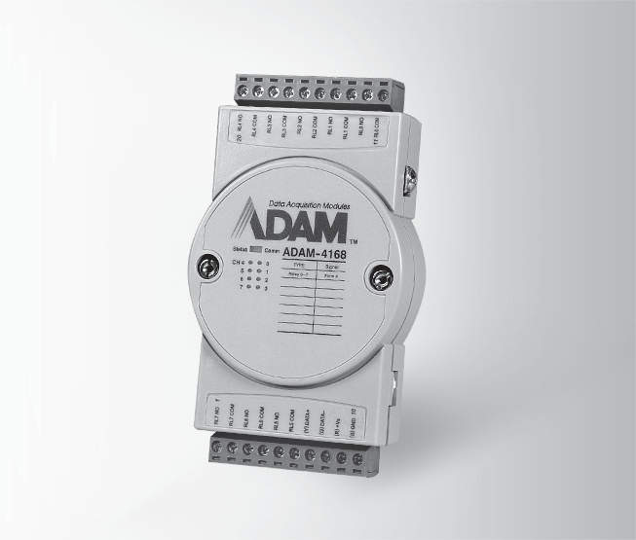
ADAM-4118
RoHS
COMPLIANT
2002/95/EC
ADAM-4150
RoHS
COMPLIANT
2002/95/EC
ADAM-4168
RoHS
COMPLIANT
2002/95/EC

Specifications

General
- Power Consumption 0.5W @ 24 VDC

Analog Input
- Channels 8 differential and independent configuration channels
- Input Impedance Voltage: 20 MΩ
Current: 120 Ω
- Input Type T/C, mV, V, mA

Input Range
Thermocouple

J | 0 ~ 760°C | R | 500 ~ 1,750°C
K | 0 ~ 1,370°C | S | 500 ~ 1,750°C
T | -100 ~ 400°C | B | 500 ~ 1,800°C
E | 0 ~ 1,000°C
Voltage mode ±15 mV, ±50 mV,
±100 mV, ±500 mV,
±1 V, ±2.5 V
Current mode ±20 mA, 4 ~ 20 mA
- Accuracy Voltage mode: ±0.1% or better
Current mode: ±0.2% or better
- Resolution 16-bit
- Sampling Rate 10/100 samples/sec
(selected by Utility)
 CMR @ 50/60 Hz 92 dB
 NMR @ 50/60 Hz 60 dB
- Overvoltage Protection ±60 VDC
- High Common Mode 200 VDC
- Span Drift ±25 ppm/°C (Typical)
- Zero Drift ±6μV/°C

Built-in TVS/ESD Protection
- Burnout Detection
Specifications
General
- Power Consumption 0.7 W @ 24 VDC

Digital Input

Channels 7
- Input Level
Dry contact: Logic level 0: Close to GND
Logic level 1: Open Wet contact: Logic level 0: 3 V max
Logic level 1: 10 ~ 30 V
(Note: The Digital Input Level 0 and 1 status can be inverted)

Supports 3 kHz Counter Input (32-bit + 1-bit overflow)
- Supports 3 kHz Frequency Input
- Supports Invert DI Status
- Over Voltage Protection 40 VDC
Digital Output
- Channels 8, open collector to 40 V (0.8A max. load)
- Power Dissipation 1W load max
- RON Maximum 150 mΩ

Supports 1 kHz Pulse Output
- Supports High-to-Low Delay Output
- Supports Low-to-High Delay Output
Specifications
General
- Power Consumption 1.8 W @ 24 VDC

Relay Output
- Output Channels 8 Form A
- Contact Rating 0.5 A @ 120 VAC
(Resistive) 0.25 A @ 240 VAC
1 A @ 30 VDC
0.3 A @ 110 VDC
- Breakdown Voltage 750 VAC (50/60 Hz)
- Initial Insulation 1 G Ω min. @ 500 VDC

Resistance
- Relay Response On: 3ms
Time (Typical) Off: 1ms

Total Switching Time 10 ms
- Supports 100 Hz pulse output
- Maximum Operating 50 operations/min
Speed (at related load)

 Storage Temperature -40 ~ 85°C
(-40 ~ 185°F)
(-40 ~ 185°F)
- Isolation Voltage
- Interface (B version)
 Operating Temperature -40 ~ 85°C
5 ~ 95% RH
 Operating Humidity
Environment
ASCII Command and Modbus/RTU
Unregulated 10 ~ 48 VDC System (1.6 second) & Communication
2 x plug-in terminal blocks (#14 ~ 22 AWG)
3,000 VDC
RS-485, micro USB
- Power Input
- Watchdog Timer

- Connector
 Supported Protocols
Common Specifications
General
Ordering Information
- ADAM-4118 Robust 8-ch Thermocouple Input Module w/ Modbus
- ADAM-4150 Robust 15-ch Digital I/O Module with Modbus
- ADAM-4168 Robust 8-ch Relay Output Module with Modbus

RS-485 I/O Modules: ADAM-4000
All product specifications are subject to change without notice. Last updated: 27-Jun-2018

