ADAM-3900 fi fl$ ! #$%&
1

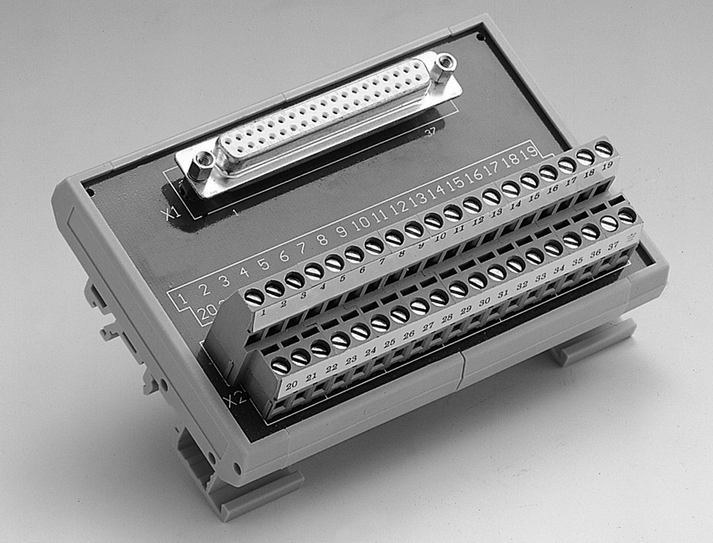
ADAM-3937

fl$ ! DB37 $@ !

#A
- DIN ¤fl ! #$%&'()*+,-.$ƒ ! DB37 !
!"#$
- fi÷ ! (W x L x H):77.5 x 146.3 x 51 mm (3.1" x 5.8" x 2.0")

¾$ !
PCI-1730, PCI-1733, PCI-1734, PCI-1750, PCI-1761

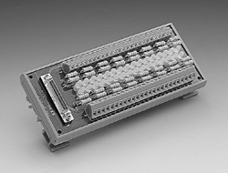
ADAM-3951

DIN fl$ ! #$%&'()
ø LED
ADAM-3968
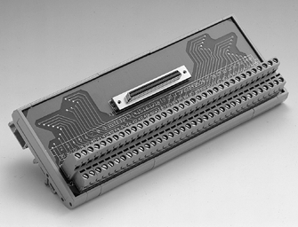
DIN fl$ ! 68 fl SCSI-II
$@ !

#A
- DIN ¤fl ! #$%&'()*+,-.$ƒ ! 68 SCSI-II
# !"#$
- fi÷ ! (W x L x H):77.5 x 191.2 x 51 mm (3.1" x 8.4" x 2.0")

¾$ !
PCI-1710/1710L, PCI-1710HG/1710HGL, PCI-1711/1711L, PCI-1712/1712L, PCI-1716/1716L, PCI-1721, PCI-1751, PCI-1753/1753E, PCI-1723, PCI-1780

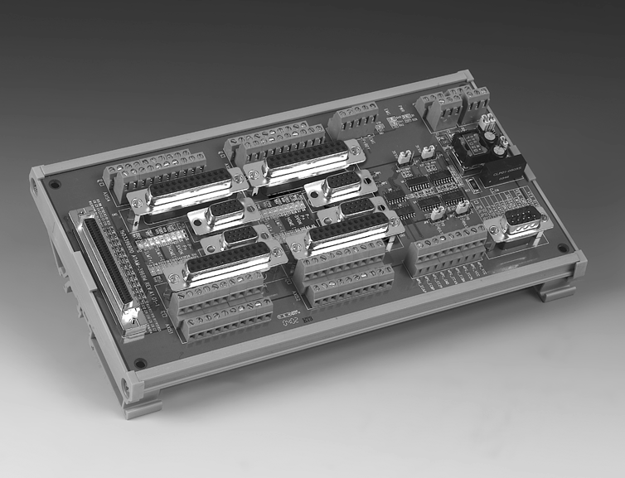
ADAM-3968M

ø LED  PCI-1241/ 1242 $@ !

fifl

IPPC
2
3

TPC
4
M

FP
5

ATM &AWS
6

DA&C
7

cPCI
8

ADAM-3000
9

fi !
ICOM
10

#A
- DIN ¤fl ! #$%&'()*+,-.$ƒ ! 50 SCSI-II
# PCI-1752/1754/1756
- fl ! #$%&'()
- LED !"# $%&'%()* ,- I/O ‰ !"
- fi÷ ! (W x L x H):77.5 x 179.5 x 41.5 mm (3.1" x 7.1" x 1.6")

¾$ !
PCI-1752, PCI-1754, PCI-1756

#A
- DIN ¤fl ! #$%&'($ƒ $ 68 SCSI-II flfi ! PCI- 1241/1242 $
eConnectivity
11
UNO
12
- $ƒ Limit/Home/Server-On/In-Position/Pulse-Output/EMS LED
- 1.1A fi !"#$%
ADAM-4000
13
- fi÷ ! (W x L x H):77.5 x 191.2 x 51 mm (3.1" x 8.4" x 2.0")

¾$ !
ADAM-5000
14
PCI-1241, PCI-1242
ADAM-6000
15
ADAM-8000
16
BAS
17

8-17
fl@ !
www.advantech.com.cn/products

