PCI-1604L PCI-1602UP

2-Port RS-232 PCI Communication Card 2-Port RS-232/422/485 Low-Profile Universal PCI Communication Card with Isolation Protection

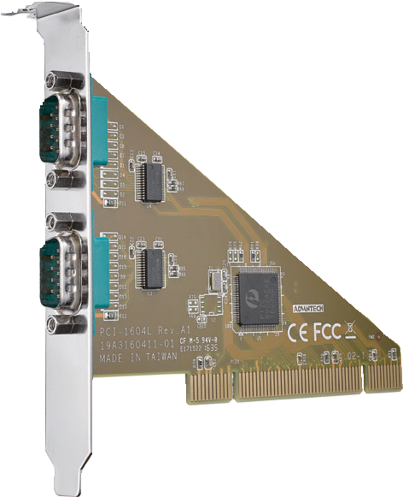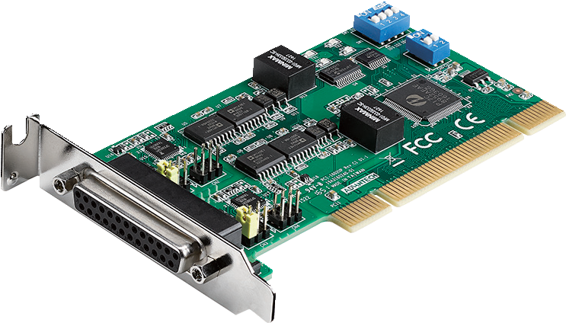
NEW

PCI-1604L PCI-1602UP

Features
RoHS
COMPLIANT 2002/95/EC
- PCI bus 2.2 compliant
- Up to 921.6 kbps speed for extremely fast data transmissions
- Level 4 ESD protection (air 15 KV , contact 8 KV)
- 2 x RS-232 ports
- 128-byte FIFO
- Supports Windows XP/7/8/10 and Linux operating systems
- -20 ~ 60 °C operating temperature
Specifications
General
- Bus Type Universal PCI v2.2
- Certification CE, FCC class A
- Connectors 2 x DB9, male
 Dimensions (L x H) 119.91 x 83.06 mm (4.72" x 3.27")
- Power Consumption 200mA @ +3.3V (typ.)

Communications
- Comm. Controller PI7C8952
- Data Bits 5, 6, 7, 8
- Data Signals RS232: TxD, RxD, RTS, CTS, DTR, DSR, DCD, RI
- FIFO 128 bytes
- Flow Control DTR/DSR, RTS/CTS, Xon/Xoff
- Parity None, Odd, Even, Mark, or Space
- Speed 50 bps ~ 921.6 kbps
- Stop Bits 1, 1.5, 2

Protection
- ESD Protection 15 KV (air), 8 KV (contact)
- EFT Protection 1 KV

Software
- Bundled Software ICOM tools
- OS Support Windows XP/7/8/10, and Linux

Environment
- Operating Humidity 5 ~ 95% RH, non-condensing
- Operating Temperature -20 ~ 60 °C (-4 ~ 140 °F)
- Storage Temperature -25 ~ 85 °C (-13 ~ 185 °F)

Ordering Information
- PCI-1604L-AE 2-port RS-232 PCI comm. card

Features
- PCI bus 2.2 compliant
- Up to 921.6 kbps speed for extremely fast data transmissions
 2 x RS-232/422/485 ports
- Supports Windows XP/7/8/10 and Linux operating systems
- 3,000 VDC isolation protection
- Automatic RS-485 data flow control
- Powerful and easy-to-use utility (ICOM tools)
- Supports any baud rate setting
Specifications
General
- Bus Type Universal PCI V 2.2
- Certification CE, FCC class A
- Connectors 1 x DB25, female
- Dimensions (L x H) 119.91 x 64.41 mm (4.72" x 2.5") (low-profile MD1)
- Power Consumption 260mA@ +3.3V (typ.)
Communications
- Communication Controller PI7C8952
- Data Bits 5, 6, 7, 8
- Data Signals RS-232: TxD, RxD, RTS, CTS, DTR, DSR, DCD, RI RS-422: Tx+, Tx-, Rx+, Rx-, RTS+, RTS-, CTS+, CTS-
RS-485: Data+, Data-
- FIFO 128 bytes
- Flow Control CTS/RTS, Xon/Xoff
- Parity None, Even, Odd, Mark and Space
- Speed 50 bps ~ 921.6 kbps
- Stop Bits 1, 1.5, 2

Protection
- EFT Protection 1 KV
- Isolation Protection 3,000 VDC
- ESD Protection 15KV (air), 8KV (contact)
- Surge Protection 1 KV

Software
- Bundled Software ICOM tools
- OS Support Windows XP/7/8/10 and Linux (check the software release note for versions supported)

Environment
- Operating Humidity 5 ~ 95% RH, non-condensing
- Operating Temperature -10 ~ 60 °C (14 ~ 140 °F)
- Storage Temperature -25 ~ 85 °C (-13 ~ 185 °F)

Ordering Information
- PCI-1602UP-CE 2-port RS-232/422/485 low-profile universal PCI comm card
w/ isolation protection
Note: Both PCI-1602UP are equipped with a DB25 to 2 x DB9 cable.

Industrial I/O
All product specifications are subject to change without notice. Last updated: 27-Jun-2018

