PCL-841
PCI-1680U

PCM-3680/I
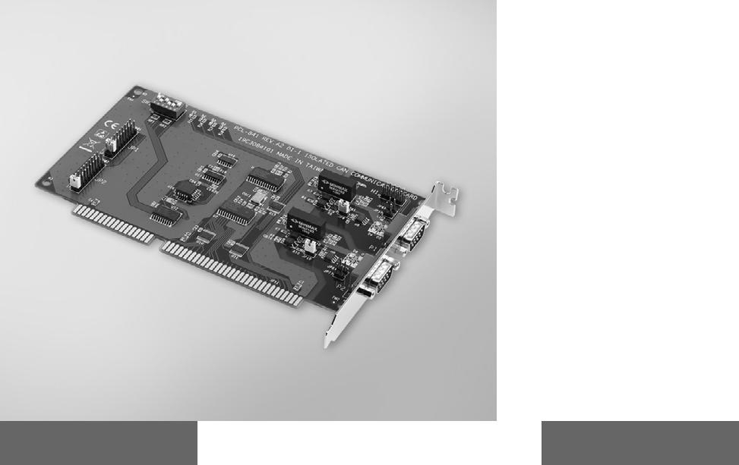

2-port CAN-bus ISA Card with Isolation Protection

2-port CAN-bus Universal PCI Card with Isolation Protection

2-port CAN-bus PC/104 / PCI-104 Module with Isolation Protection
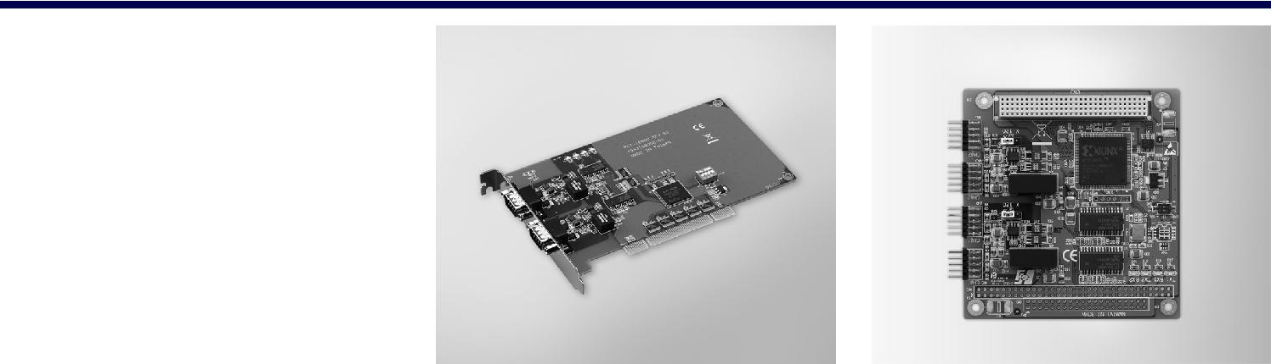

PCL-841 | RoHS | PCI-1680U | RoHS
 | COMPLIANT |  | COMPLIANT
 | 2002/95/EC |  | 2002/95/EC

Features |  | Features
 | Operates two separate CAN networks simultaneously |  | Operates two separate CAN networks simultaneously
 | High speed transmission up to 500 kbps |  | High speed transmission up to 1 Mbps
 | Optical isolation protection of 1000 VDC |  | Optical isolation protection of 2500 VDC
 | Windows DLL library and examples included |  | Windows DLL library and examples included
 | Wide IRQ selection for each port: IRQ 3, 4, 5, 6, 7, 9, |  | I/O address automatically assigned by PCI PnP
 | 10, 11, 12, 15 |  | Supports 32-bit/64-bit Windows 2000/XP/Vista/7
 | Supports 32-bit/64-bit Windows 2000/XP/Vista/7 |  | and Linux
 | and Linux

PCM-3680I
RoHS
COMPLIANT
2002/95/EC

Features

 Operates two separate CAN networks simultaneously  High speed transmission up to 1 Mbps

 16 MHz CAN controller frequency  Optical isolation protection

 Transmit/receive status LED indicators on each port  Supports wide operating temperature

 Supports 32/64-bit WinXP/Vista/7 and Linux  Supports WinCE 5.0/6.0

Specifications

General

 Card Interface ISA

 Certification CE, FCC

 Connectors 2 x DB9-M

 Dimensions 185 x 100 mm (7.3" x 3.9")

 Ports 2

 Power Consumption 5 V @ 400 mA typical

Communications

 CAN Controller SJA-1000

 CAN Transceiver 82C250

 Protocol CAN2.0 A/B

 Speed 500 kbps

 IRQ 3, 4, 5, 6, 7, 9, 10, 11, 12,

or 15

 Memory Segment Base Address
From C800H to EF00H

 Signal Support CAN_H, CAN_L

Protection

 Isolation Protection 1,000 VDC

Environment

 Operating Temp. 0 ~ 50°C (32 ~ 122°F)

Ordering Information

 PCL-841 2-port CAN-bus ISA

Comm. Card w/ Iso

Specifications

General

 Card Interface Universal PCI

 Certification CE, FCC

 Connectors 2 x DB9-M

 Dimensions 175 x 107 mm (6.9" x 4.2")

 Ports 2

 Power Consumption 5 V @ 400 mA typical

Communications

 CAN Controller SJA-1000

 CAN Transceiver TJA1051T

 Protocol CAN2.0 A/B

 Speed 1 Mbps

 CAN Frequency 16 MHz

 Signal Support CAN_H, CAN_L

Protection

 Isolation Protection 2,500 VDC

Environment

 Operating Temp. 0 ~ 70°C (32 ~ 158°F)

Ordering Information

 PCI-1680U 2-port CAN Uni-PCI

COMM Card w/Iso

Accessories

 OPT1-DB9E-AE DB9 to 10-pin wiring board

Specifications

General

 Card Interface PCM-3680: PC/104

PCM-3680I: PCI-104

 Certification CE, FCC
 Connectors 2 x DB9-M with cable
 Dimensions 90 x 96 mm

(3.6" x 3.8")
 Ports 2
 Power Consumption 5 V @ 400 mA

Communications

 CAN Controller SJA-1000
 CAN Transceiver 82C250
 Protocol CAN2.0 A/B
 Speed Up to 1 Mbps

programmable transfer

rate
 CAN Frequency 16 MHz
 Signal Support CAN_H, CAN_L

Protection

 Isolation Protection | 2,500 VDC

Environment

 Operating Temperature -25 ~ 85 °C
 Storage Temperature -40 ~ 85 °C

Ordering Information

 PCM-3680 Dual-port Iso CAN-bus

PC/104 Module
 PCM-3680I Dual-port Iso CAN-bus

PCI-104 Module

Serial Communication Cards

All product specifications are subject to change without notice Last updated: 2-Sep-2019

