PCLD-780 PCLD-880
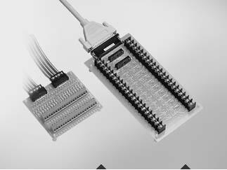

Screw Terminal Board with Flat Cables

Wiring Terminal Board with Flat Cables and Adapter

Features

 Pin to pin design

 Low-cost universal screw-terminal boards for industrial applications  40 terminal points for two 20-pin flat cable connector ports

 Reserved space for signal-conditioning circuits such as low-pass filter, voltage attenuator and current-to-voltage conversion

 Table-top mounting using nylon standoffs. Screws and washers provided for panel or wall mounting

 |  |  | PCLD-780 Only
 |  |  |  Screw-clamp terminal-blocks allow easy and reliable connections
 |  |  |  Dimensions: 102 x 114 mm (4.0" x 4.5")
 |  |  | PCLD-880 Only
 |  |  |  Supports PC-LabCard™ products with DB37 connectors
 |  |  |  Industrial-grade terminal blocks (barrier-strip) permit heavy-duty and reliable
 |  |  | connections
PCLD-780 |  | PCLD-880 |  Dimensions: 221 x 115 mm (8.7" x 4.5")

Introduction

PCLD-780 and PCLD-880 universal screw-terminal boards provide convenient and reliable signal wiring for PC-LabCard™ products with 20-pin flat-cable connectors. PCLD-880 is also equipped with a DB37 connector to support PC-LabCard™ products with DB37 connectors.

PCLD-780 and PCLD-880 let you install passive components on the special PCB layout to construct your own signal-conditioning circuits. You can easily construct a low-pass filter, attenuator or current-to-voltage converter by adding resistors and capacitors onto the board’s circuit pads.

Applications

 Field wiring for analog and digital I/O channels of PC-LabCard™ products which employ the standard 20-pin flat cable connectors or DB37 connectors
(only PCLD-880)

 Signal conditioning circuits can be implemented as illustrated in the following examples:

- Straight-through connection (factory setting) RAn = 0Ω jumper
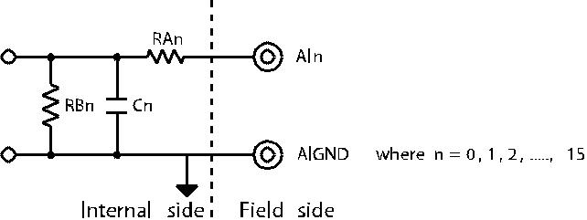

RBn = none

Cn = none

- 1.6 kHz (3dB) low pass filter

RAn = 10 KΩ RBn = none

Cn = 0.01μF

f3dB =

- 10 : 1 voltage attenuator

RAn = 9 KΩ RBn = 1 KΩ

Cn = none
Attenuation = 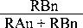 (Assume source impedance << 10 KΩ)

- 4 ~ 20 mA to 1 ~ 5 VDC signal converter

RAn = 0 Ω (short)

RBn = 250 Ω (0.1% precision resistor) Cn = none

Pin Assignments
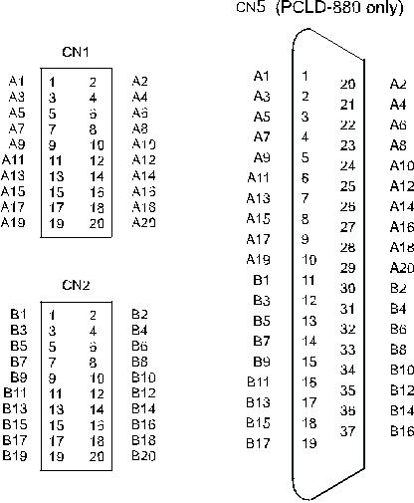

Ordering Information

 PCLD-780 Screw Terminal Board w/ Two 20-pin Flat Cables

 PCLD-880 Wiring Board w/ Two 20-pin Flat Cables & Adapter

 PCL-10137-1 DB37 Cable, 1 m

 PCL-10137-2 DB37 Cable, 2 m

 PCL-10137-3 DB37 Cable, 3 m

 PCL-10120-1 20-pin Flat Cable, 1 m

 PCL-10120-2 20-pin Flat Cable, 2 m

Online Download www.advantech.com/products

