PCIE-1751 PCIE-1753

48-Ch Digital I/O, 3-Ch Counter PCI Express Card

96-Ch Digital I/O PCI Express Card

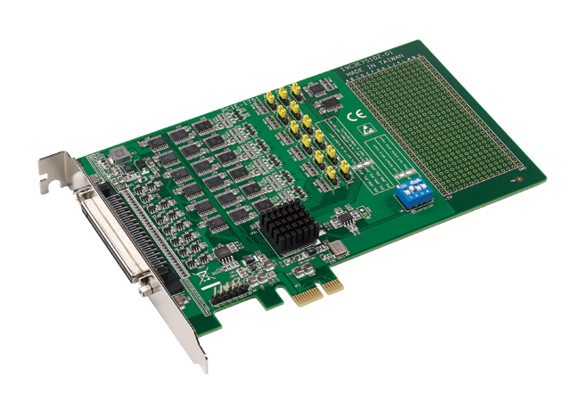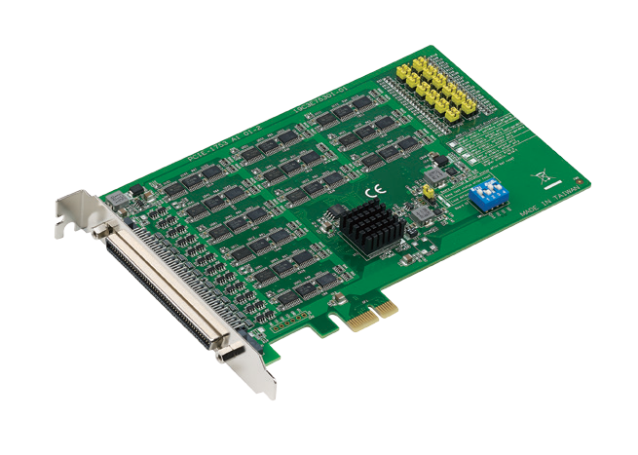
PCIE-1751
PCIE-1753
RoHS
COMPLIANT 2002/95/EC
Features
 | Emulates Mode 0 of the Intel® 8255 PPI chip (every port with nibbles)
 | Buffered circuits for a higher driving capacity compared to the Intel® 8255
 | PPI chip
 | Interrupt handling capability
 | Timer/counter interrupt capability
 | Supports both dry and wet contact
 | Retains I/O port settings and DO configuration after system reset
 | Board ID switch
 | Pattern match interrupt function for DI
 | Change-of-state interrupt function for DI
 | Programmable digital filter function for DI
 | Output status read back

Introduction
PCIE-1751 is a 48-channel digital I/O card for the PCI Express bus. The channels are divided into six 8-bit I/O ports. Users can configure 4 channels per port (nibbles) to serve as input or output channels via software. PCIE-1751 also provides three 32-bit counters. PCIE-1753 is a 96-channel digital I/O card that emulates Mode 0 of the Intel® 8255 PPI chip. However, the buffered circuits offer a higher driving capability than that of the 8255 PPI chip. The 96 I/O channels are divided into twelve 8-bit I/O ports: A0, B0, C0, A1, B1, C1, A2, B2, C2, A3, B3 and C3. Users can configure every port to serve as input or output ports via software.

Specifications

Digital Input
- Channels PCIE-1751: 48 (shared with output) PCIE-1753: 96 (shared with output)
- Compatibility 5 V/TTL
- Input Voltage Logic 0: 0.8 V max. Logic 1: 2 V min.
- Interruptible Channels PCIE-1751: 6
PCIE-1753: 12

Digital Output
- Channels PCIE-1751: 48 (shared with input) PCIE-1753: 96 (shared with input)
- Compatibility 5 V/TTL
- Output Voltage Logic 0: 0.4 V max. Logic 1: 2.4 V min.
- Output Capability Sink: 24mA @ 0.4 V
Source: 15mA @ 2.4 V

Counter/Timer (PCIE-1751 only)
- Channels 3
- Resolution 3 x 32-bit counter
- Compatibility 5 V/TTL
- Max. Input Frequency 10 MHz
- Reference Clock Internal: 20K / 200K / 2M / 20MHz
External Clock Frequency: 10 MHz External Voltage Range: 5 V/TTL

General
- Bus Type Universal PCI Express
- I/O Connectors PCIE-1751: 1 x 68-pin SCSI, female
PCIE-1753: 1 x 100-pin SCSI, female
 Dimensions (L x H) 168 x 100 mm (6.6" x 3.9")
- Power Consumption Typical: PCIE-1751: 5 V @ 400 mA
PCIE-1753: 3.3 V @ 850 mA Max.: PCIE-1751: 5 V @ 2.63 A
PCIE-1753: 3.3V @ 2.7 A
Note: Maximum power consumption includes the consumption for a +5 V output.
- Operating Temperature 0 ~ 60 °C (32 ~ 140 °F)
- Storage Temperature -20 ~ 70 °C (-4 ~ 158 °F)
- Storage Humidity 5 ~ 95% RH, non-condensing

Ordering Information
- PCIE-1751-AE 48-ch digital I/O and 3-ch counter PCI Express card
- PCIE-1753-AE 96-ch digital I/O PCI card

Accessories
- PCL-10168-1E 68-pin SCSI shielded cable, 1 m
- PCL-10168-2E 68-pin SCSI shielded cable, 2 m
- PCL-10268-1E 100-pin to 2 x 68-pin SCSI cables, 1 m
- PCL-10168-2E 100-pin to 2 x 68-pin SCSI cables, 2 m
- ADAM-3968-AE 68-pin DIN rail SCSI wiring board
- ADAM-3968/20-AE 68-pin SCSI to 3 x 20-pin box header board
- ADAM-3968/50-AE 68-pin SCSI to 2 x 50-pin box header board
- PCLD-8751-AE 48-ch isolated digital input board
- PCLD-8761-AE 24-ch replay/ isolated digital input board
- PCLD-8762-AE 48-ch relay board

Industrial I/O
All product specifications are subject to change without notice. Last updated: 27-Jun-2018

