PCL-730
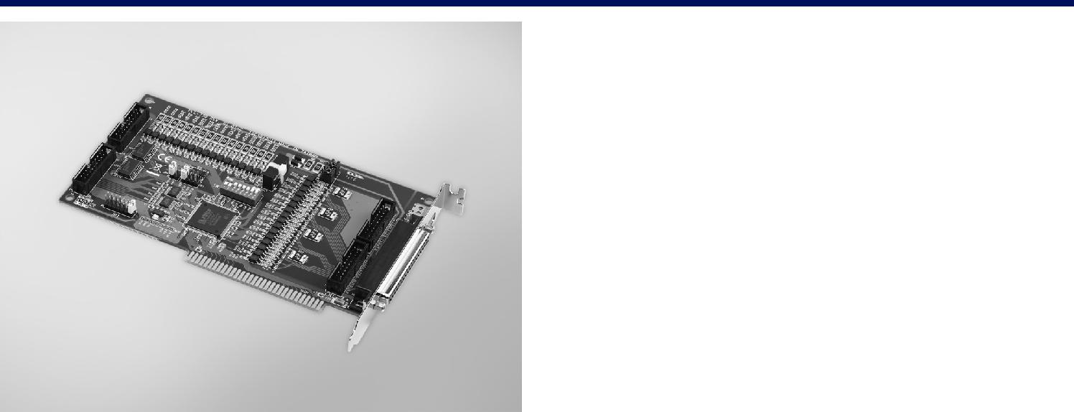

32-ch Isolated Digital

I/0 ISA Card

Features

 32 isolated DIO ch. (16 inputs and 16 outputs)  32 TTL-level DIO ch. (16 inputs and 16 outputs)  High output driving capacity  Interrupt capability

 Two 20-pin connectors for isolated digital I/O channels and two for TTL digital I/O channels

 D-type connector for isolated input and output channels  High-voltage isolation on output channels

RoHS
COMPLIANT

2002/95/EC

Introduction

The PCL-730 offers isolated digital input channels as well as isolated digital output channels with isolation protection up to 2,500 VDC, which makes them ideal for industrial applications where high-voltage isolation is required. There are also 32 TTL DIO channels.

Specifications

Digital Input

 | Channels | 16
 | Compatibility | 5 | V/TTL
 | Input Voltage | Logic 0: 0.8 V max.
 |  | Logic 1: 2.0 V min.
 | Interrupt Capable Ch. | 2 | (DI0, DI1)

Isolated Digital Input

 Channels 16

 Input Voltage Logic 0: 1 V max.

Logic 1: 5 V min., 24 V max.

 Interrupt Capable Ch. 2 (IDI0, IDI1)

 Isolation Protection 2,500 VDC

 Opto-Isolator Response 100 μs

 Input Resistance 3 KΩ @ 0.2 W

Digital Output

 | Channels | 16
 | Compatibility | 5 V/TTL
 | Output Voltage | Logic 0: 0.8 V max.
 |  | Logic 1: 2.0 V min.
 | Output Capability | Sink: 8 mA
 |  | Source: 0.4 mA

Isolated Digital Output

 | Channels | 16
 | Output Type | Sink type (NPN)
 | Isolation Protection | 2,500 VDC
 | Output Voltage | 5 ~ 40 VDC
 | Sink Current | 200 mA max./channel

 Opto-Isolator Response 100ms

General

 Bus Type ISA

 I/O Connectors 1 x 37-pin D-type female

2 x 20-pin box header for fl at cable

 Dimensions (L x H) 185 x 100 mm (7.3” x 3.9”)

 Power Consumption Typical: 5 V @ 330 mA; 12 V @ 80 mA

Max.: 5 V @ 500 mA; 12 V @ 105 mA

 Operating Temperature 0 ~ 60°C (32 ~ 140°F)

 Storage Temperature -20 ~ 70°C (-4 ~ 158°F)

 Storage Humidity 5 ~ 95% RH, non-condensing (refer to IEC 68-2-3)

Ordering Information

 PCL-730 32-channel isolated digital I/O card, user’s manual and

driver CD-ROM (cable not included)

 PCL-10120-1 20-pin fl at cable, 1m

 PCL-10120-2 20-pin fl at cable, 2m

 ADAM-3920 20-pin fl at cable wiring terminal for DIN-rail mounting

 PCLD-782 16-channel opto-isolated D/I board

 PCLD-785 16-channel relay output board

 PCLD-885 16-channel power relay (form A) output board

 PCL-10137-1 DB37 cable, 1m

 PCL-10137-2 DB37 cable, 2m

 PCL-10137-3 DB37 cable, 3m

 ADAM-3937 DB37 wiring terminal for DIN-rail mounting

Data Acquisition Boards

