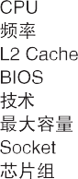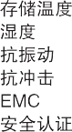

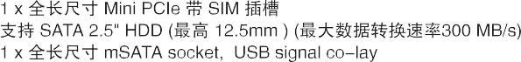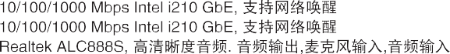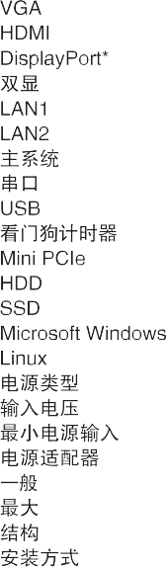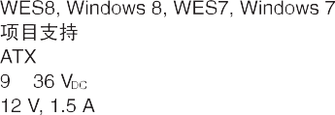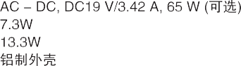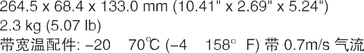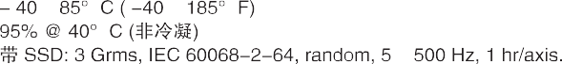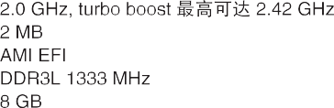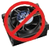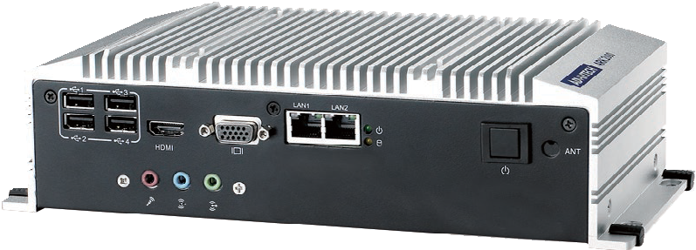

|  |  |  |
| --- | --- | --- |
|  | |  |
|  |  | |
|  | |
|  | |
|  | |
|  |  | |
|  | |
|  | |
|  |  | |
|  | |
|  | |
|  | |
|  | |
|  | |
|  |  | |
|  | |
|  |  | |
|  |  | |
|  | |
|  |  | |
|  |  | |
|  |  | |
|  | |
|  |  | |
|  | |
|  |  | |
|  | |
|  | |
|  | |
|  |  | |
|  | |
|  |  | |
|  | |
|  | |
|  | |
|  |  | |
|  | |
|  | |
|  | |
|  | |
|  | |
|  | |





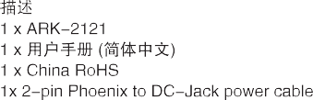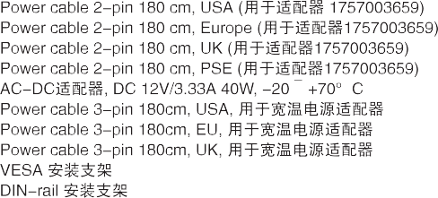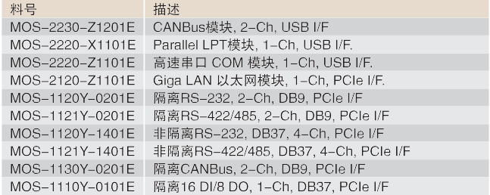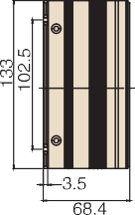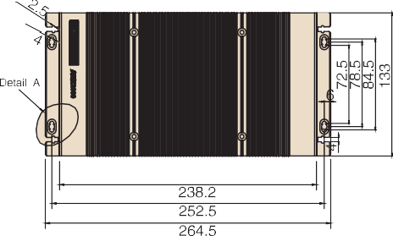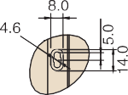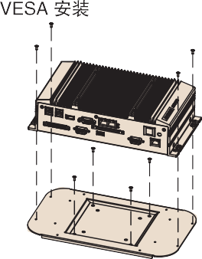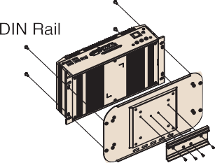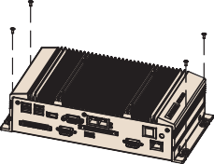



Ø



                                
                                
                                
                                



 

    
    
    
    
    
    
    

 

