USB-4751 USB-4751L

48-Ch Digital I/O USB Module 24-Ch Digital I/O USB Module
Features
- Compatible with USB 1.1/2.0
- Portable
- Bus powered
- 48/24 x TTL digital I/O
- Emulates Mode 0 of the Intel® 8255 PPI chip
- Buffered circuits offer a higher driving capacity compared to the Intel® 8255 PPI chip
- Interrupt handling capability
- Timer/Counter interrupt capability
- Supports both dry and wet contact
- 50-pin Opto-22-compatible box header
- Suitable for DIN rail mounting
- 1 x Lockable USB cable included for connection security

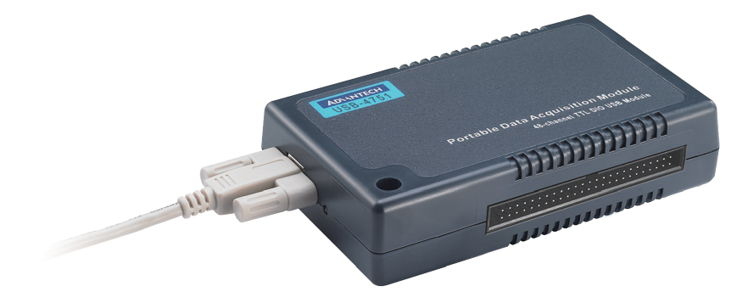Introduction
RoHS
COMPLIANT 2002/95/EC
The USB-4700 series comprises plug-and-play DAQ modules that can be installed without opening the chassis; simply plug in the modules to access collected data. Reliable and rugged enough for industrial applications, yet sufficiently affordable for home systems, USB-4700 series modules provide an easy and efficient means of adding measurement and control capabilities to USB-capable computers.
USB-4751 and USB-4751L are 48/24-bit digital I/O modules that feature a USB interface, event counter, and three 16-bit timers, which can be cascaded to provide a 32-bit timer. The 48/24 bits are divided into six/three 8-bit I/O ports that can be individually configured as input or output ports using software.

Specifications

Digital Input
- Channels USB-4751: 48 (shared with output) USB-4751L: 24 (shared with output)
- Compatibility 5 V/TTL
- Input Voltage Logic 0: 0.8 V max. Logic 1: 2 V min.

Digital Output
- Channels USB-4751: 48 (shared with input) USB-4751L: 24 (shared with input)
- Compatibility 5 V/TTL
- Output Voltage Logic 0: 0.5 V max. Logic 1: 3.8 V min.
- Output Capability Sink: 12 mA @ 0.5 V
Source: 12 mA @ 3.8 V for single channels
5 mA @ 3.8 V for all channels in high status

Counter/Timer

Channels 2
- Resolution 32-bit

Max. Input Frequency 8 MHz
General
- Bus Type USB 1.1/2.0
- I/O Connector 50-pin box headers, pin assignments are fully
compatible with Opto-22 I/O module racks
 Dimensions (L x W x H) 132 x 80 x 32 mm (5.2" x 3.15" x 1.26")
- Power Consumption Typical: 5 V @ 200 mA
Max.: 5 V @ 500 mA
- Operating Temperature 0 ~ 60 °C (32 ~ 140 °F)
- Storage Temperature -20 ~ 70 °C (-4 ~ 158 °F)
- Storage Humidity 5 ~ 95% RH, non-condensing

Ordering Information
- USB-4751-AE 48-ch digital I/O USB module
- USB-4751L-AE 24-ch digital I/O USB module

Accessories
- 1960004544 Wall mount bracket
- 1960005788 VESA mount bracket
- PCL-10150-1.2E 50-pin flat cable, 1.2 m
- ADAM-3950-AE 50-pin DIN rail flat cable wiring board
- PCLD-782B-AE 24-ch IDI board with 20-pin and 50-pin flat cables
- PCLD-785B-AE 24-ch relay board with 20-pin and 50-pin flat cables

Industrial I/O
All product specifications are subject to change without notice. Last updated: 27-Jun-2018

