PCIE-1816 PCIE-1816H

500 KS/s, 16-Bit, 16-Ch PCI Express Multifunction DAQ Card
1 MS/s, 16-Bit, 16-Ch PCI Express Multifunction DAQ Card

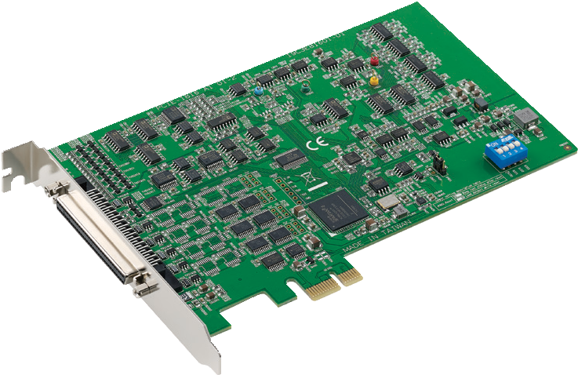
RoHS
COMPLIANT 2002/95/EC
Features
PCIE-1816
- 16 analog inputs, up to 1 MS/s, 16-bit resolution
PCIE-1816H
- 16 analog inputs, up to 5 MS/s, 16-bit resolution
PCIE-1816/1816H
- 2 analog outputs, up to 3 MS/s, 16-bit resolution
- Supports analog and digital triggers for analog I/O
- Supports waveform generation for analog output
- 24 programmable digital I/O lines
- Two 32-bit programmable counter/timers
- Onboard FIFO memory (4,000 samples)
Introduction
PCIE-1816/1816H is a 16-ch (up to 5 MS/s) multifunction DAQ card with integrated digital I/O, analog I/O, and counter functions. PCIE-1816/1816H also features analog and digital triggering support, 2-ch 16-bit analog outputs with waveform generation capability, 24-ch programmable digital I/O lines, and two 32-bit general purpose timer/counters.

Specifications

Analog Input
- Channels Single end 16

Digital I/O
- Channels 24
- Compatibility 5 V/TTL
- Input Voltage Logic 0: 0.8 V max.

Differential 8
- Resolution 16 bits
- Sample Rate PCIE-1816 Single channel 1 MS/s max.
Multiple channels 500 kS/s max.
PCIE-1816H Single channel 5 MS/s max.
Multiple channels 1 MS/s max.

- Output Voltage
- Output Capability

Counter
Logic 1: 2.0 V min.
Logic 0: 0.8 V max.
Logic 1: 2.0 V min.
Sink: 15 mA @ 0.8 V
Source: 15 mA @ 2.0 V

Note: The sampling rate of each channel is influenced by the number of used channels. For example, if 4 channels are used, the sampling rate will be 1M/4 = 250 kS/s per channel.
- Trigger Reference Digital and analog triggers
- FIFO Size 4,000 samples
- Overvoltage Protection 30 Vp-p
- Input Impedance 1 GΩ
- Sampling Mode Software and external clock
- Input Range Software programmable

PCIE-1816
Gain | 0.5 | 1 | 2 | 4 | 8
Bipolar | ±10V | ±5 | ±2.5 | ±1.25 | ±0.625
Unipolar | N/A | 0 ~ 10 | 0 ~ 5 | 0 ~ 2.5 | 0 ~ 1.25
Absolute Accuracy ( % of FSR)* | 0.0075 | 0.0075 | 0.0075 | 0.008 | 0.008

Analog Output
- Channels 2
- Resolution 16 bits
- Output Rate 3 MS/s max.
- Output Range Software programmable

Internal Reference | Unipolar | 0 ~ 5 V  0 ~ 10 V
 | Bipolar | -5 V ~ 5 V  -10 V ~ 10 V
External Reference |  | 0 ~ +x V @ -x V (-10 ≤ x ≤ 10)
- Slew Rate 20 V/µs
- Driving Capability 5 mA
- Operation Mode Static update, waveform generation
- Accuracy INLE: ± 4 LSB, DNLE: ± 1 LSB
- Channels 2
- Resolution 32 bits
- Compatibility 5 V/TTL
- Max. Input Frequency 10 MHz
- Pulse Generation Yes
- Timebase Stability 50 ppm

General
- Form Factor PCI Express x1
- Triggering 2 x Analog/2 x digital (16 bits)
- I/O Connector 68-pin SCSI, female
 Dimensions (L x W) 167 x 100 mm (6.6" x 3.9")
- Power Consumption Typical: 3.3 V @ 488 mA
12 V @ 112 mA
Max.: 3.3 V @ 2.25 A
12 V @ 390 mA
- Operating Temperature 0 ~ 60 °C (32 ~ 140 °F)
- Storage Temperature -40 ~ 70 °C (-40 ~ 158 °F)
- Storage Humidity 5 ~ 95% RH non-condensing

Ordering Information
- PCIE-1816-AE 1 MS/s, 16-bit multifunction card
- PCIE-1816H-AE 5 MS/s, 16-bit multifunction card

Accessories
- PCL-10168H-1E 68-pin SCSI shielded cable with noise rejection, 1 m
- PCL-10168H-2E 68-pin SCSI shielded cable with noise rejection, 2 m
- PCL-10168-1E 68-pin SCSI shielded cable, 1 m
- PCL-10168-2E 68-pin SCSI shielded cable, 2 m
- ADAM-3968-AE 68-pin DIN rail SCSI wiring board
- PCLD-8810E-AE 68-pin SCSI DIN-rail Wiring Board for PCIE-1800 series
- PCLD-8811-AE Low-Pass Active Filter Boar

Industrial I/O
All product specifications are subject to change without notice. Last updated: 27-Jun-2018

