PCI-1710
PCI-1710HG

100 KS/s,12 PCI ¾
@Ø "#$%&

100 KS/s,12 p !
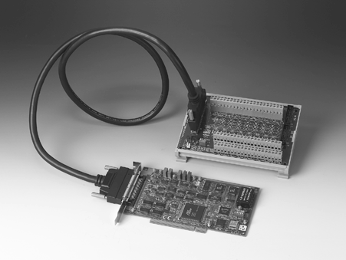PCI ¾@ !#$%&'
PCI-1710/1710L/1710HG/1710HGL
PCLD-8710
- 16 !"#$ 16 !"#
- !"# / ;
- BoardIDTM fl
- !
12 ƒ !"#
- 2
#A
- 16 ! 8 § !"#$%& ‰ !"#$
- 12 ƒ A/D § !çfl "# 100 KHz
- !"# %&'()
- !"#$%&'(
- [ 4 K çfl FIFO

$ä
PCI-1710 fi ! PCI õ !"#$%&'(%] " $% '()*+,- ./0,1 234‰% !"#%&' )*+,-./:
12 ƒ A/D § D/A § y !"# y !"#$ % / ; !"#

fi$

!"
- ‰ 16 ! 8 § !"#$%
(fi !"#$
- 9 12 ƒ
- Ø‡ FIFO 4 K çfl
- $ ! ± 30 V

- ‡ ! ($ !fifl !"#

¼ | PCL-1710/1710L | PCI-1710HG/1710HGL
: | ± 10, ± 5, ± 2.5, | ±10, ±5, ±1, ±0.5, ± 0.1
 | ± 1.25, ± 0.625 | ± 0.05, ± 0.01, ± 0.005
$ | 0 ~ 10, 0 ~ 5, 0 ~ 2.5, | 0 ~ 10, 0 ~ 1, 0 ~ 0.
 | 0 ~ 1.25 | 1, 0 ~ 0.01
- ¾ !" (CMRR)

PCL-1710/1710L |  | PCI-1710HG/1710HGL
 | ¾ !" |  | ¾ !"
0.5, 1 | 75 dB | 0.5, 1 | 75 dB
2 | 80 dB | 10 | 90 dB
4 | 84 dB | 100 | 106 dB
8 | 84 dB | 1000 | 106 dB
- p !"# (S/s,$¾ PGIA %½ !"

¼ |  | p !"#
PCL-1710/1710L | 0.5, 1, 2, 4, 8 | 100 kS/s
PCI-1710HG/ 1710HGL | 0.5, 1 | 100 kS/s
 | 5, 10 | 35 kS/s
 | 20, 100 | 7 kS/s
 | 500, 1000 | 770 S/s
:çfl "#$%&'()*+,-). 0çfl " $%&
fi¾ "CPU $ ! #$%&'#$(

- ($¾ !")
* S.E:$ D:þ9

PCL-1710/1710L |  | PCI-1710HG/1710HGL
 |  |  | 
0.5, 1 | FSR 0.01% ± 1 LSB | 0.5, 1 | FSR 0.01% ± 1 LSB | S.E/D
2 | FSR 0.02% ± 1 LSB | 5, 10 | FSR 0.02% ± 1 LSB | S.E/D
4 | FSR 0.02% ± 1 LSB | 50, 100 | FSR 0.04% ± 1 LSB | D
8 | FSR 0.04% ± 1 LSB | 500, 1000 | FSR 0.08% ± 1 LSB | D
- ⎝ ! ± 1 LSB
- ‡ ! 1 GΩ
- @ ! fifl !" ! #$%&'($%

!" (@ ! PCI-1710/1710HG)
- ‰ 2
- 9 12 ƒ
- fi  ± 1/2 LSB
- ! ± 1 LSB
- $ PC,fifl !(Direct AO)
- $ ! 10 V/ms
- $ ! fi !"#:0 ~ +5 V @ -5 V,
(fi !"#$ 0 ~ +10 V @ -10 V
fi !"#:0 ~ +x V @ -x V (-10 ≤ x 10)
- fi ! 10 mA

y !"
- ‰ 16
- ‡ ! ¼$ : 0.4 V( !
$ : 2.4 V( !
- ‡ ! ¼$ : -0.2 mA @ 0.4 V
$ : 20 mA @ 2.7 V

6-10
‡ !"#$%&'

fi$(:

fi !
PCI-1710 PCI-1710HG

fifl
1

y !"
  - ‰ 16
  - $ ! ¼$ :0.4 V( !@ 8.0 mA(
$ :2.4 V( !@ -0.4 mA(

! # / fi
  - fi® " 82C54 !"
  - fi® 3 ‰ 16 ƒ,2 !"#$% 32 ƒ !
¼; !"#$1 !"#"
  - ‡ !"fi fl TTL/CMOS
◆ $ ‰ 1:10 MHz
‰ 2: ) !" 1
‰ 0:$fi !"#$ 1 MHz fi (
$ 10 MHz)
PCI-1710 fi !"#$%&()* , :
PCI-1710 100 KS/s,12 ƒÇ !"#$%&
PCI-1710L 100 KS/s,12 ƒÇ !"#$%&'fl AO PCI-1710HG 100 KS/s,12 ƒ !"#$%&'()
PCI-1710HGL 100 KS/s,12 ƒ !"#$%&'()*fl AO

$ !"#$ &'()*
PCI-1710/1710HG $— !"#$ / !"$ $ !"$%
fi !"#$&' )*+ ƒ[ SRAM fl !"#$%& (
!"#‰ !"#$%&'()+&' -./ !"#
!"#$%&'() +-.( 100 KHz)

$§ FIFO(¢ ¢!"$‰
PCI-1710/1710/1710HG/1710HGL ƒ[ !" FIFO !; !
4K A/D çfl ! FIFO !PCI-1710 PCI-1710HG çy !

IPPC

TPC
2
3
4

FPM
5

ATM &AWS

— !
  - CE CISPR 22 class B fifi
  - I/O ®§ 68 SCSI-II flfi !
  - fl +5 V @ 850 mA( !"
+5 V @ 1.0 A( !
$ ! "#$%& )*+,- Windows fl ! #$% DA&C

ƒ[ !"#$%
6
7
PCI-1710/1710/1710HG/1710HGL !"# %&'($ƒ A/
cPCI
D q !"#$&fi !"# 82C54 fl 82C54 !"#;
8

º º !" 16 ƒ 10 MHz !"#$%$ !"#$%&'()
  - ‡fl  0 ~ 60 C (32 ~ 140 F) ( ½ IEC 68-2-1, 2)
º º fi !$ !"#$ &'()*+, flfi !"#$%&'()*

  - ‰fl  -20 ~ 70 C (-4 ~ 158 F)
  - ‡fl  5% ~ 95% RH,fl ( IEC 68-2-3)
  - flfl (L x H) 175 x 100 mm (6.9" x 3.9")
  - MTBF fl !"25º C fi !" 64,770 fi

fi !
  - PCI-1710 100 KS/s,12 ƒÇ !"#$%&'$fl "
fifi ! CD-ROM (fl !"#
  - PCI-1710L 100 KS/s,12 ƒÇ !"#$%&(fl AO),
$fl "#$%& CD-ROM (fl !"#
  - PCI-1710HG 100 KS/s,12 ƒ !"#$%&'()*$fl
$ !"#$ CD-ROM (fl !"#
  - PCI-1710HGL 100 KS/s,12 ƒ !"#$%&'()(fl
AO),$fl "#$%& CD-ROM (fl !"#
  - PCLD-8710 CJC $ $ƒ DIN ¤fl ! #$%&'
(fl !"#
  - PCL-10168 fl !"#$ 68 SCSI-II $Š $ !
fi¼ ! #$ &'fi 1
  - PCL-10168-2 fl !"#$ 168 SCSI-II $Š $ !
fi¼ ! #$ &'fi 2
  - ADAM-3968 DIN ¤fl ! 68 SCSI-II !
$fl "# 32 ƒ; !"

$† !"#%&'()*
PCL-10168 !"#$% PCI-1710/1710HG ";$ !
¼ !"#$ &'( $ !"#%& !"#$%&'"#
% ! # %‰fl "#$ &'()*+,-.  EMI/EMC
!"# &'(

$ !

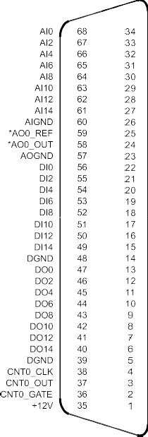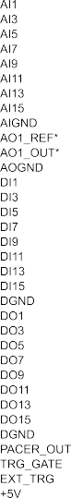
ADAM-3000

fi !
9
ICOM
10
eConnectivity
11
UNO
12
ADAM-4000
13
ADAM-5000
14
ADAM-6000
15

6-11
fl@ !
www.advantech.com.cn/products
ADAM-8000
16
BAS
17

