Intel®Xeon® E3 / Core™ i3/i5/i7 LGA1151 Modular Expansion Fanless Box PC
ARK-3530L
Features
- Support Intel® Xeon® / 6th & 7th Gen. Core™ i3/i5/i7 processor
- Triple independent display: VGA + HDMI + Optional Display
- DDR4 SO-DIMM memory support up to 32 GB
- Option 9-36V power module compatible with all-in-one ordering
- Optional modular design for 2.5" hard drive bays: internal /removable (support up to 4 sets)
- Advantech iDoor module compatible
- Advantech EMIO miniPCIe module compatible with all-in-one ordering
- Advantech ARK Plus AMO-3xxx series module compatible

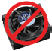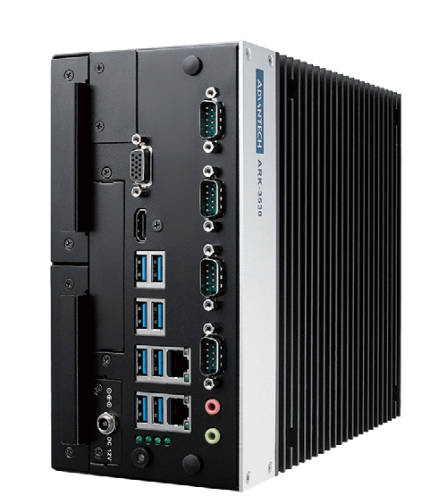Specifications
NEW
LISTED
C L _{US}
U
®
RoHS
COMPLIANT
2002/95/EC

E180881

Processor System | CPU | E3-1235L V5 | i7-7700/i7-6700 | i5-7500 | i3-7101E
 | Frequency | 2.0GHz | 3.6GHz/3.4GHz | 3.4GHz | 3.9GHz
 | L3 Cache | 8MB | 8MB | 6MB | 3MB
 | TDP | 25W | 65W | 65W | 54W
 | Chipset | C236
 | BIOS | AMI EFI 127Mbit
Memory | Technology | DDR4 2133 MHz
 | Max. Capacity | 32 GB
 | Socket | 2 x 260-pin SO-DIMM
Graphics | Chipset | Intel® HD Graphics 630
 | Graphic Engine | Direct x 12, OpenGL 4.4  HW Encode: H.265/HEVC, H.264/MPEG-4 AVC, MPEG-2, JPEG/MJPEG and VP8.  HW Decode: H.265/HEVC, H.264/MPEG-4 AVC, MPEG-2, VC-1/WMV9, JPEG/MJPEG, VP8 and VP9
 | VGA | 1920x1200@ 60Hz
 | HDMI | 1 HDMI port, HDMI 2.0 for HD video playback, 3840x2160@30Hz
 | Optional 3rd Display module | DVI-D / DP / HDMI Display Port
 | Triple Display | VGA+HDMI + 3rd display module
Ethernet | LAN1 | 10/100/1000 Mbps Intel I219-LM GbE, support Wake On Lan
 | LAN2 | 10/100/1000 Mbps Intel I210 GbE, support Wake On Lan
Audio | Interface | Realtek ALC888S, High Definition Audio, Line-out, Mic-in
Others | Watch dog Timer | 255-level timer interval, setup by software
 | TPM | TPM 2.0 (Optional by project support)
I/O Interface | Serial Port | 4 x RS-232/422/485 port with auto flow control; COM 1 support 5V/12V power supply (by jumper)
 | USB | 8 x USB 3.0 ports
 | P/S2 | 1 Port support by cable and bracket (Optional)
 | Optional I/O | 16bit DIO or 2 x RS-232 ports
Expansions | Mini PCIe | 2 x Full-size Mini PCIe (2 x support mSATA, 1 x support SIM optional AMK-A0028E)
 | M.2 1 x E key for WiFi
 | i Door | 1 set (Optional)
 | ARK Plus | AMO-3505E 2 slot Riser card for 2 x PCI, AMO-3506E 2 slot Riser card for 2 x PCIex8
Storage | HDD | 2 x 2.5" SATAIII HDD Bay with Max Height 15mm (Support Up to 4 x 2.5" SATAIII HDD Bay by Project)
 | mSATA | 2 x mSATA socket (Share with Mini PCIe)
Software Support | Microsoft Windows | Windows 10 (Windows 7 for 6th Gen CPU only)
 | Linux | By Project Support
Power Requirements | Power Type | AT/ATX
 | Power Input Voltage | 12V (9-36V as optional)
 | Power Adapter | AC to DC, 150W (Optional)
Power Consumption (CPU/Memory Only) | Typical | 25.68W
 | Max. | 88.92W
Mechanical | Construction | Aluminum housing
 | Mounting | Desk mounting
 | Dimensions (W x H x D) | 105 x 205 x 230 mm (4.13" x 8.07" x 9.06")
 | Weight | 5.1Kg
Environment | Operating Temperature | 25W/35W/65W(only 6th Gen) Processor with extended temp peripherals: -20 ~ 60° C with 0.7m/s air flow Under 73W processor with HDD: 0 ~ 40° C with 0.7m/s air flow
 | Storage Temperature | -40 ~ 85° C
 | Relative Humidity | 95% @ 40° C (non-condensing)
 | Vibration During Operation | With SSD: 3 Grms, IEC 60068-2-64, random, 5 ~ 500 Hz, 1 hr/axis.
 | Shock During Operation | With SSD: 30 G, IEC 60068-2-27, half sine, 11 ms duration
 | EMC | CE/FCC Class B, CCC, BSMI
 | Safety | CB, UL, CCC, BSMI

Fanless Embedded Box PCs
All product specifications are subject to change without notice. Last updated: 28-Mar-2019

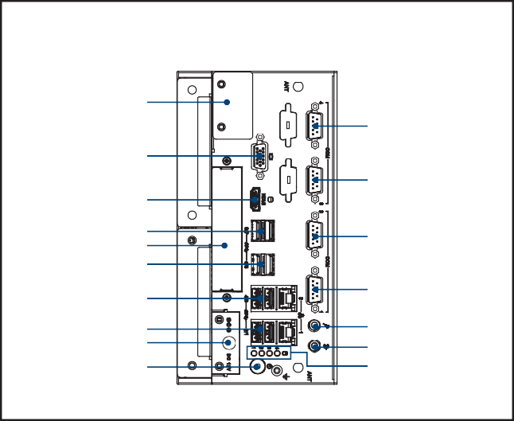
MIC in Line out HDD LED
COM1
USB 3/4 LAN2
USB 1/2 LAN1
DC in
Power on/off
COM2
HDMI
USB 7/8
iDoor USB 5/6
COM3
VGA
COM4
Optional Display
Front Panel External I/O Mechanical Layout/Drawing

Ordering Information

Part No. | CPU | DDR4 | GbE | VGA | HDMI | Option 3rd display module | RS-232/422/485 | USB 3.0 | MiniPCIe | SIM | M.2 | DC Input | Expansion
ARK-3530L-00A1 | LGA1151  Socket Type | Up to 32GB | 2 | 1 | 1 | 1 | 4 | 8 | 2 | 1 | 1 | 12V | Optional

Note: CPU/Memory/Storage and operating system bundled by request.

Packing List

Embedded OS

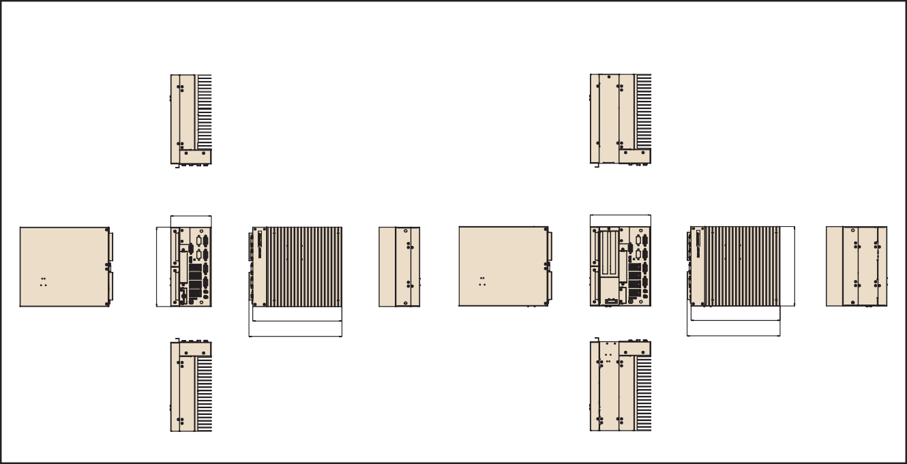
230
240
230
240
156.50
105
Unit: mm
Dimensions
205
205
Part Number | Description
- | ARK-3530L Unit
- | User Manual (Simplified Chinese)
- | China RoHS

Part Number | Description
20706WX6HS0006 | WIN10 IoT LTSB 64bit for Xeon and Core i7
20706WX6VS0012 | WIN10 IoT LTSB 64bit for Core i3/i5 and Celeron

Online Download www.advantech.com/products

ARK-3530 Default SKU Option Items

Optional Item for Default SKU

Part Number | Description
XARK-DPS-150AB-15 | AC-to-DC Adapter, DC12V 150W
96PSA-A150W12W7 | AC-to-DC Adapter, DC12V 150W
1700028547-01 | 16bit DIO Cable
1700028548-01 | COM5/6 Cable
1702002600 | Power cable 3-pin 183cm, USA type
1702002605 | Power cable 3-pin 183cm, EU type
1702031801 | Power cable 3-pin 183cm, UK type
1700000237 | Power cable, 3-Pin 183cm, PSE type

Optional MOS modules for iDoor Expansion

Part Number | Description
MOS-2230-Z1201E | CANBus module, 2-Ch, USB I/F
MOS-2220-X1101E | Parallel LPT module, 1-Ch, USB I/F.
MOS-2220-Z1101E | High Speed Com USB module, 2-Ch, PCIe I/F
MOS-2120-Z1101E | Giga LAN Ethernet module, 1-Ch, PCIe I/F.
MOS-1120Y-0202E | Isolated RS-232, 2-Ch, DB9, PCIe I/F
MOS-1121Y-0202E | Isolated RS-422/485, 2-Ch, DB9, PCIe I/F
MOS-1120Y-1402E | Non-Isolated RS-232, DB37, 4-Ch, PCIe I/F
MOS-1121Y-1402E | Non-Isolated RS-422/485, DB37, 4-Ch, PCIe I/F
MOS-1130Y-0201E | Isolated CANBus, 2-Ch, DB9, PCIe I/F
MOS-1110Y-0101E | Isolated 16 DI/8 DO, 1-Ch, DB37, PCIe I/F
MOS-2110Z-1201E | USB module, 2-Ch, PCIe I/F
MOS-2120-Z1201 | Dual Intel I210 GbE LAN iDoor, 2-Ch, PCIe I/F
*Please noted ARK-3530L can support only 1 iDoor.

Optional 9-36V DC Power Module

Part Number | Description
AMO-P010E | 9-36V DC input power module for ARK-3530L
96PSA-A150W19P4-1 | AC-to-DC Adapter, DC19V 150W, 0 ~ 40° C (for AMO-P010E)
96PSA-A220W24P4-1 | AC to DC adapter, DC 24V 220W, -20 ~ 60° C (For AMO-P010E)
1702002600 | Power cable 3-pin 183cm, USA type
1702002605 | Power cable 3-pin 183cm, EU type
1702031801 | Power cable 3-pin 183cm, UK type

ARK-3530L Optional HDD expansion Kit (Support up to 2 sets)

Part Number | Description
AMK-A0028E | 1 x internal HDD Kit (Max Height 15mm)
* Choose either AMO-P010E or AMK-A0028E

Optional Display Module
ARK Plus Extended Modules

AMO-3505E

2 Slots Riser Card Expansion Module: 2 x PCI
Specifications

General
Add on card support | 2 Slot for 2xPCI  Max Card size: 110 mm(H) x 180 mm (L) Max Power consumption: 10W for each slot
HDD/SSD | NA
Mechanical
System Dimension | 155 x 205 x 230 mm

Ordering Information

P/N | Description
AMO-3505E | 2 Slot Riser Card (2xPCI)

AMO-3506E

2 Slots Riser Card Expansion Module: 2 x PCIex8
Specifications

General
Add on card support | 2 Slot for 2 x PCIex8  Max Card size: 110 mm(H) x 180 mm (L) Max Power consumption: 10W for each slot
HDD/SSD | NA
Mechanical
System Dimension | 155 x 205 x 230 mm

Ordering Information

P/N | Description
AMO-3506E | 2 Slot Riser Card (2 x PCIex8)

Part Number | Description
AMO-D001E | DVI-D module
AMO-D002E | DP module
AMO-D003E | HDMI module

Fanless Embedded Box PCs

