ARK-2231R
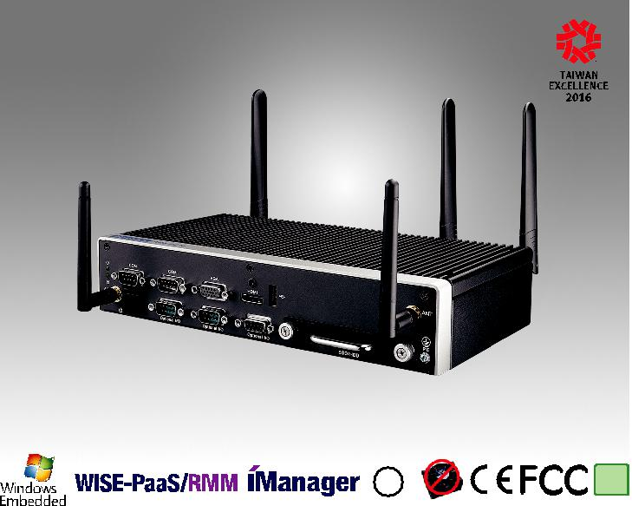

LISTED
C ^{U}®L US | RoHS
 | COMPLIANT
 | 2002/95/EC
E180881

Specifications

EN50155 Intel® Atom E3845 SoC Rolling Stock Fanless System

Features

 Intel® E3845 Quad Core 1.91 GHz SoC

 Stackable extension design, option extension kit for applications  DC 24V EN50155 S2/C1 compliant, DC 48/72/110V options

 -40 ~ 70 °C wide temperature support with EN50155 TX compliant  Solid connection for LAN/USB/Audio/COM and power input  Anti-vibration/shock proof, IEC61373 Category1, ClassB

 Built-in Advantech remote management software WISE-PaaS/RMM

 |  | ARK-2231R-S9A1E
 | CPU | Intel® E3845 Quad Core
Processor System | Frequency | 1.91 GHz
 | L2 Cache | 2 MB
 | BIOS | AMI EFI
 | Technology | DDR3L 1333 MHz
Memory | Max. Capacity | 8 GB
 | Socket | 1 x 204-pin SO-DIMM
 | Chipset | Intel® Gen7 Graphics
 |  | DirectX 11.1, OCL 1.2, OGL 3.2
 | Graphic Engine | Encode: H.264, MPEG2/4, VC1, WMV9
Graphics |  | Decode: H.264, MPEG2
 | VGA | Up to 2560 x 1600 @ 60Hz
 | HDMI | HDMI 1.4a for HD video playback, 1080P at 60Hz
 | Dual Display | Yes, VGA + HDMI
Ethernet | LAN1 | 10/100/1000 Mbps Intel i210 GbE, support Wake On Lan, M12 X-Coded
 | LAN2 | 10/100/1000 Mbps Intel i210 GbE, support Wake On Lan, M12 X-Coded
Audio | Interface | Realtek ALC888S, High Definition Audio. Line-out,Mic-in,Line-in
 | Serial Ports | 2 x RS-232/422/485 port with auto flow control
IO Interface | USB Interface | 1 x USB2.0/3.0 Water-proof, 1 x USB2.0 M12 A-Coded, 1 x USB2.0 Type A
 | GPIO | 8bit Programable DI/DO
 | GPS | On board standalone GPS, support GPS, GLONASS, GALILEO , BeiDou and QZSS signals
Other | G-Sensor | On board high resolution G-Sensor, up to 13-bit resolution at ± 16g
 | Watchdog timer | 255 levels timer interval, setup by software
 |  | 1 x Full-size Mini PCIe (SATA/PCIe/USB)
Expansion | Mini PCIe | 1 x Full-size Mini PCIe (PCIe/USB)
 |  | 1 x Full-size Mini PCIe (USB) w/Accessible SIM socket
Storage | SSD/HDD | 1 x 2.5" SATA drive bay
 | mSATA | 1 x full size mSATA socket
Software Support | Microsoft Windows | Win7, WES7, Win8, WSE8, Win10
 | Linux | Support by project
 | Power Type | ATX
Power Requirement | Power Input Voltage | DC 24V - StandardDC 48/72/110V - Options
 | Regulation | EN50155 S2/C1 Compliant
 | Power Adapter | 24V/ 150W (Option)
Power Consumption | Typical | 18W
 | Max. | 45W
 | Construction | Aluminum housing
Mechanical | Mounting | Wall / VESA / DIN-Rail Kit options
 | Dimensions (W x H x D) | 260 x 57 x 160.2 mm
 | Weight | 2.3 kg (5.07 lb)
 | Operating Temperature | With extended temperature peripherals: -40 ~ 70 °C EN50155 TX
 | Storage Temperature | - 40 ~ 85 °C ( -40 ~ 185 °F)
 | Relative Humidity | 95% @ 40 °C (non-condensing)
Environment | Vibration During Operation | IEC61373 Category1, Class B
 | Shock During Operation | IEC61373 Category1, Class B
 | EMC | CE/FCC Class B, CCC, BSMI, EN50155
 | Safety Certifications | UL, CCC, BSMI, CB, EN50155

Fanless Embedded Box PCs

All product specifications are subject to change without notice. Last updated: 13-Nov-2018

ARK-2231R

Dimensions

ARK-2231R
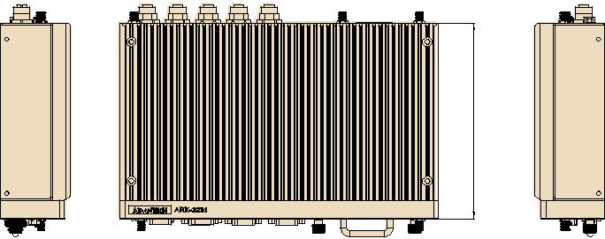

2160.

260.0
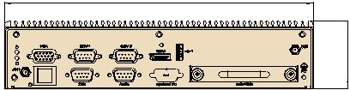

057.

ARK-2231R+AMK-R100E | Unit: mm
 | 2160.
83.6 | 260.0
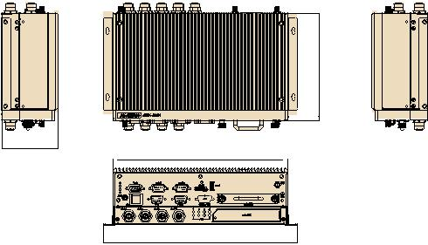

288.0
ARK-2231R+AMK-R102E
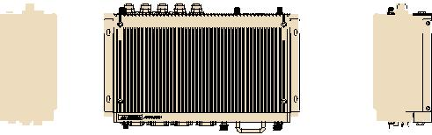

160.2

_{83.6} 260.0

288.0

Front Panel External I/O Mechanical Layout/Drawing | Rear Panel External I/O Mechanical Layout/Drawing

VGAVGA COM COM HDMI USBUSB2.20.0 | RemoteControl | USB2.0/3.0/3..0 USBUSB2.20.0
ON/OFFF DIODIO Audio OptionalI/OI/O SSD/HDSD/HDD |  | DCDCINPUT | SIMSIM | LANLAN

Ordering Information

Part No. | CPU | RAM | Display GbE |  | USB | USB 2.0/ | DIO | RS-232/ | Audio | Full-size | SIM | mSATA | 2.5" SATA II | Power | Operating
 |  |  |  |  | 2.0 | 3.0 |  | 422/485 |  | MiniPCIe |  |  | Drive Bay | Input | Temp.
ARK-2231R-S9A1E | Intel® Atom E3845 DC | Up to | 1 x HDMI | 2 | 2 | 1 | 8 bit | 2 | Lin-out, | 3 | 1 | 1 | 1 | 24 VDC | -40 ~ 70 °C
 | 1.91GHz | 8G | 1 x VGA |  |  |  |  |  | Line-in,
 |  |  |  |  |  |  |  |  | MIC

Note: Memory, storage and operating system bundled by request.

Packing List |  | Optional Item for Default SKU
Part Number | Description | Part Number | Description
ARK-2231R-S9A1E | 1 x ARK-2231R Unit | XARK-FSP180-AAAN2 | AC-to-DC Adapter, DC24V/150W
- | 1 x User Manual (Simplified Chinese) | 1702002600 | Power cable 3-pin 183cm, USA type
- | 1 x China RoHS | 1702002605 | Power cable 3-pin 183cm, EU type
1750006432 | 1 x GPS antenna 5000mm | 1702031801 | Power cable 3-pin 183cm, UK type
1960071555N011 | 2 x Wall mounting brackets for ARK-2231R | 1700029009-01 | M12 | A-coded to USB type A female, 10cm
1652001524 | 1 x Terminal Block 6P 5.00mm | 1700028852-01 | M12 | X-coded to RJ-45 female, 10cm
 |  | 1700028854-01 | M12 | A-coded to 5pin terminal block (for DC input), 10cm
Optional Embedded OS
Part Number | Description
2070015162 | WES7E 64bit ENG/T-CH/S-CH/JP
TBD | WES8E 64bit ENG/T-CH/S-CH/JP

Note: Default BIOS is for 64bit OS support only. 32bit OS will need to update BIOS

Online Download www.advantech.com/products

ARK-R Extended Modules

ARK-2231R+AMK-R100E

Extra 8 x GbE PoE + removable 2.5" drive bay
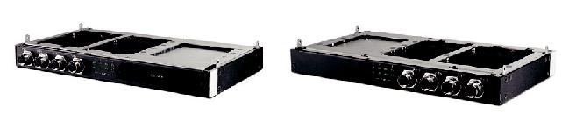

Specifications

General
PoE | 8 x 10/100/1000Base T(X) PoE+, 802.3at compliant, Total: 60W
PoE Connector | M12 X-coded, 8PIN
Drive bay | 1 x Removable 2.5" drive bay
Power Consumption | 75W (Max)
Mechanical
Dimension | 260 x 26.5 x 160.2
Environment
Operating temperature | -40 ~ 70 °C, EN50155 TX
Shock/Vibration | IEC61373 Category1, Class B

Ordering Information

P/N | Description
AMK-R100E | 8 x GbE PoE M12 X-coded, 1 x removable 2.5" drive bay

ARK-2231R+AMK-R104E

Extra 8 x 10/100 Mbps PoE + removable 2.5" drive bay

Specifications

General
PoE | 8 x 10/100 Base T(X) PoE+, 802.3at compliant, Total: 60W
PoE Connector | M12 D-coded, 4PIN
Drive bay | 1 x Removable 2.5” drive bay
Power Consumption | 75W (Max)
Mechanical
Dimension | 260 x 26.5 x 140
Environment
Operating temperature | -40 ~ 70 °C, EN50155 TX
Shock/Vibration | IEC61373 Category1, Class B

Ordering Information

P/N | Description
AMK-R104E | 8 x 10/100 Mbps PoE M12 D-Coded, 1 x removable 2.5" drive bay

Fanless Embedded Box PCs

ARK-2231R+AMK-R101E

Extra 4 x GbE PoE + removable 2.5" drive bay
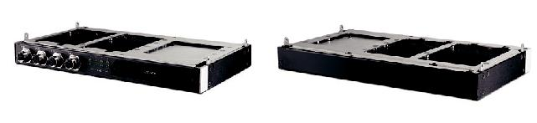

Specifications

General
PoE | 4 x 10/100/1000Base T(X) PoE+, 802.3at compliant, Total: 60W
PoE Connector | M12 X-coded, 8PIN
Drive bay | 1 x Removable 2.5" drive bay
Power Consumption | 75W (Max)
Mechanical
Dimension | 260 x 26.5 x 160.2
Environment
Operating temperature | -40 ~ 70 °C, EN50155 TX
Shock/Vibration | IEC61373 Category1, Class B

Ordering Information

P/N | Description
AMK-R101E | 4 x GbE PoE M12 X-coded, 1 x removable 2.5" drive bay

ARK-2231R+AMK-R105E

Extra 4 x 10/100 Mbps PoE + removable 2.5" drive bay

Specifications

General
PoE | 4 x 10/100 Base T(X) PoE+, 802.3at compliant, Total: 60W
PoE Connector | M12 D-coded, 4PIN
Drive bay | 1 x Removable 2.5” drive bay
Power Consumption | 75W (Max)
Mechanical
Dimension | 260 x 26.5 x 140
Environment
Operating temperature | -40 ~ 70 °C, EN50155 TX
Shock/Vibration | IEC61373 Category1, Class B

Ordering Information

P/N | Description
AMK-R105E | 4 x 10/100 Mbps PoE M12 D-Coded, 1 x removable 2.5" drive bay

