ARK-2121F

Intel® Celeron® Quad Core J1900 SoC with Multiple I/Os Fanless Box PC

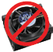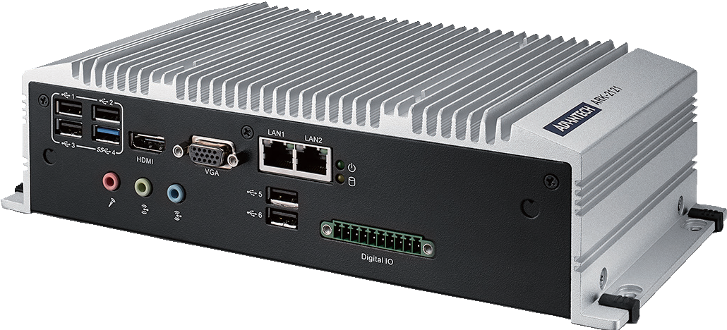
LISTED
C
U
®
L _{US}
RoHS
COMPLIANT 2002/95/EC
E180881
Features
- Intel® Celeron® J1900 Quad Core 2.0 GHz SoC with Turbo boost support
- VGA and HDMI dual independent display
- 6 x COM, 6 x USB, isolated DIO
- 9 ~ 36 VDC wide range power input
- -20 ~ 70° C extend temperature operating
- Mini PCIe expansion with SIM holder for communication module
- mSATA and 1 x 2.5" SATA storage device
- Optional DVI/2nd HDMI/4x GbE by project support
- Internal USB for security dongle

Specifications
 |  | ARK-2121F-U0A1E
Processor System | CPU | Intel Celeron Processor J1900 Quad Core SoC
 | Frequency | 2.0 GHz, turbo boost up to 2.42 GHz
 | L2 Cache | 2 MB
 | BIOS | AMI EFI
Memory | Technology | DDR3L 1333 MHz
 | Max. Capacity | 8 GB
 | Socket | 1 x 204-pin SO-DIMM
Graphics | Chipset | Intel Celeron J1900 SoC integrated, 7th Gen. Intel Graphic core
 | Graphic Engine | DirectX 11.1, OCL 1.2, OGL 3.2 Encode: H.264, MPEG2/4, VC1, WMV9 Decode: H.264, MPEG2
 | VGA | Up to 2048 x 1152 @ 60Hz
 | HDMI | 1 HDMI port (default), HDMI 1.4a for HD video playback, 1080P at 60Hz (2nd HDMI support by project only)
 | DisplayPort* | Up to 2560 x 1600 at 60Hz (by Project only)
 | DVI-D | Up to 1920 x 1200 at 60Hz (by Project only)
 | Dual Display | Yes, VGA + HDMI
Ethernet | LAN1/LAN2 | 10/100/1000Mbps Intel i210 GbE, support Wake On LAN, optional LAN3/LAN4 support by project
Audio | Interface | Realtek ALC888S, High Definition Audio. Line-out,Mic-in,Line-in
IO Interface | Serial Ports | 6 x RS-232/422/485 with auto flow control
 | USB Interface | 1 x USB 3.0, 5 x USB 2.0, 1 x internal USB 2.0 for security dongle
 | PS/2 | Yes ( by project only)
Other | Watchdog timer | 255 levels timer interval, setup by software
 | Digital I/O | 4ch digital input and 4ch digital output with 3kV isolation
Expansion | Mini PCIe | 2 x full size Mini PCIe (1 with SIM holder)
Storage | HDD | Supports one SATA 2.5" HDD Bay (Compatible with 12.5mm height HDD) (Max. Data Transfer Rate 600 MB/s)
 | mSATA | 1 x full size mSATA socket, with USB signal co-lay
Software Support | Microsoft Windows | WES8, Windows 8, WES7, Windows 7
 | Linux | Support by project
Power Requirement | Power Type | ATX
 | Power Input Voltage | 9 ~ 36 VDC
 | Minimum Power Input | 12 V, 1.5 A
 | Power Adapter | AC to DC, DC19 V/3.42 A, 65 W (Optional)
Power Consumption | Typical | 8.4W
 | Max. | 16.2W
Mechanical | Construction | Aluminum housing
 | Mounting | Din-Rail mounting, Desk/wall-mounting, VESA mounting
 | Dimensions (W x H x D) | 264.5 x 68.4 x 133.0 mm (10.41" x 2.69" x 5.24")
 | Weight | 2.3 kg (5.07 lb)
Environment | Operating Temperature | With extended temperature peripherals: -20 ~ 70° C (-4 ~ 158° F) with 0.7m/s air flow With 2.5-inch hard disk 0 ~ 45° C (32 ~ 112° F) with 0.7m/s air flow
 | Storage Temperature | - 40 ~ 85° C ( -40 ~ 185° F)
 | Relative Humidity | 95% @ 40° C (non-condensing)
 | Vibration During Operation | With SSD: 3 Grms, IEC 60068-2-64, random, 5 ~ 500 Hz, 1 hr/axis.
 | Shock During Operation | With SSD: 30 G, IEC 60068-2-27, half sine, 11 ms duration
 | EMC | CE/FCC Class A, CCC, BSMI
 | Safety Certifications | UL, CB, CCC, BSMI
* DisplayPort is supported by project only.
Fanless Embedded Box PCs
All product specifications are subject to change without notice Last updated : 5-Oct-2015

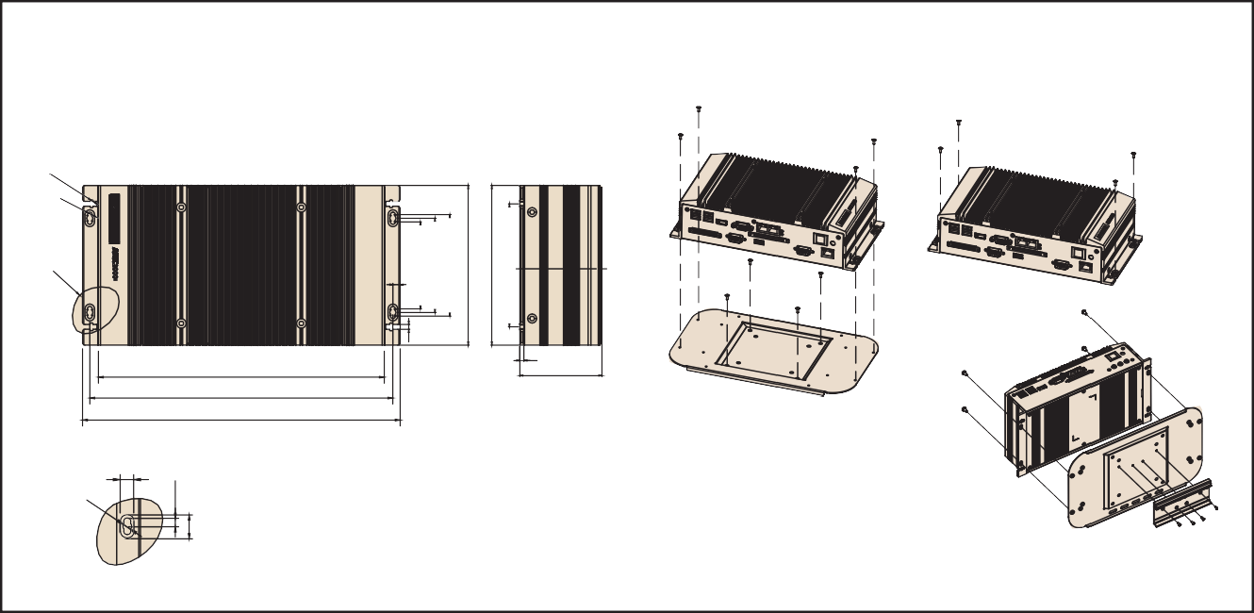
ARK-2121F
DIN Rail
3.5
68.4
238.2
252.5
264.5
6
Detail A

4
72.5
78.5
84.5
133
133
102.5

Dimensions
VESA mount Wall mount
Unit: mm

8.0

Ø4.6

Detail A

Front Panel External I/O Mechanical Layout/Drawing
Rear Panel External I/O Mechanical Layout/Drawing

USB3 USB4
HDMI LINE-OUT VGA
Digital IO
ON/OFF
COM6
COM2 COM1

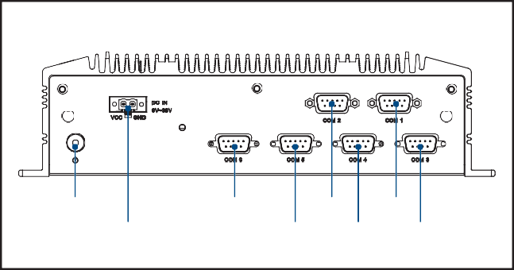
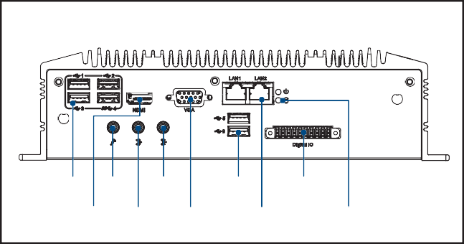
Ordering Information
DC INPUT COM5 COM4 COM3
LAN1 LAN2 PWR LED HDD LED
USB6
USB1 USB2 MIC LINE-IN USB5
5.0
14.0

Part No. | CPU | VGA | HDMI/DP* | GbE | USB 2.0 | USB 3.0 | RS-232/ 422/485 | Audio | Full-size MiniPCIe | SIM | mSATA | 2.5" SATA II  HDD Bay | Power Input | Operating Temp.
ARK-2121F-U0A1E | Intel Celeron J1900 2.0GHz | Yes | Yes | 2 | 5 | 1 | 6 | Lin-out, Line-in, MIC | 2 | 1 | 1 | 1 | 9 ~ 36 VDC | -20 ~ 70° C
Note: Memory, storage and operating system bundled by request.
*DP is support by project only.

Packing List Optional Items
Part Number | Description
96PSA-A65W19P2-2 | AC-to-DC Adapter, DC 19V/3.42A 65W, 0 ~ 40° C for Home and Office Use
1700001524 | Power cable 3-pin 183cm, USA type
170203183C | Power cable 3-pin 183cm, EU type
170203180A | Power cable 3-pin 183cm, UK type
AMK-V004E | VESA mounting kit
AMK-R004E | DIN-rail mounting kit
1652003235 | 10pin DIO Plug in block

Part Number | Description
- | 1 x ARK-2121 Unit
- | 1 x User Manual (Simplified Chinese)
- | 1 x China RoHS
1700009001 | 1x 2-pin Phoenix to DC-Jack power cable
1960069484N000 | 2 x LAN clip
Embedded OS

Part Number | Description
2070013717 | WES7E 64bit ENG/JP/TC/SC
2070013716 | WES8E 64bit ENG/JP/TC/SC

Online Download www.advantech.com/products

