ARK-1123H
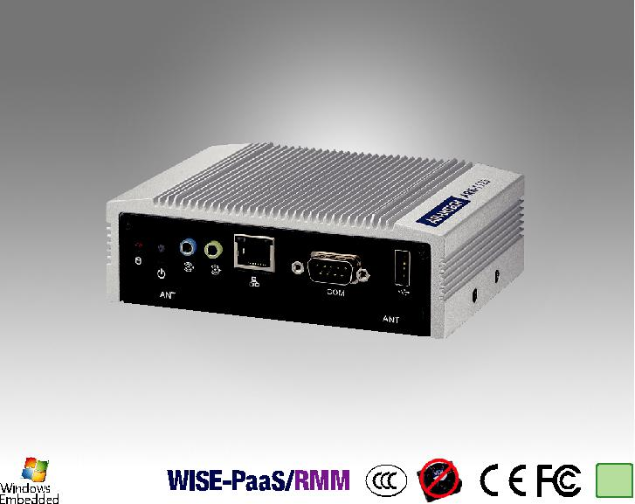

RoHS
COMPLIANT

2002/95/EC

Specifications

Intel® Celeron Quad Core J1900 SoC with Dual HDMI/GbE IoT Fanless BOX PC

Features

 Intel® Celeron J1900 Quad Core 2.0 GHz SoC  1 x 2.5" SATA HDD/SSD Bay
 2 x GbE for Multiple Internet Transmission

 2 x Independent HDMI

 1 x RS-232/422/485 (BIOS selection)

 1 x Full-Size MiniPCIe (ex. WLAN or WWAN module)

 1 x Half Size mSATA

 Optional VESA / DIN Rail / Wall Mounting kits  Threaded DC jack design
 Supports SUSIAccess and Embedded Software APIs  Support WIFI 802.11 a/b/g/n bundled for IoT Gateway

 |  | ARK-1123H-U0A2E
 | CPU | Intel® Celeron™ Processor J1900 Quad Core 2.0 GHz SoC
Processor System | Frequency | 2.0 GHz (Up to 2.41 GHz w/ burst frequency enabled)
 | L2 Cache | 2 MB
 | BIOS | AMI EFI 64 Mbit (Default BIOS is supported for 64-bit OS installation, BIOS for 32-bit OS is supported by project)
 | Technology | DDR3L 1333MHz
Memory | Max. Capacity | 8 GB
 | Socket | 1 x 204-pin SO-DIMM
 | Chipset | Intel® Atom SoC integrated
Graphics |  | DirectX* 11.1, OGL 3.0, OCL 1.1, OGL ES 2.0
 | Graphic Engine | Encode: H264, MPEG2/4, VC1, WMV9
 |  | Decode: H264, MPEG2
 | HDMI | 2 x Lockable HDMI connector, support up to 1920 x 1080 at 60Hz (2nd HDMI w/o audio function by Intel limitation)
Audio | Main System | ALC-888S, High Definition Audio. Line-out & Line-in
Ethernet | LAN #1 | 10/100/1000 Mbps Intel I210 GbE, support Wake on LAN
 | LAN #2 | 10/100/1000 Mbps Intel I210 GbE, support Wake on LAN
I/O Interface | Serial Ports | 1 x RS-232/422/485 (BIOS selectable)
 | USB Interface | 2 x USB 2.0 & 1 x USB3.0
Other | Watchdog timer | 255-level timer interval, setup by software
Expansion | Mini PCIe | 1 x Full-size Mini PCIe, support WLAN or WWAN module
Storage | 2.5" Drive Bay | 1 x 2.5” SATA HDD Bay (Max Height 9.5mm)
 | mSATA | 1 x Half-size mPCIe (Suggest to assembly by CTOS or T-Part due to complex installation)
Software Support | Microsoft Windows | WES7, Windows 7, WE8S, Windows 8 and Windows 10
 | Linux | Support (by Project)
Power Requirement | Power Input Voltage | Single 12 VDC
 | Power Adapter | AC to DC, DC12 V/3 A, 36 W with threaded design
Power Consumption | Typical | 5.64W
 | Max. | 14.04W
 | Construction | Aluminum housing
Mechanical | Mounting | VESA/DIN Rail/Wall Mounting Kits (Optional)
 | Dimensions (W x H x D) | 133.8 x 43.1 x 94.2 mm (5.27" x 1.7" x 3.71")
 | Weight | 0.8kg
 | Operating Temperature | With extended temperature SSD/mSATA/RAM : -20 ~ 60° C with 0.7m/s air flow
 |  | With standard temperature HDD/SSD/mSATA/RAM peripherals:0 ~ 40° C with 0.7m/s air flow
 | Storage Temperature | -40 ~ 85° C (-40~185° F)
Environment | Relative Humidity | 95% @ 40° C (non-condensing)
 |  | With mSATA/SSD: 3 Grms, IEC 60068-2-64, random, 5 ~ 500 Hz, 1 hr/axis
 | Vibration During Operation
 |  | With HDD: 0.5Grms, IEC 60068-2-64, random, 5~500Hz, 3 axes, 1hr/axis
 | Shock During Operation | With mSATA/SSD: 30 G, IEC 60068-2-27, half sine, 11 ms duration
 |  | With HDD: 10G, IEC 60068-2-27, half sine, 11 ms duration
Regulation | EMC | CE/FCC Class B, CCC, BSMI
 | Safety | UL, CCC, BSMI, CB

Fanless Embedded Box PCs

All product specifications are subject to change without notice. Last updated: 10-Jan-2019

ARK-1123H

Dimensions
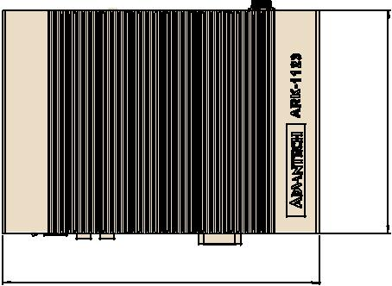

DIN Rail | 100 | Unit: mm
18.05
 | 75
 |  | 34.8347.

94.20

133.80
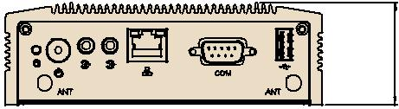

 |  | Ø4.
 |  | 50(4X)
35.05 | 66
VESA mount | 100
8 |  | 3 | 7534. | 2547.100
110 | 75

Wall mount

A

164.40

152.40

9093. 73.90

1143.

 | Ø4
18.25 | .
 | 2
 | 0(8X
 | )

 | 4
105 |  | DetailA
 | 10 | Scale2:1
6 | 2

Front Panel External I/O Mechanical Layout/Drawing
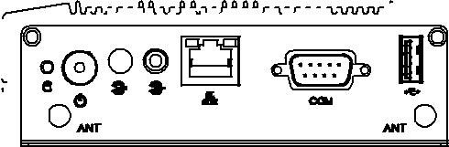

HDD LED Line in LAN USB2..0

On/Off Line out COM

Rear Panel External I/O Mechanical Layout/Drawing

DC IInput USB3..0 LAN

HDMII USB2..0 HDMII

Ordering Information

Part Number | CPU | RAM | HDMI | GbE | USB | USB | RS-232/ | Audio MiniPCIe |  | 2.5" HDD | mSATA | Operating
 |  |  |  |  | 2.0 | 3.0 | 422/485 |  |  | bay |  | Temperature
 | Intel Celeron |  |  |  |  |  |  | Line in
ARK-1123H-U0A2E |  | Up to 8GB | 2 | 2 | 2 | 1 | 1 |  | 1 Full size 1 |  | 1 (H/S) | -20 ~ 60° C
 | J1900 |  |  |  |  |  |  | Line out

Note: Memory, storage and operating system bundled by request.

Packing List

Part Number | Description
- | 1 x ARK-1123H Unit
- | 1 x User Manual (Simplified Chinese)
96PSA-A36W12W7 | 1 x AC to DC adapter DC 12V/3A 36W, -20 ~ 60° C

Embedded OS (Only available for T-Parts OEM, and CTOS service)
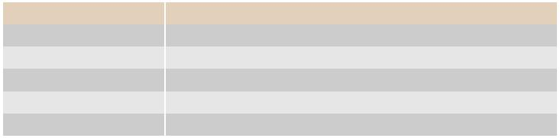

Part Number | Description
2070013033 | WES7E 64-bit with EN/JP/TC/SC (OS size around 11G)
2070013371 | WE8S 64-bit with EN/JP/TC/SC (OS size around 13G)
2070014792 | WIN10 IoT LTSB_x64_Eng
2070014334 | Win10 IoT Core_x32 V10.1.10586.0 EN
2070014369 | IDP-WR3.1_x64 V1.0.1 EN

Optional Items
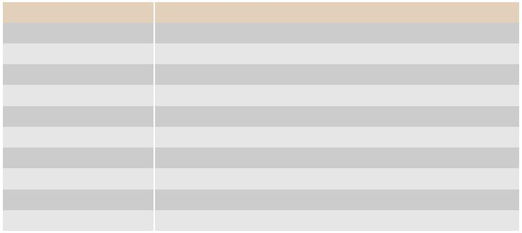

Part Number | Description
1700001524 | Power Cable 3-pin 180cm, USA type
170203183C | Power Cable 3-pin 180cm, Europe type
170203180A | Power Cable 3-pin 180cm, UK type
1700008921 | Power Cable 3-pin PSE Mark 183cm
AMK-V003E | ARK-112X series VESA mounting kit
AMK-R001E | ARK-112X series DIN-rail mounting kit
AMK-W001E | ARK-112X series Wall mounting kit
1700023855-01 | 1M lockable HDMI cable
1700023856-01 | 3M lockable HDMI cable
AMO-WIFI08E | WIFI802.11a/b/g/n, Atheros AR9462,2T2R

Online Download www.advantech.com/products

